
RE MTP Overview
Year 6 Autumn 2
Jigsaw Unit Overview
Theme | Christmas
Concept | Prayer & Worship
Religion | Christianity
Enquiry Question | Do Christmas celebrations and traditions help Christians understand who Jesus was and why He was born?
Learning Intention | To explore the Christian belief in the Virgin Birth and to assess the significance of this to Christians.
Assessment | Engagement  Do Christmas celebrations and traditions help Christians understand who Jesus was and why He was born?  I can start to explain how some of the ways I choose to  celebrate are directly linked to the event I am celebrating,  and how other ways are not.  I can identify when I am celebrating in a way that reflects  the meaning of the event. | Knowledge & Understanding  I can explain why Christmas is important to Christians.  I can describe some of the ways that Christians would  celebrate Christmas and start to understand which of these  would help them understand who Jesus was and why he  was born.  I can explain how Christians use Christmas celebrations  and traditions to remind themselves of Jesus’ birth and life  and can explain which activities do this. |  | Evaluation/Critical Thinking  I can explain why Christians would find some celebrations to remind them of Jesus’ birth and life.  I can explain that people may celebrate Christmas in different ways and say whether or not I feel this relates to  Jesus.  I can explain my own feelings on whether or not it is important to follow Christian beliefs in all Christmas celebrations.


RE MTP
Year , Autumn 2 Week 1
Step 1: Engagement | Lesson 1
Focus Skill | Interpreting / discerning  Interpret the significance and impact of different forms of religious and spiritual expression (e.g. music/art).
Learning Intention | To apply my understanding of celebration to the Christian tradition.  To explore Christmas traditions and celebrations.
SOLO SC: Uni- Structural Bronze | I can recognise some Christmas celebrations and traditions.
SOLO SC: Multi- Structural Silver | I can describe some Christian celebrations and traditions.
SOLO SC: Relational Gold | I can apply my understanding of celebration to the Christian tradition.
SOLO SC: Extended Abstract Platinum | I can reflect on the notion of whether you need to be a Chrsitian to celebrate Christmas.
Key Vocabulary for the lesson/unit | Mr Bean  Tolerance  Belonging  Respect  Celebration  Tradition
Starter | What is a celebration?  What celebrations do you know of?  What happens at a celebration?
Lesson Journey | This is the engagement lesson so a lesson based around Mr Bean’s concept of Christmas.  Show the following clips: Merry Christmas Mr Bean  https://www.youtube.com/watch?v=XhaSA4uSuMw  https://www.youtube.com/watch?v=W91IK06uv5E  https://www.youtube.com/watch?v=jIto_eQuDOQ  How does Mr Bean celebrate Christmas?  What traditions does he partake in?  Christmas tree, decorations, cards, Turkey, carol singers, food and drink, presents
Activity | Leave a blank page before starting the task- this is where the learning enquiry question will be stuck in the next session.  Does Mr Bean need to be a Christian to celebrate Christmas?  Bronze: What are some of the celebrations and traditions he partakes in.  Silver: What is the purpose of these celebrations and traditions?  Gold: Do you celebrate Christma or a similar religious festival in a similar way?  Platinum: Mr Bean clearly celebrates Christmas. Does this mean he is a Christian?
Possible Misconceptions  (What are the children likely to find challenging?) | The concept of celebrating Christmas if you are not religious. Nowadays seen as more of a secular festival with more emphasis on presents and food- has it lost its meaning?
Resources | Show the following clips:  https://www.youtube.com/watch?v=XhaSA4uSuMw  https://www.youtube.com/watch?v=W91IK06uv5E  https://www.youtube.com/watch?v=jIto_eQuDOQ | Pillar Links | HEART  Does Mr Bean belong to the Christian tradition?  Is it Mr Bean’s responsibility to celebrate Christmas?  Should he show respect and tolerance to those who are Christians but do not take part in the celebrations?
Working Wall  (What will go on the WW from this lesson?) | Not for this session.

RE MTP
Year , Autumn 2 Week 2
Step 2: Investigation | Lesson 2
Focus Skill | Reflection of religious beliefs  Explain some of the challenges offered by the variety of religions and  beliefs in the contemporary world.
Learning Intention | To integrate the significance of Jesus’ birth with Christian traditions.  To explore
SOLO SC: Uni- Structural Bronze | I can identify Christmas traditions that originated from Jesus’ birth.
SOLO SC: Multi- Structural Silver | I can list the most relevant Christmas traditions that originated from Jesus’ birth.
SOLO SC: Relational Gold | I can integrate the significance of Jesus’ birth with Christian traditions.
SOLO SC: Extended Abstract Platinum | I can speculate on whether Christmas is now viewed as more of a secular celebration than a religious festival in society.
Key Vocabulary for the lesson/unit | Tradition  Luke’s Gospel  Nativity  Bethlehem  Customs  Secular- (Not connected with religious or spiritual matters)
Starter | Introduce Learning Enquiry Question:  Do Christmas celebrations and traditions help Christians understand who Jesus was and why he was born?  Explain to students that this is the question they will be answering at the end of this topic and the lessons over this half term will build your knowledge and understanding to answer the question confidently.  Have A4/A5 sheet with Learning Enquiry Question ready to stick in on the blank page left last session.
Lesson Journey | Recap of last session and the point of watching Mr Bean- yes he is hilarious and it is one of the greatest tv programmes of all time but there was relevance to the session:  Last week we looked at how Mr Bean celebrated Christmas and the traditions associated with Christmas that he partook in.  We agreed that just because he celebrated Christmas it did not mean he was definitely a Christian. What is important is that it was his choice to celebrate and he remained respectful and tolerant of those of other religions who may celebrate it in a different manner.  Introduce the meaning of tradition:  Tradition- a custom or act that is passed down through the generations and is done again and again year on year.  Ask the class to discuss as many traditions as they know and write a class list.  Christmas cakes, crackers, Christmas trees, stars, angels, Christmas cards, holly wreaths, building nativity scenes or cribs in public places and homes, parties, decorations, turkey, Father Christmas, reindeer etc.  But what are the relevance of these in relation to Jesus and his birth? (Always link back to LE Question)  https://www.biblegateway.com/passage/?search=Luke%202&version=NIV  Read and familiarize with the birth of Jesus from Luke’s Gospel
Activity | Q) In your opinion, what is the true meaning and purpose of Christmas?  Possible Response:  To a Christian believer, Christmas is a time to celebrate the birth of Jesus (their Messiah). This occurs on the 25th December each year; it is known as Christmas Day.  To me, in my family, Christmas is a time to spend time with each other, eat a large meal and open presents that are bought for each other. Often, we will sing songs, play games and occasionally, attend the local church for a hymn service.
Possible Misconceptions  (What are the children likely to find challenging?) | The idea that people from all faiths and cultures can celebrate Christmas.  Secular- its meaning and relevance for the session.
Resources | https://www.biblegateway.com/passage/?search=Luke%202&version=NIV | Pillar Links | Heart:  Belonging, Responsibility, Respect and Tolerance
Working Wall  (What will go on the WW from this lesson?) | Learning Enquiry Question clearly visible in class.

RE MTP
Year , Autumn 2 Week 3
Step 2: Investigation | Lesson 3
Focus Skill | Interpreting  Interpret the significance and impact of different forms of religious and spiritual expression (e.g. music/art).
Learning Intention | To analyse the concept of Incarnation in relation to Nativity.  To explore the concept of incarnation.
SOLO SC: Uni- Structural Bronze | I can define the concept of Incarnation.
SOLO SC: Multi- Structural Silver | I can describe the concept of Incarnation.
SOLO SC: Relational Gold | I can analyse the concept of Incarnation in relation to Nativity.
SOLO SC: Extended Abstract Platinum | I can analyse the concept of Incarnation in relation to Nativity and reflect on how this provides a greater understanding into who Jesus was.
Key Vocabulary for the lesson/unit | Messiah  Incarnation  Nativity  Gold  King  Gifts  John  Flesh
Starter | Pose Learning Enquiry Question again and remind pupils we always have this question in focus when completing these sessions.  The Word [God] became flesh and dwelt among us’ (John 1:14)  Put the above quote on board and challenge pupils to discuss what it means.
Lesson Journey | Explain how the quote is referencing one of these core principles of Christianity: Incarnation  The word Incarnation comes from the Latin word flesh.  Incarnation is the central belief of Christianity that God became Flesh.  God assumed a human form and became Jesus Christ on Earth.  Jesus was truly God and truly man.  Incarnation is intrinsically linked to the Nativity  https://www.youtube.com/watch?v=wEN5MYtOMkU  Show above clip as quick recap and familiarise with Nativity.  Questions to ask:  Three Wise Men and Gift Giving  Why did Jesus receive these gifts?  How do they help us understand who Jesus was?  The Three Wise Men brought gifts of gold, incense and myrrh.  It is easy to see why gold is an appropriate gift for Jesus Christ. Gold is the metal of kings. When gold was presented to Jesus, it acknowledged his right to rule. The wise men knew Jesus was the King of kings.  By reflecting on the gifts Jesus received we can understand who Jesus was. The tradition of Nativity reminds us that Jesus was born as a King.
Activity | The Word [God] became flesh and dwelt among us’ (John 1:14)  Bronze: Using the above quote, define Incarnation.  Silver: Using the above quote define and describe the concept of Incarnation.  Gold: Why is Nativity fundamental to the concept of Incarnation, specifically the fact that Jesus was born as a baby?  Platinum: Why is Nativity fundamental to the concept of Incarnation, specifically the fact that Jesus was born as a baby? In addition, what other aspects of Nativity provide a greater understanding as to who Jesus was?  Exemplar Response:  God assumed a human form and became Jesus Christ on Earth.  The God of the Universe created the world and everything in it – chose to become a tiny baby. Although never stopping to be God, he knew exactly what it was like to be a human – for good and for bad. He made friends, he found enemies. He knew joy and sorrow. He laughed and he got angry. He wanted to understand what us as humans have to go through every day. He wanted to fully understand the range of emotions that we experience so he could too. The tradition of the Nativity is vital in understanding why Jesus was born and fully understanding the concept of Incarnation- although Jesus was God on Earth, he needed to show he was human too and so was born as a baby.  The Nativity story also involves three wise men, who bring three gifts to Jesus (gold, frankincense and myrrh). Gold is the metal for kings and Jesus is said to be the King of Kings on Earth according to Christinaity.
Possible Misconceptions  (What are the children likely to find challenging?) | Incarnation was Jesus arriving as a baby and not a grown man.
Resources | https://www.youtube.com/watch?v=wEN5MYtOMkU | Pillar Links | Heart:  Belonging, Responsibility, Respect and Tolerance
Working Wall  (What will go on the WW from this lesson?) | Not for this session.

RE MTP
Year , Autumn 2 Week 4
Step 2: Investigation | Lesson 4
Focus Skill | Application and Making Links/Synthesis  Explain the reasons for and effects of diversity within and between religions, beliefs and cultures.
Learning Intention | To evaluate the significance of Christmas traditions.
SOLO SC: Uni- Structural Bronze | I can name Christmas traditions during a debate.
SOLO SC: Multi- Structural Silver | I can discuss Christmas traditions during a debate.
SOLO SC: Relational Gold | I can evaluate the significance of Christmas traditions during a debate.
SOLO SC: Extended Abstract Platinum | I can evaluate the significance of Christmas traditions and theorise the future relevance of such traditions during a debate.
Key Vocabulary for the lesson/unit | Tradition  Christmas Carol  King  Humankind  Nativity
Starter | Recap of previous session on Incarnation:  What does Incarnation mean?  Why did Jesus arrive in human form as a baby during the Nativity?  Why is the Nativity and important Christmas tradition helping us understand who Jesus was and why He was born?
Lesson Journey | Last week we looked at how the tradition of the Nativity helps Christians to understand who Jesus was and why He was born.  Today we are going to focus on some more Christmas traditions and evaluate how they help Christians understand who Jesus was.  Christmas Carols:  A song on the theme of Christmas, traditionally sung at Christmas.  What Christmas Carols do we know?  https://www.youtube.com/watch?v=nEH7_2c644Q  SILENT NIGHT  https://www.youtube.com/watch?v=xqooC4ZG75Y  HARK THE HERALD ANGEL SING  https://www.youtube.com/watch?v=1FuF7H0uJww  RUDOLPH THE RED NOSED REINDEER  https://www.youtube.com/watch?v=3CWJNqyub3o  JINGLE BELLS  The Christmas Carols of Silent Night and Hark the Herald Angel Sing refer to the Nativity and Jesus’ birth. The latter directly references Jesus as a King which helps us understand who He is. He was born as a King in order to save humankind. The gift of gold brought by the three wise men reaffirm this- gold was seen as the metal of kings.  Silent Night highlights Jesus arriving into the world in human form as a baby. The concept of Incarnation, which is God assuming human form on Earth, is present in both Christmas Carols. They both help us understand who He was and why He was born into the world this way.  Rudolph the Red Nosed Reindeer and Jingle Bells do not directly refer to Nativity. They are more associated with wider Christmas traditions such as Father Christmas and celebrations.  Church Service, Decorations, Giving Gifts  How do these traditions help Christians understand who Jesus was?  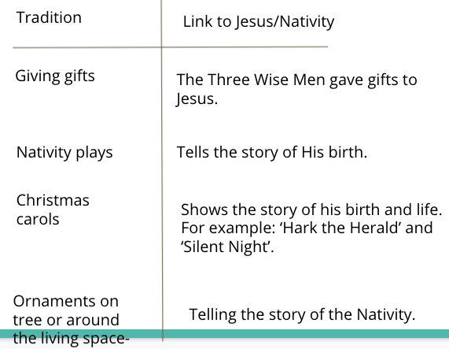
Activity | Debate:  Christmas Carols are the most important tradition in helping Christians understand who Jesus was and why He was born.  Split the class in half or in groups to debate this statement. Those in favour and those against.  The purpose of this activity is to explore the different traditions and for students to become more familiar with their relevance to Jesus and whether they give any insight into his birth and why He was born.
Possible Misconceptions  (What are the children likely to find challenging?) | Inferring from the lyrics of the Christmas Carols what the actual message is.  Articulating their ideas in a debate.  Lack of confidence in speaking in front of peers.
Resources | https://www.youtube.com/watch?v=nEH7_2c644Q  SILENT NIGHT  https://www.youtube.com/watch?v=xqooC4ZG75Y  HARK THE HERALD ANGEL SING  https://www.youtube.com/watch?v=1FuF7H0uJww  RUDOLPH THE RED NOSED REINDEER  https://www.youtube.com/watch?v=3CWJNqyub3o  JINGLE BELLS | Pillar Links | Heart:  Belonging, Responsibility, Respect and Tolerance
Working Wall  (What will go on the WW from this lesson?) | Not for this session.

RE MTP
Year , Autumn 2 Week 5
Step 3: Evaluation | Lesson 5
Focus Skill | Explaining  Use religious vocabulary and concepts to explain in detail, principal beliefs, teachings, values and practices.
Learning Intention | To argue whether Christmas celebrations and traditions help Christians understand who Jesus was and why He was born.
SOLO SC: Uni- Structural Bronze | I can rank Christmas traditions in order of their relevance to Jesus and His birth.
SOLO SC: Multi- Structural Silver | I can rank Christmas traditions in order of their relevance to Jesus and His birth and outline their relevance.
SOLO SC: Relational Gold | I can argue whether Christmas celebrations and traditions help Christians understand who Jesus was and why He was born.
SOLO SC: Extended Abstract Platinum | I can argue whether Christmas celebrations and traditions help Christians understand who Jesus was and why He was born and reflect on the true meaning of Christmas.
Key Vocabulary for the lesson/unit | 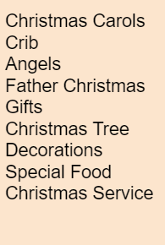  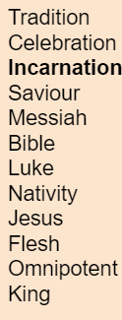
Starter | A recap of main ideas and themes covered so far in the unit and run through of the key vocabulary that students will be using to answer their Learning Enquiry Question.
Lesson Journey | 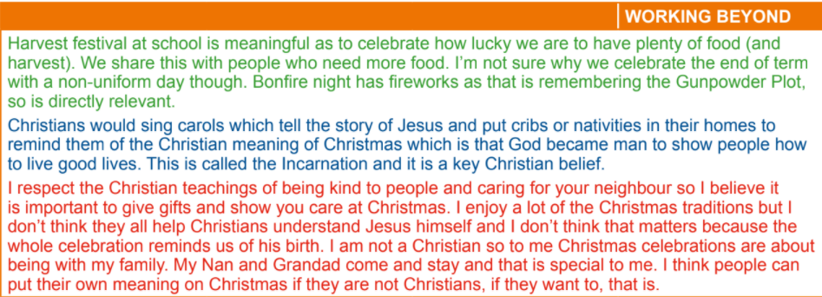  Display this exemplar response:  Response broken down into three sections:  Red: Engagement- personal celebrations that students partake in and the meaning behind them celebrations.  Blue: Knowledge- what celebrations and traditions do Christinas partake in to remind them of Jesus’ life? Which ones are more relevant than others?  Green: Evaluation-What is the purpose of these traditions? Are they still relevant? Is Christmas still about remembering Jesus and his birth? Is there one true meaning to Christmas?  Note: This is classified as a Greater Depth response.  With the knowledge and concepts covered however, the expectation is that their responses would be of a higher quality.
Activity | Majority of pupils will be answering Gold/Platinum question  They will complete this using the format modelled above.  For Bronze and Silver responses- complete the sheet from Jigsaw.  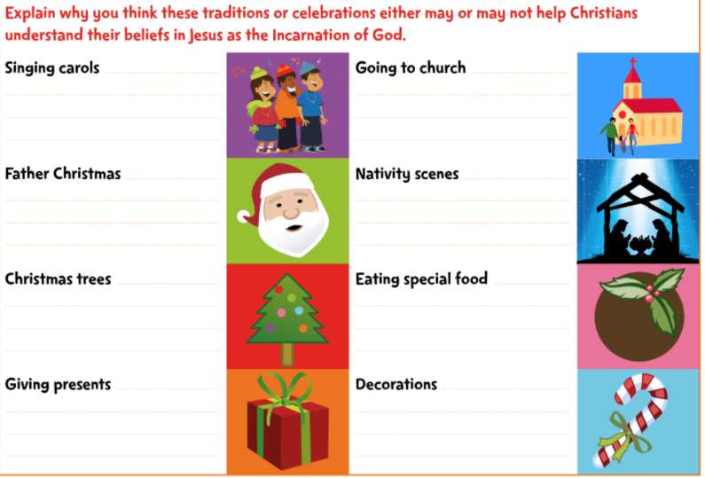  Bronze: Cutting out images and arranging in Diamond Formation in order of relevance to Jesus.  Silver: As above but explaining the thought process behind the decisions.
Possible Misconceptions  (What are the children likely to find challenging?) | Some students may be confused on how to structure their answer using the three categories. If these issues do arise allow for students to construct their answer how they see fit.  For example- combining engagement with knowledge or evaluation in the first paragraph etc
Resources | Exemplar answer to Learning Enquiry Question | Pillar Links | Heart:  Belonging, Responsibility, Respect and Tolerance
Working Wall  (What will go on the WW from this lesson?) | HIGH LEVEL RESPONSES TO LEARNING ENQUIRY QUESTION

RE MTP
Year , Autumn 2 Week 6
Step 4: Expression | Lesson 6
Focus Skill | Interpreting/Discerning  Interpret the significance and impact of different forms of religious and spiritual expression (e.g. music/art).
Learning Intention | To create an illustration to express the Holy Trinity Doctrine.
SOLO SC: Uni- Structural Bronze | I can draw an image that expresses the Holy Trinity Doctrine.
SOLO SC: Multi- Structural Silver | I can draw and label an image that expresses the Holy Trinity Doctrine.
SOLO SC: Relational Gold | I can create an illustration to express the Holy Trinity Doctrine.
SOLO SC: Extended Abstract Platinum | I can invent an illustration to express the Holy Trinity Doctrine.
Key Vocabulary for the lesson/unit | Incarnation  Holy Trinity  God  Father  Son  Holy Spirit  Omnipotent  Theologians
Starter | Recap of the concept of Incarnation and how this was fundamental to our LE Question and our unit.  Today we are going to look at another concept linked to Incarnation- The Holy Trinity
Lesson Journey | What is the Holy Trinity?  Pose questions and take feedback.  https://www.youtube.com/watch?v=AQkFlzFJ3kA  Then show the above clip.  Explain how:  Christians believe in the Trinity – that is, in God as Father, Son and Holy Spirit.  It is important to realise that this does not mean that Christians believe in three gods – they do not. Christians believe in one God that has three parts.  Christians believe that God took human form as Jesus Christ (Incarnation), that people can know God the Father in Heaven, and that God is present today through the work of the Holy Spirit.  Omnipotent= present everywhere.  The Holy Trinity remains one of the most difficult concepts for humans to comprehend worldwide.  In order for this concept to be understood more clearly, theologians and thinkers have produced diagrams and illustrations of The Holy Trinity.  Share with the class of the classic depictions of the Holy Trinity and draw out any unique features and similar features they all share.  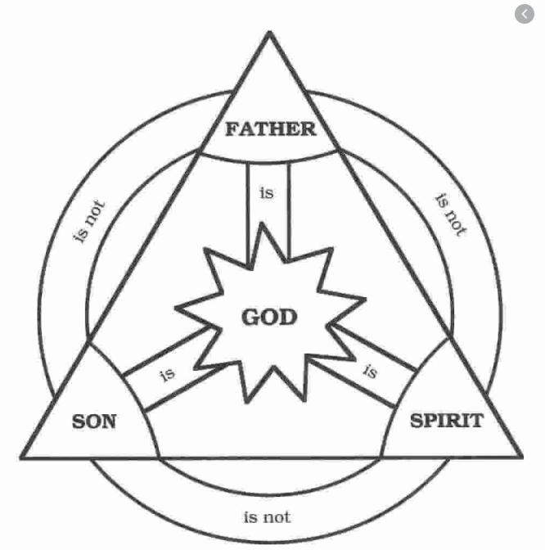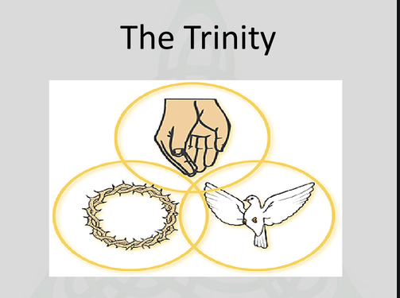
Activity | Bronze: Copy one of the depictions of The Holy Trinity into your book.  Silver: As above but annotate your image.  Gold: Using the images shown as a template, create your own depreciation of the Holy Trinity.  Platinum: Produce a unique depiction of the Holy Trinity.
Possible Misconceptions  (What are the children likely to find challenging?) | The Holy Trinity is one of the most complex and studied concepts in religion so it will be perfectly understandable for pupils to ask questions and struggle to be able to to comprehend how God is one with three parts.  Be honest and state that there are many experienced theologians and scholars who struggle to explain the concept but if you can remember that it is not three gods but one God with three parts.
Resources | https://www.youtube.com/watch?v=AQkFlzFJ3kA  Print out of some visuals of the Holy Trinity | Pillar Links | Hands:  Creating and Experiencing
Working Wall  (What will go on the WW from this lesson?) | High quality representations of the Holy Trinity.

