
RE MTP Overview
Year 6 Summer 2
Jigsaw Unit Overview
Theme | Covenant
Concept | Commitment
Religion | Christianity
Enquiry Question | How did Jesus create a ‘New Covenant’ and what does that mean to  Christians today?
Learning Intention | We are learning to understand the Christian belief that Jesus fulfilled the Old  Testament Covenant and created a ‘New Covenant’.
Resources | Previous Learning Slides  Summer 2 RE Pre-Learning Slides
Assessment | WTS  I can think of something that I could change which would  benefit others.  I can describe the meaning behind a Biblical text with  regard to the New Covenant.  I can explain why I have ranked these texts in this order  with regard to their importance to Christians. | EXS  I can explain how I may or may not want somebody  to commit to do something for me in return for my  Commitment.  I can make links between the Bible texts I have chosen  and the New Covenant.  I can reflect on the Christian belief in the New Covenant  and whether it is relevant to Christians today. |  | GDS  I can use my judgement to decide whether my commitment  is conditional or unconditional and can explain why I have chosen this option.  I can explain how different texts build together to form  evidence towards Jesus creating a New Covenant  (assessed throughout investigation as well as Activity  Sheet).  I can explain my opinion on how relevant the New  Covenant is to Christians today.
Enrichment


RE MTP
Year 6, Summer 2 Week 1
Step 1: Engagement | Lesson 1
Focus Skill | Identity, experience and empathy  Have the ability to see the world through the eyes of others, and recognise issues from their point of view.
Learning Intention | To apply the concept of promise to my life.
SOLO SC: Uni- Structural Bronze | I can define what a promise is.
SOLO SC: Multi- Structural Silver | I can describe the features of a promise.
SOLO SC: Relational Gold | I can apply the concept of a promise to my life.
SOLO SC: Extended Abstract Platinum | I can reflect on the impact of promises in modern society.
Key Vocabulary for the lesson/unit | Covenant  Promise  Oath  Government  Binding  Monarchy  Salvation
Starter | Open up link and watch following Recess episode: Some Friend  https://www.youtube.com/watch?v=EG_7yssw_3E  Draw out the message of the episode and the importance of the promise made.
Teacher Input/Activity | - Pose question to students;  ‘When was the last time you made a promise to someone?”  “What is the longest time you have kept a promise?”  “How long have you kept someone waiting to receive something you have promised?”  - Introduce the term covenant and note how it is a very similar concept to a promise but much more serious.  Other similar term is an oath.  - Show MPs swearing an oath (similar to covenant) whilst beginning their role and this would last 4-5 years.  https://www.youtube.com/watch?v=EG_7yssw_3E  - Show Joe Biden swearing an oath  https://www.youtube.com/watch?v=EG_7yssw_3E  - Decide on a class definition of ‘promise’  TASK: Quote from Recess Episode and Picture  “He made a promise that, no matter what, every year he would come to my birthday party.”  Bronze: What was the promise made in this episode?  Silver: Who was involved in the promise and why would it have been a difficult promise to keep?  Gold: When have you had to make a promise similar to the one shown and what were the challenges associated with the promise?  Platinum: What is the difference between the promise made in the Recess clip and the promise made by Joe Biden? Which one is more important?
Possible Misconceptions  (What are the children likely to find challenging?) | The wider implications of promises in society
Resources | https://www.youtube.com/watch?v=EG_7yssw_3E Recess episode  https://www.youtube.com/watch?v=EG_7yssw_3E  MP oath  https://www.youtube.com/watch?v=EG_7yssw_3E Joe Biden | Pillar Links | - Heart  Responsibility to see a promise through  Belonging to the person who you have made a promise to.
Working Wall  (What will go on the WW from this lesson?) | Not for first session

RE MTP
Year 6, Summer 2 Week 2
Step 2: Investigation | Lesson 2
Focus Skill | Explaining  Use religious vocabulary and concepts to explain in detail, principal beliefs, teachings, values and practices.
Learning Intention | To summarise the covenants made by God in the Old Testament.
SOLO SC: Uni- Structural Bronze | I can label covenants made by God in the Old Testament.
SOLO SC: Multi- Structural Silver | I can recognise the key figures involved in those covenants.
SOLO SC: Relational Gold | I can summarise the covenants made by God in the Old Testament.
SOLO SC: Extended Abstract Platinum | I can theorize why some of the covenants were broken.
Key Vocabulary for the lesson/unit | Genesis  Moses  Abraham  God  Oath  Exodus  Noah
Starter | Introduce Learning Enquiry Question:  How did Jesus create a ‘New Covenant’ and what does that mean to  Christians today?  Ensure that students understand that a covenant is much more serious than promises discussed in last lesson- that it is a legally binding agreement.  Explain that in Jewish tradition/culture it was the same as a contract.
Teacher input / Activity | Provide background knowledge- in the Old Testament, God made several covenants with different people- however some were conditional and others unconditional.  Draw out what these terms means- conditional- reliant on something else and unconditional- not expecting anything back.  1) Provide pairs with examples of covenants (below)  Questions- Who is the covenant between?  What is the covenant?  Is it conditional or unconditional?  2) Question after they have read the extracts- are there any similarities?  Genesis 2: 15-17- Adam and Eve - that if they didn’t eat from the tree of knowledge then they would never die.  • Genesis 9: 8-17- end of the story of Noah: God made an unconditional Covenant. He freely promised to never flood the Earth  again and that the rainbow was the sign.  • Genesis 17: 1-7 - God’s Covenant with Abraham and how he was promised a son even though he and his wife were nearly  100. This was unconditional - Abraham would have this done for him without him needing to do anything.  • Exodus 19: 5-6 - God’s Covenant with Israel through Moses (10 Commandments follow in chapter 20conditional on  Israelite’s keeping the laws.  Task:  Bronze:  Silver:  Gold:  Platinum:
Possible Misconceptions
(What are the children likely to find challenging?)
Resources
Working Wall
(What will go on the WW from this lesson?)

RE MTP
Year , Summer 2 Week 3
Step 2: Investigation | Lesson 3
Focus Skill | Explaining  Use religious vocabulary and concepts to explain in detail, principal beliefs, teachings, values and practices.
Learning Intention | To draw and explain how Jesus created a New Covenant.
SOLO SC: Uni- Structural Bronze | I can draw an example of Jesus fulfilling the new Covenant
SOLO SC: Multi- Structural Silver | I can draw and describe an example of Jesus fulfilling the new Covenant.
SOLO SC: Relational Gold | I can draw and explain an example of Jesus fulfilling the new Covenant.
SOLO SC: Extended Abstract Platinum | I can draw an example of Jesus fulfilling the new Covenant and reflect on its for Christians today.
Key Vocabulary for the lesson/unit | Covenant  Promise  Oath  Government  Binding  Monarchy  Salvation  Genesis  Moses  Abraham  God  Oath  Exodus  Noah
Starter | Recap of last lesson and the covenants that were covered from the Old Testament.  Begin by showing Isaiah 24:5 and challenge pupils to draw out the key message of the extract  The Old Covenant has been broken and there will have to be a new one.
Teacher input / Activity | https://www.youtube.com/watch?v=8ferLIsvlmI  - Show the above clip to provide added detail on the new Covenant involving God and humans through Jesus's Life and death.  - Explore these bible extracts which focus on the different ways that Jesus is fulfilling the New Covenant.  Matthew 5: 17-19: Jesus himself talking about how he came to fulfil the old Covenant in the Sermon on the Mount (Could also look at Beatitudes as a way of living).  • Jesus summarised the 10 Commandments into two: Matthew 22: 34-39  • Jesus himself said that the Last Supper created the New Covenant (Matthew 26:28, Mark 14:24, Luke 22:20).  TASK- “Then he took a cup, and when he had given thanks, he gave it to them, saying, “Drink from it, all of you. This is my blood of the covenant, which is poured out for many for the forgiveness of sins. “  Bronze: Using the source, draw Jesus fulfilling the New Covenant.  Silver: Using the source, draw an example of Jesus fulfilling the Covenant and annotate your image.  Gold: Using the sources discussed in class, draw Jesus fulfilling the Covenant and explain your reasoning.  Platinum: Using the sources discussed, draw Jesus fulfilling the Covenant. What is the impact for Christians today?
Possible Misconceptions  (What are the children likely to find challenging?) | The distinction between the Old and New Covenant.
Resources | https://www.youtube.com/watch?v=8ferLIsvlmI | Pillar Links | - Hands  Creating an image to accompany the Covenant source
Working Wall
(What will go on the WW from this lesson?)

RE MTP
Year 6, Summer 2, Week 4
Step 2: Investigation | Lesson 4
Focus Skill | Identity, experience and empathy  Have the ability to see the world through the eyes of others, and recognise issues from their point of view.  Questioning  Interpret the different answers given by religions, and their different perspectives, to form their own opinions.
Learning Intention | To ask questions that deepen my understanding of the Old and New Covenants.
SOLO SC: Uni- Structural Bronze | I can ask questions about the general concept of Covenant.
SOLO SC: Multi- Structural Silver | I can ask specific questions relating to the New Covenant.
SOLO SC: Relational Gold | I can ask questions that deepen my understanding of the Old and New Covenants.
SOLO SC: Extended Abstract Platinum | I can analyze the responses gathered to reflect on why the New Covenant is important to Christians today.
Key Vocabulary for the lesson/unit | Covenant  Promise  Oath  Government  Binding  Monarchy  Salvation  Genesis  Moses  Abraham  God  Oath  Exodus  Noah  Covenant  Promise  Oath  Government  Binding  Monarchy  Salvation  Genesis  Moses  Abraham  God  Oath  Exodus  Noah
Starter | Recap of previous learning with focus on the Last Supper as Jesus revealing the New Covenant  Display Learning Enquiry Question again.
Teacher Input / Activity | - Start by asking students to write 3-4 to questions that they would like to ask the visitor.  Share success criteria with the students to allow them to see the requirements needed in their questions to reach a certain standard.  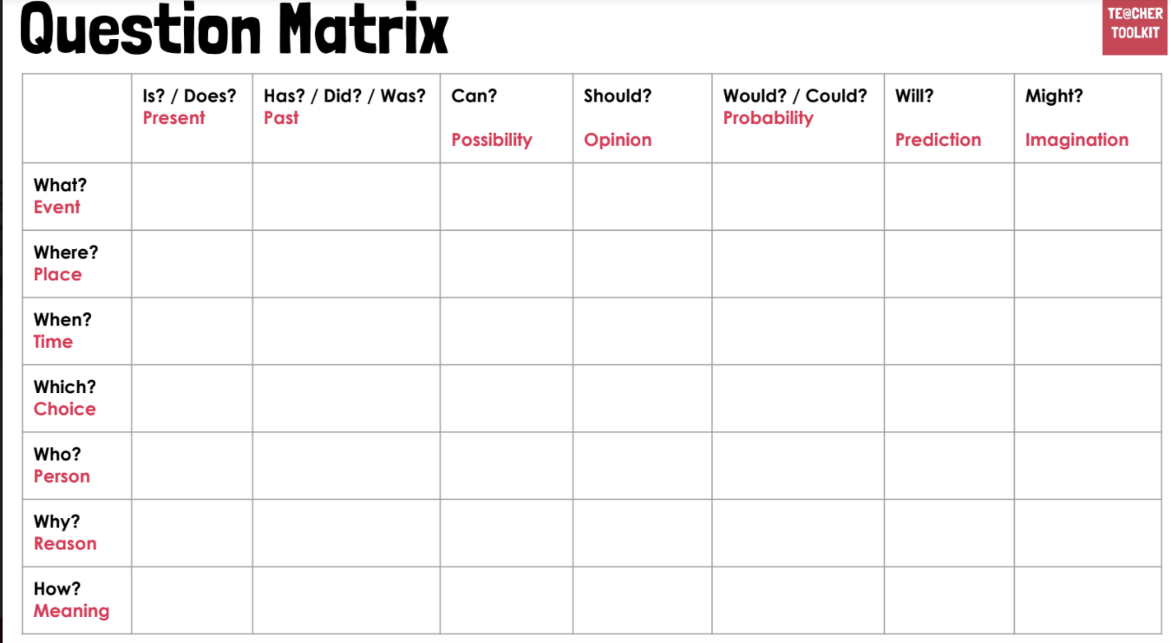  Visitor should be prepared beforehand that this is a focus on the Old and New Covenants- a particular area of Christianity.  Encourage pupils to ask more meaningful questions:  When would you reflect on the new Covenant?  What will be the next Covenant?  Which extract from the Bible gives you the clearest idea of the Covenant?
Possible Misconceptions  (What are the children likely to find challenging?) | Asking general questions about Chrisitinaity  The visitor would be happy to oblige but there must be a focus on the concept of Covenant and its links to Salvation.
Resources | Christian minister- Contact of JL who recently did an assembly for Year 2 | Pillars | Heart  - Respect  - Tolerance  - Kindness  Hands  - Experience
Working Wall
(What will go on the WW from this lesson?)

RE MTP
Year 6, Summer 2, Week 5
Step 3: Evaluation | Lesson 5
Focus Skill | Explaining  Use religious vocabulary and concepts to explain in detail, principal beliefs, teachings, values and practices.  Reflection of religious beliefs  Explain some of the challenges offered by the variety of religions and  beliefs in the contemporary world.
Learning Intention | To explain how Jesus created a New Covenant and what it means for Christians today.
SOLO SC: Uni- Structural Bronze | I can sort bible texts showing the New Covenant being formed in order of importance to Christians.
SOLO SC: Multi- Structural Silver | I can sort bible texts showing the New Covenant being formed in order of importance to Christians and explain my reasoning.
SOLO SC: Relational Gold | I can explain how Jesus created a New Covenant and what it means for Christians today.
SOLO SC: Extended Abstract Platinum | I can reflect on the Christian belief in the New Covenant and question its relevance for Christians today.
Key Vocabulary for the lesson/unit | Covenant  Promise  Oath  Government  Binding  Monarchy  Salvation  Genesis  Moses  Abraham  God  Oath  Exodus  Noah
Starter | Low stakes quiz to recap learning so far  Vocabulary focus- Covenant, Salvation, Jesus, Prophets etc...
Teacher Input / Activity | This is the assessment lesson for the topic.  The Learning Enquiry Question (which should have been referred to constantly throughout the topic)  TASK:  Bronze: Use the Jigsaw sheet to complete the sorting exercise.  Silver: Use the jigsaw sheet and use the sentence starters to complete.  Gold: Answering the LEQ using the format shown on JIgsaw  Platinum: Answering the LEQ using the format shown with understanding of the impact on Christian faith today.
Possible Misconceptions  (What are the children likely to find challenging?) | Deciding what level of question they are going to answer-
Resources | The Jigsaw Activity sheet for Bronze and Silver Level
Working Wall
(What will go on the WW from this lesson?)

RE MTP
Year 6, Summer 2, Week 6
Step 4: Expression | Lesson 6
Focus Skill | Interpreting / discerning  Interpret the significance and impact of different forms of religious and spiritual expression (e.g. music/art).
Learning Intention | To make a plan for a covenant personal to me.
SOLO SC: Uni- Structural Bronze | I can name a person I am going to form a covenant with.
SOLO SC: Multi- Structural Silver | I can outline the features of my covenant.
SOLO SC: Relational Gold | I can make a plan for a covenant personal to me.
SOLO SC: Extended Abstract Platinum | I can create a covenant to fulfill whilst at secondary school.
Key Vocabulary for the lesson/unit
Starter | Bring the unit back to the first session  Who can remember the episode we watched?  Recap of Recess and the promise made between TJ and Menlo
Teacher Input / Activity | .Although a covenant is a formal and serious agreement or promise. law or a formal written agreement between two or more people, businesses, countries for these purposes pupils can make a covenant with themselves.  Teacher to provide class with a covenant they are going to make themselves.  This could be a written agreement
Possible Misconceptions
(What are the children likely to find challenging?)
Resources |  | Pillar Links
Working Wall
(What will go on the WW from this lesson?)

