
RE MTP Overview
Year 6 Summer 1
Jigsaw Unit Overview
Theme | Beliefs and Meaning
Concept | Beliefs & Moral Values
Religion | Islam
Enquiry Question | Does belief in Akhirah (life after death) help Muslims lead better lives?
Learning Intention | We are learning that the concept of Jihad can be interpreted differently leading to different actions and consequences.
Resources | Previous Learning Slides  Summer 1 RE Pre-Learning Slides
Assessment | Engagement  WTS: I can explain how knowing that my actions have consequences makes a difference to the choices I make.  EXS: I can give examples of times my choices have been influenced and may have changed when I considered the consequences that might follow.  GDS: I can start to explain how my beliefs about right and wrong, actions and consequences make a difference to the choices I make. | Knowledge & Understanding  WTS: I can describe some of the ways that Muslims try to lead lives respectful to God and start to say why this is important to them.  EXS: I can explain how believing in Akhirah influences Muslims to do their best to lead good lives.  GDS: I can explain how the belief in Akhirah influences Muslim decisions and choices as to how to behave towards God and other people. |  | Evaluation/Critical Thinking  WTS: I can identify why leading a good life might be a good idea and why people think this.  EXS:I can recognise what motivates or influences me to lead a good life and compare it with what motivates and influences Muslims.  GDS: I can ask questions about life after death and explore how what I believe about this might influence my life.
Enrichment | Visit a Mosque


RE MTP
Year 6, Summer 2 Week 1
Step 1: Engagement | Lesson 1
Focus Skill | Identity, Experience and Empathy: Have the ability to see the world through the eyes of others, and recognise issues from their point of view.
Learning Intention | To explain how consequences drive my decision making processes  To explore the decision making process
SOLO SC: Uni- Structural Bronze | I can recognise that my actions have consequences.
SOLO SC: Multi- Structural Silver | I can describe how consequences can be both positive and negative
SOLO SC: Relational Gold | I can explain how consequences drive decision making processes  I can explain influences on the decisions I make
SOLO SC: Extended Abstract Platinum | I can reflect on whether i believe it is ever acceptable to break the law and why
Key Vocabulary for the lesson/unit | Motivation  Consequences  Morality  Law  Just War Theory  Utilitarianism
Starter | Visuals and video clip of the war- Quick recap of what they have learned in previous topic.  Jamboard Question - Is war ever right?
Teacher Input/Activity | Summer 1 Quiz on GC forms  - TTYP Previous Learning Slides  - Provide different scenarios of a person’s actions.  Open up discussion with pairs or bigger groups regarding whether it is ever acceptable.  - See resources for examples.  Example of Bansky and his art- is he breaking the law?  - Flow chart of possible decisions.  - Reflection -  “Your teacher is in the middle of teaching a very important lesson when you decide to jump out of your seat, run across the classroom and shout loudly at them to get their attention.  By doing this you have broken several school rules and have appeared to show a huge amount of disrespect to your teacher and classmates.”  1. What could happen as a result of your actions?  2. What could be the positive and negative consequences of your actions?  3. Does the motivation (the reasons for) your action affect the consequences? How?
Possible Misconceptions  (What are the children likely to find challenging?) | Considering how others may react in a similar situation- (showing empathy)
Resources | - Video clip of war  - Images of controversial actions e.g. someone with a knife in the chest (stabbing vs surgeon), grabbing a child (abduction vs saving from being run over, stealing (greed vs survival), blood transfusion (health vs religious belief) | Pillar Links | Health:  - Healthy mindset  - Positive behaviour  - Moral compass
Working Wall
(What will go on the WW from this lesson?)

RE MTP
Year 6, Summer 1, Week 2
Step 2: Investigation | Lesson 2
Focus Skill | Explaining: Use religious vocabulary and concepts to explain in detail, principal beliefs, teachings, values and practices.
Learning Intention | To explain how Muslims try to lead good lives and question whether this is always easy  To explore what it means to live a good life in Islam
SOLO SC: Uni- Structural Bronze | I can identify one way in which Muslims try to lead a good life
SOLO SC: Multi- Structural Silver | I can list ways in which Muslims try to lead good lives  I can list describe ways in which Muslims try to lead a good life
SOLO SC: Relational Gold | I can explain how Muslims try to lead good lives and question whether this is always easy  I can explain why it might not always be easy to live a good life for Muslims
SOLO SC: Extended Abstract Platinum | I can reflect argue on the importance of intention over the action itself
Key Vocabulary for the lesson/unit | 5 Pillars of Islam  Allah  Judgement  Morality  Consequence  Intention
Starter | Utilitarianism example (cart with lever decision)  Open to discussion about consequences of actions, what drives your decision making process?
Teacher input / Activity | - What is a good life? Does it mean having a roof over your head or being financially successful?  Is having a good life the same as being a good person?  Is it your responsibility or duty to use your wealth to help others?  Can you think of anyone who has a good life? Why?  - What can you remember from the previous unit of how Muslims show commitment to God? Remembering the 5 Pillars.  - Show video and discuss the different examples shown- charity, fasting and praying.  - Task- Case study of Keanu Reeves  Tragic backstory and how he has overcome such adversity and tragedy to lead what many would consider a ‘good life.’  Task- Anthony Joshua  Drugs conviction when he was younger- 18) 14 year jail term but served 100 days. Suspended by the team, sponsors let him go- now considered the model athlete and role model to youngsters.  Provide hypothetical- context of a mugging or assault- he steps in and resolves the issue but in term hurts the attacker.  Does the intention of saving the person outweigh the consequence of the mugger being hospitalised?  Task- Provide similar case study involving a Muslim who has not been able to donate their contribution to charity. Are they still leading a good life?  Bronze- identify charity as the Pillar  Silver- being able to list other Pillars  Gold- provide challenges to this Pillar  Plat- determine whether intention is crucial and if they intended to give to charity whether this is what ultimately signifies a good life.
Possible Misconceptions
(What are the children likely to find challenging?)
Resources | What does it mean to be a Mulsim (Video)  Anthony Joshua case study  Second case study for Muslim person | Pillar Links | Heart:  - Responsibility  - Belonging  - Respect
Working Wall
(What will go on the WW from this lesson?)

RE MTP
Year 6, Spring 2 Week 3
Step 2: Investigation | Lesson 3
Focus Skill | Identity, Experience and Empathy: Have the ability to see the world through the eyes of others, and recognise issues from their point of view.  Reflection of Religious Beliefs: Explain some of the challenges offered by the variety of religions and  beliefs in the contemporary world.
Learning Intention | To explain how believing in Akhirah influences Muslims to do their best to lead good lives.  To explore the belief in Akhirah and how it influences Muslims to lead a good life.
SOLO SC: Uni- Structural Bronze | I can define what Akhirah is
SOLO SC: Multi- Structural Silver | I can describe what Muslims believe happens to an individual when they die  I can describe what Muslim’s believe about Akhirah
SOLO SC: Relational Gold | I can explain how believing in Akhirah influences Muslims to do their best to lead good lives.  I can explain why Akhirah could have an impact on a Muslim’s life
SOLO SC: Extended Abstract Platinum | I can theorise about the ultimate motivation for doing good  I can reflect how religious beliefs may impact how someone lives their life
Key Vocabulary for the lesson/unit | Jihad  Akhirah  Motivation  5 Pillars  Superficial  Altruism
Starter | - Recapping the 5 Pillars and how Muslims use these to lead good lives.  - What are the challenges and struggles involved
Teacher input / Activity | The Greater Jihad controversy  The Prophet is said to have called the internal Jihad the "greater Jihad".  On his return from a battle, the Prophet said: "We are finished with the lesser jihad; now we are starting the greater jihad." He explained to his followers that fighting against an outer enemy is the lesser jihad and fighting against one's self is the greater jihad (holy war).  The spiritual struggle or effort of every Muslim to follow the teachings of Allah in their own lives e.g. overcoming anger, greed, pride, working for social justice etc is called ‘Greater Jihad’  - Use this to lead on to Learning Enquiry Question:  Does belief in Akhirah (life after death) help Muslims lead better lives?  - Emphasise that this is the question they will be answering at the end of this unit and that these lessons are building up their knowledge base to answer confidently and accurately.  Ensure children remember that Muslims believe that Allah will judge them when they die and weigh up the good things they have done against the not so good i.e. every Muslim will have a judgement day which will determine whether they go to heaven after they die. It may also determine which tier/part of Heaven they are allowed to go to.  Akhirah is the term used in Islam to describe the belief in everlasting life after death.  Muslims regard life on Earth as a test from Allah, to prepare them for eternal life. Importantly, though, Muslims believe that Allah will not test them beyond their limits. This encourages Muslims to take responsibility for their actions.  TASK-  Bronze- Using the source to define what the afterlife is for Muslims  Silver- Using the source to describe the journey through the afterlife  Gold- Considering more the man’s actions in the source. (solely for the purpose of something..)  Plat- Focusing on the selfie element and ultimate motivation for doing good- superficial vs altruism reason even if a person still benefits from it.  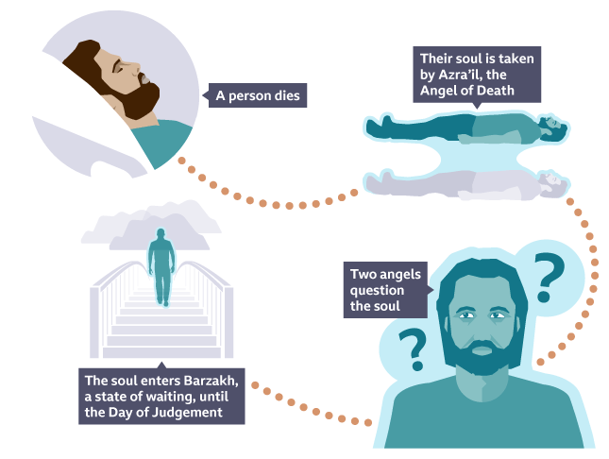  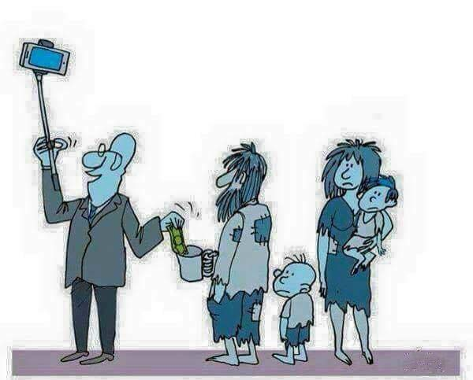  Note:What if the selfie man was not successful and was given them his last five pound note or his shoes?  Is there a difference between him buying some shoes and giving them and giving his own shoes?
Possible Misconceptions
(What are the children likely to find challenging?)
Resources | Sources: (images above) | Pillar Links | Heart:  - Responsibility  - Belonging  - Respect
Working Wall  (What will go on the WW from this lesson?) | Learning Enquiry Question  Does belief in Akhirah (life after death) help Muslims lead better lives?  Big and bold and easy to see in the classroom.

RE MTP
Year 6, Summer 1, Week 4
Step 2: Investigation | Lesson 4
Focus Skill | Questioning: Interpret the different answers given by religions, and their different perspectives, to form their own opinions.
Learning Intention | To ask questions that deepen my understanding of Akhirah  To investigate Akhirah
SOLO SC: Uni- Structural Bronze | I can ask questions about the 5 Pillars of Islam  I can explain the belief in Akhirah
SOLO SC: Multi- Structural Silver | I can ask questions about good deeds performed by Muslims  I can question the belief in Akhirah
SOLO SC: Relational Gold | I can ask questions that deepen my understanding of Akhirah
SOLO SC: Extended Abstract Platinum | I can analyse information gathered to justify my opinion on Akhirah as the ultimate motivation for doing good.
Key Vocabulary for the lesson/unit | Jihad  Akhirah  Motivation  5 Pillars  Superficial  Altruism  Tolerance  Respect
Starter | Pose the question:  Does belief in Akhirah (life after death) help Muslims lead better lives?  Summarise what has been covered so far over the last two lessons.  Good actions, motivations for the actions, intentions and the importance of Akhirah.  Inform students that a visitor will be popping in to share their insight and experiences on Islam.
Teacher Input / Activity
Possible Misconceptions
(What are the children likely to find challenging?)
Resources | - A visitor  - Question Matrix | Pillar Links | Heart  - Respect  - Tolerance  - Kindness  Hands  - Experience
Working Wall
(What will go on the WW from this lesson?)

RE MTP
Year 6, Summer 1, Week 5
Step 3: Evaluation | Lesson 5
Focus Skill | Explaining: Use religious vocabulary and concepts to explain in detail, principal beliefs, teachings, values and practices.
Learning Intention | To explain to what extent belief in Akhirah helps Muslims lead better lives
SOLO SC: Uni- Structural Bronze | I can sort ways a Muslim might try to lead a good life in order of importance
SOLO SC: Multi- Structural Silver | I can describe how a belief in Akhirah motivates Muslims to lead a good life.
SOLO SC: Relational Gold | I can explain to what extent belief in Akhirah helps Muslims lead better lives
SOLO SC: Extended Abstract Platinum | I can theorise about the ultimate motivation for doing good
Key Vocabulary for the lesson/unit | Akhirah  5 Pillars of Islam  Jihad  Allah  Judgement  Morality  Consequence  Intention  Motivation  Ego  Ethical  Morality
Starter | Low stakes quiz to recap key vocabulary and content studied so far.  Definition of Akhirah, 5 Pillars  Pairs, groups- whiteboards etc...
Teacher Input / Activity | - Start by asking students to write 3-4 to questions that they would like to ask the visitor.  Share success criteria with the students to allow them to see the requirements needed in their questions to reach a certain standard.  What is a good act to perform in everyday life?  How might Akrhirah influence the actions of a Muslim?  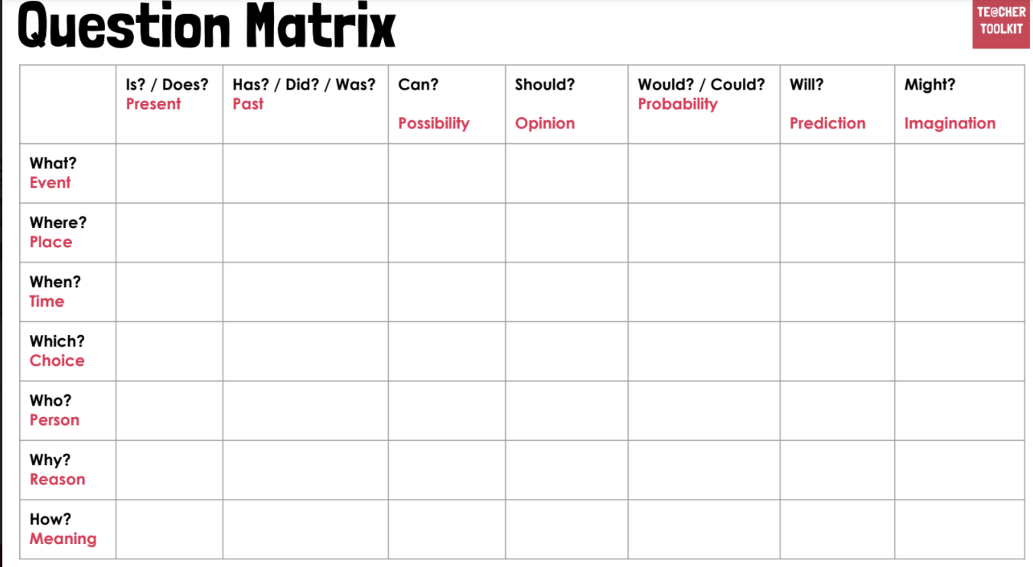  Note: Focusing on questions beginning:  How might…  Why will…  - Asking the questions and recording the responses  - Note taking in RE books  - Gauge from the quiz if there are any big gaps and consolidate through discussion.  - Depending on previous lesson (whether visitor was present or not) discuss the findings and anything they found particularly insightful or beneficial.  - Present the learning enquiry question:  Does belief in Akhirah (life after death) help Muslims lead better lives?  Task- Bronze- Jigsaw activity- Diamond 9  Task Silver- Written response to LEQ  Task Gold- Written response to LEQ  Task Plat- Written response to LEQ  Model WAGOLL of response:  Green- my opinion of what being good is  Blue- knowledge of Akhirah and whether it leads Muslim to lead a good life  Red- Personal reflection on the topic
Possible Misconceptions  (What are the children likely to find challenging?) | Students who may have missed lessons and important concepts.  Possibly using a similar Bronze sheet for them.
Resources | WAGOLL  Diamond 9 Resource for bronze task | Pillar Links | Heart  - Belonging  - Responsibility  - Tolerance  - Respect
Working Wall  (What will go on the WW from this lesson?) | WAGOLL

RE MTP
Year 6, Summer 1, Week 6
Step 4: Expression | Lesson 6
Focus Skill | Identity, Experience and Empathy: Have the ability to see the world through the eyes of others, and recognise issues from their point of view.
Learning Intention | To make a plan that will support my transition to Year 7
SOLO SC: Uni- Structural Bronze | I can identify positive things I can do to help me settle in at secondary school
SOLO SC: Multi- Structural Silver | I can rank the positive things I can do to support my transition to Year 7 in order of importance
SOLO SC: Relational Gold | I can make a plan that will support my transition to Year 7
SOLO SC: Extended Abstract Platinum | I can reflect on challenges pupils may face and offer support and advice where appropriate
Key Vocabulary for the lesson/unit | Transition  Support  Challenge
Starter | Reflect what will be similar and different at secondary school.  Similar- uniform, Monday to Friday, some subjects, clubs,  Different- pupils, teachers, size of building, timetables, the responsibility you have, consequences, independence, homework
Teacher Input / Activity | - Discussion regarding the ‘different’ side and what I can do to ensure that the transition is as smooth as possible.  - After the generating of ideas, providing 9 things they can do to support a good transition.  - Ranking them in order of importance- which one would be the most important in ensuring a good transition.  - After they have been ranked- what positive steps could you take to address these issues.  - Feedback on Diamond 9 and encourage other students to offer their individual advice.
Possible Misconceptions  (What are the children likely to find challenging?) | General understanding of secondary school.  Your success coming from within- individual responsibility
Resources | Diamond 9 Resource  Sugar paper for flipchart | Pillar Links | Health:  - Staying Safe  - Positive Mind Set  - Positive behaviour
Working Wall  (What will go on the WW from this lesson?) | Similar and Different at secondary school poster

