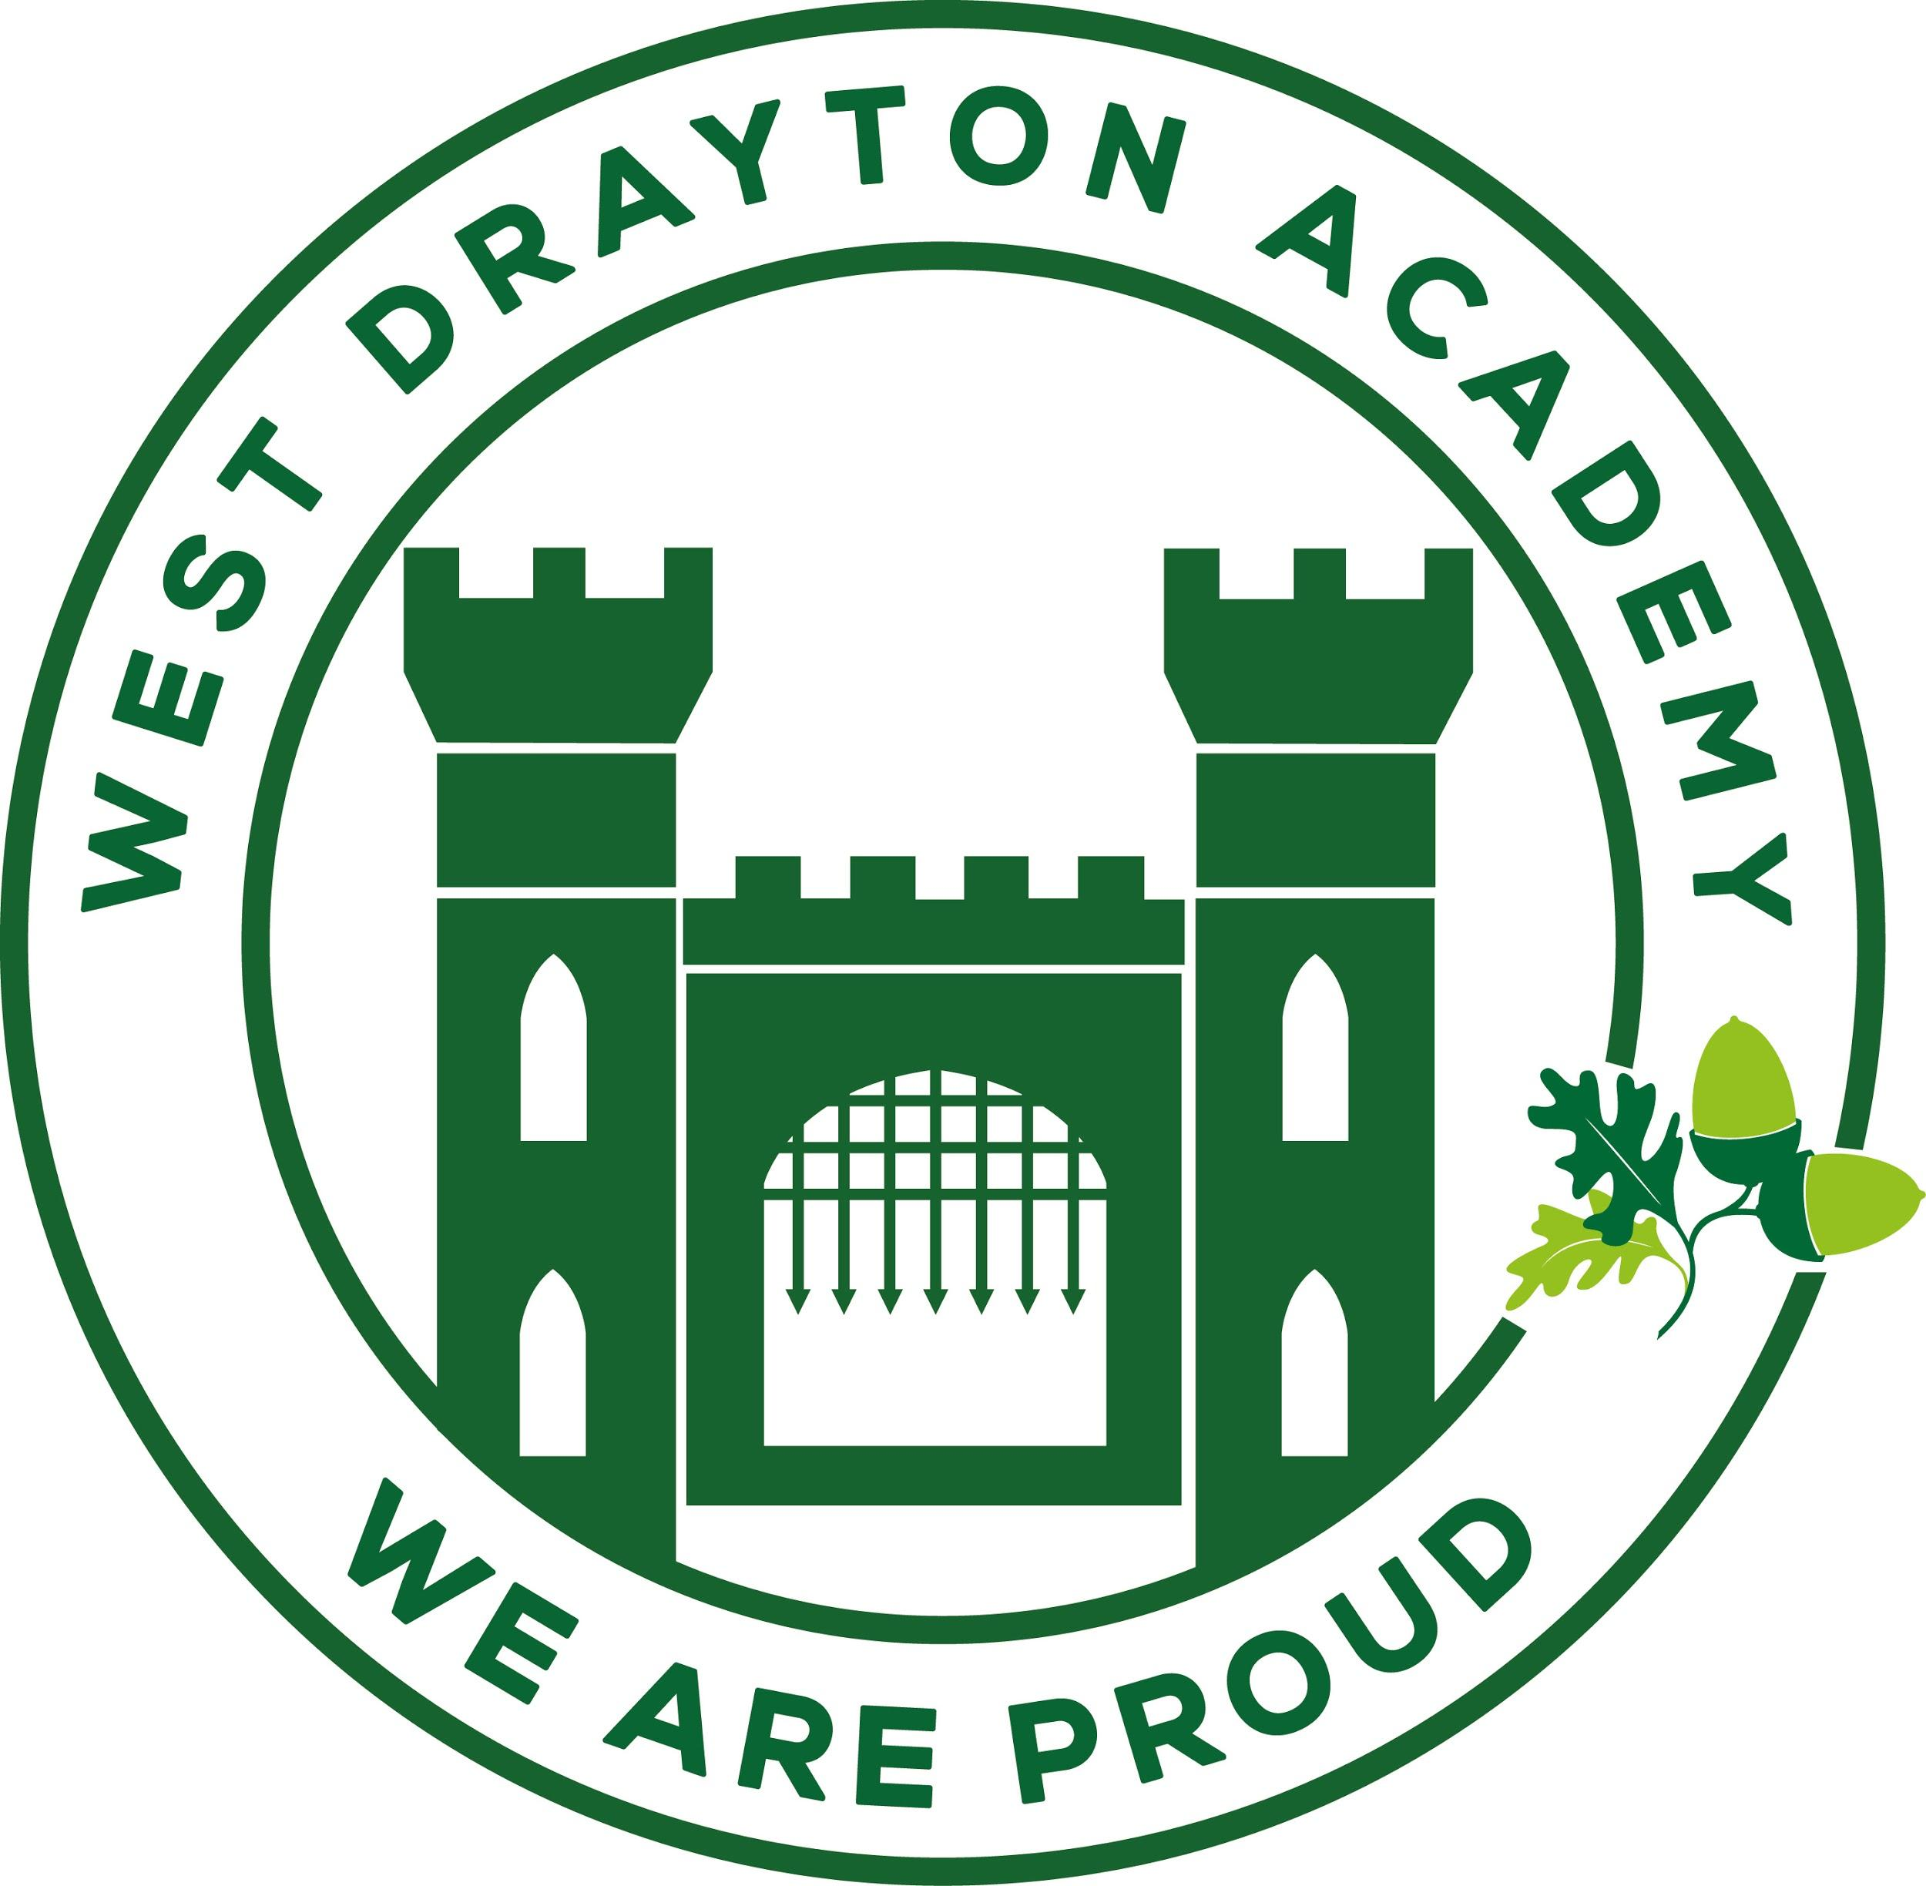
RE MTP Overview
Year 6 Spring 2
Jigsaw Unit Overview
Theme | Easter
Concept | Beliefs & Moral Values
Religion | Christianity
Enquiry Question | Is Christianity still a strong religion 2000 years after Jesus was on Earth?
Learning Intention | We are learning to examine the influences Christianity still has in the world and to  evaluate whether it is still a strong religion.
Resources
Assessment | Engagement  WTS: I can describe how people have influenced me in different  ways and say why I think this happened.  EXS: I can explain how the influence people have had on me  has affected what I see as important.  GDS: I can explain how I would like to be a positive influence on  others. | Knowledge & Understanding  WTS: I can describe one way that Christianity seems to be a  strong religion today.  EXS: I can explain how one of the reasons people use to  suggest that Christianity is a strong religion today can be  counteracted.  GDS: I can explain a range of arguments to suggest Christianity  is a strong religion today and also give you the opposing  arguments. |  | Evaluation/Critical Thinking  WTS: I can start to consider whether I think Christianity is a  strong religion now.  EXS:I can give my opinion as to whether Christianity is a strong  religion now and say why I think this.  GDS: I can express my opinion as to whether Christianity is a  strong religion now giving reasoned arguments.

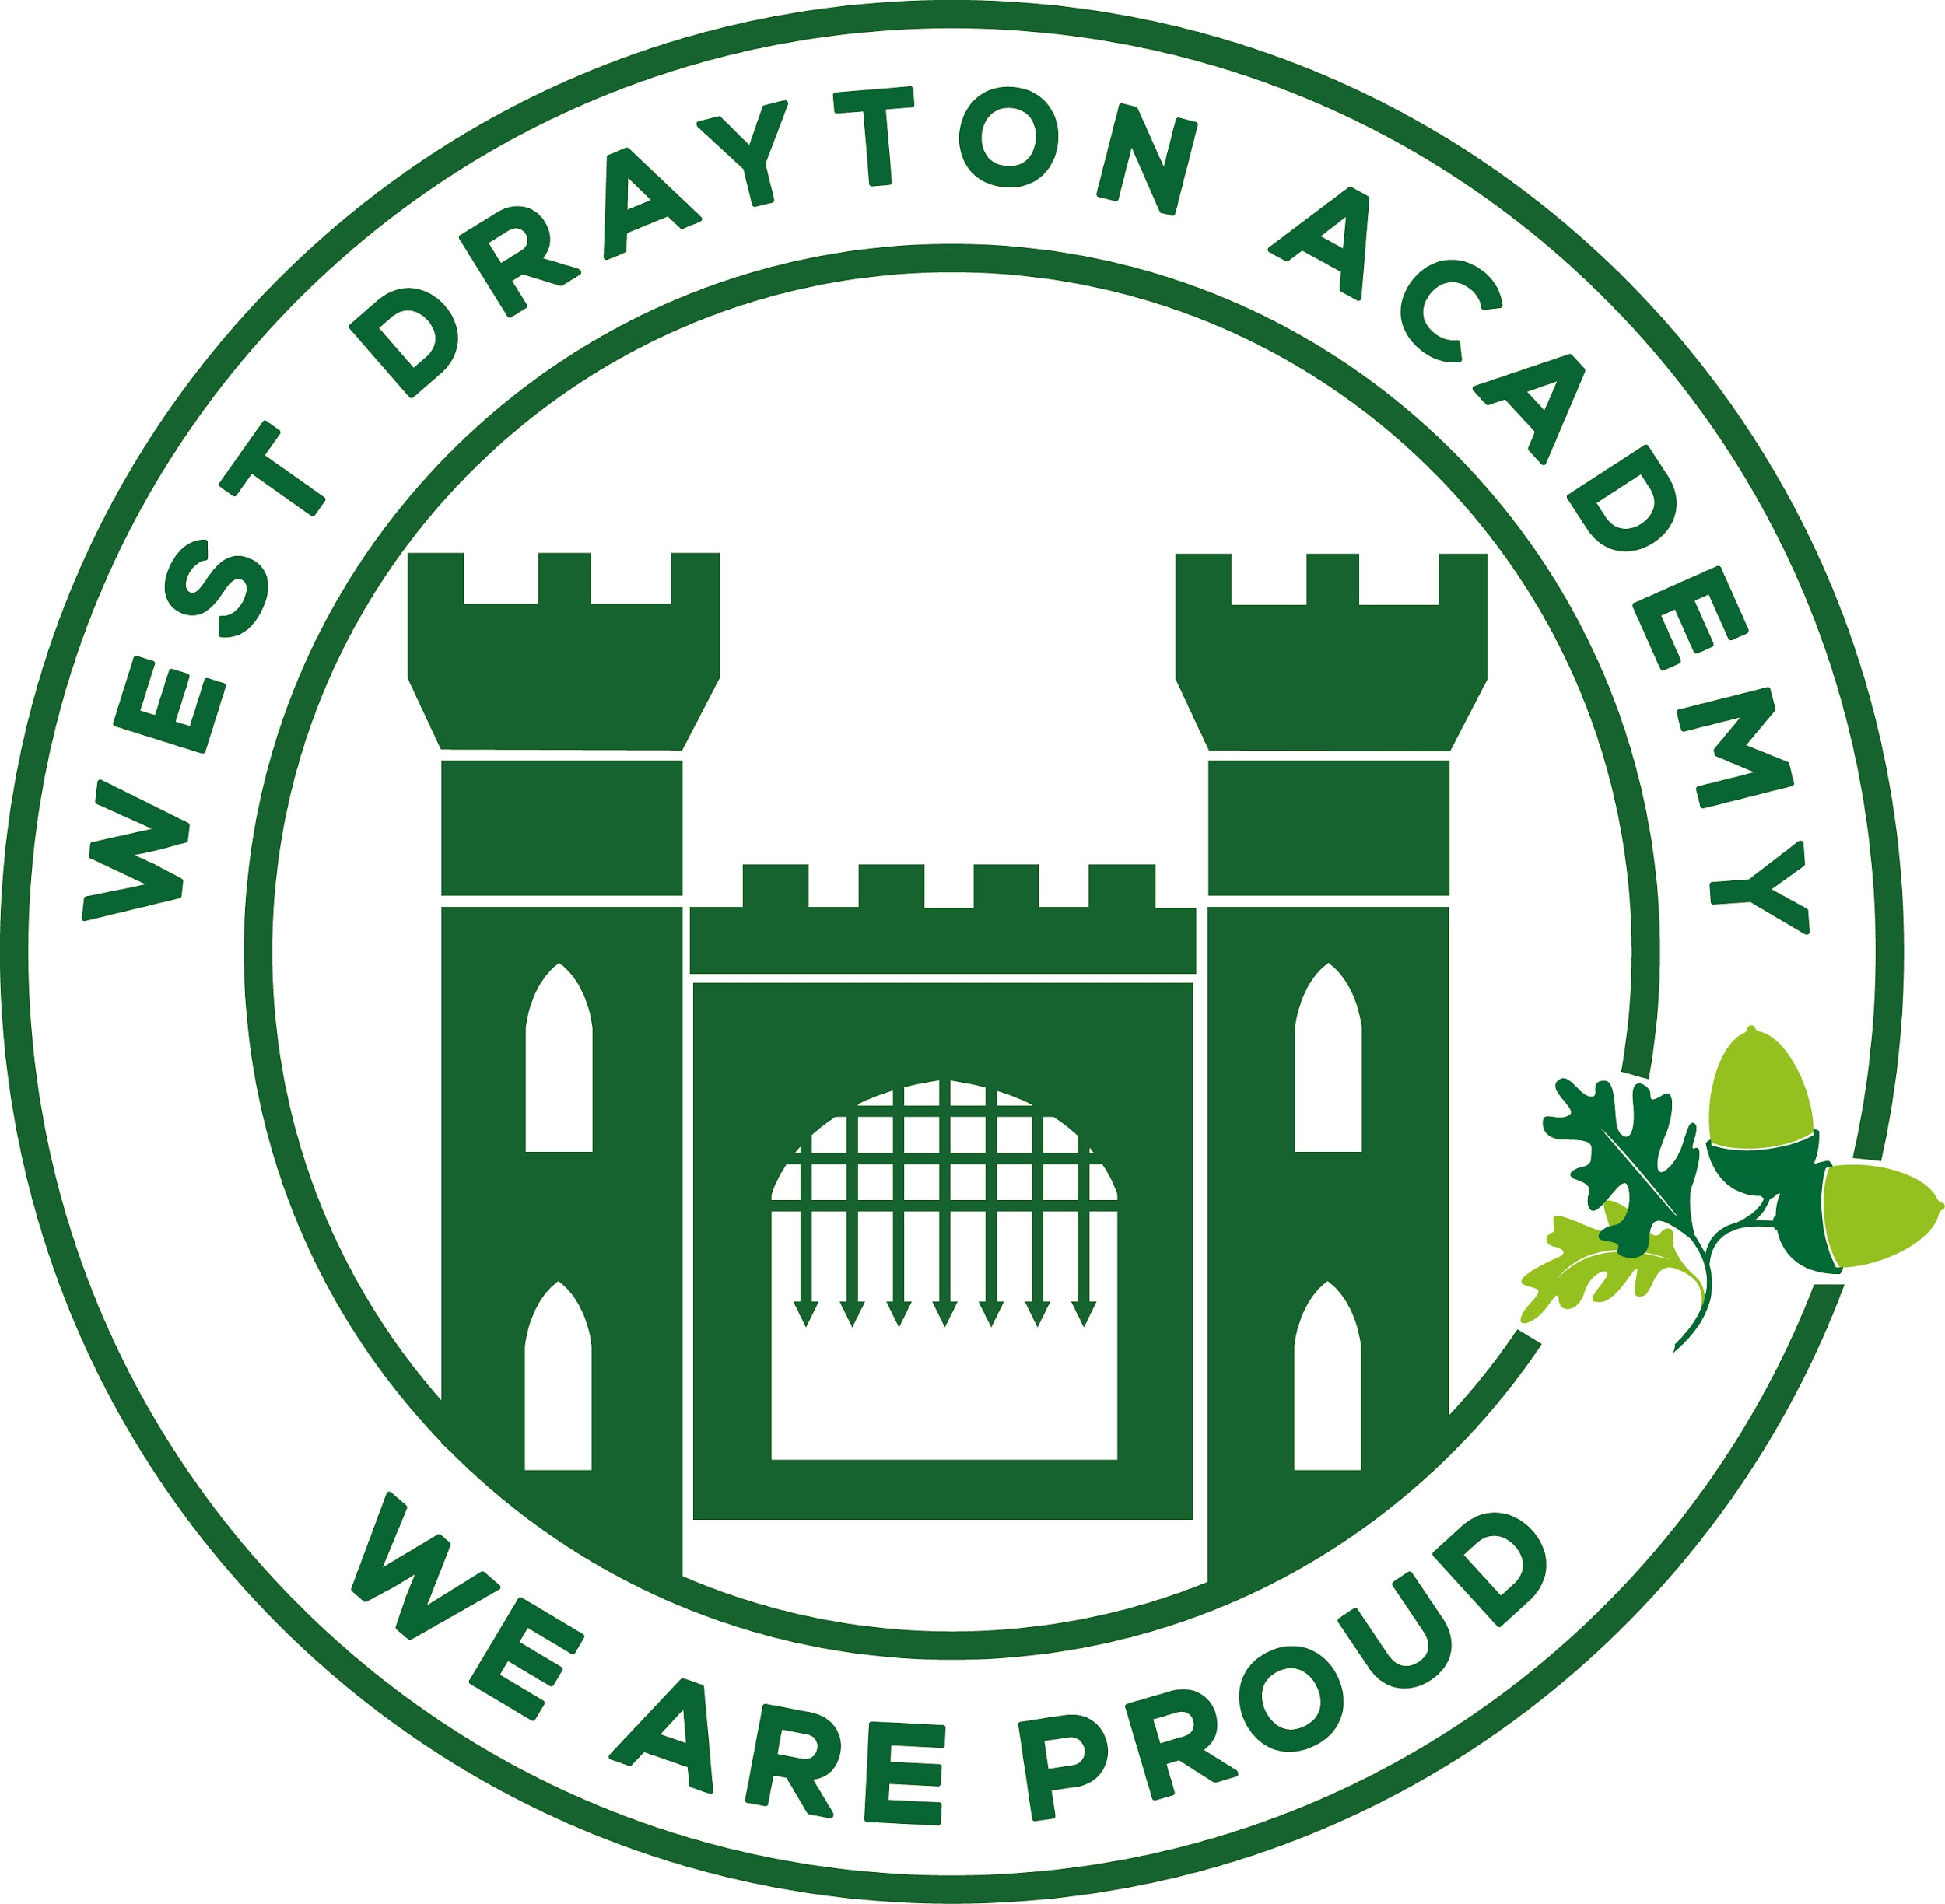
RE MTP
Year 6, Spring 2 Week 1
Step 1: Engagement | Lesson 1
Focus Skill | Identity, experience and empathy  Have the ability to see the world through the eyes of others, and recognise issues from their point of view.
Learning Intention | To explore the people who have had a strong influence on my life.
SOLO SC: Uni- Structural Bronze | To recognise the influential people in my life.
SOLO SC: Multi- Structural Silver | To describe how certain individuals have influenced my life.
SOLO SC: Relational Gold | To analyse the influence of people on my life.
SOLO SC: Extended Abstract Platinum | To reflect on the concept of influence in the wider world.
Key Vocabulary for the lesson/unit | Influence, Family, Society
Starter | Show pictures of Rowan Atkinson, Paul Scholes, picture of a teacher, family etc.  What do these pictures all have in common? Encourage discussion.  They have all had an influence on the life of Mr Forster
Lesson Journey | Pose the question- “Who are the most influential people in your life?”  Before the discussion begins discuss what influential means and generate some synonyms: powerful, strong, important, noteworthy, distinguished.  Are there any people who have had an influence on your life who are sadly not longer with us?  What memories do you have of that person?  Any photos, objects.  Is there anything you still do that you did when you were together?  Does their influence change whether they are here or not?  Let us think about influential people throughout history- has their influence always been positive? Link back to the previous History unit on 21st Century Conflict- Adolf Hitler as an influential leader.
Activity | Create a fact file on the person/people who have influenced your life.  How have they influenced you, what have they taught you, what beliefs, which of the 4 Pillars did they demonstrate?  What have you done as a result of this influence? EG- taken up a hobby, worked harder  Is it just yourself that this person/group has influenced?
Possible Misconceptions  (What are the children likely to find challenging?) | What influence actually means. Important to discuss the range of synonyms- who is important in your life, who has had a strong presence in your life etc  May struggle to provide detailed responses to why they have had an influence.
Resources | Slides | Pillar Links | Health- Have these people influenced your positive behaviour. Are they role models?  Heart- The respect for this person stems from the influence on your life?
Working Wall  (What will go on the WW from this lesson?) | Nothing for this lesson- Engagement- focus on the discussion

RE MTP
Year , Spring 2 Week 2
Step 2: Investigation | Lesson 2
Focus Skill | Interpreting/Discerning  Interpret the significance and impact of different forms of religious and spiritual expression (e.g. music/art).  In this case- religious symbols and festivals.
Learning Intention | To investigate how festivals and symbols show that Christianity is still a strong religion.
SOLO SC: Uni- Structural Bronze | To recognise Christian symbols and festivals.
SOLO SC: Multi- Structural Silver | To list the symbols associated with each festival.
SOLO SC: Relational Gold | To explain the significance of Christian symbols.
SOLO SC: Extended Abstract Platinum | To invent my own Christian symbol and explain its significance to Christianity.
Key Vocabulary for the lesson/unit | Religious Festival  Symbol  Resurrection  Jesus  Ichthys
Starter | LEARNING ENQUIRY QUESTION PRESENTED  Is Christianity still a strong religion 2000 years after Jesus was on Earth?  A thorough discussion to be had regarding the question and breaking down what it actually means. Link the idea of ‘strong’ to ‘influential’ discussed in the last lesson. When we talk about a strong religion we are enquiring as to whether Christianinty still has the same influence as it did in the past.  All of these lessons will be building up to answering this question. Everything we learn and discuss is vital in helping you provide a personal response at the end of the unit.
Lesson Journey | Begin my providing a list of festivals- some which are Christian and some that are not. Pupils to sort into each group. This could be done in pairs or as a class- judge the room.  EG- Remembrance Day, Valentines Day, Pancake Day and Halloween NO  Mother’s Day, Ash Wednesday, Christmas etc YES  Encourage a discussion regarding whether we are Christian or not, which do we celebrate ourselves, which do we celebrate at school. A chance to link to Christmas traditions unit- being respectful and tolerant of other people’s religious beliefs and practices.  Focus on Christian symbols- why do Christians wear a cross? Jesus’ death and resurrection- can be linked to previous topic on eternity.  Eggs at Easter- new life linked to Jesus’ resurrection  Bread and Wine- Jesus’ body and blood  Ichthys- fish symbol, Jesus fish- used in early Christinaity to highlight who was a Christian  Nowadays- car bumper stickers- different to cross in the sense that can be quite hidden on a person whereas the fish symbol can be seen by everyone.  Can anyone think of where fish are discussed in the bible?
Activity | You are a Museum Curator in charge of the religious symbols. You are starting a new exhibit. You must draw the Christian symbol and explain why it is important to the Christian faith.  Challenge- You are an archaeologist who has just discovered a new religious symbol- buried deep into the ground. What does it look like, what are its features, what is it made of and why is it significant to Christians?
Possible Misconceptions  (What are the children likely to find challenging?) | The relevance of the fish symbol- secret symbol used by early Christians that still have a significance today.  Need to rely on some prior knowledge of Jesus, his stories and teachings, hopefully have built up the knowledge base from previous lessons.
Resources | Symbols from newly delivered RE supplies in PPA room  Slides | Pillar Links | Hands- exploring the Christian symbols and festivals.  Creating my own symbol
Working Wall  (What will go on the WW from this lesson?) | Learning Enquiry Question in big, bold lettering so clear for everyone to see:  Is Christianity still a strong religion 2000 years after Jesus was on Earth?

RE MTP
Year 6, Spring 2 Week 3
Step 2: Investigation | Lesson 3
Focus Skill | Reflection of religious beliefs  Explain some of the challenges offered by the variety of religions and  beliefs in the contemporary world.
Learning Intention | To investigate whether Christianity still has a strong influence in wider society.
SOLO SC: Uni- Structural Bronze | To name ways in which Christianity can be shown to still be having an influence on society
SOLO SC: Multi- Structural Silver | To describe where in society this influence is still felt.
SOLO SC: Relational Gold | To predict the influence on Christianity in society in future.
SOLO SC: Extended Abstract Platinum | To hypothesize what might happen if the proportion of people practicing religion continues to fall...
Key Vocabulary for the lesson/unit | Religious texts, Koran, Bible, Torah  Census  Religious groups  Atheism
Starter | Show a clip of the national anthem being sung- see if the link to Euro 96 pre match game is on Youtube.  Why is this being shown? Listen to the words- God save our gracious Queen….  This is the national anthem that is sung at major sporting events, Olympics, World Cups and is heard around the world.  What does this tell you about the influence that Chrisianity still has?
Lesson Journey | LEARNING ENQUIRY QUESTION PRESENTED  Show a clip of a courtroom scene- person swears an oath on the Bible.  For centuries, magistrates have dispensed justice in England and Wales, and relied on the Bible to force people to tell them the truth.  Its moral force was unquestioned, placing intense pressure on witnesses to tell the truth.  The oath, still sworn by witnesses and defendants as they hold a holy book, has given the English language one of its most familiar sentences.  "I swear by Almighty God [to tell] the truth, the whole truth, and nothing but the truth."  Does this demonstrate a strong Christian influence in society  The Koran, Old Testament can also be used for Muslims and Jews.  People now also have the choice not to use a religious text.  What does this show?  Present the 10 Commandments- can provide background- given to Moses at Mt Sinai in Book of Exodus  Reflect on the laws in this country- thou shalt not kill or steal built into the laws of modern society.  How can we see that Christianity is losing its influence?  https://www.bbc.co.uk/news/uk-32722155
Activity
Possible Misconceptions
(What are the children likely to find challenging?)
Resources | https://www.bbc.co.uk/news/uk-24588854  Religious oaths news article  https://www.bbc.co.uk/news/uk-32722155  Is the UK still a Christian country? | Pillar Links | Heart- belonging to a religion and what it means to belong to that religion.  Responsibility- as a member of that religion do you have a responsibility to promote that religion?
Working Wall  (What will go on WW from this lesson?) | Images of the presence of Christinaty in society if needed.

RE MTP
Year , Spring 2 Week 4
Step 3: Evaluation | Lesson 4
Focus Skill | Explaining  Use religious vocabulary and concepts to explain in detail, principal beliefs, teachings, values and practices.
Learning Intention | To provide a reasoned response to our Learning Enquiry Question.
SOLO SC: Uni- Structural Bronze | To name ways that show Christianity is still a strong religion today.
SOLO SC: Multi- Structural Silver | To describe different ways to show how Christianity is still a strong religion today.
SOLO SC: Relational Gold | To argue that there are reasons for and against Christianity still being a strong religion today.
SOLO SC: Extended Abstract Platinum | To reflect on the reasons for and against Christianity still being a strong religion today and arriving at a justified conclusion.
Key Vocabulary for the lesson/unit | See key vocabulary from previous lessons.
Starter | LEARNING ENQUIRY QUESTION PRESENTED  What does this question actually mean?  Recap what we have investigated in the previous lessons.  Building up our knowledge base in order to answer our question confidently and accurately.
Lesson Journey | Provide template responses from JIgsaw  Break down what each section refers to in Green, Blue and Red  Stress that these are personal responses but must include knowledge from our Investigation lessons.
Activity | Answer the Learning Enquiry Question  30 mins
Possible Misconceptions  (What are the children likely to find challenging?) | If any pupils have missed lessons in the build up they are going to struggle. I would suggest having a response sheet with sentence starters to prompt.
Resources | Slides  Previous Learning | Pillar Links | Head- showing independence to provide a well thought out, personal response and challenging oneself to go further with the question.
Working Wall  (What will go on WW from this lesson?) | Examples of high quality responses.  Perhaps template responses from Jigsaw but I do not think they are of the quality that could be produced by pupils.  STRESS HIGH EXPECTATIONS THEREFORE OF HANDWRITING, PRESENTATION AND DETAIL.

RE MTP
Year , Spring 2 Week 5
Step 4: Expression | Lesson 5
Focus Skill | Interpreting / discerning  Interpret the significance and impact of different forms of religious and spiritual expression (e.g. music/art).
Learning Intention | To design a Christian symbol.
SOLO SC: Uni- Structural Bronze | To draw a Christian symbol
SOLO SC: Multi- Structural Silver | To draw a Christian symbol using different materials.
SOLO SC: Relational Gold | To create a Christian symbol using physical resources.
SOLO SC: Extended Abstract Platinum | To invent a religious symbol using a range of materials.
Key Vocabulary for the lesson/unit | Religious Festival  Symbol  Resurrection  Jesus  Ichthys
Starter | Display a range of symbols and recap their significance and importance to Christianity. An opportunity to see what knowledge has been consolidated over the course of the Unit.
Lesson Journey | Stress the importance of this stage in the Learning Journey Sequence  Expression- taking what you have learned and expressing through art/music etc  Recap from Lesson 2 the various religious symbols and festivals
Activity | This lesson is adapted from Lesson 2 of the Lesson Journey. Ideally this could be taught by JJ who would be able to provide more resources and expertise for the design stage.  Using the symbols that the pupils have looked at- design and create using paint, pencil. Chalk, tissue paper, cardboard etc.
Possible Misconceptions  (What are the children likely to find challenging?) | May lack ideas- have a bank ready from lesson  Printouts of symbols for them to recreate in their own format
Resources | Various materials:  Paper, Card, Tissue paper, pastels, chalk, cardboard, glue, scissors | Pillar Links | Hands- most definitely the most creative stage of the Learning Journey
Working Wall  (What will go on WW from this lesson?) | Again, high quality work could be displayed if appropriate.

