
RE MTP Overview
Year 6 Spring 1
Jigsaw Unit Overview
Theme | Belief and Meaning
Concept | Beliefs & Moral Values
Religion | Christianity
Enquiry Question | Is anything ever eternal?
Resources
Assessment | Engagement  WTS: I can start to show an understanding of the concept of  eternity.  EXS: I can start to show an understanding of the concept of  Eternity.  GDS: I can explain the difference it would make to me to know  that something was eternal. | Knowledge and Understanding  WTS: I can describe what a Christian might learn about life after  death from a Bible story.  EXS: I can make links between different Christian beliefs and  their views on whether anything is ever eternal.  GDS: I can explain why Christians believe some things are  eternal and the difference this makes to them. |  | Evaluation/Critical Thinking  WTS: I can ask important questions about eternity.  EXS: I can reflect on my own beliefs about whether anything is eternal.  GDS: I can give my own answer to whether anything is eternal and give my reasons.


RE MTP
Year 6, Spring 1 Week 1
Step 1: Engagement | Lesson 1
Focus Skill | Identity, experience and empathy  Have the ability to see the world through the eyes of others, and recognise issues from their point of view.
Learning Intention | LI: to analyse the concept of ‘forever.’
SOLO SC: Uni- Structural Bronze | I can define the concept of ‘forever’.
SOLO SC: Multi- Structural Silver | I can describe the concept of ‘forever’.
SOLO SC: Relational Gold | I can analyse the concept of ‘forever.’
SOLO SC: Extended Abstract Platinum | I can theorize the implications of the concept of ‘forever.’
Key Vocabulary for the lesson/unit | INFINITY  ENDLESS  FOREVER  EVERLASTING  IMMORTALITY
Starter | LEAVE THE FIRST PAGE BLANK- THE LEARNING ENQUIRY QUESTION WILL BE STUCK IN THE NEXT SESSION*
Lesson Journey |   Can you think of any synonyms for the word FOREVER?  What does Forever actually mean?  Show the following images on the next slide and ask pupils the following question:  Which of these things will last forever?    MR BEAN FRIENDSHIP MOUNTAINS  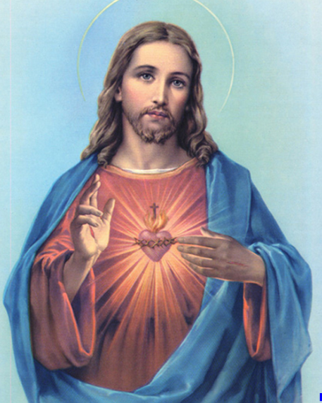  JESUS MEMORIES TREES  Open up to discussion and challenge students to explain why they believe some of these will exist forever and others not.  What needs to happen for something to exist forever?  Who determines that- yourself, your faith, your beliefs?
Activity | Bronze:  Silver:  Gold:  Platinum:
Possible Misconceptions  (What are the children likely to find challenging?) | Grasping the complete extent of the term ‘forever’  The term is used loosely these days.
Resources | Images above  https://docs.google.com/presentation/d/1NhucC6DXFPPyBWBnUdU-RHjAsV0Q4_rpVFwGBYisrlU/edit#slide=id.gb329e6288a_0_5  (Will need editing) | Pillars
Working Wall  (What will go on the WW from this lesson?) | Not for this session.

RE MTP
Year , Spring 1 Week 2
Step 2: Investigation | Lesson 2
Focus Skill | Explaining  Use religious vocabulary and concepts to explain in detail, principal beliefs, teachings, values and practices.
Learning Intention | To explore Jesus’ teachings on love.
SOLO SC: Uni- Structural Bronze | I can list examples of Jesus’ teachings on love.
SOLO SC: Multi- Structural Silver | I can describe examples of Jesus’ teachings on love.
SOLO SC: Relational Gold | I can summarise Jesus’ teachings on love.
SOLO SC: Extended Abstract Platinum | I can reflect on the challenges posed by Jesus’ teachings on love.
Key Vocabulary for the lesson/unit | Infinity  Immortal  Tim Tebow  Eternal Life  Passage  Jesus  Salvation
Starter | Stick in the Learning Enquiry Question on the blank page which you left last session.  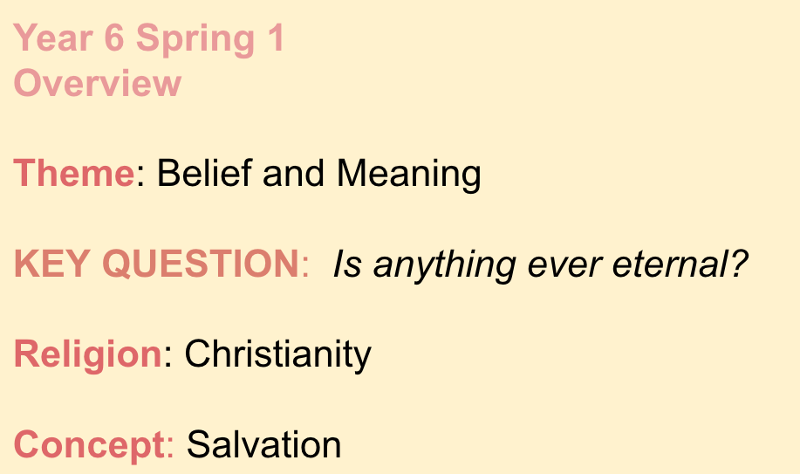
Lesson Journey | - Introduce the Learning Enquiry Question:  Last half term in RE our work was all based around the traditions of Christmas. We looked at some traditions and whether they helped Christians to understand who Jesus was and why He was born.  This half term we are staying on the religion of Christianity and focusing on the idea of Eternity.  Our Learning Enquiry Question that we are working towards answering:  Is anything ever eternal?  - What does eternity mean?  Do you know any synonyms for the word eternity?  - Today, we are going to consider whether ‘love’ is eternal based on the teachings of Jesus.  We are going to study a series of Bible references and investigate how Jesus portrayed love.  - Show the following Bible References  Matthew 5: 43-45, Luke 32:34, John 3:16  How do they help us to understand Jesus’ teachings on love?  Side note connection to John 3:16 which is very cool.    Tim Tebow- devout Catholic who painted the Bible Verse John 3:16 under his eyes for a college game.  Exactly three years later he played in a championship game and the following stats occurred:  Tim Tebow’s stats for a game exactly 3 years from when he displayed 3:16:  Threw for 316 yards  Yards per rush were 3.16  Yards per completion were 31.6  Ratings for the game were 31.6  Time of possession was 31.6  Coincidence? Maybe...
Activity
Possible Misconceptions  (What are the children likely to find challenging?) | Not appreciating how cool that Tim Tebow statistic is.
Resources | https://docs.google.com/presentation/d/1KJ_2RSa7MU7zQRDlglEBkN3kfrxwqGx8edRzaHYS1-I/edit#slide=id.gb4a7d0f3c5_0_46  (Will need editing )
Working Wall
(What will go on the WW from this lesson?)

RE MTP
Year 6, Spring 1 Week 3
Step 2: Investigation | Lesson 3
Focus Skill
Learning Intention | I can investigate whether love is eternal or not, using Jesus’ teachings and my own opinion.
SOLO SC: Uni- Structural Bronze | I can list reasons why love is or is not eternal.
SOLO SC: Multi- Structural Silver | I can explain why love is or is not eternal.
SOLO SC: Relational Gold | I can argue whether love is eternal or not, using Jesus’ teachings and my own opinion.
SOLO SC: Extended Abstract Platinum | I can reflect on what life would be like without love.
Key Vocabulary for the lesson/unit | Unconditional, eternal, belief, christians.
Starter
Lesson Journey | Debate: can love be eternal? Before we discuss what Christians think, let’s see what we all think. Give the following prompts, but discussion is not limited to these ideas.  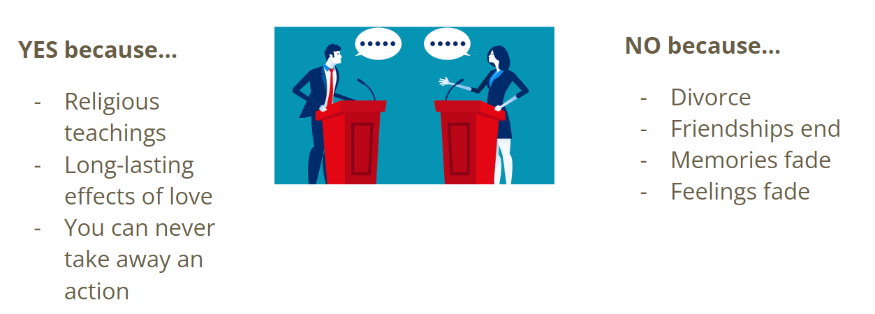  Teacher input: Christians believe in heaven and hell.  TTYP: Heaven is… Hell is…  Feedback as a class.  Note: If children haven’t shown understanding of this from answering what heaven and hell is. Explain that Christian’s believe that because of Jesus’ resurrection (coming back to life after death), Christians will be able to have life after death in heaven.
Activity | Bronze: Create a t-chart. Love is eternal vs love isn’t eternal. List the reasons.  Silver: Complete bronze. Pick one example from the list and write a sentence explaining why this shows that love either is or is not eternal.  Gold: Can love be eternal? Write a paragraph answering this question arguing ‘for’ and ‘against’. You must include Christian’s belief and your own opinion.  Platinum: What would life be like without love?
Possible Misconceptions  (What are the children likely to find challenging?) | Be sensitive to children’s personal situations e.g. divorce, death.
Resources | NA | Pillar Links
Working Wall  (What will go on WW from this lesson?) | Scribe ideas from debate on flip chart paper for working wall.

RE MTP
Year , Spring 1 Week 4
Step 3: Evaluation | Lesson 4
Focus Skill
Learning Intention | I can explore whether life is eternal or not.
SOLO SC: Uni- Structural Bronze | I can list reasons why life is or is not eternal.
SOLO SC: Multi- Structural Silver | I can explain why life is or is not eternal.
SOLO SC: Relational Gold | I can argue whether life is eternal or not, using Jesus’ teachings and my own opinion.
SOLO SC: Extended Abstract Platinum | I can reflect on how a mobius strip links to the enquiry question, Is anything ever eternal?
Key Vocabulary for the lesson/unit | Eternal, christian, humanist.
Starter
Lesson Journey | Teacher input: Christians believe that because of Jesus’ resurrection (he dies and then comes back to life), christians will be able to have life after death (eternal life).  Have a watch…  https://youtu.be/ZQDGTtfwDSY  How do christians get to heaven? Can everyone go to heaven?  https://youtu.be/iWSkdx-XwWY  Paired discussion & feedback as a class.  Having watched the video, do you think people who have done good deeds should go to heaven? How do you feel about this?  https://youtu.be/X-J16F1K97k  Do you agree with your thoughts from the previous question or do you want to reconsider?  Christians believe that for eternal life they need to believe in God, do their best to follow the Ten Commandments and the 2 great commandments, and ask for forgiveness when they need it (sin). They believe Jesus made forgiveness possible by His crucifixion.  Do you think a non-christian can go to heaven? Is going to heaven a christians only motivation for doing good things?  Share alternative perspective:  Humanists reject the idea or belief in a supernatural being such as God. This means that Humanists class themselves as agnostic or atheist.  Humanists have no belief in an afterlife, and so they focus on seeking happiness in this life. They rely on science for the answers to questions such as creation, and base their moral and ethical decision-making on reason, empathy and compassion for others.  Humanists are concerned with human welfare and happiness and believe that this is the one and only life and world they have.  As a result, they believe that people should make the most of their lives while on Earth. However, they also believe that they have a duty to support others to live fulfilling lives too – this includes people who are alive today as well as future generations.
Activity | Task: The children choose how they want to present their work: written paragraph, slides, poster or voice recording.  Bronze: list reasons why life is or isn’t eternal.  Silver: pick one thing from the list and explain how it shows life is eternal.  Gold: argue for and against whether life is eternal. Use examples e.g. Jesus’ teachings and your own opinion.  Platinum: https://www.steamsational.com/how-to-make-a-mobius-strip/#:~:text=A%20mobius%20strip%20is%20a%20strip%20of%20paper%2C%20twisted%20once,math%20in%20a%20concrete%20way. Using this link, have a go at creating a mobius strip. How does this link to our big question of Is anything eternal?
Possible Misconceptions  (What are the children likely to find challenging?) | They may find it difficult to listen or appreciate another religion's perspective.
Resources | Chromebooks
Working Wall  (What will go on WW from this lesson?) | If a child makes a good poster, photocopy and put it on working wall.

RE MTP
Year , Spring 1 Week 5
Step 4: Expression | Lesson 5
Focus Skill | Evaluation & expression lesson.
Learning Intention | I can explore why Christians believe some things are eternal and the difference this makes to them. I can give my own opinion about whether anything is eternal, justifying my answer.
SOLO SC: Uni- Structural Bronze | I can describe what a christian may learn about life after death from a bible story and start to show an understanding of the concept of eternity.
SOLO SC: Multi- Structural Silver | I can make links between different christian beliefs and their views on whether anything is ever eternal. I can reflect on my own beliefs about whether anything is eternal.
SOLO SC: Relational Gold | I can explain why Christians believe some things are eternal and the difference this makes to them. I can give my own opinion about whether anything is eternal, justifying my answer.
SOLO SC: Extended Abstract Platinum | I can reflect on what questions I might have about eternity.
Key Vocabulary for the lesson/unit
Starter
Lesson Journey | Recap prior learning up to this point.  - Christian teaching on LOVE…  - Love your enemies. This was based on the bible verse from Mathew: "You have heard that it was said, 'Love your neighbour and hate your enemy.' But I tell you: Love your enemies and pray for those who persecute you." Matthew 5:43-44. Summarised on the board with this image:    - Give to those in need and you’ll be rewarded in heaven. This was based on the bible verse from Luke: “Sell your possessions and give to those in need. This will store up treasure for you in heaven! And the purses of heaven never get old or develop holes. Your treasure will be safe; no thief can steal it and no moth can destroy it. Wherever your treasure is, there the desires of your heart will also be.” (Luke 12:33-34 NLT). Summarised on the board with this image:  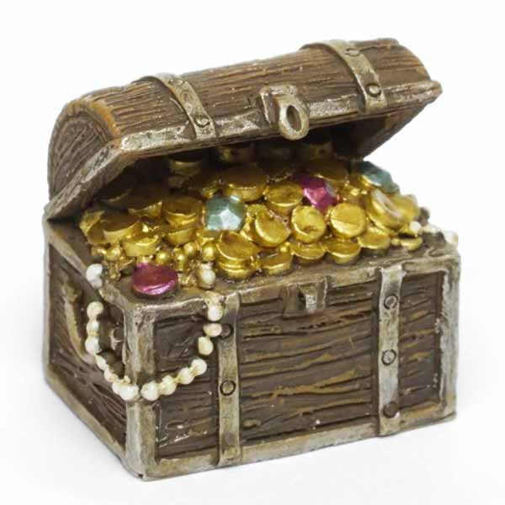  - God sacrificed his son so that christians could receive eternal life. Summarised with image below:  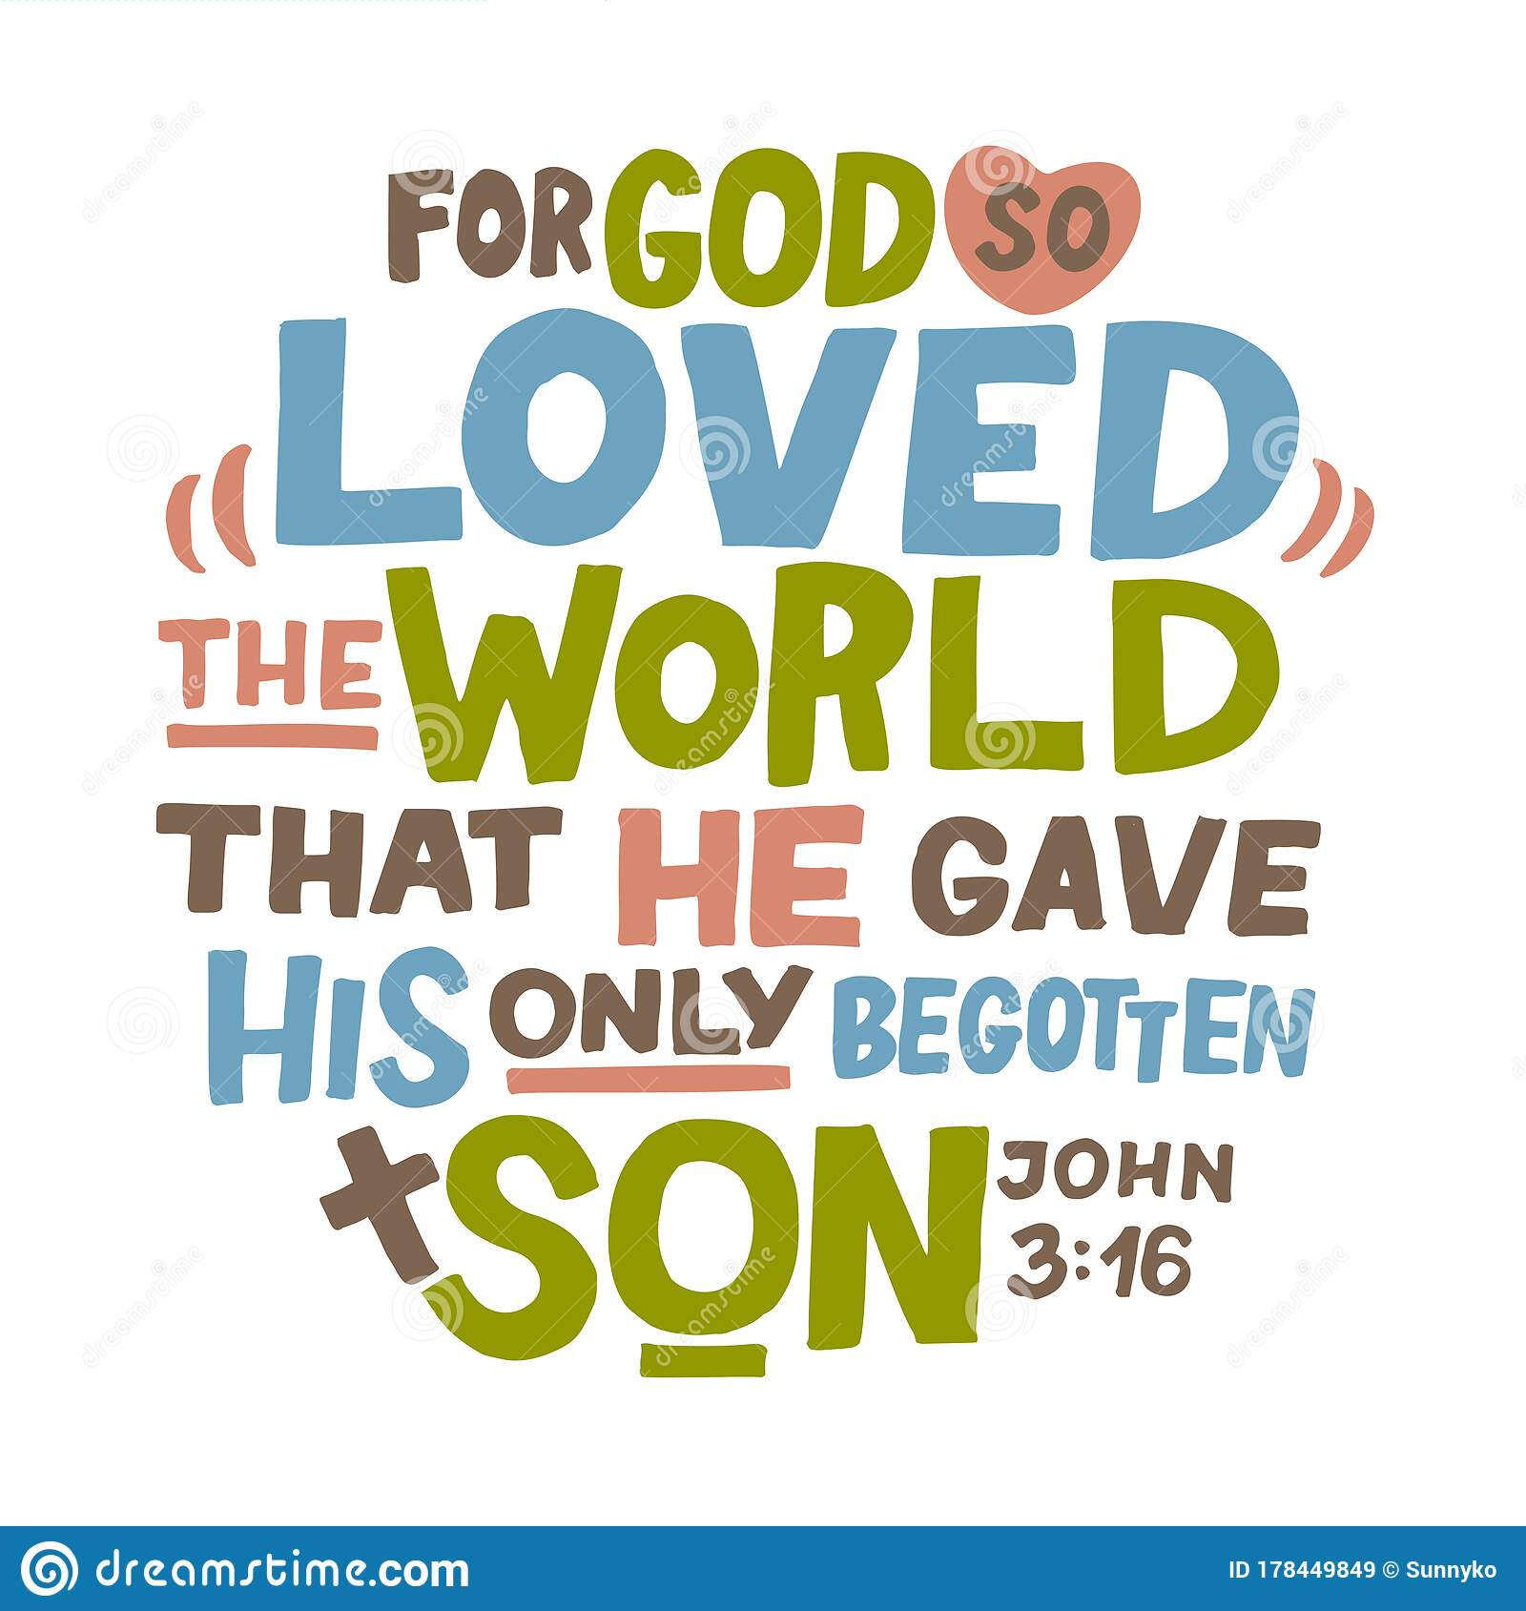  Task: children complete the appropriate part of the worksheet.  2) Christians teachings on LIFE.  - Christians believe that because of Jesus’ resurrection (he dies and then comes back to life), christians will be able to have life after death (eternal life).  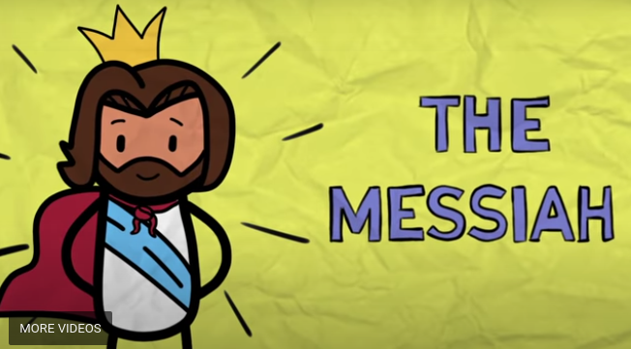  - Christians should help people so that they receive eternal life in heaven. Sheep can’t live on their own, they need a shepherd to guide them. Goats are stubborn and do their own thing. Jesus says when he is resurrected he will return and separate people like he separates the goats and the sheep. He will separate people into two groups: those who have lived good lives and believe in god will go to heaven and those who have sinned and reject god will go to hell.    - If christians can accept their flaws/mistakes everyone is able to go to heaven. This is from the story of the two thieves. The two thieves are crucified on either side of Jesus. They have both done wrong and are considered deserving of their punishment, whereas Jesus is not. One mocked Jesus and thought Jesus should be able to save himself and the men as he was ‘the son of god’. The other man asked for forgiveness and to be remembered. Because of this Jesus said he would be accepted in heaven.  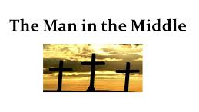  Task: children complete the appropriate part of the worksheet.
Activity | Task: children complete the appropriate part of the worksheet answering the two questions - Do christians believe anything is eternal? Do you believe anything is eternal?  Responses will show whether children are working at bronze, silver or gold.  Example responses can be found in the ppt.
Possible Misconceptions
(What are the children likely to find challenging?)
Resources
Working Wall
(What will go on WW from this lesson?)

