
RE MTP Overview
Year 5, Autumn 2
Jigsaw Unit Overview
Theme | Christmas
Concept | Beliefs & Moral Values
Religion | Christianity
Enquiry Question | Is the Christmas story true?
Learning Intention | To evaluate the different accounts of the Christmas story and understand that stories can be true in different ways.
Resources | Twinkl unit: RE - The Christmas Story - Year 6.
Assessment | Engagement  WTS: I can start to explain why people may see an event in different ways.  EXS: I can start to explain how ‘true’ could mean different things to different people, and how stories can be ‘true’ in different ways.  GDS: I can give my opinion on whether a favourite story is ‘true’ and explain why. | Knowledge & Understanding  WTS: I can describe what a Christian learns from the Christmas story.  EXS: I can start to explain the Christian belief that Jesus was the Incarnation of God.  GDS: I can identify different sources of the Christmas story and explain the meaning of Christmas to Christians (Incarnation). |  | Evaluation/Critical Thinking  WTS: I can start to explain that true can mean different things relating to the Christmas story.  EXS: I can start to express an opinion on whether the Christmas story is true and what this might mean to Christians.  GDS: I can explain my own opinion on whether the Christmas story is true and say what Christians might think of my opinion.
Enrichment


RE MTP
Year 5, Autumn 2, Week 1
Step 1: Engagement | Lesson 1
Focus Skill | Questioning: Suggest answers to some questions raised by the study of religion and beliefs and use evidence from secondary sources.
Learning Intention | To compare and contrast two eye-witness accounts.  To compare and contrast
SOLO SC: Uni- Structural Bronze | I can list what is the same and what is different.
SOLO SC: Multi- Structural Silver | I can describe what is the same and what is different.
SOLO SC: Relational Gold | I can compare and contrast two eye-witness accounts, explaining what is the same and what is different.  I can compare and contrast two eye-witness accounts
SOLO SC: Extended Abstract Platinum | I can reflect on why accounts of the same event are different.
Key Vocabulary for the lesson/unit | Eye-witness account, subjective.
Starter | TTYP: What does the word ‘truth’ mean? How do we know if something is true or not?
Teacher Input / Activity | Share new vocabulary:  Explain the term ‘eye-witness account’.  Watch:  Watch the video clip with no sound (https://www.youtube.com/watch?v=AvpLCQxSPQA) START 0:39 - STOP 2:35. Children have 2 mins to write their eye-witness account on whiteboards. Ask some children to share their accounts.  Discussion:  Are the accounts the same? Why? Why not?  Watch:  Watch the SAME clip WITH sound.  Discussion:  What happened? Does it match your eye-witness account? What’s different and why? What’s the same? So which of our accounts are true?  Share:  Explain different types of truth: scientific, historical, religious.  Explain that eye-witness accounts are subjective and even though we have all witnessed the same event, we each see things through our own lens.  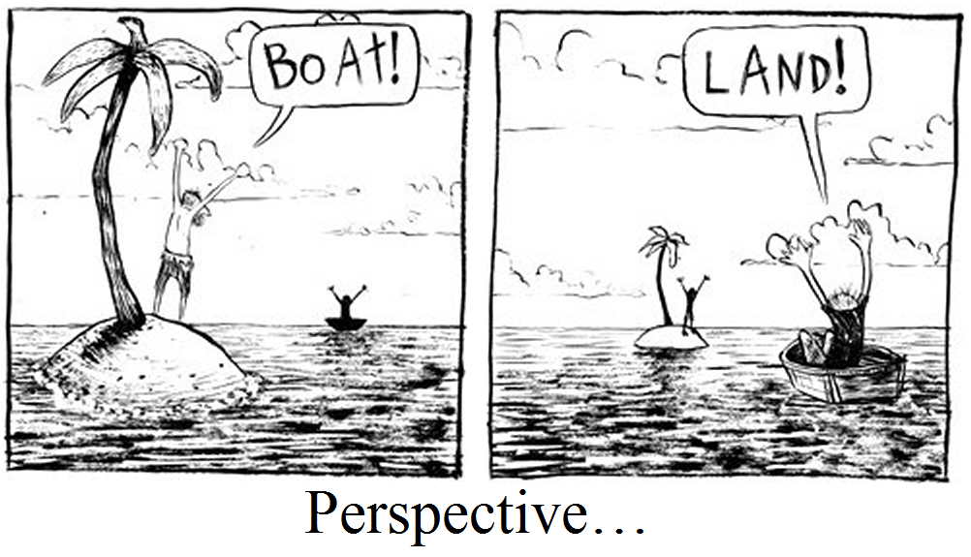  Task:  In groups children are given two articles from different newspapers/internet about the same event.  Bronze: Identify and list what is the same and what is different.  Silver: Complete the table (see below) to describe what is the same and what is different.  Gold: To write a paragraph to explain what is similar and different about the two articles.  Platinum: To reflect on why the accounts differ from one another.
   | Article 1 | Article 2
  What are the articles about?
  5W’s:
  - Who
  - What
  - Where
  - When
  - Why
  Main similarities.
  Main differences.
Possible Misconceptions
(What are the children likely to find challenging?)
Resources | Worksheet - table (put above table into w/sheet). Two articles about the same event from different sources (not provided - need resourcing). https://www.bbc.co.uk/newsround/57983879  https://www.timeforkids.com/g56/win-for-mental-health-2/?rl=en-940 | Pillar Links | Head: Tolerance  Heart: Respect
Working Wall  (What will go on the WW from this lesson?) | Key vocabulary and definition: eye-witness account, subjective.

RE MTP
Year 5, Autumn 2, Week 2
Step 2: Investigation | Lesson 2
Focus Skill | Explaining: Explain connections between questions, beliefs, values and practices.
Learning Intention | To explain why we are thinking about different types of truth in relation to the Christmas story.  To explore the concept of ‘truth’.
SOLO SC: Uni- Structural Bronze | I can define the word ‘true’.
SOLO SC: Multi- Structural Silver | I can describe different types of truth.
SOLO SC: Relational Gold | I can explain why we are thinking about different types of truth in relation to the Christmas story.
SOLO SC: Extended Abstract Platinum | I can reflect on why it is important to consider other people’s perspectives.  I can reflect on why stories might have different versions.
Key Vocabulary for the lesson/unit | Christmas, gospel, nativity, true, disciples.
Starter | TTYP (verbal or whiteboards): What do you already know about Christmas? Teacher to collate ideas onto thought shower on flip chart paper.
Teacher Input / Activity | 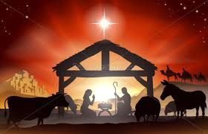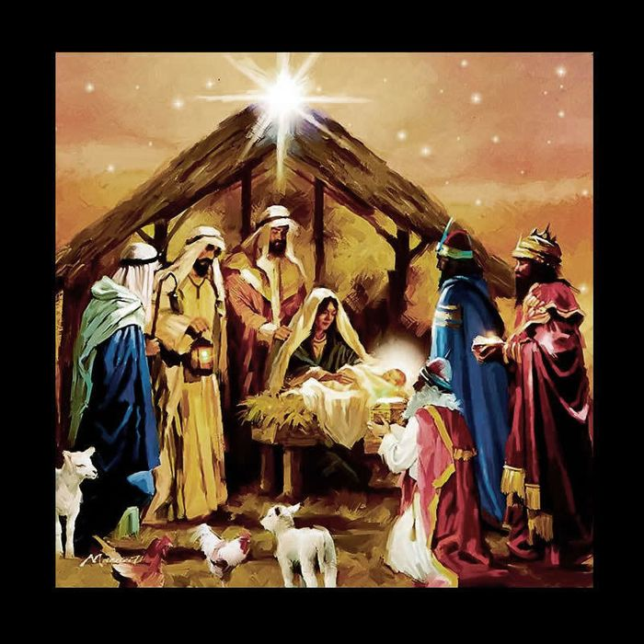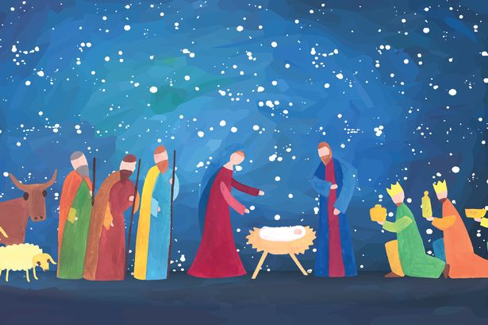  Share images of nativity scenes: TTYP - What event is happening in these images? Who is in these images?  E.g. birth of Jesus, shepherds, animals (sheep, cattle, cow), kings.  Watch video: https://youtu.be/FrTFAZPQxpE Class discussion: Who was present at the birth of Jesus? Why are they all present at the same time? Angel Gabriel, animals, shepherds, three wise men. All present because different signs all sent them there e.g. angel gabriel sent the shepherds and the wise men were guided by a star.  Read statements - stand up (true) / sit down (false): which are true, which are false?  - London is in Wales.  - Henry VIII had 6 wives.  - Ice is colder than water.  - Penguins live in the North Pole.  - Your body is made up of cells.  (Answers: false, true, true, false, true)  … how did you know they were true or false? E.g. I know it’s a historical fact that Henry VIII had six wives. I know that Scientifically ice is colder than water.  Class discussion: What does the word ‘true’ mean?  Share definition: in accordance with fact or reality; accurate or exact.  Class discussion: What might impact different versions of the truth? Think back to the experience from last lesson - when we recount the event e.g. a day / week / month later; different peoples perspectives.  Introduce the different types of truth: scientific (test results, data, statistics), historic (objects, documents, sound recordings and film) and religious. [https://www.bbc.co.uk/bitesize/guides/zpxpr82/revision/2] - need to print a visual, or note this on flip chart paper for WW so this can be referred to throughout the unit.  Share information:  - Gospels: literally means ‘good news’. They are books of the new testament recounting Jesus’ life. Gospel writers are: Matthew, Mark, Luke and John - Jesus’ four disciples (special friends). Q: What impact would it have on the truth if there are four different accounts of Jesus’ life? The bible records important events in the life of Jesus in the gospels. The gospels were probably not written as events happened. They would have been told and retold before recording, therefore specific events, dates and times may have become unknown (or irrelevant). The fixing of a festival date to commemorate an event does not necessarily have to happen on the actual date of the event (e.g. The Scouting/Guiding movement chose the birthday of the founders, not the actual date they first started the movement). The Gospels which retell the birth of Jesus agree on the main points and disagree on nothing (we are going to look at this in more detail next lesson - comparing two gospel accounts).  - This half term we are going to investigate the key question: Is the Christmas story true?  Task:  Bronze: write a definition for the word ‘true’ / could be a wordle (synonyms for ‘true’).  Silver: describe different types of truth & list examples  E.g. Scientific truth - truths based on observations and scientific tests / experiments. For example last half term we know that the higher concentration of squash to water the stronger the squash is. We also know we can separate some solids using a magnet.  Gold: (based on what you have learnt today about the word ‘truth’ and the gospels) explain why we are thinking about different types of truth in relation to the Christmas story.  E.g. The Christmas story is recorded in the bible and written by four different people (disciples). We know that truth means accurate or exact. If there are four different versions we therefore have four different perspectives, therefore not all aspects of the story could be true/accurate.  Platinum: Watch the video of the blind men and the elephant: https://www.youtube.com/watch?v=Vn9BUfUCL4I Answer the question - why is it important to consider other people’s perspectives?
Possible Misconceptions  (What are the children likely to find challenging?) | Understanding the different types of truth.
Resources | Power Point  RE exercise books  Video link: https://youtu.be/FrTFAZPQxpE | Pillar links | Head: Tolerance and Independence  Heart: Respect
Working Wall  (What will go on the WW from this lesson?) | Definition of ‘true’.  Image / flip chart of different types of truth.

RE MTP
Year 5, Autumn 2, Week 3
Step 2: Investigation | Lesson 3
Focus Skill | Application and making links/synthesis: Explain how and why differences in belief are expressed.
Learning Intention | To compare and contrast two different accounts of the Christmas story from the bible and justify why the accounts differ.  To compare and contrast two versions of the Christmas story.
SOLO SC: Uni- Structural Bronze | I can identify similarities and differences between the two accounts.  I can identify similarities between the two accounts.
SOLO SC: Multi- Structural Silver | I can describe the similarities and differences between the two accounts.  I can identify differences between the two accounts.
SOLO SC: Relational Gold | I can compare and contrast two different accounts of the Christmas story from the bible and justify why the accounts differ.  I can compare and contrast two different accounts of the Christmas story from the bible
SOLO SC: Extended Abstract Platinum | I can construct my own short story which is written from two different perspectives.  I can justify why the accounts differ.
Key Vocabulary for the lesson/unit | Magi (wise men), Jesus/Messiah/’King of the Jews’, perspective.
Starter | Two truths and a lie game. Play as a class / in pairs.
Teaching Input / Activity | Share:  Reminder - the bible is made up of accounts from different people (gospels).  Explain the Christmas story appears in two gospels: Matthew & Luke. We are going to read two different accounts of the Christmas story in the Bible according to different people: Matthew & Luke.  As a class: Read the two Gospels (Luke & Matthew - see Twinkl sheet *adapt as only chp2 of Matthew’s account is needed*) - chn have a copy 1 between 2. Teacher to lead, with chns input, how to summarise the two accounts. Link to VIPERS reading skills - encourage chn to annotate text with who & when. Highlight to chn that this is an example of summarising a text - taking the key pieces of information.  Notes for teacher to support the comparison:  Activity:  Bronze: Using the notes gathered on the flip chart paper summarising the story, sort the statements (*see Twinkl activity sheet) into the venn diagram.  Silver: Using the notes gathered on the flip chart paper summarising the story, complete the venn diagram.  Gold: Using the notes gathered on the flip chart paper summarising the story, complete the venn diagram. Explain why the accounts differ.  E.g. Matthew’s account focuses on the perspective of the Magi (wise men), whereas Luke’s account focuses on the perspective of the Shepherds. Therefore they are both very different.  Platinum: Create a short story which is written from two different perspectives. (Develops on from last lessons platinum task where they watch a story - therefore this lesson they are applying their learning from that and this lesson to create their own)  Discussion (plenary):  Who’s version of the Christmas story is true? Why? Why are there different versions? What type of ‘true’ is this?  Not right / wrong answer - discussion. There are different versions because they are written by different people, as there were multiple witnesses so they’ve been recorded from different perspectives. This is an example of religious truth.
  Luke Ch 2: 1-20  People: Caesar Augustus, Joseph, Mary, Angel, Shephards, Jesus/Messiah.  Location: Nazareth in Galilee, Judea, Bethlehem, manger in Bethlehem.  Event:  - Caesar Augustus ordered a census, so Joseph had to return home, with Mary (who was pregnant) to Bethlehem to register.  - Mary was expecting a baby and had it when she arrived in Bethlehem in a manger (as there were no guest rooms available).  - Shepherds were watching over their flock.  - An angel appeared to them and said that the messiah, the lord, had been born.  - The Shepherds decided to go to Bethlehem & found Mary, Joseph and Jesus.  - They spread the word about the child. | Matthew Ch 2: 1-16  People: Jesus/Messiah/’King of the Jews’, King Herod, chief priests, teachers of the law, Magi  Location: Bethlehem in Judea, Jerusalem.  Event:  - After Jesus had been born in Bethlehem, Magi, from the east, came to Jerusalem to find the ‘King of the Jews’ as they’d seen a star.  - King Herod was distrubed by the news of the Messiah’s birth and gathered chief priests and teachers of law to find out who was the ‘King of the Jews’.  - King Herod wanted to know where the child was born and was told ‘In Bethlehem in Judea’.  - King Herod sent the Magi to search for the child.  - The Magi were delighted to see the child and gave gifts of gold, frankincense and myrrh.  - The Magi were warned in a dream not to return to Herod, so they went a different route.  - An angel warned Joseph in a dream to escape to Egypt as Herod wanted to kill Jesus.  - Herod was furious that the Magi had outwitted him and ordered all boys in Bethlehem under two to be killed.
Possible Misconceptions  (What are the children likely to find challenging?) | The multiple terms used to describe Jesus (Messiah/’King of the Jews’).
Resources | Copies of Luke/Matthew extracts (1 between 2) Twinkl w/sheet - needs amending to remove part of Matthew extract.  Sorting activity sheet.  Flip chart paper  Plain paper | Pillar Links | Head: challenge
Working Wall  (What will go on the WW from this lesson?) | Flip chart of similarities / differences.

RE MTP
Year 5, Autumn 2, Week 4
Step 2: Investigation | Lesson 4
Focus Skill | NA - knowledge based lesson
Learning Intention | To explain what incarnation means for Christians.  To explore what incarnation means for Christians.
SOLO SC: Uni- Structural Bronze | I can identify which stories show Christian’s believe God is fully human / was also God.  I can understand why Jesus is significant for Christians.
SOLO SC: Multi- Structural Silver | I can describe which stories show Christian’s believe God is fully human / was also God.  I can sort reasons which Christian’s believe show Jesus as human/and also God.
SOLO SC: Relational Gold | I can explain what incarnation means for Christians.
SOLO SC: Extended Abstract Platinum | To reflect on why the Christmas story is important to Christians.
Key Vocabulary for the lesson/unit | Incarnation, nativity.
Starter | Ethan is a brother, a friend, a son, an artist, a footballer,  a student. He is all of these things, yet still one person.  Write down all the things you ‘are’.  Feedback as a class.
Teacher Input / Activity | Share: (use Twinkl ppt) who Jesus is; holy trinity; the term ‘incarnate’ (to take or embody a human form).  Discussion:  Share nativity image - which parts show the human part of the story? Which parts show the godly part of the story?  Share images of human stories from the bible. Christians believe that these stories show that while Jesus was still God, he made himself vulnerable to show he understands what it means to be human. Opportunity for discussion / chn to share any knowledge of these stories.  - Showing anger  - Dying e.g. Easter dying on the cross  - Being born human e.g. Christmas  - Sharing a meal e.g. christians take communion to represent ‘The Last Supper’  - Working as fishermen  - Having friends e.g. he has 12 disciples  Share images of … stories from the bible. Christians believe that these stories show that Jesus was God, who could perform great miracles. Opportunity for discussion / chn to share any knowledge of these stories.  - Walking on water  - Healing the sick  - Rising from the dead  - Bringing people back from the dead  - Feeding the 5000  - Turn water into wine  Share: why incarnation is important to Christians.  Task:  Bronze: sort the images into two sections (a) which show Jesus is human (b) which show Jesus is God.  Silver: same as bronze + describe one of the pictures from each side E.g. This picture shows Jesus being born which shows he is human. This picture shows Jesus can walk on water. This isn’t something humans can do! Therefore it shows Jesus is God.  Gold: Explain what incarnation means. E.g. Christians believe that Jesus was God in human form and God sent him to be born as Jesus so he could show people how to live good lives and teach about forgiveness. Christians should follow Jesus’ example and forgive others. This is called incarnation.  Platinum: Give a nativity image. Answer question - why is the Christmas story important to Christians (using the key term ‘incarnation’).
Possible Misconceptions
(What are the children likely to find challenging?)
Resources | 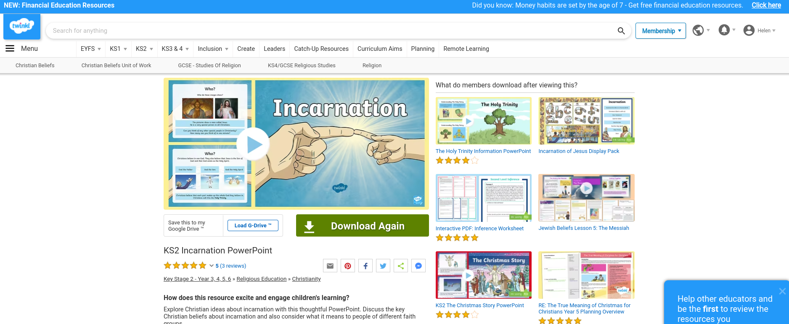  Image above of Twinkl ‘Incarnation’ ppt needed.  Images (from Twinkl ppt) for bronze + silver activity.  Nativity image (any). | Pillar Links | Head: Tolerance and Independence  Heart: Respect
Working Wall  (What will go on the WW from this lesson?) | Images of human & … images.

RE MTP
Year 5, Autumn 2, Week 5
Step 3: Evaluation | Lesson 5
Focus Skill | Questioning: Suggest answers to some questions raised by the study of religions and beliefs, using evidence from secondary sources.
Learning Intention | To explain what Jesus’ birth means to Christians & whether the Christmas story is true.  Summarise the significance of the Christmas story to the Christians.
SOLO SC: Uni- Structural Bronze | I can identify what happened in the Christmas story (bullet point/list ideas).
SOLO SC: Multi- Structural Silver | I can describe what happened in the Christmas story.
SOLO SC: Relational Gold | I can explain what Jesus’ birth means to Christians & whether the Christmas story is true.
SOLO SC: Extended Abstract Platinum | I can reflect on whether it matters to Christian’s if the Christmas story is true.
Key Vocabulary for the lesson/unit | Incarnation, truth, Christian, Christamas.
Starter | TTYP: What are the different types of truth?
Teacher Input / Activity | Recap: Recap on different types of truth: scientific, historical, personal, religious etc.  Share: Some Christian’s believe the Christmas story is literal, like a historical truth. Some believe it is metaphorical, therefore it doesn’t matter if it didn’t happen exactly like the gospels say, as the most important part is Jesus’ birth (his incarnation).  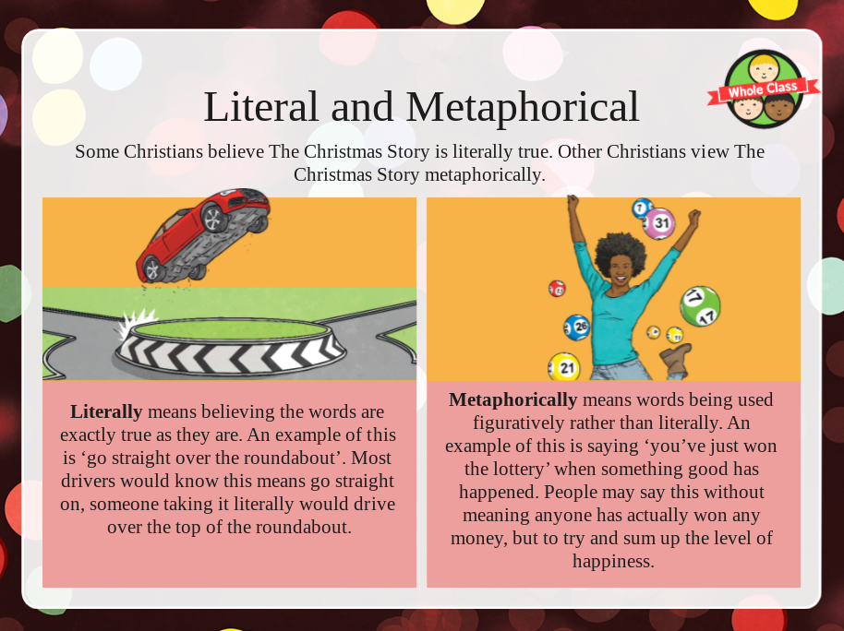  Assessment Activity answering the enquiry question:  Children to complete the Jigsaw Activity Sheet.  Bronze: Answer the question in a list/bullet points: What do you know about the story of Jesus’ birth? (lesson 2)  Silver: Answer the question in full sentences: What do you know about the story of Jesus’ birth? (lesson 2)  Gold: Answer the questions: What does Jesus’ birth mean to christians? (lesson 4 incarnation) & Is the Christmas story true? (lesson 3/5).  Platinum: Answer the question: Does this matter to christians? (lesson 5) Chn must justify their answer.  Examples of bronze, silver and gold answers:  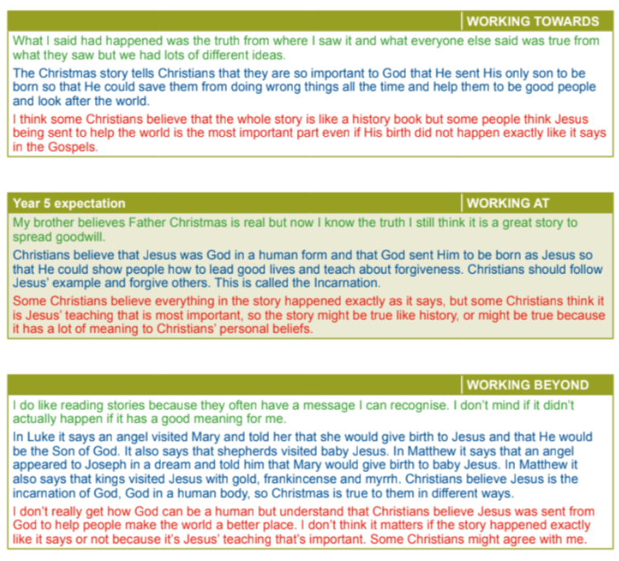
Possible Misconceptions
(What are the children likely to find challenging?)
Resources | Jigsaw activity sheet. | Pillar Links | Heart: respect  Head: challenge
Working Wall  (What will go on the WW from this lesson?) | NA

RE MTP
Year 5, Autumn 2, Week 6
Step 4: Expression | Lesson 6
Focus Skill | Explaining: Explain connections between questions, beliefs, values and practices.
Learning Intention | To explain what I have learnt from the fiction story The Journey and how this links to my learning from this unit.
SOLO SC: Uni- Structural Bronze | I can identify what I have learnt from the story.
SOLO SC: Multi- Structural Silver | I can describe what I have learnt from the story.
SOLO SC: Relational Gold | I can explain what I have learnt from the fiction story The Journey and how this links to my learning from this unit.
SOLO SC: Extended Abstract Platinum | I can reflect on another fiction story I have read that I have learnt from and justify what I have learnt from it.
Key Vocabulary for the lesson/unit | Refugee.
Starter | 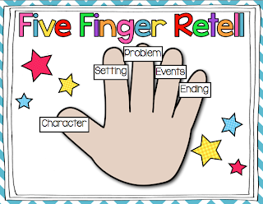  TTYP: five finger retell of The Journey by Francesca Sanna (Reading lessons).
Teacher Input / Activity | Context for lesson: reinforcing that stories can be meaningful whether they have happened or not! Question from Jigsaw scheme: What is a story that you have learnt the most from and why? WDA have chosen to link this to our story from our Reading lessons as it is a fictional story based on interviews with real people. Therefore, linking to discussion in this unit about different types of truth. It is an example of personal truth.  Discussion: Show front cover of The Journey by Francesca Sanna. TTYP - what have we learnt from this story? Share and feedback as a class.  Share: In this unit we have been discussing the Christmas story and answering our enquiry question, is it true? Therefore we are going to link our learning about different types of truth to The Journey and that it is meaningful whether it happened or not.  Recap: What is The Journey based on? Francesca Sana met two girls in a refugee centre in Italy. She then interviewed more refugee families from Europe and then created the book as a tribute to them.  Task:  Bronze: annotate an image of the books front cover with what they have learnt from this story.  Silver: annotate an image of the books front cover describing what they have learnt from this story.  Gold: stick in the picture of the books front cover. Explain what I have learnt from this story. Explain how this links to this RE unit.  Platinum: to think of another fiction story I have read and explain what I have learnt from it (*You may want to get chn to consider this before the lesson so they can write about it without having to spend time thinking about it - could set this as a hwk task for previous week*).
Possible Misconceptions  (What are the children likely to find challenging?) | Platinum: thinking of a story on the spot - may need some prior thinking time for this.
Resources | Images of front cover of The Journey to be stuck into books. | Pillar Links | Head: challenge
Working Wall  (What will go on the WW from this lesson?) | NA

