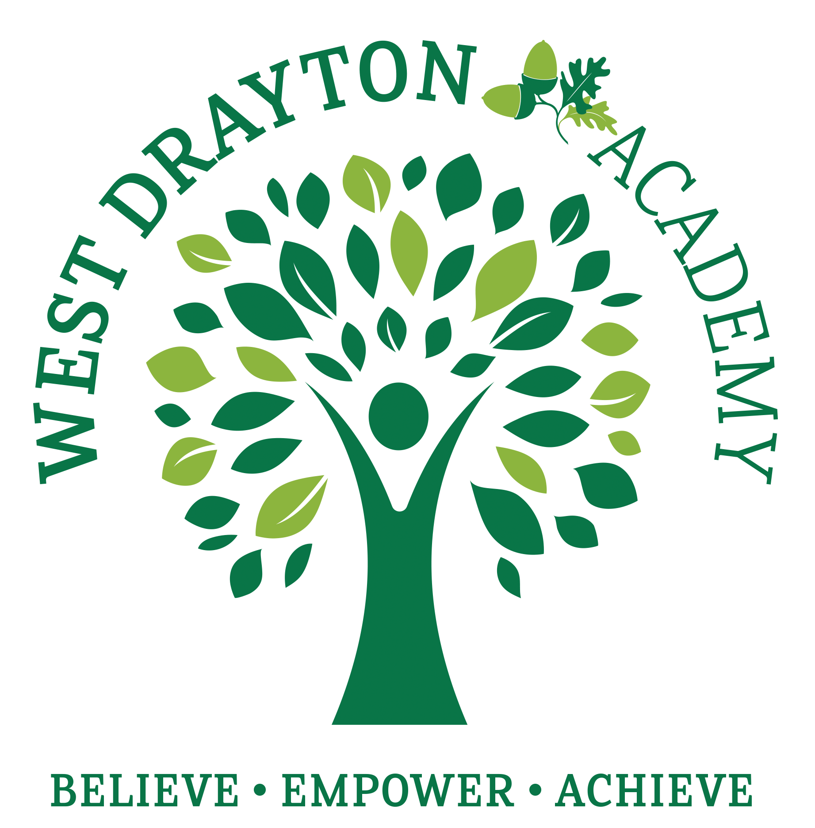
RE MTP Overview
Year 5, Spring 1
Jigsaw Unit Overview
Theme | Beliefs and moral values
Concept | Beliefs & Moral Values
Religion | Sikhism
Enquiry Question | Are Sikh stories important today?
Learning Intention | To understand the relevance of Sikh stories today.
Assessment | Engagement  WTS: I can give an example of a story that teaches me how to behave towards other people  EXS: I can explain how some stories can teach people about what is important and how to behave.  GDS: I can give my opinion as to why stories may be important to people today. | Knowledge & Understanding  WTS: I can describe what a Sikh/non-Sikh might learn from a Sikh story and start to explain why stories can be important.  EXS: I can recognise that stories can be an important way of expressing belief and meaning and can explain the relevance of a Sikh story  GDS: I can tell you several Sikh stories and explain why some of these are relevant to Sikhs and non-Sikhs. |  | Evaluation/Critical Thinking  WTS: I can understand how what Sikhs learn from stories can influence how they behave.  EXS: I can explain how some stories can teach Sikhs about what is important in life and relate this to non-Sikhs.  GDS: I can explain why Sikh stories could be considered important today.
Enrichment | 100 Club: recite a poem - could the chn recite their poems and perform them to the class / another Year 5 class as an extension to the last lesson?

Step 1: Engagement | Lesson 1
Key Vocabulary for the lesson | Favourite, special, important, meaning.
Focus Skill | Explaining: Explain connections between questions, beliefs, values and practices.
Learning Intention | To explain how some stories can teach people about what is important and how to behave.  To explore morals and lessons in stories.
SOLO SC: Uni- Structural Bronze | I can identify what makes a book special.
SOLO SC: Multi- Structural Silver | I can describe what the moral of a story is.
SOLO SC: Relational  Gold | I can explain how some stories can teach people about what is important and how to behave.
SOLO SC: Extended Abstract Platinum | I can reflect on whether there could be a better ending for a story.  I can explain how this relates to religious stories.
Starter | Think (chn to think quietly to themselves): Book vs Kindle: which is better? Write ideas on whiteboards. This will feed into the first task.
Teacher Input / Activity | *Teacher note: there is no expectation of a written outcome for this lesson, it is a discussion based lesson.  - Following on from starter activity...Pair/Share (leads into class debate) - Book vs Kindle: which is better? Encourage chn to explain why.  - The teacher shares what their favourite book is and why.  - * Chn need to be asked in advance to bring in their favourite book.* Show & tell: chn to share their favourite books and why. Ask: what makes the book so special? What’s more important, the book or the actual story? E.g. They may be presents from relatives or be reminders of particular times in their lives, e.g. the first book they were able to read for themselves. Relate to the book vs Kindle discussion. Is it the book that is important or the story or information in it? (Option: could make a class display of their special books).  - Read the traditional tale ‘Little Red Riding Hood’ to the class. Ask: What is the meaning behind the story? What can we learn from this text? Not to talk to strangers / not to share personal information e.g. Red Riding Hood told the wolf where she was going. Ask: Could there be a better ending? Would you tell a small child this story? Did the story really happen? Could you give it a different ending?  - Explain that this half term in RE we are going to be exploring stories from the Sikh religion that have morals and meanings. We’ll be exploring the question: Are Sikh stories important today?
Curriculum Links | Clear links to Reading (engagement - children discussing their favourite books).
Resources | Chn will need to bring in their favourite books.  Teacher needs to bring in their favourite book / have thought in advance of the lesson what it is. | Pillar Links | Head: communication (discussion lesson - communicating opinions)  Heart: respect (respecting others opinions even if different from our own)
Working Wall  (What will go on the WW from this lesson?) | NA - option to make a display in the classroom of chns favourite books.

Step 2: Investigation | Lesson 2
Key Vocabulary for the lesson | Guru Granth Sahib, Guru Nanak, teacher, Gurdwara, diversity, theme.
Focus Skill | Interpreting/Discerning: Recognise and explain diversity within religious expression, using appropriate concepts.  N.B. The religious expression we are recognising in this unit is religious stories.
Learning Intention | To explain how the themes of diversity in a story are relevant to Sikhs and non-Sikhs.  To explore morals in Sikh stories.
SOLO SC: Uni- Structural Bronze | I can identify the themes of diversity in a story.
SOLO SC: Multi- Structural Silver | I can describe the moral message of the story.
SOLO SC: Relational Gold | I can explain how the themes of diversity in a story are relevant to Sikhs and non-Sikhs.
SOLO SC: Extended Abstract Platinum | I can reflect on how the story relates to our four pillars.
Starter | 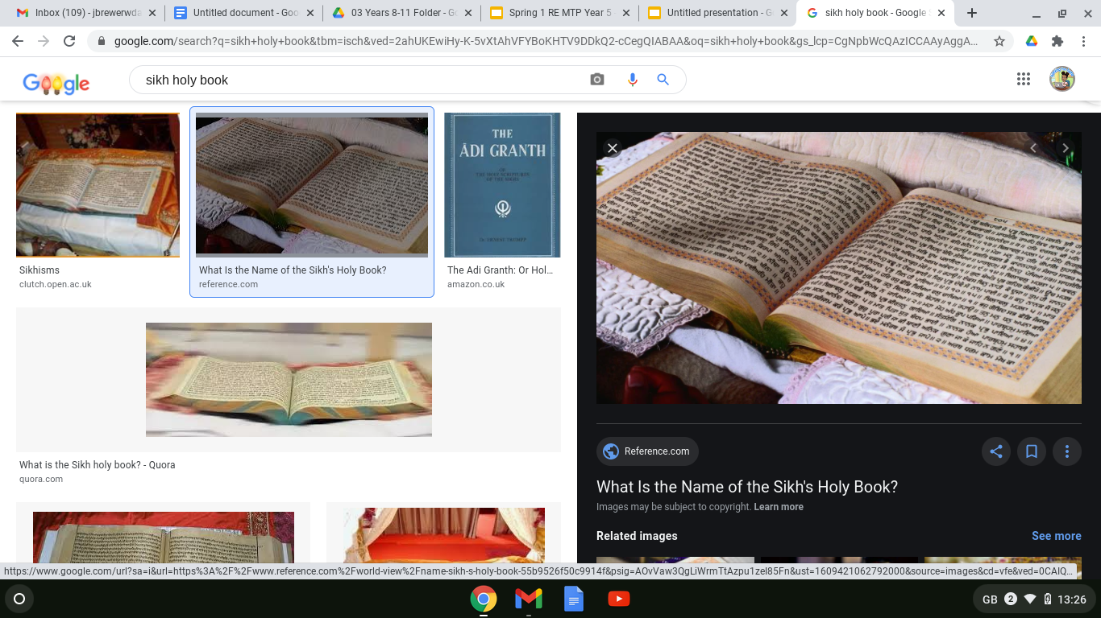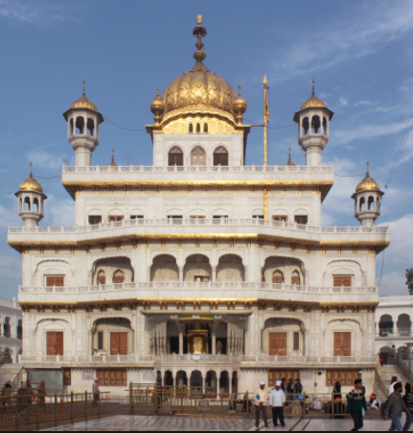  TTYP: What are these two images showing?
Teacher Input / Activity | - Introduce chn to the Guru Granth Sahib. Share information: the Guru Granth Sahib is the Sikh holy book. It was written by Guru Nanak (who began Sikhism) and other Gurus after him. 'Guru' means teacher. It can be found in the Gurdwara, which is the place where Sikh’s go to worship.  - Share key vocabulary and meanings.  - Watch video. Ask: Why is the holy book so important? It’s important because it teaches Sikhs how God wants them to live their lives. Why do Sikhs show the Guru Granth Sahib a lot of respect? They show it great respect because they believe it’s the Sikh’s last Guru (great teacher). Explain that we're going to learn about some of the stories from the Guru Granth Sahib and decide whether they are still important today and whether they are relevant for Sikh’s and non-Sikh’s.  - Watch video of the story of the Jasmine flower (stop at 1:44).  - Recap of learning from Autumn 1. Ask: What does equality mean? The same rights, status and responsibilities for all members of a society, group or family. Ask: What are the five key Sikh beliefs? God is in everything; it’s a Sikh’s duty to serve others; all people should be treated as equals; Sikhs should share what they can with others; Sikhs should earn their living honestly.  - Discussion: Share what a ‘theme’ is: an idea that occurs throughout the story. Ask: What are the themes of the story? How does the story teach diversity? Is anyone more important than any other? How does this story link to Sikh’s beliefs? Can non-sikhs learn from this story? *Teacher note: read the completed table below so you can support/guide this discussion to draw out appropriate responses.  - In the next three lessons chn will complete a table, which will inform their persuasive argument (L5). Give chn a blank table for them to complete (they should be able to complete independently based on the discussion that you have just had as a class). See completed table for teacher info below:  *Teacher note: at bronze level chn will be able to identify the theme; at silver they can describe the theme/moral of the story; at gold they can explain how it is relevant to Sikhs and non-sikhs; at platinum level they will be able to make links with how the story relates to our four pillars.  - Provide a picture of the milk bowl. Chn draw a jasmine flower in the bowl and write what the world needs more of in the bowl e.g. kindness, goodness, honesty, happiness, peace etc. Opportunity to display these in the classroom.  - Chn self-assess using LI solo strips.
  Story | Themes | Describe theme/moral | How the story is relevant to...
  Story | Themes | Describe theme/moral | Sikhs | Non-Sikh’s
  Story of the Jasmine flower | Everyone should be equal (no matter if they are rich/poor or kind/unkind). Treat everyone with respect. Make people feel welcome. Treat others as you want to be treated. | Guru Nanak proved that there is room for everyone no matter what their qualities. He proved this to the messenger by adding a flower to a full bowl of milk and it not overflowing. | Sikhs have five key beliefs and one of them is that all people should be treated as equals, therefore this story is there to teach sikhs this key belief that is fundamental to their religion and should form the basis of everything they do.  Sikhs can learn that there is always room in their lives for the Sikh religion and God and that even if they think they are busy, they should make time to practise their religion. | Equality is important in all religions. It is not just relevant to Sikhs.  At school using our heart is one of our four pillars. We want to show kindness and respect to each other and make sure everyone feels a sense of belonging in our school community. We show this by playing with everyone, we wouldn’t want someone to feel excluded for any particular reason. We would ensure everyone gets a turn and would share things with each other. If someone was new to school we would make them feel welcome.
Curriculum Links | Chn will need to apply their learning from Autumn 1: meaning of equality and the five key Sikh beliefs (God is in everything; it’s a Sikh’s duty to serve others; all people should be treated as equals; Sikhs should share what they can with others; Sikhs should earn their living honestly.)  Applying the story to our four pillars and other aspects of school life.
Resources | LI solo strips  Blank table template. | Pillar Links | Heart: kindness, respect & belonging (how these qualities are the moral of a Sikh story and therefore important to Sikhs and how they are important for everyone no matter what religion)
Working Wall  (What will go on the WW from this lesson?) | Some / all of the children’s milk bowls (task 7) could be put on the WW/a display.  Write up the five key sikh beliefs onto flip chart paper and display on WW as key knowledge from Autumn 1.  Definition of equality.  Definition of theme.

Step 2: Investigation | Lesson 3
Key Vocabulary for the lesson/unit | Carpenter, equality, theme, honesty.
Focus Skill | Interpreting/Discerning: Recognise and explain diversity within religious expression, using appropriate concepts.
Learning Intention | To explain how the themes of a story are relevant to Sikhs and non-Sikhs.  To explore morals in Sikh stories.
SOLO SC: Uni- Structural Bronze | I can identify the themes of diversity in a story.
SOLO SC: Multi- Structural Silver | I can describe the moral message of the story.
SOLO SC: Relational Gold | I can explain how the themes of a story are relevant to Sikhs and non-Sikhs.
SOLO SC: Extended Abstract Platinum | I can reflect on how the story relates to our four pillars.
Starter | TTYP: What is a carpenter?  
Teacher Input / Activity | - Either: as a class, guide the chn in acting out the story of ‘Bhai Lalo and Malik Bhago’. Or bullet point the story, giving each group a copy, and get the chn to independently create a performance of the story in groups. Then some groups can share their performances with the class. (N.B. Acting out as opposed to reading to support engagement)  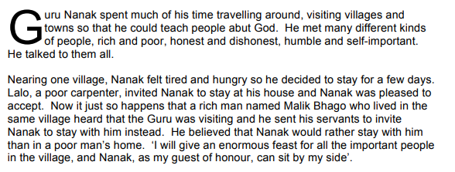  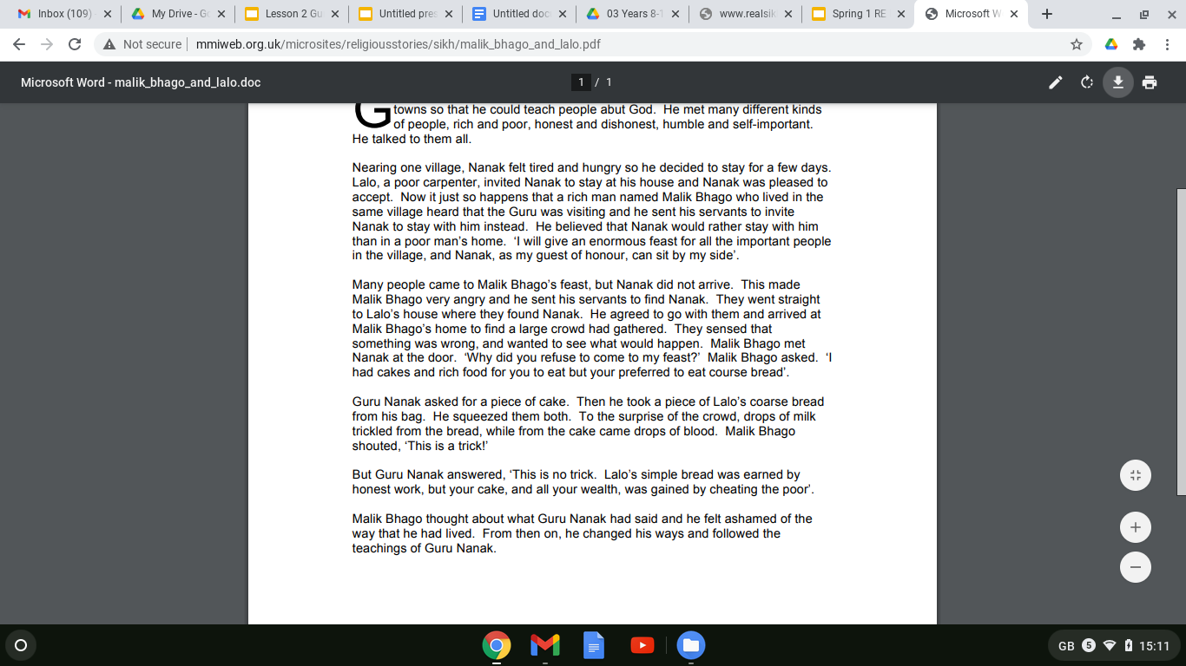  - Remind chn what a ‘theme’ is: an idea that occurs throughout the story. TTYP: What are the themes in this story? Equality and honesty. Ask: Are these important in today’s world? Why? Where is there inequality? What can be done about it? *Teacher note: read the completed table below so you can support/guide this discussion to draw out appropriate responses.  - In lessons 2-4 chn will complete a table (give a new blank one each lesson, rather than adding onto their one from last lesson), which will inform their persuasive argument (L5). Give chn blank table for them to complete (they should be able to complete independently based on the discussion that you have just had as a class). See completed table for teacher info below:  *Teacher note: at bronze level chn will be able to identify the theme; at silver they can describe the theme/moral of the story; at gold they can explain how it is relevant to Sikhs and non-sikhs; at platinum level they will be able to make links with how the story relates to our four pillars.  - Platinum:  - Chn self-assess using LI solo strips.
  Story | Themes | Describe the theme/moral | How this story is relevant to...
  Story | Themes | Describe the theme/moral | Sikhs | Non-sikhs
  Bhai Lao and Malik Bhago | Equality and honesty | The story teaches that you should treat everyone equally and shouldn’t make judgements about people based on differences e.g. rich/poor. You should be honest as this will be recognised. | Sikhs have five key beliefs and this story teaches four out of the five beliefs. One of them is that all people should be treated as equals, therefore this story is there to teach sikhs this key belief (the story focuses on rich/poor both being equal). Next, it is a Sikh’s duty to serve others and in the story the man served Guru Nanak by letting him stay in his home and feeding him. Thirdly, Sikhs should share what they can with others. In the story, the man (although he didn’t have much) shared his home and food with Guru Nanak. Finally, Sikhs should earn their living honestly. The story shows that the rich man hadn’t done this as he had stolen from the poor and therefore Guru Nanak chose not to stay with him. | Chn to link to 4 pillars E.g. This story shows that the man learnt from his mistakes and changed his ways. This is one of our four pillars of using our ‘Head’. We are all human and are bound to make mistakes, but as long as we are honest about them and learn from them that is ok.
Curriculum Links | Link to Jigsaw PSHE: Celebrating Difference (Autumn 2). There are clear connections that can be made with learning in PSHE this half term in relation to diversity and morals and linking to the morals of the Sikh stories.  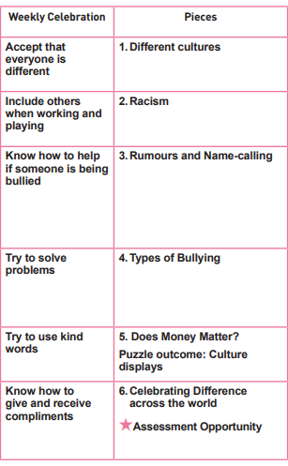  Applying the story to our four pillars and other aspects of school life.
Resources | Blank table  LI solo strips | Pillar Links | Heart: kindness, respect & belonging (these qualities are the moral of a Sikh story and therefore important to Sikhs and they are important for everyone no matter what religion).  Head: learning from our mistakes (the Sikh story is an example of someone who learnt from their mistakes).
Working Wall  (What will go on the WW from this lesson?) | NA

Step 2: Investigation | Lesson 4
Key Vocabulary for the lesson/unit | Courage, theme, Vaisakhi, Khalsa, Gurdwara.
Focus Skill | Interpreting/Discerning: Recognise and explain diversity within religious expression, using appropriate concepts.
Learning Intention | To explain how the themes of a story are relevant to Sikhs and non-Sikhs.
SOLO SC: Uni- Structural Bronze | I can identify the themes in a story.
SOLO SC: Multi- Structural Silver | I can describe the moral message of the story.
SOLO SC: Relational Gold | I can explain how the themes of a story are relevant to Sikhs and non-Sikhs.
SOLO SC: Extended Abstract Platinum | I can reflect on how the story relates to our four pillars.
Starter | Read this story: Vaisakhi and the birth of the Khalsa, either independently or in pairs.
Teacher Input / Activity | - Using this template, chn create a storyboard of this story.  - 2) Discuss as a class: Ask: What are the themes of this story? Courage and standing up for what you believe in. Ask: Are these important in today’s world? Why? *Teacher note: read the completed table below so you can support/guide this discussion to draw out appropriate responses.  - As a class, read ‘how is it celebrated now’ in this document. Ask: How are these themes relevant today to Sikhs/nonSikhs? *Teacher note: read the completed table below so you can support/guide this discussion to draw out appropriate responses.  - In lessons 2-4 chn will complete a table (give a new blank one each lesson, rather than adding onto their one from last lesson), which will inform their persuasive argument (L5). Give chn blank table for them to complete (they should be able to complete independently based on the discussion that you have just had as a class). See completed table for teacher info below:  *Teacher note: at bronze level chn will be able to identify the theme; at silver they can describe the theme/moral of the story; at gold they can explain how it is relevant to Sikhs and non-sikhs; at platinum level they will be able to make links with how the story relates to our four pillars.  - Chn self-assess using LI solo strips.
  Story | Theme | Describe the theme/moral | How this story is relevant to...
  Story | Theme | Describe the theme/moral | Sikhs | Non-Sikhs
  Vaisakhi and the birth of the Khalsa | Courage.  Standing up for what you believe in. | The men in the story all had courage because they all agreed to go into the tent preparing to give their life, which would have been frightening. They were all prepared to stand up for what they believed in. | This story is relevant to Sikhs as it created the basis of the Sikhs baptism ceremony.  It made the Vaisakhi (harvest festival) one of the most important dates in the year for Sikhs.  It was when the term ‘Khalsa’ was created - the collective name for Sikhs who have been baptised.  The date is still celebrated by Sikhs now, by visiting Gurdwaras (their place of worship). They decorate them, have parades/ processions, sing hymns and pray. They give thanks and pray for the year ahead. | The moral/theme of the story is relevant to non-sikhs because it encourages people to have courage and stand up for what they believe in.  For example, lots of young people e.g. Greta Thunberg is standing up for what they believe in (climate change), by speaking publicly and attending peaceful protests. In school we can show this by respectfully voicing our opinion even if it is different to others e.g. in Votes for schools lessons where we are discussing different topics/issues.  In our school community we can stand up for what we believe in through public speaking events or by making sure we voice our opinion to the school council reps. This links to our ‘Head’ pillar as we are challenging ourselves.
Curriculum Links | Applying the story to our four pillars and other aspects of school life.
Resources | LI solo strips.  Blank table. | Pillar Links | Head: challenging. Explaining how the Sikh story could apply to non-sikhs and the ‘head’ pillar.
Working Wall  (What will go on the WW from this lesson?) | Refer chn to the definition of ‘theme’, which is already on WW from lesson 2.

Step 3: Evaluation | Lesson 5
Key Vocabulary for the lesson/unit | Persuasive, theme, Sikh, Guru, equality, respect, courage.
Focus Skill | Reflection of religious beliefs: Recognise and explain the impact of beliefs (including festivals) and ultimate questions on individuals and communities.  and  Explaining: Explain connections between questions, beliefs, values and practices.
Learning Intention | To argue why Sikh stories should be part of the school curriculum.
SOLO SC: Uni- Structural Bronze | I can list reasons why Sikh stories should be a part of the school curriculum.
SOLO SC: Multi- Structural Silver | I can outline reasons why Sikh stories should be part of the school curriculum.
SOLO SC: Relational Gold | I can argue why Sikh stories should be part of the school curriculum.
SOLO SC: Extended Abstract Platinum | I can reflect on what the counter argument could be.
Starter | Look back at the three tables in your book (lessons 2, 3 and 4). TTYP and recap:  - The story  - The theme  - How they’re relevant to Sikh’s  - How they’re relevant to non-Sikh’s
Teacher Input / Activity | - Recap the three stories that have been investigated in this unit (Jasmine Flower, Bhai Lao and Malik Bhago and Vaisakhi & the birth of the Khalsa). The key messages from these are: equality, respect, honesty and courage.  - Task: write a paragraph, arguing that Sikh stories are important today and should be part of the school curriculum.  Teacher to prompt chn - where can we find this information? In the ‘how is this relevant to non-sikhs’ section of our tables. N.B. recommend that chn do this on a separate piece of paper and then stick into books, as opposed to in their book, so they can flick back through their book to find the information easily.  - Chn self-assess on LI solo strips.  *Teacher notes - examples of bronze, silver, gold responses:  Bronze: response would be bullet pointed reasons, taken from the three tables.  E.g.  - The Sikh stories all have good morals that everyone can learn from.  - The Jasmine flower story teaches that everyone should be treated equally.  Silver: In the Sikh story ‘The Bowl and the Jasmine Flower’ the people say that there is no room for Guru Nanak in the city and they give him a full bowl of milk to show this. Nanak puts a Jasmine flower in the milk to show that there is room in the bowl for a flower so there is room in the city for him. From this story, Sikhs can learn that everyone should be treated equally. This is a good message to have as part of the school curriculum to help everyone think about how to make sure everyone feels included, such as when playing at play/lunch times.  Gold: All of the Sikh stories have an important meaning. In the story about the Khalsa, some Sikh men are willing to sacrifice their lives for their religion. They do not end up having to sacrifice their lives but the fact that they were prepared to do this shows how much their religion meant to them and this story is telling Sikhs that their religion should be the most important thing in their lives. Even for non-Sikhs this is an important question so could help everybody think about what is so important they would sacrifice their life for it. I’m not sure the school curriculum is the place for thinking about this as some stories are gruesome and their meanings too grown-up for children.  Platinum: The story of the Khalsa is about men being prepared to give up their lives for their religion. This story would only really be relevant to Sikhs because they are specifically about the importance of one of the Gurus and the Sikh religion in general. The story about ‘Guru Nanak, Mardana, the Bowl and the Jasmine Flower’ is about making room in your life for what is important, even if it highlights your flaws. You should face them and try to be better. This story is relevant to non-Sikhs because everyone can relate to making room in their lives for something or someone important. The story about ‘Guru Nanak, Malik Bhago and Lalo’ is also relevant to non-Sikhs because it is about not making people suffer just so that you can show off. So, even though some of the stories would not be suitable for children and some would not be very meaningful to non-Sikhs, there are lots of Sikh stories which have meanings that everyone can learn from so perhaps it would be good for these ones to be in the school curriculum, definitely in R.E.
Curriculum Links | Links clearly with writing outcome for this half term. Chn have been taught in writing how to write a persuasive advert. They can apply some aspects of this to their paragraph e.g. modal verbs, giving clear opinions and reasons for these, positive language.
Resources | LI solo strips  Paper to write persuasive argument on | Pillar Links | Applying all pillars mentioned in L2-4 as evidence towards their persuasive argument.
Working Wall  (What will go on the WW from this lesson?) | NA

Step 4: Expression | Lesson 6
Key Vocabulary for the lesson/unit | Love, Peace, Equality, Belonging, Courage, Respect, Welcoming, Honesty, Truth (as applicable).
Focus Skill | NA
Learning Intention | To apply knowledge of themes from Sikh stories by creating an acrostic poem.
SOLO SC: Uni- Structural Bronze | I can identify keywords for an acrostic poem to show themes from Sikh stories.
SOLO SC: Multi- Structural Silver | I can outline the themes from Sikh stories in a poem.
SOLO SC: Relational Gold | I can apply knowledge of themes from Sikh stories by creating an acrostic poem.
SOLO SC: Extended Abstract Platinum | I can compare my poem with someone elses and evaluate the reasons for differences.
Starter | Look at the words on the board and choose one that you’d like to write a poem about: Love, Peace, Equality, Belonging, Courage, Respect, Welcoming, Honesty or Truth.
Teacher Input / Activity | - Introduce/remind chn what an acrostic poem is. Watch this video OR share this info:  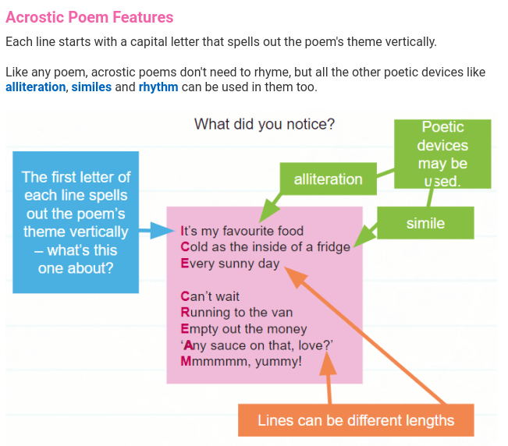  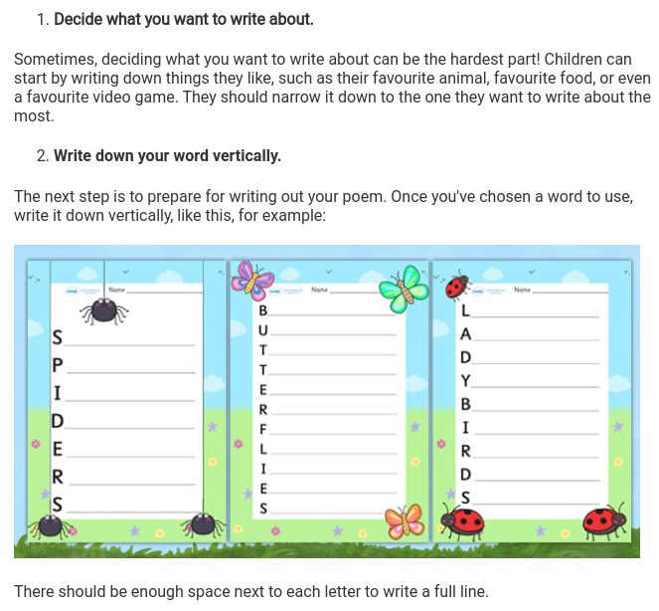  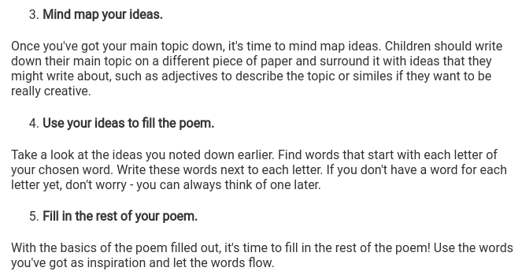  - Chn have chosen a moral concept from the selection on the board as part of their starter activity: Love, Peace, Equality, Belonging, Courage, Respect, Welcoming, Honesty or Truth.  - Mind map ideas.  - Create a thought shower.  - Chn write their acrostic poem (teacher to provide bordered paper for chn to write their poem on).  - Chn could read out their poems to the class.  - Platinum: compare their poem to someone elses and discuss what they liked about it / how they could improve it e.g. suggest a simile they could use.  - Chn self-assess using LI solo strips.
Curriculum Links | Opportunity for the poems to be used as evidence for writing e.g. E1, E2, E5.  100 Club: recite a poem - opportunity for the chn to recite their poems and perform them to the class / another Year 5 class as an extension to this last lesson.
Resources | Bordered paper.  LI solo strips. | Pillar Links | The concepts for the poems (Love, Peace, Equality, Belonging, Courage, Respect, Welcoming, Honesty or Truth) all link to the four pillars that have been discussed and explored in this unit.
Working Wall  (What will go on the WW from this lesson?) | Some examples of poems could be added to WW/classroom display.

