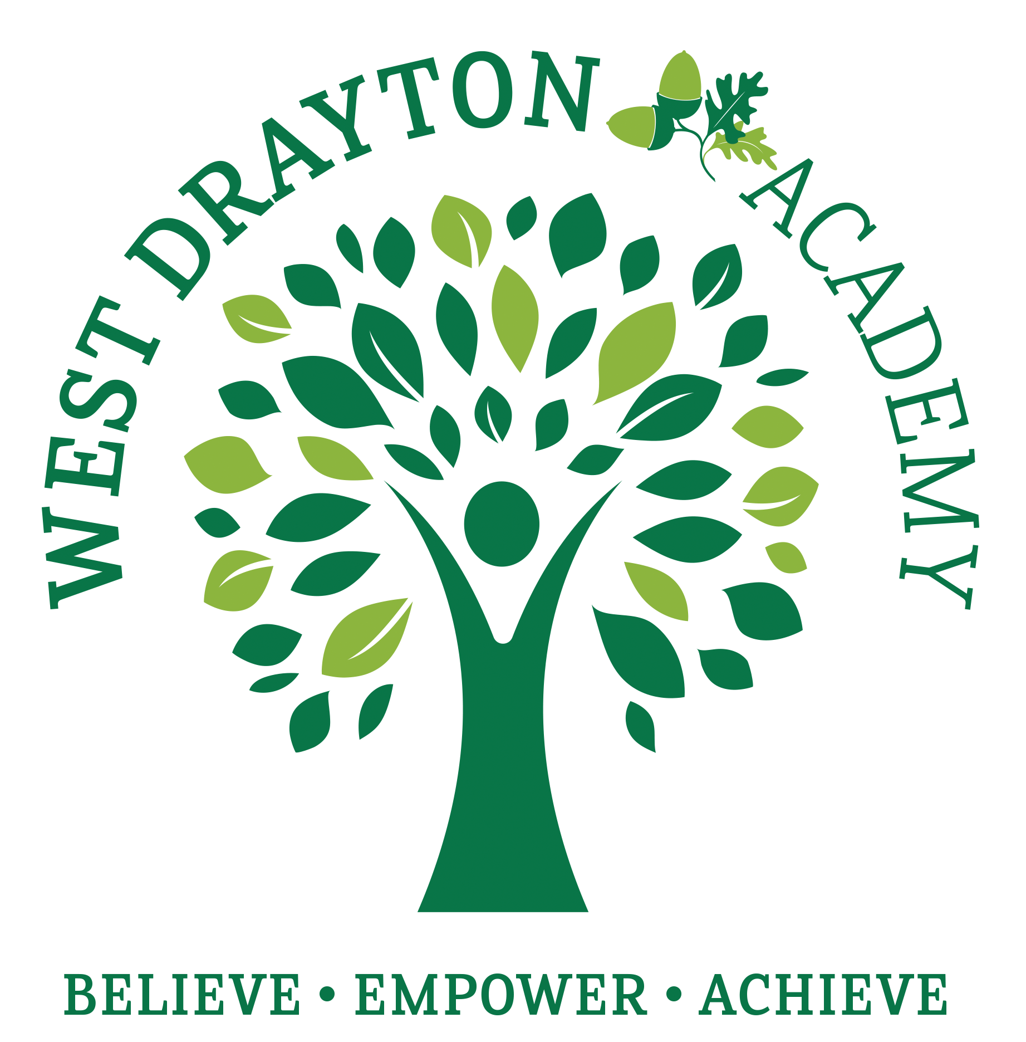
RE MTP Overview
Year 3 Autumn 2
Jigsaw Unit Overview
Theme | Christmas
Concept | Prayer & Worship
Religion | Christianity
Enquiry Question | Has Christmas lost its true meaning?
Learning Intention | We are learning to find out what the true meaning of Christmas is to Christians and compare this with what Christmas means to us
Assessment | Engagement  WTS: I can explain what Christmas means to me.  EXS: I can explain what Christmas means to me and talk about whether this involves giving and receiving gifts  GDS: I can explain what gift I would like to give to the world and what difference it would make. | Knowledge & Understanding  WTS: I can tell you what the nativity story tells Christians about Jesus (given to the world by God).  EXS: I can start to explain the Christian belief that Jesus was God in human form and why God gave him to the world.  GDS: I can make the links between Christian beliefs about Christmas and the way they celebrate it. |  | Evaluation/Critical Thinking  WTS: I can talk about some of the different ways Christmas is celebrated by Christians and non-Christians.  EXS: I can start to tell you what Christmas means to Christians and what it means to me.  GDS: I can recognise that Christmas means different things to different people.
Enrichment

Step 1: Engagement | Lesson 1
Starter | Wrap Huey Owl/object in the centre of the parcel for ‘pass the parcel’ game as a surprise when the last layer of paper is taken off. (Teacher is mindful of who celebrates Christmas or not) Play ‘Pass the parcel’ (the parcel wrapped in Christmas paper); and every time the music stops the child with the parcel says something about their experience of Christmas or of the Christmas holidays. Tch to scribe on paper f/c the information children share about their Christmas experiences or their experiences during the Christian holidays if they do not celebrate Christmas. This f/c needs to be referred during the input/task. Add f/c to RE display.
Key Vocabulary for the lesson/unit | Christmas, nativity, Mary, Joseph, Jesus Christ, God, disciples, wise men, angel
Focus Skill | Skill:  Reflection of religious beliefs: Identify the impact of beliefs (including festivals) on individuals, groups and communities.  Questioning: Ask thought-provoking questions about religions and beliefs.
Learning Intention | To explain the Christian beliefs about Christmas and the way they celebrate it.  To explore Christian beliefs about Christmas
SOLO SC: Uni- Structural Bronze | I can label a nativity scene.  I can identify the key characters from the nativity story.
SOLO SC: Multi- Structural Silver | I can describe the events of the nativity story.  I can describe some of the events from the nativity story.
SOLO SC: Relational Gold | I can explain the Christian beliefs about Christmas and the way they celebrate it.  I can explain why the nativity story is an important part of Christmas for Christians.
SOLO SC: Extended Abstract Platinum | I can make links between Christian beliefs about Christmas and the way they celebrate it.  I can describe some of the ways Christians celebrate Christmas.
Teacher Input / Activity | Teachers find out from children what they already know about the first Christmas.  What do you know about Christmas?  Teacher shares Christmas story with chn and discusses key events making reference to experience shared in starter.  Bronze: Provide chn with a picture of the nativity scene with key vocabulary/words and ask chn to label what the Christian story tells Christians about Jesus. Challenge: Use words in sentence  WTS response may be: I think Christmas is a time to give presents to the people we love. The nativity story tells Christians that Jesus was a gift to the world from God.  Silver: Provide chn with key events from the Nativity story and ask chn in pairs to describe the events of the nativity story  Gold: Ask chn to explain why Christian celebrate Christmas using their knowledge of the nativity story.  Platinum: Ask chn to write sentences about Why is Christmas important to Christians? How do they celebrate it?
Possible Misconceptions  (What are the children likely to find challenging?) | Misconceptions about ‘santa’ - why does Father Christmas bring gifts?  Nativity story may conflict with their own beliefs and result in further questions/discussion  What is the true meaning behind Christmas compared to what they see on TV etc.
Resources | Christmas wrapping paper to wrap pass the parcel for starter  Activity sheets  Pictures of key events of the nativity story  First Christmas video (Nativity story) | Pillar Links | Hands - experiencing
Working Wall  (What will go on the WW from this lesson?) | F/c of children's Christmas experiences or their experiences during the Christian holidays if they do not celebrate Christmas. This f/c needs to be referred to during the input/task and future lessons.

Step 2: Investigation | Lesson 2
Starter | Recap Christmas story. Reinforce the significance of shepherds, wise men, star, gifts, etc.
Key Vocabulary for the lesson/unit | Advent candle, Christmas pudding, Advent calendar with Nativity scene, Christmas carol sheet, Christmas card, Christmas tree fairy
Focus Skill | Skills  Questioning: Ask thought-provoking questions about religions and beliefs.  Explaining: Make links between beliefs, stories and practices.
Learning Intention | To explain the purpose of items used to celebrate Christmas  To explore items linked to christmas
SOLO SC: Uni- Structural Bronze | I can identify items linked to Christmas.  I can name different items linked to Christmas.
SOLO SC: Multi- Structural Silver | I can describe the items used at Christmas.  I can describe the purpose of different items that are linked to Christmas.
SOLO SC: Relational Gold | I can explain the purpose of items used to celebrate Christmas  I can explain how different items remind Chrisitans of the true meaning of Christmas.
SOLO SC: Extended Abstract Platinum | I can justify which items reflect the true meaning of Christmas  I can reflect on which items I think are the most important to Chrisitans.
Teacher Input / Activity | From the ‘Big Christmas Gift Box’, choose a child to pull out a mystery item. (Items could include: Advent candle, Christmas pudding, Advent calendar with Nativity scene, Christmas carol sheet, Christmas card, Christmas tree fairy, etc.)  Each group takes its mystery item back to their table to explore and discuss the questions below and then a selected group member will feed back to class.  Explore what Christmas means to Christians using the items as a starting point.  Key questions for discussion:  Bronze: Can you name items linked to Christmas?  Silver: What items are used as part of Christmas celebrations?  Gold: Why are these items used and what is their importance at Christmas?  Platinum: Which items reflect the true meaning of Christmas? How do you know?  Conclude: To Christians, Christmas is very important because they are celebrating God’s son, Jesus, coming to earth to help people.
  What is it? | How is it used at Christmas? | What might it mean to Christians?
Possible Misconceptions  (What are the children likely to find challenging?) | Challenges with understanding why items are used and why they are used. Lots of items used to celebrate Christmas are commercialised and children’s understanding of them may not reflect the true meaning of Christmas.
Resources | Markers  Large f/c or sugar paper  Big Christmas gift box items  Pictures of objects used to celebrate Christmas | Pillar Links | Hands - exploring
Working Wall  (What will go on the WW from this lesson?) | Key vocabulary

Step 2: Investigation | Lesson 3
Starter | Recap the Christmas nativity story. In pairs ask chn to summarise the first Christmas story. Recap the main events.
Key Vocabulary for the lesson/unit | Nativity, christmas, Jesus Christ, Mary & Joseph, Santa, reindeer, snow, elfs, presents
Focus Skill | Skills:  Questioning: Ask thought-provoking questions about religions and beliefs.  Explaining: Make links between beliefs, stories and practices.
Learning Intention | To compare and contrast what represents the true meaning of Christmas.  To explore non religious (secular) symbols of Christmas.
SOLO SC: Uni- Structural Bronze | I can label what represents Christmas.  I can describe a range of symbols that are linked to Christmas.
SOLO SC: Multi- Structural Silver | I can sort what represents Christmas.  I can explain that some symbols are religious and some are not.
SOLO SC: Relational Gold | I can compare and contrast what represents the true meaning of Christmas.  I can explain how non religious symbols are connected to Christmas.
SOLO SC: Extended Abstract Platinum | I can evaluate what reflects the true meaning of Christmas.  I can reflect on which symbols I think could be important to everyone.
Teacher Input / Activity | - Show chn 2 x different Christmas cards (Christmas santa scene and a traditional nativity scene) and discuss  Discussion  - What can you see on the Christmas cards?  - Why are the two Christmas cards different?  - Which Christmas card represents the true meaning of Christmas? How do you know?  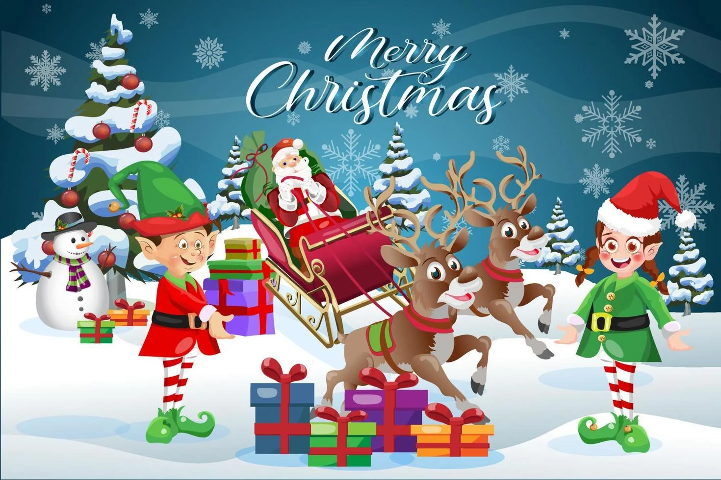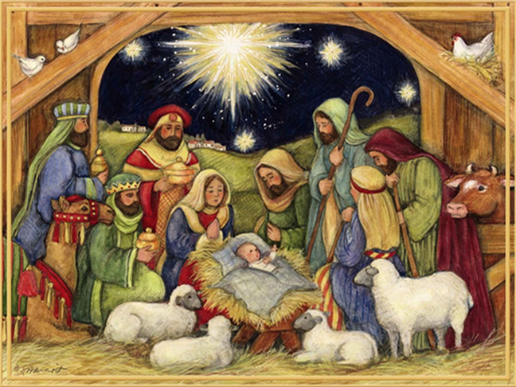  Task  - Give chn a selection of Christmas cards.  - Children can label the aspects that represent Christmas and sort the Christmas cards which reflect or don’t reflect the true meaning of Christmas for Christians.  - Provide chn with pictures of the two contrasting Christmas cards  - In pairs ask them to discuss the similarities and differences between the two cards  - Ask chn to give feedback to the class teacher to record their idea on f/c using Venn diagram. Chn to record notes/ideas on Venn diagram  - 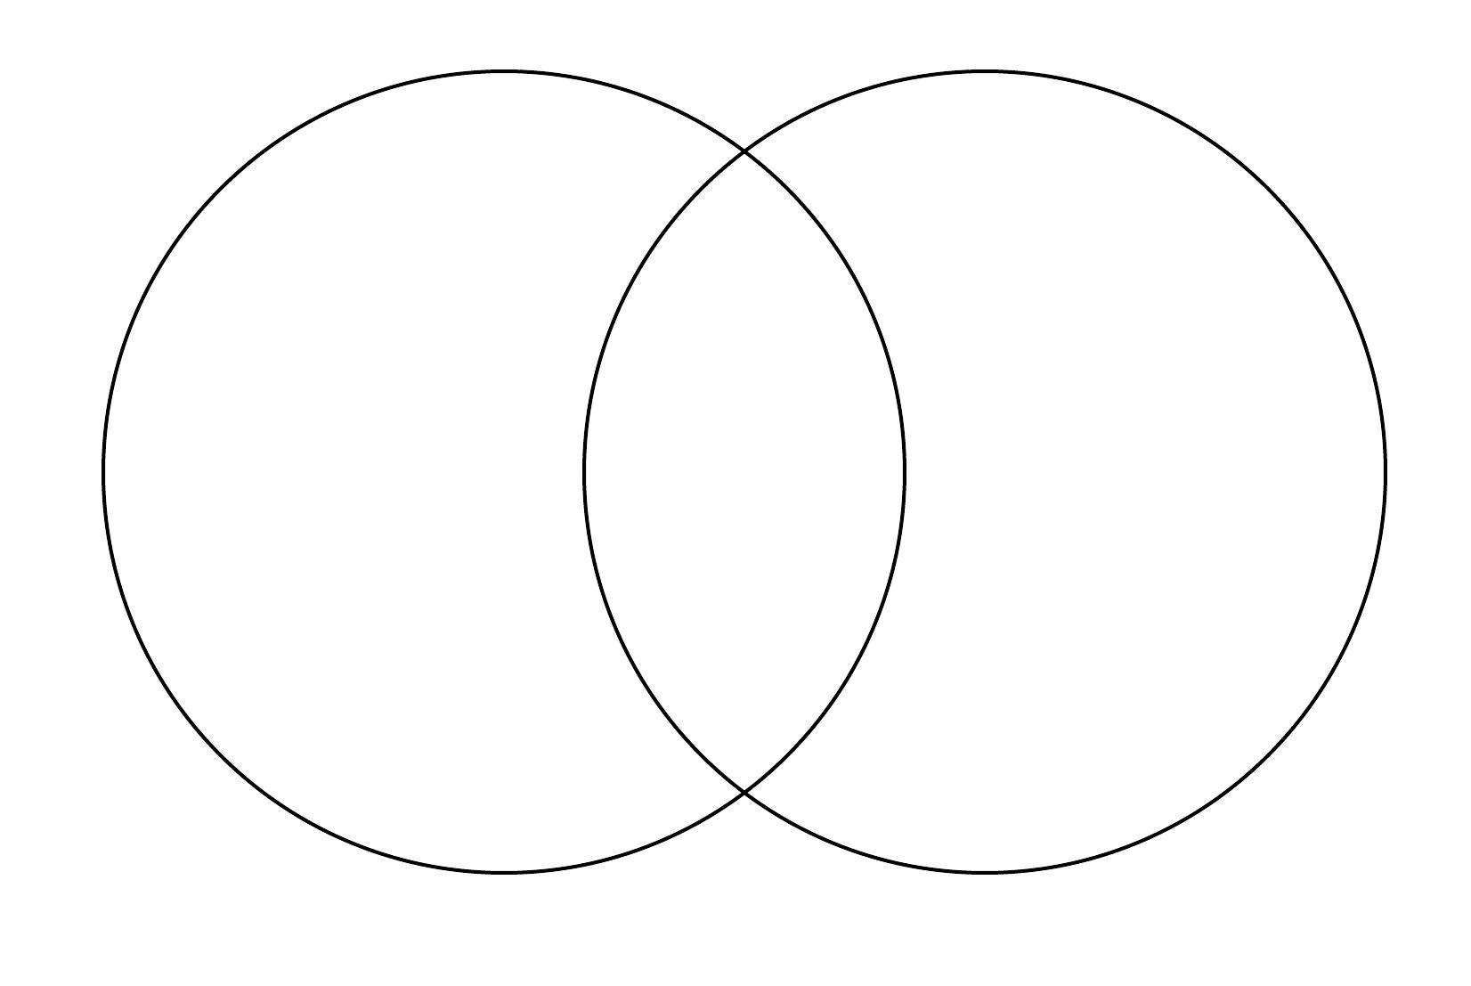  - As a class, discuss What is the true meaning of Christmas for Christians? Evaluate why
Possible Misconceptions  (What are the children likely to find challenging?) | Understanding why Christmas is celebrated in different ways!
Resources | Venn diagrams  Two contrasting nativity scenes/cards | Pillar Links | Hands - exploring
Working Wall  (What will go on the WW from this lesson?) | F/c notes

Step 2: Investigation | Lesson 4
Starter | Recap on the nativity story with partner  Recap on what items represent the true meaning of christmas.
Key Vocabulary for the lesson/unit | Christmas tree, non-christian, christian, christmas
Focus Skill | Skills:  Questioning: Ask thought-provoking questions about religions and beliefs.  Explaining: Make links between beliefs, stories and practices.
Learning Intention | To explain which aspects of Christmas are non-Christian and Christian
SOLO SC: Uni- Structural Bronze | I can identify non-Christian and Christian aspects of Christmas
SOLO SC: Multi- Structural Silver | I can list non-Christian and Christian aspects of Christmas
SOLO SC: Relational Gold | I explain which aspects of Christmas are non-Christian and Christian
SOLO SC: Extended Abstract Platinum | I can justify which aspects of Christmas reflect Christian beliefs.
Teacher Input / Activity | - Through discussion teacher to explore with children how certain aspects of Christmas celebrations reflect a religious (Christian) meaning in comparison to other non-Christian aspects of the celebration  - What does having ‘meaning’ mean?  - Make a class Christmas tree with decorations to show all the non-Christian aspects of Christmas (that might be meaningful to the children) e.g. gifts, cards, meals, family etc.  - Make a second Christmas tree with decorations to show ways in which Christmas is meaningful to Christians. (Include birthday card for Jesus, thank yous to Jesus for saving/helping the world, star, gold, frankincense etc. anything to illustrate Christian meaning which is that Jesus is the incarnation of God on earth i.e. God sent Jesus to the earth to save/rescue people from their ‘sin’ and show them how to gain salvation.)  - Ask chn to justify which aspects of Christmas which reflect Christian beliefs
Possible Misconceptions  (What are the children likely to find challenging?) | Challenging questions:  What is the true meaning of christmas?  What does having ‘meaning’ mean?
Resources | 2 Christmas tree sheets  Pictures of Christmas related aspects (Christian/Non-Christian) | Pillar Links | Hands - exploring, creating
Working Wall
(What will go on the WW from this lesson?)

Step 3: Evaluation | Lesson 5
Starter | Children sort religious and non-religious words, pictures and objects. e.g. Santa, birth of Jesus. Could do this using Christmas cards or advent calendars. Some cards may be in both piles, e.g. Christmas presents.
Key Vocabulary for the lesson/unit | Sants, birth of Jesus, Christmas presents, advents calendars, christmas cards
Focus Skill | Skills  Application and making links: Identify similarities and differences in features of religions and beliefs.
Learning Intention | I can explain why Christmas is important to Christians and some non-Christians.
SOLO SC: Uni- Structural Bronze | I can identify how Christians or non-Christians celebrate Christmas.
SOLO SC: Multi- Structural Silver | I can describe how Christians or non-Christians celebrate Christmas.
SOLO SC: Relational Gold | I can explain why Christmas is important to Christians and some non-Christians.
SOLO SC: Extended Abstract Platinum | I can reflect on whether Christmas has lost its true meaning.
Teacher Input / Activity | - Teacher to explore Qu: What is the true meaning of Christmas to Christians?  - Show chn slide of both religious and non religious Christmas celebrations to support chn’s discussion  - Provide each table with question stems to discuss as a group  - Some people do not celebrate Christmas because…  - Christmas is important to Christians because…  - Christians celebrate Christmas by…  - At Christmas I…  - To me Christmas means…  - Christians believe Jesus is...  Task: Children complete the Activity Sheet.  Plenary: Discussion  - Do I think Christmas has lost its true meaning?  - Does Christmas mean the same to you as it does to Christians?
Possible Misconceptions  (What are the children likely to find challenging?) | Religious and non-religious words and celebrations eg. santa
Resources | Discovery activity sheet (adapted for different abilities | Pillar Links | Heart - tolerance/respect
Working Wall
(What will go on the WW from this lesson?)

Step 4: Expression | Lesson 6
Starter | Recap nativity story  Recap question from previous lesson: Do you think christmas has lost its true meaning?
Key Vocabulary for the lesson/unit | Christmas, kindness, generosity
Focus Skill | n/a
Learning Intention | To explain how my gift will make the world a better place.
SOLO SC: Uni- Structural Bronze | I can name a gift which will make the world a better place.
SOLO SC: Multi- Structural Silver | I can list gifts which will make the world a better place.
SOLO SC: Relational Gold | I can explain how my gift will make the world a better place.
SOLO SC: Extended Abstract Platinum | I can justify why my gift is the best in order to make the world a better place.
Teacher Input / Activity | - Teacher to display key question on IWB If you could give the world one gift at Christmas to make it a better place, what would it be?  - In pairs chn to discuss question and record their ideas on mini whiteboard  - Chn show tch their board and tch to collect chn’s ideas and display them for reference for chn  Task:  - Children make their gift to the world using a blank bauble template to express their wishes for the world.  - Children could draw a picture of their ‘gift’  - The gift doesn’t have to be a physical object but could be a idea/word e.g kindness  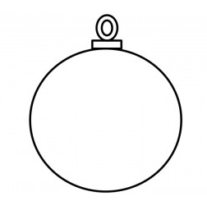  - Children to share their ‘gift’ wish for the world with class.  - Teacher to display baubles
Possible Misconceptions  (What are the children likely to find challenging?) | Some gift children suggest may not help the world to be a better place but instead be a gift which they would like personally for Christmas such as a new toy car or a barbie
Resources | Bauble template  A4 Sheet x15 | Pillar Links | Hand- creating and exploring
Working Wall  (What will go on the WW from this lesson?) | Bauble display

