
RE MTP Overview
Year 3, Summer 1
Jigsaw Unit Overview
Theme | Beliefs and Practices
Concept | Beliefs & Moral Values
Religion | Hinduism
Enquiry Question | How can Brahman be everywhere and in everything?
Learning Intention | We are learning to understand the Hindu belief that there is one God with many different aspects.
Resources | Discovery RE
Assessment | Engagement  WTS: I can explain how I may be special in different ways to different people.  EXS: I can explain some of the different roles I play whilst still being me.  GDS: I can describe some of the characteristics that make me me even when I am playing different roles. | Knowledge & Understanding  WTS: I can tell you about some Hindu gods and start to explain their significance to Hindus.  EXS: I can describe what a Hindu might believe about one of the Hindu gods and start to understand that Brahman is in everything.  GDS: I can make links between Hindu beliefs regarding Brahman and gods with how they choose to live their lives. |  | Evaluation/Critical Thinking  WTS: I can ask questions about what Hindus believe.  EXS: I can recognise what I think about some Hindu beliefs about Brahman and gods, showing respect to Hindus  GDS: I can reflect on Hindu beliefs and express thoughts on these.

RE MTP
Year 3 , Summer 1 Week 1
Step 1: Engagement | Lesson 1
Focus Skill | Reflection of self: Recognise and explain the individual roles and responsibilities in life.
Learning Intention | To explain the importance of different roles I play in life  To investigate the different roles I play in life
SOLO SC: Uni- Structural Bronze | I can define responsibility  I can identify different roles in life.
SOLO SC: Multi- Structural Silver | I can list different responsibilities I have in life  I can identify the different responsibilities I have in life
SOLO SC: Relational Gold | I can explain the importance of different roles I play in life
SOLO SC: Extended Abstract Platinum | I can evaluate the reasons why responsibility increases with age and give a justified reason when someone is old enough to choose their religion.
Key Vocabulary for the lesson/unit | responsibility, roles
Starter | Brainstorming what the word responsibility means
Teacher Input / Activity | Step 1 Engagement  - Discuss how as an individual, we have different roles and responsibilities to play in a family and life.  - Tch to discuss ‘Who are you and what do you mean to different people?’ e.g. daughter, sister, friend, niece, pupil at school, granddaughter and so on (T to model an example on a net cube - scribe the roles of someone on one cube.  - TASK 1: children complete the net of the cube writing what role they play in family and in society.  - T to discuss how they are different to different people but still themselves.. T to model how to list what being a sister or daughter or friend entails.  - TASK 2: Children bullet point (under each heading) the responsibilities they play in their different roles.  - TASK 3: Children explain the importance of the roles they play in life  - Tch to reinforce that there is only one of them and whilst they are different things to different people, they are still themselves. All the sides are parts of the same YOU. What is it about you that is inside the box that makes you you?  Pupil Expectations  Silver - WTS: I can explain how I may be special in different ways to different people.  I think I am most special as a son to my Dad. He is proud of me.  Gold - EXS: I can explain some of the different roles I play whilst still being me.  I am a Year 3 School Council Rep. a brother and a cub. I am still me wherever I am.  Platinum - GDS: I can describe some of the characteristics that make me me even when I am playing different roles.  I try to be really kind no matter who I am with because I hate it when people are unkind to me. That is inside my first box and is something I want my murti to have.
Possible Misconceptions  (What are the children likely to find challenging?) | Understanding that although they have different roles, they are still the same person.
Resources | Large sugar paper (brainstorm)  Chunky marker pens  1 x net cube for each child  scissors | Pillar Links | Heart - Showing kindness and respect about Hinduism  Head - learning about British law and religious belief
Working Wall  (What will go on the WW from this lesson?) | Thought bubble of responsibility displayed on the working wall

RE MTP
Year 3, Summer 1, Week 2
Step 2: Investigation | Lesson 2
Focus Skill | Explaining: Make links between beliefs, stories and practices.
Learning Intention | To explain why Hindus believe Brahman can be in everything  To explore Hindu beliefs about Brahman
SOLO SC: Uni- Structural Bronze | I can match the different forms of Brahman  I can identify the different forms of Brahman
SOLO SC: Multi- Structural Silver | I can describe the different roles of Brahman
SOLO SC: Relational Gold | I can explain why Hindus believe Brahman can be in everything
SOLO SC: Extended Abstract Platinum | I can reflect on the importance of Brahman in Hinduism
Key Vocabulary for the lesson/unit | Deity  Brahman  Gods and Goddesses
Starter | Revisit the word responsibility. TTYP: What does this word mean to you?
Teacher Input / Activity | Step 2: Investigation  - Discuss the concept of Brahman with children and explain the definition to children: Brahman is the supreme spirit and the other Gods and Goddesses are different representations of Brahman. Braham is the foundation of life.  - Show children a box labelled ‘Brahman’ and explain that inside this box we can find out what Hindus believe about Brahman.  - Inside the box, have many different deities and, as each deity is revealed, explain to the children that this is what Brahman looks like. Qu: How can this be? How can Brahman look like so many different things? Make link with lesson before (roles/responsibility net)  - Guide chn to match the deity to its role using word and picture cards. T to discuss and talk through the different Hindu deities and what their roles are.  - Tell the children a story about one of the gods, e.g. Ganesha/Lakshmi. Watch(3 min) story of GaneshaGanesha: The Origin of The Elephant Headed God - Hindu Mythology Stories - See U in History  - Teach children that there is one God who Hindus see in many different forms: This God is called Brahman.  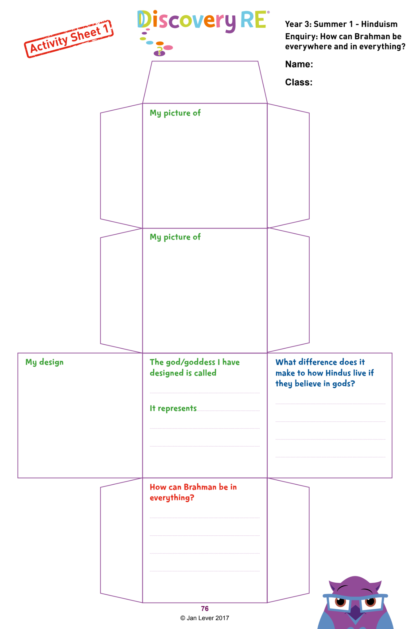  Activities:  - Children match the deity to its role using picture cards see Twinkl resource Hindu Gods Picture Cards Matching Activity  - Children discuss and outline the different roles and responsibilities of 3 main Gods or Goddesses  - Children retell the story and explain the significance it has to Hindu beliefs  - Use the Activity Sheet cube net to record their learning about gods/godesses.  Pupil Expectations  Silver - WTS: I can tell you about some Hindu gods and start to explain their significance to Hindus.  The 2 gods/goddesses on my cube are Ganesha and Lakshmi. They are significant to Hindus because Ganesha is the god of education and wisdom and helps solve problems; Lakshmi is the goddess who brings wealth.  Gold - EXS: I can describe what a Hindu might believe about one of the Hindu gods and start to understand that Brahman is in everything.  Hindus believe that Brahman is everything. This means that they would look after living things, like animals. Brahman is like the salt in the salt water. You can’t see it but you know it is there. I can tell you about Ganesha... (see above but expect knowledge of the story).  Platinum - GDS: I can make links between Hindu beliefs regarding Brahman and gods with how they choose to live their lives.  If a Hindu believes Brahman is in everything, it would make a difference to everything he does because he would not want to harm anyone or anything. He wouldn’t want to step on an ant or splat a spider. He would probably be a vegetarian too.
Possible Misconceptions | Brahman is a range of Gods and Goddesses merged into one.
Resources | Powerpoint  Activity sheet 1 (Discovery RE net)  Twinkl resource Hindu Gods Picture Cards Matching Activity  IWB  Additional stories to watch  Lord Ganesha Stories - Ganesha's Victory - Short Stories for Children | Pillar Links | Hands and heart - sorting and linking symbolism to meaning. Respectful and kind when sharing ideas and beliefs.
Working Wall  (What will go on the WW from this lesson?) | Photocopy of one child’s work  Make a class mobile of their cubes and their Hindu god cubes.

RE MTP
Year 3, Summer 1, Week 3
Step 2: Investigation | Lesson 3
Focus Skill | Interpreting / discerning: Describe and suggest meanings for symbols and other forms of religious expression.  Application and making links / synthesis: Describe similarities and differences within and between religions and beliefs.
Learning Intention | To compare the expression of faith in Hinduism with my own belief  To explore the Hindu faith
SOLO SC: Uni- Structural Bronze | I can identify how Hindus use deities in the temple and for puja
SOLO SC: Multi- Structural Silver | I can describe how deities are used in the temple and for puja
SOLO SC: Relational Gold | I can compare the expression of faith in Hinduism with my own belief
SOLO SC: Extended Abstract Platinum | I can argue for or against the statement.  “All religions have their own Pathway of belief. True or false?”
Key Vocabulary for the lesson/unit | Omnipresent
Starter | Picture inference- what do they infer and predict.
Teaching Input / Activity | - Watch video (2 min) https://www.bbc.co.uk/programmes/p0114z20 How Hindus use deities in the temple and for puja.  - Explain One important type of puja in Indian temple and private worship is arati, the waving of lighted lamps before an image of a deity or a person to be honoured. In performing the rite, the worshipper circles the lamp three or more times in a clockwise direction while chanting a prayer or singing a hymn.  Hindu’s believe that by having darshan of the god's image, one takes the energy that is given by the deity, and receives blessings.  - Watch (3 min) https://www.bbc.co.uk/programmes/p01140qs  Activities:  - TASK: children bullet point ideas in a table to describe how deities are used.  - Discuss how every religion is different and does not express the same faith as they do in Hinduism. Discuss and write ideas about what is similar and/or different with another/or their own religion  - TASK:  - Bronze: Match statements to show how deities are used in the temple and for Puja  - Silver: Children list two ways deities are used  - Gold: Children compare the beliefs in Hinduism with their own belief in a venn diagram  - Platinum: “All religions have their own Pathway of belief. True or false?” Children write their for/against ideas and discuss it with their partner.
Possible Misconceptions  (What are the children likely to find challenging?) | That different religions do not share common beliefs and practices.
Resources | Statements to match (bronze)  Venn diagram (gold) | Pillar Links | Hands and heart - sorting and linking symbolism to meaning. Respectful and kind when sharing ideas and beliefs.
Working Wall  (What will go on the WW from this lesson?) | Bullet pointed sheets (partner work)

RE MTP
Year 3, Summer 1, Week 4
Step 2: Investigation | Lesson 4
Focus Skill | Identity, experience and empathy: Make links between values and commitments, including religious ones, and their own attitudes and behaviour.
Learning Intention | To explain the three main deities in Hinduism and explain what they represent  To explore the three main deities in Hinduism
SOLO SC: Uni- Structural Bronze | I can define the term ‘trimurti’  I can identify the three main deities in Hinduism
SOLO SC: Multi- Structural Silver | I can describe what the trimurti represents
SOLO SC: Relational Gold | I can explain the three main deities in Hinduism and explain what they represent
SOLO SC: Extended Abstract Platinum | I can reflect on how my life would be affected if I was a Hindu
Key Vocabulary for the lesson/unit | Brahma-creator  Vishnu- preserver  Shiva-destroyer
Starter | Complete a visualising activity.  Teacher to explain what the Gods in the trimurti look like while children draw a representation of them
Teacher Input / Activity | - Watch video (5 min) The Three Main Gods in Hinduism (Trimurti)  - Tch to discuss the term trimurti  - Explain how these are the main deities and explain what they represent.  - Brahma - creator  - Vishnu - preserver  - Shiva - destroyer  Activities:  TASK: children explain what each God represents under their images from the starter  Experiment - Take a glass of water. Add some salt - it will dissolve into the water and you won’t be able to see it or  remove it. Now taste the water and you will taste the salt in every drop of the water. In this analogy the water represents the world and the salt represents Brahman, though invisible Brahman is omnipresent (everywhere.) Ask key qu: How can Brahman be everywhere and in everything? How would this affect your life if you were a Hindu?  TASK: Class debate. Children are split into two groups: One side writes ideas about how Brahman can be everywhere and in everything using their own experiences of religion while the others write ideas about how it is not possible for this to happen.
Possible Misconceptions
(What are the children likely to find challenging?)
Resources | https://www.youtube.com/watch?v=sT2jorwmtBk | Pillar Links | Heart - Listening with respect to other religious practices.  Head - reflection on own practice of commitment
Working Wall
(What will go on the WW from this lesson?)

RE MTP
Year 3, Summer 1, Week 5
Step 3: Evaluation | Lesson 5
Focus Skill | Make links between values and commitments, including religious ones, and their own attitudes and behaviour.
Learning Intention | To explain how Hindu’s show commitment to God  To explore how Hindu’s show commitment to God
SOLO SC: Uni- Structural Bronze | I can draw one way that Hindus shows commitment to God (evaluation)  I can identify how Hindus show commitment to God
SOLO SC: Multi- Structural Silver | I can describe one way that Hindus shows commitment to God  I can describe ways that Hindus shows commitment to God
SOLO SC: Relational Gold | I explain how Hindu’s show commitment to God  I can argue the pros and con of how Hindus show commitment to God
SOLO SC: Extended Abstract Platinum | I can design my own Hindu God  I can reflect on Hindu beliefs and express thoughts on these.
Key Vocabulary for the lesson/unit
Starter | Recap on the different Gods and Goddesses in Hinduism and how Hindus show their commitment to God. Write ideas on a flipchart
Teacher Input / Activity | Step 3: Evaluation  - In pairs, on A3 sheets of paper, children write down everything they have learnt about Hindu Gods and how they show commitment to God.  - Tch to ask class for feedback and discuss further  - Teacher to brainstorm ideas about Gods/Goddesses children could create for Hinduism.  - Discuss ideas such as kindness, wealth, friendship etc which could be depicted in their design  Activity:  Children complete the cube and design their own God or Goddess  Pupil Expectations  Silver - WTS: I can ask questions about what Hindus believe.  I wonder if the stories about the gods are true or just stories. Who is Brahman? Do all Hindus believe in  gods?  Gold - EXS: I can recognise what I think about some Hindu beliefs about Brahman and gods, showing respect to Hindus.  I think it is important to look after living things. I think we should treat them properly. If I were a Hindu I would think that I would have a better life next time if I look after living things. If Brahman is in everything, Hindus would need to treat everyone and everything with respect and kindness. That is a good thing, I think.  Platinum - GDS: I can reflect on Hindu beliefs and express thoughts on these.  I don’t think there is such a thing as Brahman but I still think it is right to be kind to animals. I find it hard to understand all the different gods, like Ganesha as they seem so unrealistic, but I suppose they can be if they are gods. It feels a bit confusing.
Possible Misconceptions
(What are the children likely to find challenging?)
Resources | Cube (A3 copy) | Pillar Links | Head - reflect and justify own choices and practice  Heart - share and listen to each other ideas and thoughts  Health - kindness to all helps us and each other
Working Wall  (What will go on the WW from this lesson?) | Children’s brainstormed ideas.

RE MTP
Year 3, Summer 1, Week 6
Step 4: Expression | Lesson 6 - Not complete
Focus Skill | Identity, experience and empathy: Show an understanding of moral and religious issues, and how they can guide lifestyle choices.
Learning Intention | To compare and contrast the importance of each commitment. (Expression)  To explore the idea of commitment
SOLO SC: Uni- Structural Bronze | I can identify ways that I show commitment.
SOLO SC: Multi- Structural Silver | I can list ways that I show commitment.  I can identify ways that Hindus show commitment
SOLO SC: Relational Gold | I can compare and contrast the importance of each commitment.
SOLO SC: Extended Abstract Platinum | I can evaluate my order of importance linking beliefs and values
Key Vocabulary for the lesson/unit
Starter | Recap how Hindu’s show commitment to God
Teacher Input / Activity | Step 4 Expression  - Using Activity Sheet 2, read the poem from the Upanishads  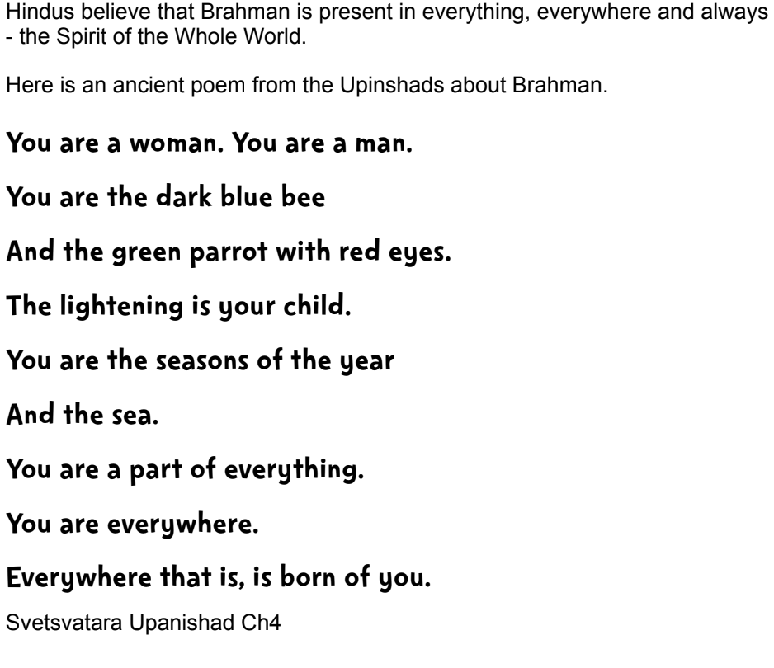.  - Explain that today chn will write their own poem in the same format (on sheet).  - Through shared writing Tch to model writing poem with class input.  - Brainstorm key ideas for chn to use a word bank to support them when writing their own poem  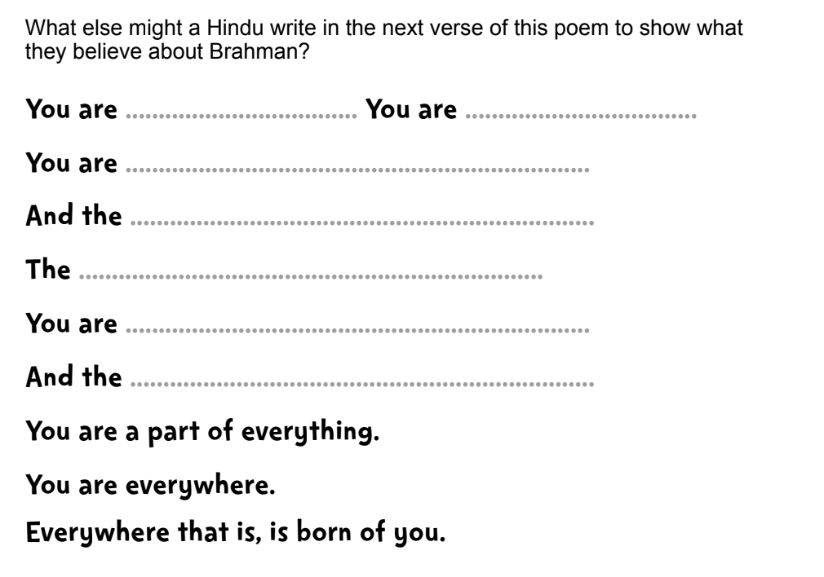  Activity:  Children write their own poem in the same format (on sheet). Chn could illustrate the poem with movement/dance/music.
Possible Misconceptions  (What are the children likely to find challenging?) | Children may find it difficult to express their understanding through a poem. Support children through brainstorming ideas (word bank/phrases)
Resources |  | Pillar Links | Hands - Creating figures and untigin figures of commitment.  Heart - understanding we share many similar ideas and thoughts (connected)
Working Wall
(What will go on the WW from this lesson?)

