
RE MTP Overview
Year 3 Spring 2
Jigsaw Unit Overview
Theme | Easter - Forgiveness
Concept | Beliefs & Moral Values
Religion | Christianity
Enquiry Question | What is ‘good’ about Good Friday?
Learning Intention | We are learning to recall key events in the Easter story and understand why Jesus’ crucifixion symbolises hope for Christians.
Resources | Activity sheet, crucifix, Bible, Large picture cards for the Easter story: Palm Sunday, Maundy Thursday, Good Friday, etc
Assessment | Engagement  WTS: I can explain that rescuing means helping a bad situation get better.  EXS: I can suggest how a person may rescue/help others who are in difficult situations  GDS: I can talk about people who are special to me because  they have rescued me from difficult situations and/or shown me how I could help others. | Knowledge & Understanding  WTS: I can say what some of these symbols represent e.g.  cross: cross/bread/wine.  EXS: I can start to tell you why Christians believe Jesus’ death is important.  GDS: I can start to explain why Christians see Jesus’ death as ‘good’. |  | Evaluation/Critical Thinking  WTS: I can ask questions about The Last Supper and Jesus’  death.  EXS: I can start to reflect on whether I agree with Christian beliefs about Jesus’ death.  GDS: I can reflect on whether I agree with Christian beliefs about why Jesus died and give my own thoughts/opinions.

RE MTP
Year 3, Spring 2
Step 1: Engagement | Lesson 1
Focus Skill | n/a
Learning Intention | To explain how to help a person in a difficult situation.
SOLO SC: Uni- Structural Bronze | To define the word rescue
SOLO SC: Multi- Structural Silver | To list ways showing how a person may rescue/help others who are in difficult situations.
SOLO SC: Relational Gold | To explain how to help a person in difficult situations.
SOLO SC: Extended Abstract Platinum | To evaluate why certain people are special to me, identifying how they have rescued me from difficult situations and/or shown me how I could help others.
Key Vocabulary for the lesson/unit | rescue, difficult situation, special
Starter | Tell the children a story about Huey Owl forgetting his PE kit and him getting in trouble.  Discuss the feelings of Huey and what people could do to make him feel better.  Ask: How might Huey be feeling?  Ask: Is it his fault he forgot his PE kit?  Ask: What could Huey do in the future to remember his PE kit?
Teacher Input / Activity | Step 1 Engagement  - Explain to the children that there are some bad situations that cannot be helped, however there are other bad situations that can be resolved by the help of friends or family. Explain to the children that they will be helping Huey  Ask: What could they do to save the day?  Ask: How can we rescue the situation for Huey Owl?  - (Optional) Children make up and act out stories where somebody saves the day/rescues a situation, e.g. Billy has forgotten his PE kit and will get into trouble, but his friend Josh lends him his at playtime.
Teacher Input / Activity | Activity:  Give chn an outline of a heart or ask them to draw a heart outline and write in it some of the things they can do to:  -Show how to help Huey resolve his problem  -Comfort Huey in his time of distress  -Show their love and gratitude to people who are special to them.  Pupil Expectations  Silver - WTS: If I lent Josh my PE kit for football training, I would be rescuing a bad situation for him. It means saving somebody from having a big problem.  Gold - EXS: I was really worried about a new club that I was going to after school but my teacher found some other people who already went to it who would look after me and spoke to the teacher running the club so she knew I was nervous. This really saved the day because she made sure I was OK after that and I really enjoyed it.  Platinum - GDS: We can share or listen to each other when friends are worried because that helps and often people think of ways to solve issues when they have time to talk or think. My Granny always knows what to say or do so I thought of her when I was drawing my heart as I would love to help her as much as she has always helped me when I have a problem.
Possible Misconceptions  (What are the children likely to find challenging?) | -Putting themselves in Huey’s position to address what they think would be the best way to help him
Resources | Outline of heart | Pillar Links | Heart - kindness, responsibility  Head - learning from our mistakes
Working Wall  (What will go on the WW from this lesson?) | Key vocabulary added to working wall

RE MTP
Year 3, Spring 2 Week 2
Step 2: Investigation | Lesson 2
Focus Skill | Interpreting and discerning: Describe and suggest meanings for symbols and other forms of religious expression.  Reflection of religious beliefs: Identify the impact of beliefs (including festivals) on individuals, groups and communities.
Learning Intention | To explain the importance of the Last Supper and Jesus’ words
SOLO SC: Uni- Structural Bronze | I can identify what some of these symbols represent e.g. bread & wine.
SOLO SC: Multi- Structural Silver | I can describe the events leading up to Jesus death
SOLO SC: Relational Gold | I can explain the importance of the Last Supper and Jesus’ words
SOLO SC: Extended Abstract Platinum | I can justify why Jesus did not run away even though Jesus knew he was going to die
Key Vocabulary for the lesson/unit | Last supper, Jesus, disciples, symbolise, betray, Passover
Starter | Huey Owl invites children to start the lesson by eating a little square of bread (prior to lesson as part of the 100 club chn good bake bread in preparation for the lesson) and sipping blackcurrant squash but give no explanation yet.
Teacher Input / Activity | Step 2 Investigation  - Share the Easter story up to and including The Last Supper Use Twinkl login to access the story https://www.twinkl.ie/go/resource/tg2-re-7-the-last-supper-motion-story  - Discuss the significance of the bread and wine and why Jesus used the bread to symbolise his body and the wine his blood.  - Pair talk: ask chn to describe the events leading up to Jesus death (The Last Supper)  - Talk about how these words are a sign that Jesus knew what was coming, i.e. that he was going to die soon.  Ask: If He knew what was going to happen why didn’t Jesus leave that night? Why did Jesus not run away?  - Discuss why the Last Supper was such an important event and what it tells use about Jesus  Ask chn to explain - answers could include:  It is an important event because:  - It leads to the Jesus’s death and resurrection  - It created the sacrament of Holy Communion still practised in Churches today  What does it tell us about Jesus:  - He knows he will have to die but faces it bravely  - He knows what will happen in the future (i.e Judas’ betrayal)  - He has come to offer salvation through his body and blood to save us from our sins  Activity:  Bronze: Ask chn to identify what some of these symbols represent e.g. bread & wine.  Silver: Ask chn to describe the events leading up to Jesus death  Gold: Ask chn to explain the importance of the Last Supper and Jesus’ words  Platinum: Chn to justify why Jesus did not run away even though Jesus knew he was going to die
Possible Misconceptions  (What are the children likely to find challenging?) | Children may struggle to relate to the symbols within the Last Supper (bread = body & wine = blood) Tch to be prepared to provide further explanations to support understanding
Resources | Last Supper Story Click here (use your login for Twinkl to play) https://www.twinkl.ie/go/resource/tg2-re-7-the-last-supper-motion-story | Pillar Links | Heart - respect, tolerance  Head - communication
Working Wall  (What will go on the WW from this lesson?) | Add key events of the Last Supper and key vocabulary to working wall  Pictures for working wall can be found here https://www.twinkl.ie/resource/t-t-19245-the-last-supper-story-powerpoint

RE MTP
Year 3, Spring 2 Week 3
Step 2: Investigation | Lesson 3
Focus Skill | Interpreting and discerning: Describe and suggest meanings for symbols and other forms of religious expression.  Reflection of religious beliefs: Identify the impact of beliefs (including festivals) on individuals, groups and communities.
Learning Intention | To explain why Jesus’ crucifixion symbolises hope for Christians
SOLO SC: Uni- Structural Bronze | I can sequence the key events of the Easter story (Last Supper & Jesus Crucifiction)
SOLO SC: Multi- Structural Silver | I can describe why Christians believe Jesus’ death is important.
SOLO SC: Relational Gold | I can explain why Jesus’ crucifixion symbolises hope for Christians
SOLO SC: Extended Abstract Platinum | I can justify why Christians see Jesus’ death as ‘good’
Key Vocabulary for the lesson/unit | Tomb, cross, crucifixion, crucify, Jesus, disciples, forgive, sins
Starter | Recap The Last Supper story - discuss Jesus knowing that he was going to die:  If Jesus knew he was going to die why did he not run away?
Teacher Input / Activity | Step 2 Investigation  - Share the next part of the story following on from the Last Supper up to and including Jesus’ crucifixion. (WatchThe Story of Easter (Jesus' Sacrifice)  - After watch Jesus’s Sacrifice with children, label large sequencing cards which depict the story so far. Label each day, e.g. Palm Sunday, Maundy Thursday.  - Ask: Does anyone know what we call the day that Jesus died? Show the label ‘Good Friday’ and ask the children for their thoughts.  - Discuss: What was good about Good Friday? Who was it NOT good for?  - Show chn a crucifix.  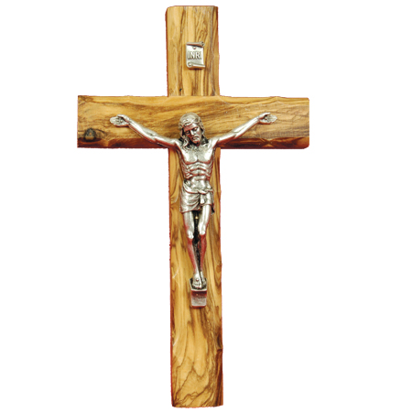  - Ask: Why do they think Jesus died like this? What do the bread and wine symbolise?  - Explain to the children that Palm Sunday was the day the Jesus arrived at Jerusalem and Maundy (or washing of the feet) Thursday is celebrated as a day of remembrance where Jesus and his friends had the Last Supper (passover) as Good Friday would be the day that Jesus died.  - Discuss the meaning behind and importance of Palm Sunday, Maundy Thursday, Good Friday, wine, bread and cross.  Activity:  Bronze: Ask chn to sequence the key events of the Easter story (Last Supper & Jesus Crucifiction)  Silver: Ask chn describe why Christians believe Jesus’ death is important.  Gold: Ask chn to explain why Jesus’ crucifixion symbolises hope for Christians  Platinum: Chn to justify why Christians see Jesus’ death as ‘good’
Possible Misconceptions  (What are the children likely to find challenging?) | Children may struggle to relate to the symbols within the Last Supper (bread = body & wine = blood) and what Jesus dying on the cross symbolises (salvation, forgiveness of sins. Children may find it challenging to understand Tch to be prepared to provide further explanations to support understanding
Resources | The Story of Easter (Jesus' Sacrifice) | Pillar Links | Heart - respect, tolerance  Head - communication
Working Wall  (What will go on the WW from this lesson?) | Add key pictures and words to working wall

RE MTP
Year 3, Spring 2 Week 4
Step 2: Investigation | Lesson 4
Focus Skill | Interpreting and discerning: Describe and suggest meanings for symbols and other forms of religious expression.  Reflection of religious beliefs: Identify the impact of beliefs (including festivals) on individuals, groups and communities.
Learning Intention | To explain what is good about Good Friday
SOLO SC: Uni- Structural Bronze | I can identify an unkind thing that happened to Jesus during his crucification
SOLO SC: Multi- Structural Silver | I can describe the key events of Jesus’ crucifiction
SOLO SC: Relational Gold | I can explain what is good about Good Friday
SOLO SC: Extended Abstract Platinum | I can reflect on why Christians celebrate Easter and what the easter eggs symbolise
Key Vocabulary for the lesson/unit | Crucifiction, crucify, Jesus, sacrifice, forgive, sins, cross, tomb, resurrection
Starter | Recap the significance of the Last Supper and Jesus’s Cruxifiction
Lesson Journey | Step 2 Investigation  - Introduce key question: What is good about Good Friday?  - Share the video clip of Good Friday and Easter eggs www.bbc.co.uk/education/clips/zjgkq6f  - Read the extract from the Bible in the book of Luke Chapter 23  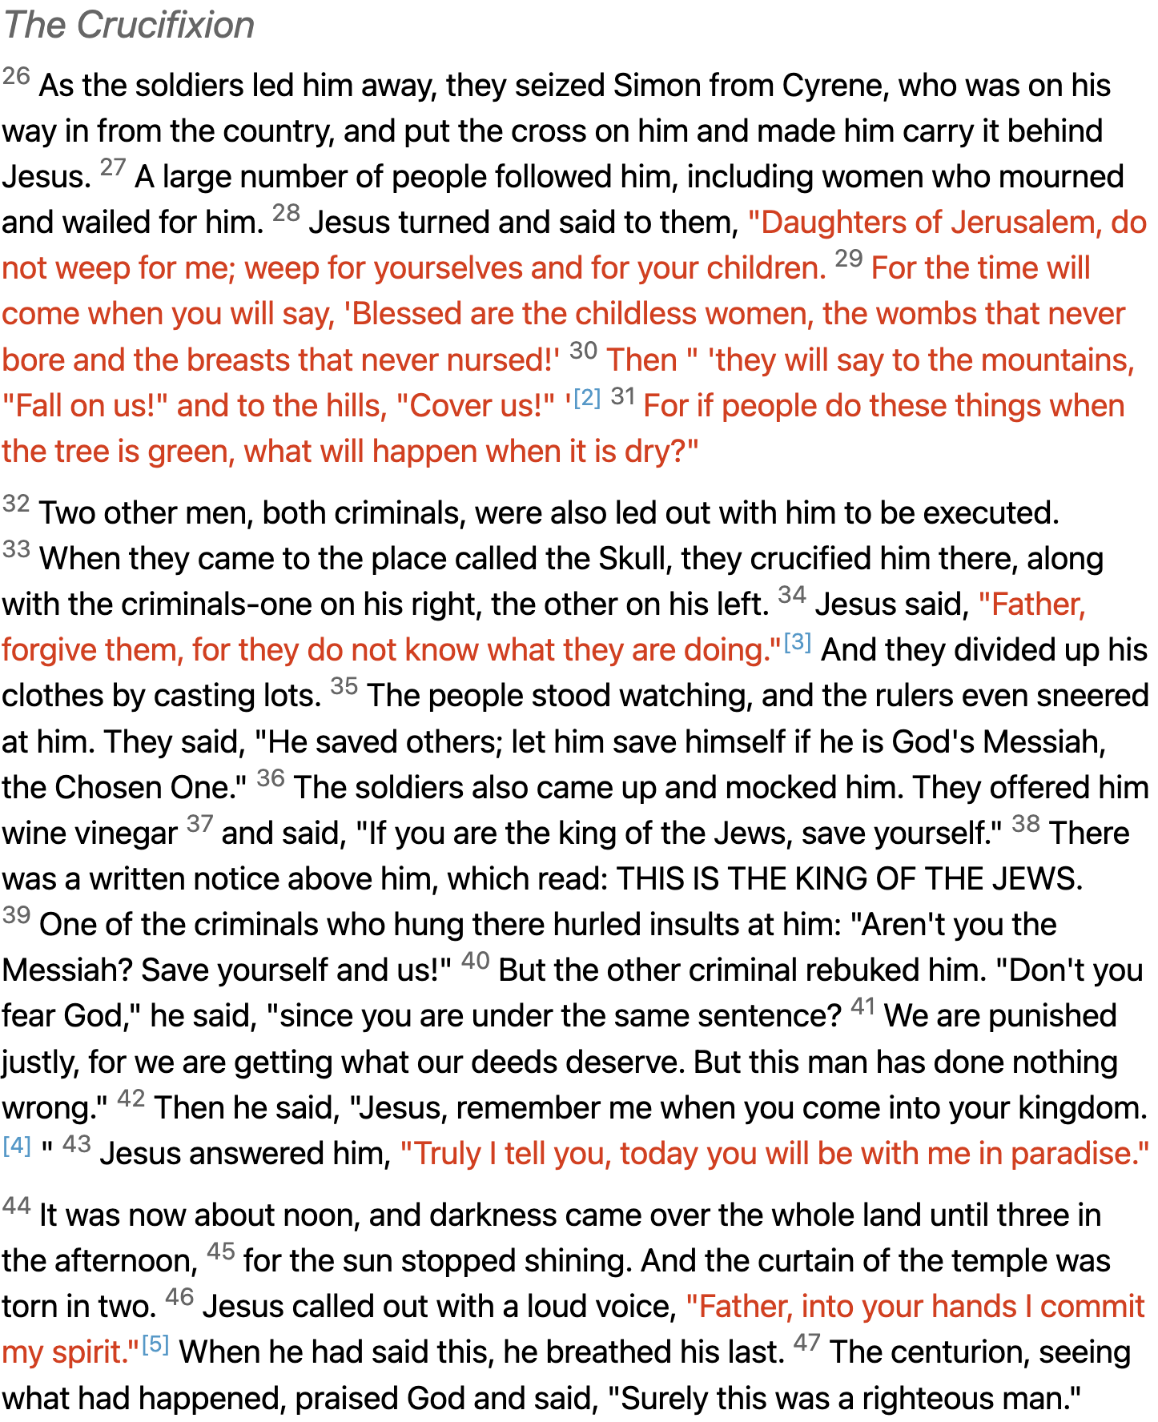  - Explore further, from a Christian perspective, how Jesus’ death was part of God’s plan to show people they can be forgiven and start afresh. Just before Jesus died he said “Father forgive them”. What did people need forgiving for?  - Explain that Christians believe God made a beautiful world, but when people started forgetting how to be good to each other and how to look after the planet, He sent Jesus to make things better, to save the day, to redeem the situation. This meant forgiving people for what they had done wrong.  - WatchThe Christian Story of Easter | Religions of the World watch from 1:18  - Talk to the children about the significance of the tomb and how Christian’s remember/represent this today.  - Discuss the importance and significance of the Easter Egg.
Activity | Activity:  Bronze: Ask chn to identify an unkind thing that happened to Jesus during his crucification  Silver: Ask chn describe the key events of Jesus’ crucifiction  Gold: Ask chn to explain what is good about Good Friday  Platinum: Ask chn to reflect on why Christians celebrate Easter and what the easter eggs symbolise  Children write about what is good about Good Friday, the significance of the Easter Egg
Possible Misconceptions  (What are the children likely to find challenging?) | Children may struggle to relate to the symbols within the Last Supper (bread = body & wine = blood) and what Jesus dying on the cross symbolises (salvation, forgiveness of sins. Children may find it challenging to understand Tch to be prepared to provide further explanations to support understanding
Resources | - www.bbc.co.uk/education/clips/zjgkq6f  - The Christian Story of Easter | Religions of the World watch from 1:18  - Extract Bible in the book of Luke Chapter 23  Optional - visit a Church to find out about communion and the link to the Last Supper. Ask Vicar the key question. Visiting Christian speaker to share what Jesus’ death means to them. | Pillar Links | Heart - respect, tolerance  Head - communication
Working Wall  (What will go on the WW from this lesson?) | Add key vocabulary to working wall

RE MTP
Year 3, Spring 2 Week 5
Step 3: Evaluation | Lesson 5
Focus Skill | Questioning: Ask thought-provoking questions about religions and beliefs.  Interpreting and discerning: Describe and suggest meanings for symbols and other forms of religious expression.  Reflection of religious beliefs: Identify the impact of beliefs (including festivals) on individuals, groups and communities.
Learning Intention | To explain why Jesus’ death was important
SOLO SC: Uni- Structural Bronze | I can identify the importance of Jesus death
SOLO SC: Multi- Structural Silver | I can list things which were good or bad about Jesus death
SOLO SC: Relational Gold | I can explain why Jesus’ death was important to Christians
SOLO SC: Extended Abstract Platinum | I can reflect on who Good Friday was good for and express my own opinion about Jesus’ death
Key Vocabulary for the lesson/unit | Good Friday, rescue, forgive, sacrifice, save, resurrection
Starter | Revisit key question: What was good about Good Friday?
Lesson Journey  Activity | Step 3 Evaluation  - Christians believe that Jesus willingly died to save them/rescue them and came back to life again to prove they will also have life in Heaven when they die. So from something sad and painful came something amazing!  - Think back to Engagement lesson (first lesson about Huey and his PE kit) where we spoke about the word rescue and how we could help Huey Owl with his problem of forgetting his PE kit. Link this back to the Easter Story where Christians believe Jesus’ death was to rescue the people. Christians believe Jesus ‘saved the day’ by rescuing the situation and helping people turn over a new leaf and get better at loving each other.  - Discuss Who was Good Friday good for? Who was it not good for? Do Christians today think it was good for them?  Activity:  Chn to complete activity sheet  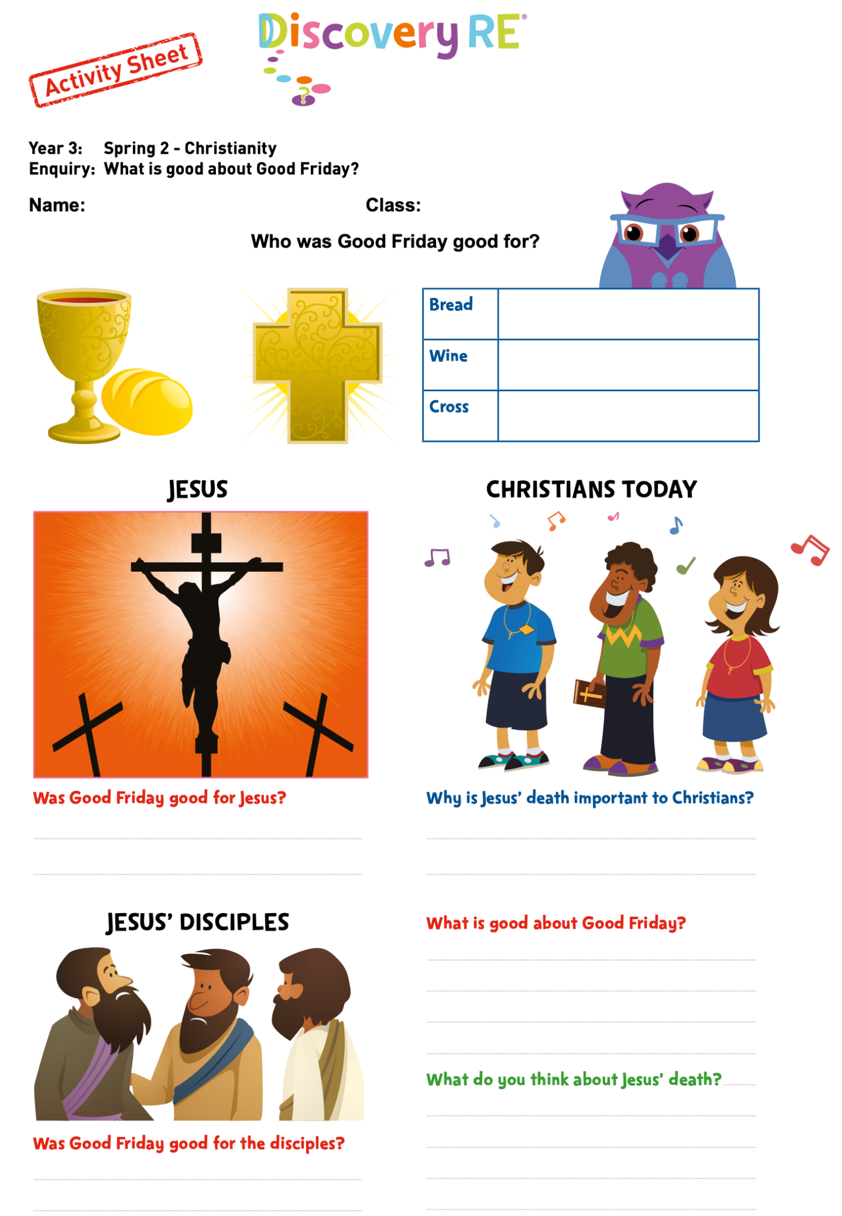
Pupil Expectations (responses)
Silver - WTS: It was good and bad for Jesus’ disciples. It was bad because Jesus died on the cross but it was good because they were happy when He came back to life. The cross represents Jesus’ death and the bread and wine represent His body and blood.

I wonder how the guards felt when Jesus came back to life. Did they get the sack? Can someone really come back to life again?

Gold - EXS: Christians believe it’s good that Jesus died because that showed He saved the day. He promised that people could go to Heaven after their bodies die so He helped the world and saved people by helping them and giving them Heaven. When they are sorry for what they have done wrong.

I don’t know if I agree with Christians believing Jesus died to redeem the world. I think that would have been better if He had lived longer so He had longer to teach people how to lead good lives.

Platinum - GDS: I think Christians think Jesus died and came back to life again. They think He did this to save them from their sins. This means they will also have the chance to go to Heaven. So I suppose for Christians that could mean Jesus’ death was good.

I think that’s a bit selfish though. It would be better for Christians to read the Bible to work out how to lead good lives and then they could get to Heaven that way because God would be pleased with them then Jesus could have lived longer. He didn’t do anything wrong after all.

Possible Misconceptions  (What are the children likely to find challenging?) | Children may struggle to relate to the symbols within the Last Supper (bread = body & wine = blood) and what Jesus dying on the cross symbolises (salvation, forgiveness of sins. Children may find it challenging to understand why Good Friday was good for certain individuals (disciples, Jesus, etc) Tch to be prepared to provide further explanations to support understanding
Resources | Activity sheet - RE Discovery resource | Pillar Links | Heart - respect, tolerance  Head - communication
Working Wall  (What will go on the WW from this lesson?) | Add key vocabulary to working wall

RE MTP
Year 3, Spring 2 Week 6
Step 4: Expression | Lesson 6
Focus Skill | n/a
Learning Intention | To explain why it is important to show love and gratitude to people
SOLO SC: Uni- Structural Bronze | I can identify someone special I am grateful for
SOLO SC: Multi- Structural Silver | I can list things to be thankful for
SOLO SC: Relational Gold | I can explain why it is important to show love and gratitude to people
SOLO SC: Extended Abstract Platinum | I can justify why showing love and gratitude to others makes them feel special
Key Vocabulary for the lesson/unit | Gratitude, grateful, thankful, appreciate, love
Starter | Recap the the significance of the Easter story for Christians
Lesson Journey  Activity | Step 4 Expression  - Explain that today we are going to think of someone who is special to us. Give chn thinking time and ask them to write the name of the person on a mini whiteboard. Chn may need support if they are unable to think of someone.  - Explore the definition of the word gratitude and grateful ensure chn are clear about the definition and are able to provide examples of how to demonstrate their gratitude to others.  - Partner talk: Ask pairs to identify and share a time someone showed them gratitude or when they showed gratitude to someone else  - As a class, brainstorm all the things we can be thankful/grateful for. Tch to scribe on flipchart paper  - Ask chn to explain what showing gratitude is important.  - Ask: What would the world be like no one showed gratitude?
Lesson Journey  Activity | Activity:  Children to create a gratitude jar for display. They need to use the heart outlines and write things they are thankful for and that they can do to show their love and gratitude to people who are special to them.  
Possible Misconceptions  (What are the children likely to find challenging?) | Some chn may struggle to identify or recall a time they showed or received gratitude. Tch to support chn with examples
Resources | Heart outline  Colour pencils/felt tips | Pillar Links | Hands - creating  Heart - kindness
Working Wall  (What will go on the WW from this lesson?) | Create a display to reflect children’s work to showcase their gratitude hearts

