
RE MTP Overview
Year 3 Spring 1
Jigsaw Unit Overview
Theme | Jesus’ Miracles
Concept | Beliefs & Moral Values
Religion | Christianity
Enquiry Question | Could Jesus heal people? Were these miracles or is there some other explanation?
Learning Intention | We are learning to retell Bible stories when miracles have happened and question whether Jesus really did perform miracles.
Assessment | Engagement  WTS: I can talk about what I think a miracle is  EXS: I can talk about some of the things in the world that people think of as miracles and begin to tell you about a miracle I would like to see happen today.  GDS: I can explain why some people may describe something they see as a miracle when there may also be another explanation. | Knowledge & Understanding  WTS: I can retell a story about Jesus healing someone and say one thing Christians might believe about Jesus.  EXS: I can explain one Christian viewpoint about one of Jesus’ healing miracles.  GDS: I can explain two different ways Christians might interpret one of Jesus’ healing miracles. |  | Evaluation/Critical Thinking  WTS: I can identify some of the questions people ask about Jesus’ healing miracles.  EXS: I can start to say whether I believe Jesus actually healed people or not.  GDS: I can explain how Christians may describe and explain Jesus’ miracles.
Enrichment

Step 1: Engagement | Lesson 1
Key Vocabulary for the lesson/unit | Illness, poorly, medicine, antibiotics, long term illness
Focus Skill | Skill:  Reflection of religious beliefs: Identify the impact of beliefs on individuals, groups and communities.  Explaining: Make links between beliefs, stories and practices.  Questioning: Ask thought-provoking questions about religions and beliefs.
Learning Intention | To explain what happens and how it feels when we get ill  To explore how feeling ill affects us
SOLO SC: Uni- Structural  Bronze | I can identify how I feel when I am ill  I can name some common illnesses.
SOLO SC: Multi- Structural Silver | I can list what helps us feel better when we are ill  I can describe how it feels to be ill.
SOLO SC: Relational  Gold | I can explain what happens and how it feels when we get ill  I can explain what happens to my body when I am ill.
SOLO SC: Extended Abstract Platinum | I can evaluate why some people may get better without visiting a doctor or taking medication  I can reflect on different ways to get better.
Starter |   Start the lesson with Huey Owl telling the children he feels poorly and asking them for their advice on how he can get better.
Teacher Input / Activity | 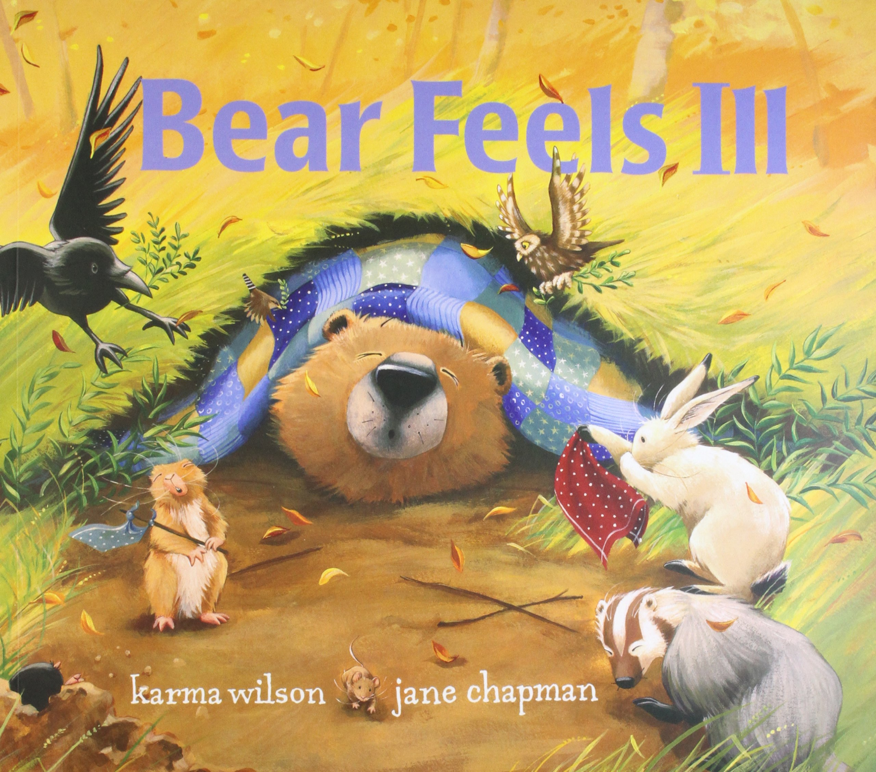  Step 1 Engagement  - Read or watch the story: ‘Bear Feels Sick’ by Karma Wilson (or similar)  (6 minutes) Bear Feels Sick by Karma Wilson. Grandma Annii's Story Time  - Discuss what happened to Bear and how he felt better.  Ask: How do our bodies get better when we are poorly?  If you are poorly what do you do?  Who looks after you?  How do you get better?  Do you go to the doctor/need medicine? Sometimes we can help ourselves - how?  Does frame of mind help?  - For extra information to support children watch (1 minute) What happens when you get sick?  Ask: Are all illnesses always flu or cold? What about other long term illnesses or injuries people could have? Are these illnesses always easy to cure?  Activity:    Provide each table group with large flipchart paper and marker pens. Alternatively could work in pairs instead use large A3 paper  Ask chn to work as a group to record what happens and how it feels when we get poorly/sick.  Tch to gather feedback from groups  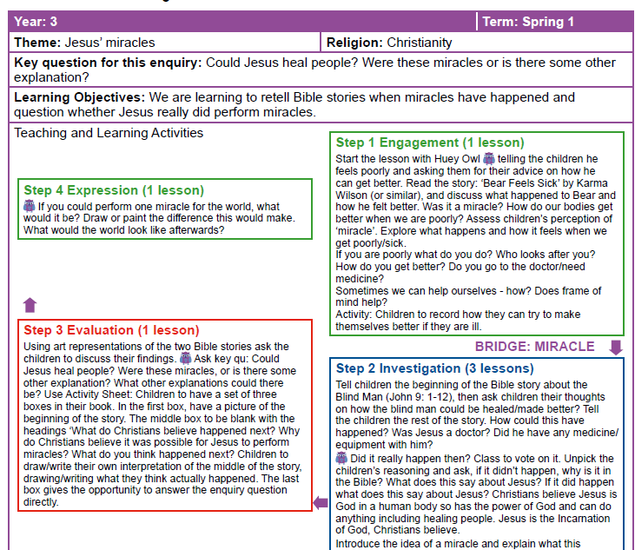
Possible Misconceptions  (What are the children likely to find challenging?) | Be sensitive to chn who may have family members who are unwell or are fighting long term illness
Resources | Flipchart paper & marker pens | Pillar Links | Heart - mutual respect and tolerance of those of different faiths and beliefs
Working Wall  (What will go on the WW from this lesson?) | Key vocabulary, flipcharts compiles by chn during lesson

Step 1: Engagement | Lesson 2
Key Vocabulary for the lesson/unit | miracle, medical, scientifically proven, belief, view, surprising, desperate
Focus Skill | Skills:  Reflection of religious beliefs: Identify the impact of beliefs on individuals, groups and communities.  Explaining: Make links between beliefs, stories and practices.  Questioning: Ask thought-provoking questions about religions and beliefs.
Learning Intention | To explain and give examples of things in the world that people view as miracles.  To explore miracles
SOLO SC: Uni- Structural Bronze | I can define the word miracle  I can identify an event that could be considered a miracle.
SOLO SC: Multi- Structural Silver | I can describe what I think a miracle is  I can explain what a miracle is.
SOLO SC: Relational Gold | I can explain and give examples of events in the world that people view as miracles.  I can give some examples of miracles that are believed to have taken place.
SOLO SC: Extended Abstract Platinum | I can evaluate why some people may describe something they see as a miracle when there may be another explanation.  I can reflect on why some people are more likely to believe in miracles.
Starter | Recap the story of Bear feels Sick. Discuss how the bear got better.
Teacher Input / Activity | Step 1 Engagement  - Tch to explain that Christians believe in miracles.  - Ask: What is a miracle? (Definition: A miracle is a wonderful and surprising event that is believed to be caused by God.)  - Ask: When the bear got better was it a miracle?  - Teacher to explore and assess children’s perception of a ‘miracle’  - Teacher to explain that miracles are events which aren’t always curing people who are unwell but are also answers to prayers for events to occur when people are in great/desperate need.  - Watch two witness accounts of miracles and discuss:  Witness 1: (3 minutes) Once Skeptical of Healings, Woman Experiences Miracle Watch a witness statement of a woman’s experience of receiving a miracle of healing for her back injury  Witness 2: (2 minutes) An INCREDIBLE Miracle I Witnessed in Africa Use this witness account of miracle to support discussions/explanations of miracle of receiving water  - Discuss people witness accounts of receiving a miracle. Ask: What led both individuals to believe so strongly that they received a miracle from God?  - Ask: Can you think of things in the world that people think of as miracles? Tch to assess pupils' responses.  - Use talk partners to allow chn to share their ideas before feeding back. Tch to circulate and listen in on partner discussion.  - Silver - WTS: Can chn talk about what they think a miracle is?  - Gold - EXS: Can chn talk about some of the things in the world that people think of as miracles and begin to tell you about a miracle I would like to see happen today?  - Platinum - GDS: Can chn explain why some people may describe something they see as a miracle when there may also be another explanation?  Activity: In RE books - Chn record what a miracle is and describe and provide examples of things in the world that people view as miracles. Challenge: evaluate why some people may describe something as a miracle. Consider other explanations.
Possible Misconceptions  (What are the children likely to find challenging?) | Chn may not understand how miracles can happen when it is medically unexplainable. Chn most likely have never witnessed a miracle so may find it difficult to comprehend.
Resources | Video clips | Pillar Links | Heart - mutual respect and tolerance of those of different faiths and beliefs
Working Wall  (What will go on the WW from this lesson?) | Key vocabulary

Step 2: Investigation | Lesson 3
Key Vocabulary for the lesson/unit | Blind, new testament, old testament, Bible, Holy book, heal, miracle
Focus Skill | Skills:  Reflection of religious beliefs: Identify the impact of beliefs on individuals, groups and communities.  Explaining: Make links between beliefs, stories and practices.  Questioning: Ask thought-provoking questions about religions and beliefs.
Learning Intention | I can explain a Christian’s viewpoint about Jesus’ healing miracle.  To explore Christian beliefs about the miracles of Jesus
SOLO SC: Uni- Structural Bronze | I can identify the miracle Jesus performed  I can recount one of the miracles Jesus performed.
SOLO SC: Multi- Structural Silver | I can describe how Jesus performed the miracle.
SOLO SC: Relational  Gold | I can explain a Christian’s viewpoint about Jesus’ healing miracle.  I can explain what Christian think about the miracles of Jesus.
SOLO SC: Extended Abstract Platinum | I can evaluate ways Christians interpret Jesus healing and how God's power was demonstrated through healing miracles  I can reflect on my own beliefs about miracles.
Starter |   Recap what a miracle is?  Show chn a bible and explain that it is the Christians Holy book. It is divided up into two parts: the old testament (before Jesus was born) and the new New Testament (after Jesus' birth) . Explain that the new testament tells the story of the life of Jesus on Earth and the early days of Christianity.
Teacher Input / Activity | Step 2 Investigation  - Explain to chn that today we are going to look at a one of the Bible stories in the new testament about a Blind Man (John 9: 1-12)  - Watch the beginning of the video clip (1 minute)Blind Man Healed | The Life of Jesus | John 9:1-12 | 23 of 49  - Pause video clip at 1:00 Ask children their thoughts on how the blind man could be healed/made better?  - Let the children watch the rest of the story.  - Ask: How could this have happened? Was Jesus a doctor? Did he have any medicine/ equipment with him? Did it really happen then? Class to vote on it. Unpick the children’s reasoning and ask, if it didn’t happen, why is it in the Bible? What does this say about Jesus? If it did happen, what does this say about Jesus?  - Tch to explain that Christians believe Jesus is God in a human body so has the power of God and can do anything including healing people. Jesus is the Incarnation of God, Christians believe.  - Discuss the idea of a miracle and recap what this means…something that happens outside the usual rules of nature/expectations. (Jesus had a special ability to heal people..does anyone today have this ability?)  Activity: Ask chn to write sentences to explain how Jesus healed the blind man.  Silver: Describe how Jesus healed someone and say one thing Christians might believe about Jesus.  WTS Pupil response example: Jesus healed a man who could not see. This story is in the Bible and Christians think the Bible is true. This story might show Christians that Jesus has God’s power and is not just a normal man. Normal men can’t make blind people see can they? Otherwise the doctor would have sorted out my Nan’s bad eyes  Gold: Explain one Christian viewpoint about one of Jesus’ healing miracles.  EXS pupil response example: Some Christians believe that everything in the Bible is true because it is the word of God, that means if the Bible says He healed someone, He must have done. The Bible says that Jesus could heal people because He was the Son of God.  Platinum: Evaluate different ways Christians might interpret one of Jesus’ healing miracles.  GDS pupil response example: Some Christians would just think Jesus is God’s son so He had the power to do anything, so He could do miracles. He healed the man. Some Christians might think that Jesus gave the blind man the ability to see again.
Possible Misconceptions  (What are the children likely to find challenging?) | Chn may perceive the water the blind man washed his face with as having special powers. Chn need to understand that Jesus healed the man not the water.
Resources | Bible to show children  Video clip of story Jesus heals blind man | Pillar Links | Heart - mutual respect and tolerance of those of different faiths and beliefs
Working Wall  (What will go on the WW from this lesson?) | Key vocabulary  Pictures from story

Step 2: Investigation | Lesson 4
Key Vocabulary for the lesson/unit | paralyzed, new testament, Bible, Holy book, heal, miracle, incarnation
Focus Skill | Skills:  Reflection of religious beliefs: Identify the impact of beliefs on individuals, groups and communities.  Explaining: Make links between beliefs, stories and practices.  Questioning: Ask thought-provoking questions about religions and beliefs.
Learning Intention | I can explain a Christian’s viewpoint about Jesus’ healing miracle.
SOLO SC: Uni- Structural Bronze | I can identify the miracle Jesus performed
SOLO SC: Multi- Structural Silver | I can describe how Jesus performed the miracle
SOLO SC: Relational Gold | I can explain a Christian’s viewpoint about Jesus’ healing miracle.
SOLO SC: Extended Abstract Platinum | I can evaluate ways Christians interpret Jesus healing and how God's power was demonstrated through healing miracles
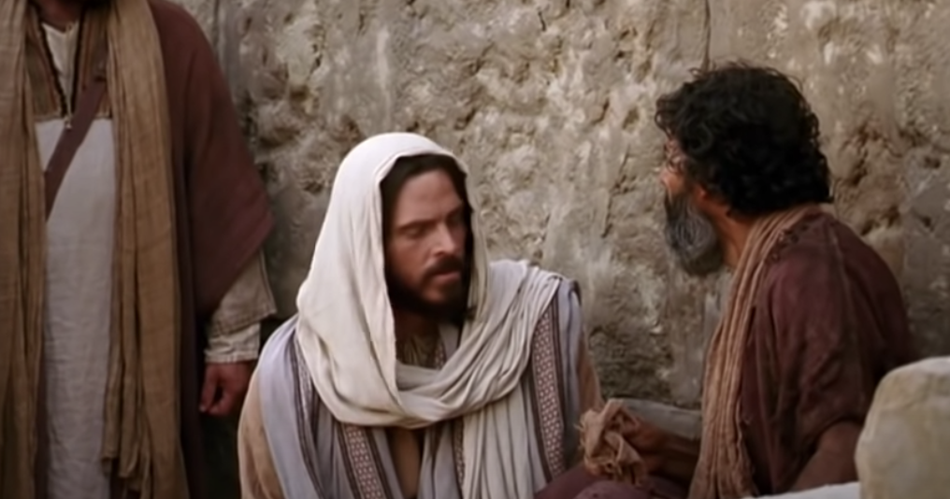
Recap what a miracle is? Remind the chn of the Bible story of Jesus healing the blind man.
Teacher Input / Activity | Step 2 Investigation  - Use the story of the Paralysed Man (Mark 2: 1-12) to continue exploring this concept of a miracle. Watch the story of Jesus heals a paralyzed man remind chn that although we watching a video clip it is another Bible story from the new testament Mark 2:1-12 (Jesus Heals a Paralyzed Man)  A few days later, when Jesus again entered Capernaum, the people heard that he had come home. 2 They gathered in such large numbers that there was no room left, not even outside the door, and he preached the word to them. 3 Some men came, bringing to him a paralyzed man, carried by four of them. 4 Since they could not get him to Jesus because of the crowd, they made an opening in the roof above Jesus by digging through it and then lowered the mat the man was lying on. 5 When Jesus saw their faith, he said to the paralyzed man, “Son, your sins are forgiven.”  6 Now some teachers of the law were sitting there, thinking to themselves, 7 “Why does this fellow talk like that? He’s blaspheming! Who can forgive sins but God alone?”    8 Immediately Jesus knew in his spirit that this was what they were thinking in their hearts, and he said to them, “Why are you thinking these things? 9 Which is easier: to say to this paralyzed man, ‘Your sins are forgiven,’ or to say, ‘Get up, take your mat and walk’? 10 But I want you to know that the Son of Man has authority on earth to forgive sins.” So he said to the man, 11 “I tell you, get up, take your mat and go home.” 12 He got up, took his mat and walked out in full view of them all. This amazed everyone and they praised God, saying, “We have never seen anything like this!”  - Was that a miracle? Do the children have any questions for Huey Owl? Chn can use the envelope cards (print from Discovery RE)  Task: Chn could work as a group or in pairs to formulate questions for the Owl Crew  - Do stories have to be true (i.e. actually happened) to be meaningful? Were Jesus’ miracles just stories to make people think Jesus was special/God on earth, or that we should help people who are sick? Was it possible that Jesus did make people better even though He wasn’t a doctor? *Reinforce Christians’ believe Jesus was the Incarnation of God.  Activity: Ask chn to write sentences to explain how Jesus healed the paralyzed man. Chn can add to their ideas from last week’s lesson about how Jesus healed the blind man.  Silver: Describe how Jesus healed someone and say one thing Christians might believe about Jesus.  WTS Pupil response example: Jesus healed a man who could not walk. This story is in the Bible and Christians think the Bible is true. This story might show Christians that Jesus has God’s power and is not just a normal man. Normal men can’t make a paralyzed person walk. Otherwise doctors would not have to give people wheelchairs to get around.  Gold: Explain one Christian viewpoint about one of Jesus’ healing miracles.  EXS pupil response example: Some Christians believe that everything in the Bible is true because it is the word of God, that means if the Bible says He healed someone, He must have done. The Bible says that Jesus could heal people because He was the Son of God.  Platinum: Evaluate different ways Christians might interpret one of Jesus’ healing miracles.  GDS pupil response example: Some Christians would just think Jesus is God’s son so He had the power to do anything, so He could do miracles. He healed the man. Some Christians might think that Jesus gave the man the confidence to try walking, and he gave it a go and could walk a bit.
Possible Misconceptions  (What are the children likely to find challenging?) | Teacher note: Incarnation The New Testament presents Jesus as the answer: the Messiah and Saviour, who will repair the effects of sin and the Fall and offer a way for humans to be at one with God again. For Christians, Incarnation means that Jesus is God in the flesh, and that, in Jesus, God came to live among humans. From ‘Understanding Christianity’ Church of England
Resources | Bible to show children  Video clip of Jesus heals the paralyzed man  envelope cards (print from Discovery RE) | Pillar Links | Heart - mutual respect and tolerance of those of different faiths and beliefs
Working Wall  (What will go on the WW from this lesson?) | Key vocabulary  Pictures from story  Questions for Owl Crew (envelopes)

Step 3: Evaluation | Lesson 5
Key Vocabulary for the lesson/unit | Paralyzed, healed, forgave, sins, power, Son of God, Jesus
Focus Skill | Skills:  Reflection of religious beliefs: Identify the impact of beliefs on individuals, groups and communities.  Questioning: Ask thought-provoking questions about religions and beliefs.  Explaining: Make links between beliefs, stories and practices.
Learning Intention | To explain how Christians may describe and explain Jesus’ miracles
SOLO SC: Uni- Structural Bronze | I can identify one thing Christian’s might believe about Jesus
SOLO SC: Multi- Structural Silver | I can describe what Christian believe about Jesus’ healing miracles
SOLO SC: Relational  Gold | I can explain how Christians may describe and explain Jesus’ miracles
SOLO SC: Extended Abstract Platinum | I can evaluate whether I believe Jesus healed people or not
Starter | Teacher to respond to the questions posed to the ‘Owl Crew’
Teacher Input / Activity | Step 3 Evaluation  - Using pictorial representations of the two Bible stories ask the children to discuss their findings. Tch to recap both Bible stories of Jesus’ miracles he performed - healing blind man and healing a paralyzed man  - Tell the chn that today we are going to evaluate the story of Jesus healing the paralyzed man.  - (3 minutes)Jesus Heals a Paralyzed Man - Bible For Kids  - Discuss the key events that happened in this story. Show chn the picture of the paralyzed man is being lowered down from the gap in the ceiling  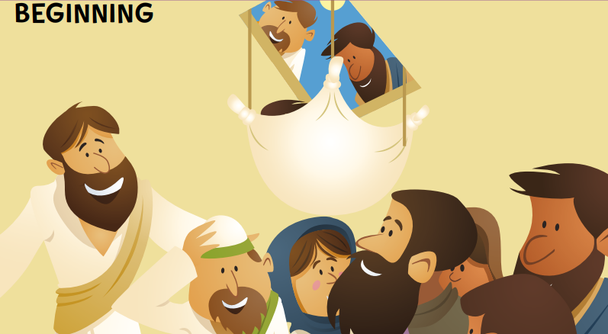  - Together evaluate the key question. Ask key qu: Could Jesus heal people? Were these miracles, or is there some other explanation? What other explanations could there be?  - Focus on the middle of the story where Jesus heals the paralyzed man (2:00)  - Discuss:  - What Christians believe happened next?  - What else might Christians believe happened?  - What do YOU think happened?  - Look at the ending of the story where the paralyzed man gets up and walks out the door  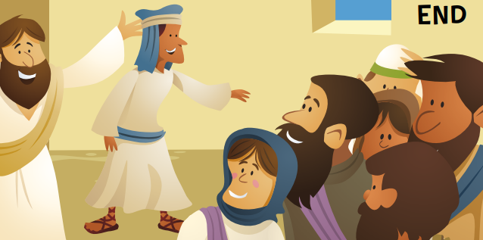  Ask: Could Jesus really heal people? Were these miracles or is there some other explanation?  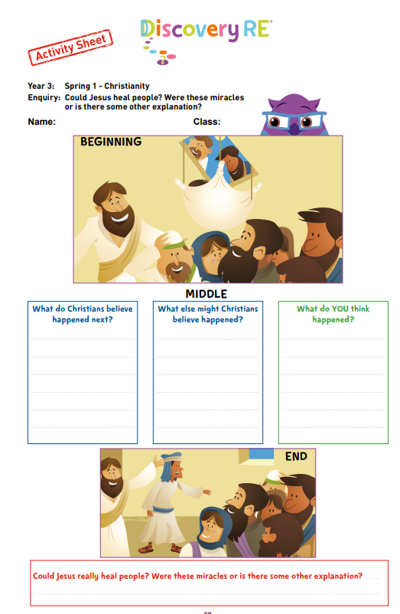  Activity: Use Activity Sheet: Children have a set of three boxes in their book. In the first box, have a picture of the beginning of the story.  The middle box to be blank with the headings ‘What do Christians believe happened next? Why do Christians believe it was possible for Jesus to perform miracles? What do you think happened next?  Children write their own interpretation of the middle of the story, writing what they think actually happened.  Challenge: The last box gives the opportunity to answer the enquiry question directly. key qu: Could Jesus heal people? Were these miracles, or is there some other explanation? What other explanations could there be?  Some examples of pupil responses  Silver - WTS: Even though lots of Christians believe Jesus had the power to heal people and do other miracles, sometimes, I wonder if they were just pretending to be ill. So I think people ask if it really did happen  Gold - EXS: I believe Jesus healed people too because He was a special man and why wouldn’t He have powers if He was God in a human body on earth? OR I don’t think Jesus really healed all these people because I don’t believe in miracles. I expect it was wishful thinking and when people met Jesus they felt better because He was such a special person.  Platinum - GDS: I think Christians understand that if you trust in something you can have a greater belief that it would work. Sometimes if you stop worrying about something and just think it will be OK, it is
Possible Misconceptions  (What are the children likely to find challenging?) | Teacher note: Incarnation The New Testament presents Jesus as the answer: the Messiah and Saviour, who will repair the effects of sin and the Fall and offer a way for humans to be at one with God again. For Christians, Incarnation means that Jesus is God in the flesh, and that, in Jesus, God came to live among humans. From ‘Understanding Christianity’ Church of England
Resources | Video clip  Activity sheet | Pillar Links | Heart - mutual respect and tolerance of those of different faiths and beliefs
Working Wall
(What will go on the WW from this lesson?)

Step 4: Expression | Lesson 6
Key Vocabulary for the lesson/unit | World challenges, miracles, unemployment, water scarcity, climate change - global warning (reliance on fossil fuels), rich/poor gap, poverty, homelessness, food shortages, global pandemic (Covid)
Focus Skill | Skill:  Reflection of religious beliefs: Identify the impact of beliefs (including festivals) on individuals, groups and communities.  Questioning: Ask thought-provoking questions about religions and beliefs.
Learning Intention | To explain why changes to the world will make it a better place
SOLO SC: Uni- Structural  Bronze | I can identify something to make the world a better place
SOLO SC: Multi- Structural Silver | I can describe how changing something will make the world a better place
SOLO SC: Relational  Gold | I can explain why changes to the world will make it a better place
SOLO SC: Extended Abstract Platinum | I can reflect on the impact a change to the world challenges will make the world a better place
Starter | Recap the miracles Jeusus performed.
Teacher Input / Activity | Step 3 Expression  - If you could wish for one miracle for the world, what would it be?  - Group Task:  Provide each table group with large flipchart paper and marker pens.  Ask chn to brainstorm things in the world that need to change to make the world a better place.  - Tch to gather feedback from groups  6 Biggest Global problems we facing:  - Water  - Poverty  - Health  - Education  - Climate change  - Tolerance (beliefs, race, politics)  Example of world challenges: unemployment, water scarcity, climate change - global warning (reliance on fossil fuels), rich/poor gap, homelessness, food shortages, global pandemic (Covid)  Activity:  Give chn sentence starter: If I could wish for one miracle for the world, it would be...  Children could choose to write a sentence to describe/ explain the difference their wish for the world would make. Challenge: What would the world look like afterwards?  
Possible Misconceptions  (What are the children likely to find challenging?) | Children may not be able to relate to the global challenges the world faces.
Resources | Wish sheet  Flipchart paper  Marker pens | Pillar Links | Heart - mutual respect and tolerance of those of different faiths and beliefs
Working Wall  (What will go on the WW from this lesson?) | Corridor display - teacher to display chn’s wishes for the world on display in a ‘miracle’ wish jar



