
RE MTP Overview
Year 2 Spring 1
Jigsaw Unit Overview
Theme | Prayer at home
Concept | Prayer & Worship
Religion | Islam
Enquiry Question | Does praying at regular intervals help a Muslim in his/her everyday life?
Learning Intention | We are learning to explain what commitment means to us and to Muslims by  knowing about how Muslims pray 5 times a day.
Unit Resources | The Qur’an  Sofia Owl  Lesson 1 Engagement Trolls can’t stop feeling gonoodle  Pictures of different stages of Muslim prayer  Activity sheet 1 & 2 (Discovery RE)  Lesson 2/3 Five Daily Prayers for reference |  |  | Link Salat - Muslim Prayer  envelope cards from the Discovery RE  Lesson 4 Visitor: Muslim to talk about prayer  Lesson 5 Muslim Prayer  Lesson 6 Small Talk: Goals
Assessment  Evidence in Discovery RE Journals: Activity Sheets. | Engagement  WTS: I can say how it feels to do something lots of times in a day.  EXS: I can explain how it felt to have to stop doing something to reach the target we had set.  GDS: I can explain how commitment can be hard and can describe how it would feel to reach a goal. | Knowledge & Understanding  WTS: I can remember some things about Muslim prayer.  EXS: I can use the right words to describe how Muslims pray and begin to explain why they do this.  GDS: I can describe the Muslim prayer routine and explain how they believe this could help them in their everyday lives. |  | Evaluation/Critical Thinking  WTS: I can tell you one way praying 5 times a day may help a Muslim.  EXS: I can start to think through how praying 5 times a day might help in some ways more than others.  GDS: I can decide on 3 ways Muslims might be helped in their everyday lives by praying 5 times a day, and can explain my reason for one of these.

RE MTP Overview
Year 2 Spring 1
Step 1: Engagement | Lesson 1
Focus Skill | Identity, experience and empathy: Respond sensitively to others’ experiences and feelings and to their values of right and wrong.
Learning Intention | To explain how it feels to have to stop doing something to reach a goal we committed to achieving
SOLO SC: Uni- Structural  Bronze | I identify how it feels to do something lots of times in a day.
SOLO SC: Multi- Structural  Silver | I can describe how it would feel to reach a goal.
SOLO SC: Relational  Gold | I can explain how it feels to have to stop doing something to reach a goal we committed to achieving
SOLO SC: Extended Abstract Platinum | I can reflect on how commitment can be hard and can relate this to other things I have experienced.
Key Vocabulary for the lesson/unit | commitment, experience, healthy, fit, exercise
Starter |   Show chn Sofia Owl. Tell the chn that Sofia owl has a challenge for them to take part in today.
Lesson Journey | Step 1: Engagement  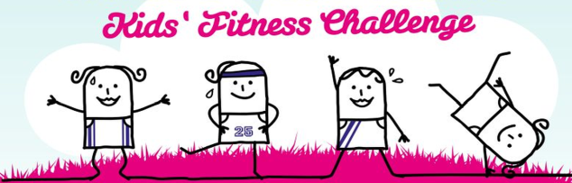  - Tch to explain to the children that today we are going to make a real effort to keep fit.  - Instructions for today’s Challenge:  - During the day we are going to stop what we are doing when I ring the chime/bell, face the same way and keep fit to music.  - We will do this 5 times during the day and each time we will do a different exercise.  - We all choose to do this because we believe it’s important to keep fit and we are making a commitment to keeping fit and healthy.
Activity | - Children to dance/move to music Trolls can’t stop feeling gonoodle  - At the end of day - ask questions through the use of talk partners to enable all chn to articulate their answers before asking for feedback. Chn could also have group discussions and tch could choose a spokesperson from each table for feedback.  - Ask: How did you feel? Did it interrupt your day? Did you find it easier to learn afterwards? Would you choose to do that every day? Why? Ask chn to explain their thoughts in detail.  - Tch to scribe chn’s ideas/feedback on large flipchart and add to working wall  Examples of pupil responses  - Silver - WTS: When we exercised the third time I was happy because I knew what we were going to do and it got easier.  - Gold - EXS: When the bell rang I was really enjoying building with Lego so I was a bit grumpy about having to stop, but I knew we had to exercise five times so I just had to do it.  - Platinum - GDS: It was harder than I thought to keep stopping to exercise but I got used to the routine so it got easier. I know that reaching goals takes effort and I was proud to be able to tell my brother we had exercised five times today.
Possible Misconceptions  (What are the children likely to find challenging?) | Note: If possible repeat this exercise every day for the week. (You are trying to establish that it takes a lot of effort and commitment to exercise 5 times every day).
Resources | Sofia Owl  Trolls can’t stop feeling gonoodle | Pillar Links | Head - challenge and resilience  Hands - experiencing  Health - healthy lifestyle
Working Wall  (What will go on the WW from this lesson?) | Flipchart with feedback from challenge

RE MTP Overview
Year 2 Spring 1
Step 2: Investigation | Lesson 2
Focus Skill | Reflection of religious beliefs: Identify how religion and beliefs are expressed in different ways.  Identity, experience and empathy: Respond sensitively to others’ experiences and feelings and to their values of right and wrong.  Interpreting / discerning: Identify possible meanings for symbols and other forms of religious expression.  Questioning: Ask questions about their own and others’ feelings and experiences
Learning Intention | To explain why the different stages and actions of Muslim prayer are important
SOLO SC: Uni- Structural  Bronze | I can label pictures of different stages of Muslim prayer
SOLO SC: Multi- Structural  Silver | I can describe what each prayer action symbolises for Muslims
SOLO SC: Relational  Gold | I can explain why the different stages and actions of Muslim prayer are important
SOLO SC: Extended Abstract Platinum | I can reflect on what impact praying five times a day might have on a Muslim’s daily life
Key Vocabulary for the lesson/unit | Muslim prayer, Salah, Muslims, Pillar of Islam, Qu’ran, posture, symbolise
Starter | Tch to recap exercise challenge children completed in the previous lesson and explain to the children that we showed a real commitment to keeping fit. Run through the routine, recapping the direction we faced, the call to exercise (bell/chime), doing it regularly ect.
Lesson Journey | Step 2 Investigation  - Before watching the clip, ask the class in what way they prepare for school in the morning. Do they wake up on their own/ have their clothes ready/ wash/ eat anything/ check their homework/ pack their lunch?  - Show children a clip of Muslims praying (without sound) Watch: Salat Muslim Prayer  - Ask: what are these people doing? Tch to explain to children that these people are Muslims and they are praying.  - Explain that when praying there are different postures. Click on resource Muslim Prayer Positions  - Children could try out the different prayer postures. Note: Children only try out postures. Children are not to follow in whole practice of praying out loud.  - Teacher to draw out similarities between our exercise routine (physical movement, facing the same way, all moving together, etcT  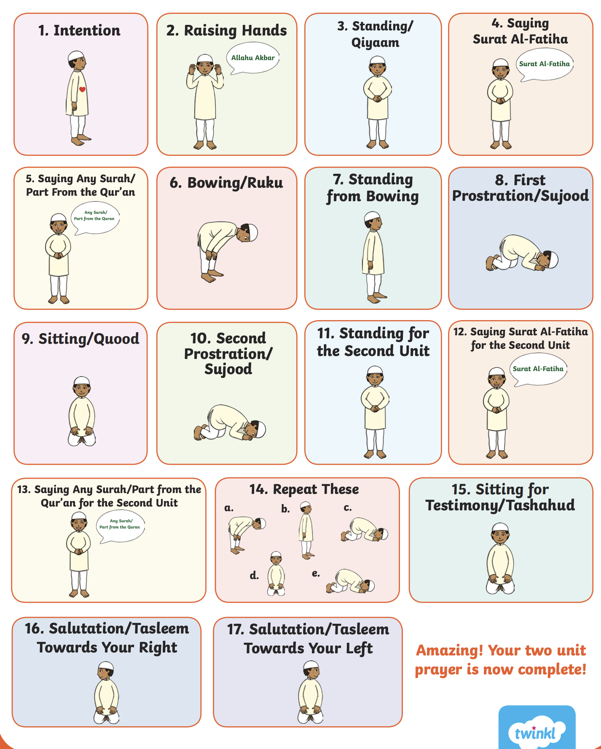  - Ask: How would you feel doing this five times a day?  - Tch to explain a Muslim prepares for prayer and goes through one rak'ah. Each action is explained, including reciting intention (niyyah), washing (wudu), bowing (ruku) and prostration (sujud)  - Watch clip of Muslim praying again (with sound) Watch: Salat Muslim Prayer to show children the different prayer postures and how prayers are being said help Muslim’s to focus on God (Allah) and talk to him.  - Ask children how would this help a Muslim to focus? Through learning about Muslim prayer, teach who, when, where, what, why? (Because God has asked them to and it says this in the holy book, the Qur’an).  - Do children have any questions for Sofia Owl? Use envelope cards from the Discovery RE
Activity | Activity:  Using a picture of the different stages - reciting intention (niyyah), washing (wudu), bowing (ruku) and prostration (sujud), label what each action symbolises and why it is significant.  Challenge: What impact might praying five times a day have on a Muslim’s daily life?
Possible Misconceptions  (What are the children likely to find challenging?) | Children may have been absent on the day of exercise challenge and may not be able to relate to the idea of commitment.  Subject knowledge  Teacher Notes - Additional information for preparing for Salah and pictures of postures How to perform Salah Information
Resources | envelope cards from the Discovery RE  Link Salah - Muslim Prayer  The Qur’an  Pictures of different stages of Muslim prayer | Pillar Links | Heart - respect, belonging, tolerance, responsibility  Head - resilience
Working Wall  (What will go on the WW from this lesson?) | Display chn’s envelope questions on working wall  Key vocabulary  Pictures of how to prepare for Salah

RE MTP Overview
Year 2 Spring 1
Step 2: Investigation | Lesson 3 & Lesson 4 (visitor)
Focus Skill | Reflection of religious beliefs: Identify how religion and beliefs are expressed in different ways.  Identity, experience and empathy: Respond sensitively to others’ experiences and feelings and to their values of right and wrong.  Interpreting / discerning: Identify possible meanings for symbols and other forms of religious expression.  Questioning: Ask questions about their own and others’ feelings and experiences
Learning Intention | To explain why prayer is important to Muslims
SOLO SC: Uni- Structural  Bronze | I can identify the time of each prayer for Muslims
SOLO SC: Multi- Structural  Silver | I can describe how Muslims pray.
SOLO SC: Relational  Gold | I can explain why prayer is important to Muslims
SOLO SC: Extended Abstract Platinum | I can reflect on the Muslim prayer routine and explain how they believe this could help them in their everyday lives.
Key Vocabulary for the lesson/unit | Muslim prayer, Salah, Muslims, Pillar of Islam, Qu’ran, posture, symbolise, rak'ah, wudu, niyyah, ruku, sujud, Makkah
Starter | Recap different prayer positions and how much commitment this requires to practice praying 5 x per day.
Lesson Journey | 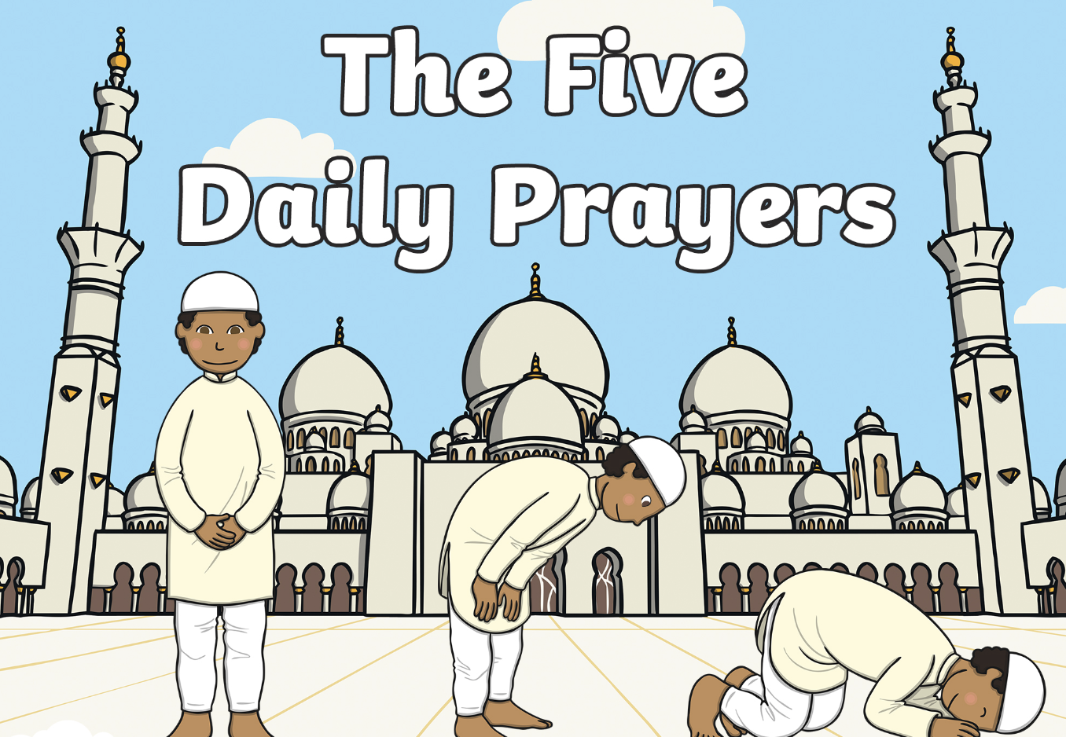  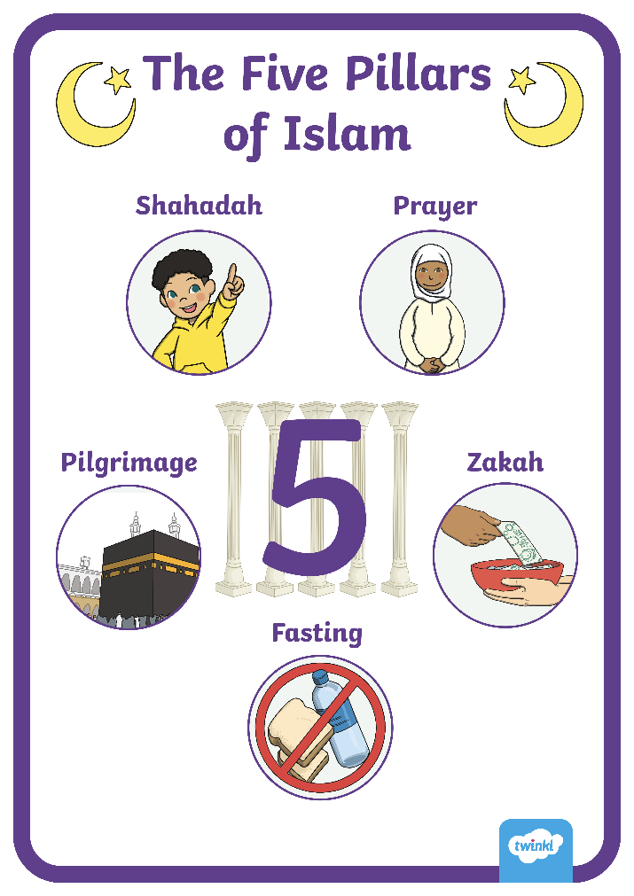  Step 2 Investigation (2 lessons)  Lesson 3  - Tch to explain the Five Daily Prayers and the important of prayer to Muslims  - Tch to explain that prayer is the 2nd Pillar of Islam  - Salah is the obligatory Muslim prayers, performed five times each day by Muslims. It is the second Pillar of Islam. All Muslims try to do this. Muslim children as young as seven are encouraged to pray. God ordered Muslims to pray at five set times of day:  - salah al-fajr: dawn, before sunrise  - salah al-zuhr: midday, after the sun passes its highest  - salah al-'asr: the late part of the afternoon  - salah al-maghrib: just after sunset  - salah al-'isha: between sunset and midnight  - Ask: chn to identify the time of each prayer for Muslims and list the names of the prayers on mini whiteboards  - Preparation for next RE lesson (Lesson 4): Explain to chn that in our next RE lesson we will have a Muslim visitor talk to us about prayer. Ask: Do the children have any questions for our Muslim visitor? What else would you like to know about Muslim prayer? Teacher to scribe questions on large flip chart in preparation for our visitor.  Lesson 4: Enrichment: Talk to a Muslim visitor about prayer.
Activity | Activity:  In RE books ask chn to explain why prayer is important to Muslims.  Challenge: reflect on the Muslim prayer routine and explain how they believe this could help them in their everyday lives.  Examples of pupil responses:  - Silver - WTS: Muslims pray five times a day. God told them to do this. They kneel down, then lay down, then stand up and they talk to God.  - Gold - EXS: Muslims pray because it helps them focus and remember that God gave them everything. They face  Makkah and pray to Allah and do this five times a day to show respect of Allah.  - Platinum - GDS: Muslims pray five times a day because they have a timetable. This helps them remember God and all has done for them and not get carried away with their own stuff. The timetable means they won’t forget God. They face Makkah when they hear the call to prayer. Before they pray they have to be clean so they wash their head, hands, arms and feet.
Possible Misconceptions  (What are the children likely to find challenging?) | Children may not have any experience of what prayer is and what it means.
Resources | Resource - Five Daily Prayers  Envelope cards from the Discovery RE  Muslim visitor to talk about prayer (Lesson 4) | Pillar Link | Heart - respect, belonging, tolerance, responsibility  Head - resilience
Working Wall  (What will go on the WW from this lesson?) | Key vocabulary  Pictures of five pillars of Islam  Pictures of different prayer times
RE MTP Overview
Year 2 Spring 1
Step 3: Evaluation | Lesson 5
Focus Skill | Reflection of religious beliefs: Identify how religion and beliefs are expressed in different ways.  Identity, experience and empathy: Respond sensitively to others’ experiences and feelings and to their values of right and wrong.  Interpreting / discerning: Identify possible meanings for symbols and other forms of religious expression.
Learning Intention | To explain ways in which Muslims might be helped in their everyday lives by praying 5 times a day
SOLO SC: Uni- Structural  Bronze | I can identify one way praying 5 times a day may help a Muslim.
SOLO SC: Multi- Structural  Silver | I can describe how praying five times a day might help in some ways more than others
SOLO SC: Relational  Gold | I can explain ways in which Muslims might be helped in their everyday lives by praying 5 times a day
SOLO SC: Extended Abstract Platinum | I can reflect on some of the challenges Muslims may face praying 5 times a day.
Key Vocabulary for the lesson/unit | Muslim prayer, Salah, Muslims, Pillar of Islam, Qu’ran, posture, symbolise, rak'ah, wudu, niyyah, ruku, sujud
Starter | Recap the importance of prayer to Muslims.
Lesson Journey | Step 3 Evaluation  - Introduce key qu: Does praying at regular intervals everyday help a Muslim in his/her everyday life  - Ask chn to recall the times and names of the 5 daily prayers. For reference: Five Daily Prayers  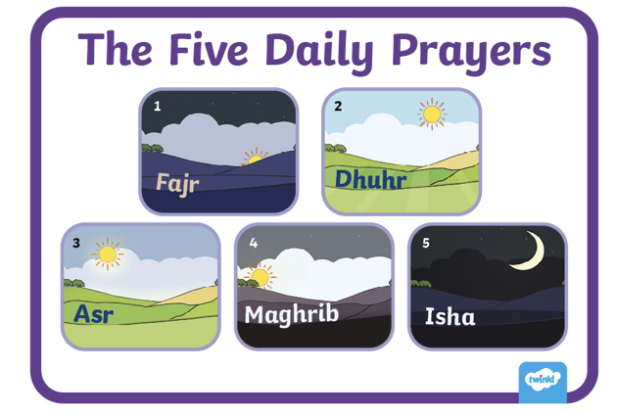  - Watch: Muslim Prayer discuss how Muslim’s prayer. Talk about the different places Muslims pray. Ask: Does it always need to be at a mosque?  - Talk partners: Ask chn to share what they already know about eh Muslim prayer routine. Tch to receive feedback and discuss and provide further explanations  - Ask: How praying at regular intervals helps a Muslim.  - Ask: What does praying 5 times a day help Mulsim in their everyday life? Ask chn for some examples and explain why they pray for help.  - Tch gather feedback and record responses on flipchart paper
Activity | 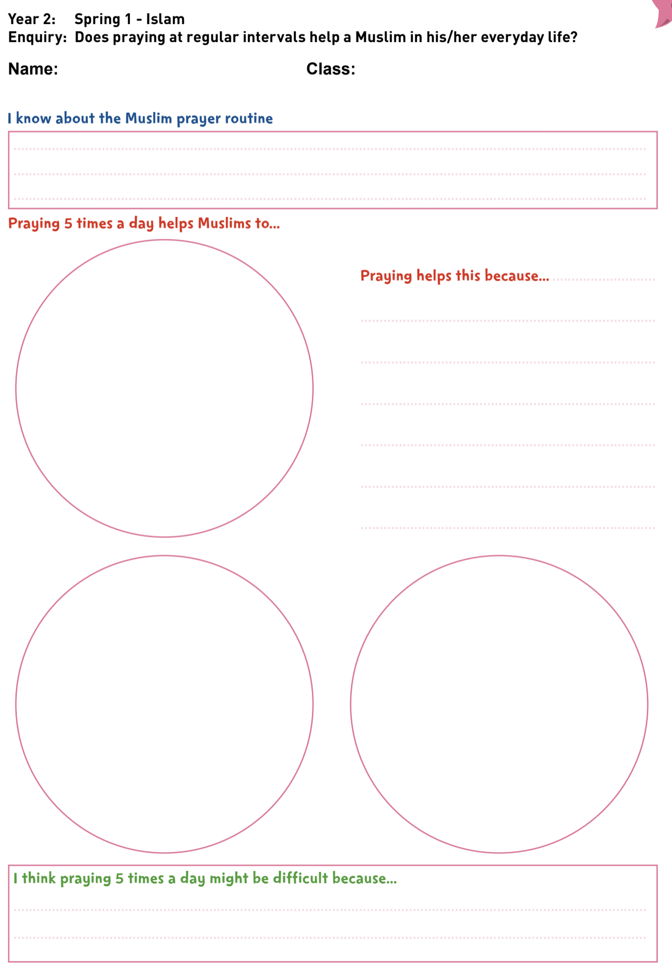  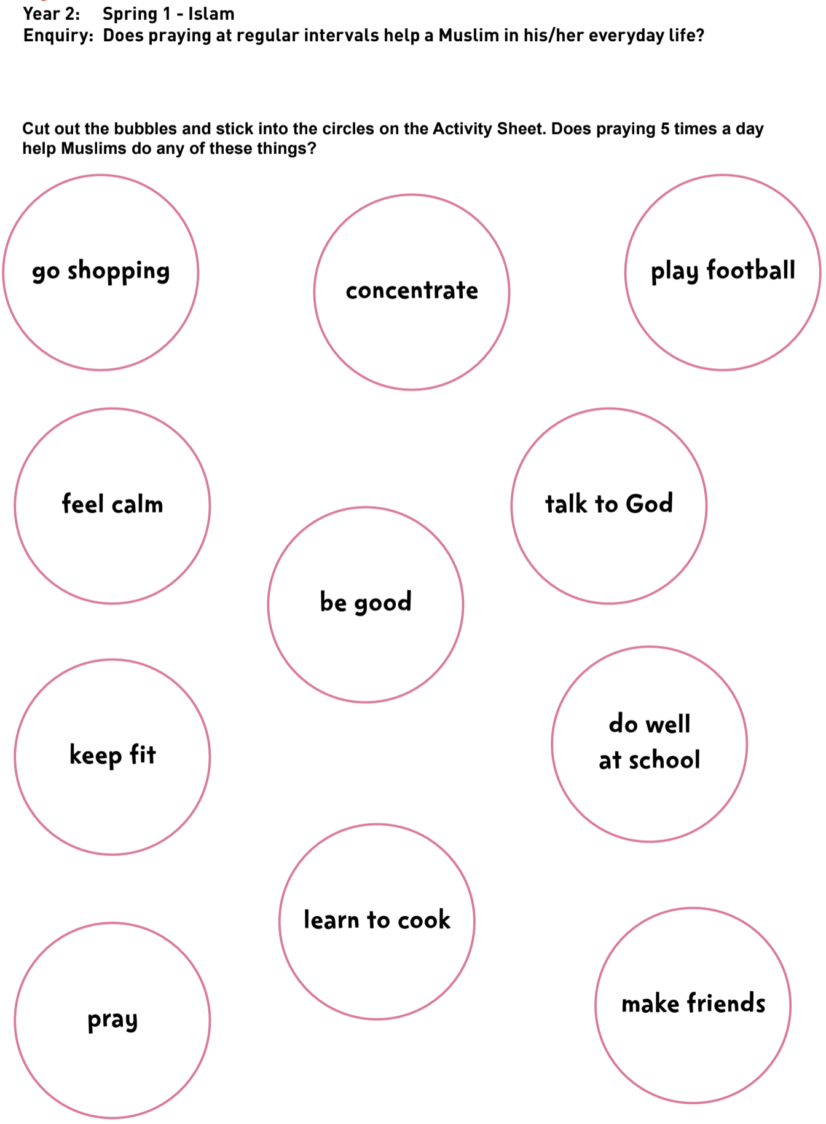  Activity:  Enquiry: Does praying at regular intervals help a Muslim in his/her everyday life?  Task 1:  In the box, children draw/write what they remember about the Muslim prayer routine.  Task 2:  Children cut out 3 bubbles and stick on the task sheet i.e. the 3 things they think praying 5 times a day would help  Muslims with. Explain their reasons next to one bubble. Then complete the last box: Why might praying 5 times a day be difficult?  Examples of pupil responses:  Silver - WTS: Praying would help Muslims be good.  Gold - EXS: If I was a Muslim praying five times a day, I think it would help me think about God instead of always  thinking of my own stuff, like football. I think it probably helps Muslims feel calm because they are talking  to God.  Platinum - GDS: I think praying 5 times a day would help Muslims talk to God, be good and feel calm because going  through the movements and saying the right prayers would help them feel they are doing what Allah  wants them to do.
Possible Misconceptions  (What are the children likely to find challenging?) | Chn may not be able to recognise how prayer helps Muslims and may need further support identifying possible challenges
Resources | Activity sheet 1 & 2 (Discovery RE)  Five Daily Prayers for reference | Pillar Links | Heart - respect, belonging, tolerance, responsibility  Head - resilience
Working Wall
(What will go on the WW from this lesson?)

RE MTP Overview
Year 2 Spring 1
Step 4: Expression | Lesson 6
Focus Skill | Questioning: Ask questions about their own and others’ feelings and experiences
Learning Intention | To explain why goals take commitment to achieve
SOLO SC: Uni- Structural  Bronze | I can identify a goal I would like to achieve
SOLO SC: Multi- Structural  Silver | I can describe why a achieving a goal is important
SOLO SC: Relational  Gold | I can explain why goals take commitment to achieve
SOLO SC: Extended Abstract Platinum | I can evaluate some of the challenges people face when trying to achieve the goal and reflect on how it feels to reach a goal
Key Vocabulary for the lesson/unit | commitment, goal, resilience, challenge, determined
Starter | Recap what chn have learnt about the importance of regular prayer for Muslims. Reflect on the impact prayer has on Muslim’s life.
Lesson Journey | Step 4 Expression (1 lesson)  - Talk to chn about a goal they want to commit to. A goal is something you determine you want to achieve  - Ask: How can we reach our goal? E.g. hard work, commitment.  - Watch: Small Talk: Goals  - Discuss why goal setting is important to help you successfully achieve it.  How do setting goals help us in life?  What is the purpose of setting goals?  How can you overcome challenges you may face when trying to achieve a goal?  What role does commitment play in achieving goals?  - Discuss how commitment to achieving a goal is similar to the commitment Muslim’s have to demonstrate daily to prayer at regular intervals.
Activity | Activity:  Use Activity Sheet 2 ask chn to draw a picture of themselves achieving a goal in the middle of the trophy.  Ask chn to write down 3 key words or sentences to express how it feels to have achieved it.  Does praying at regular intervals help a Muslim in his/her everyday life?  
Possible Misconceptions  (What are the children likely to find challenging?) | To help chn identify goal link to Jigsaw - Dreams and Goals Puzzle www.jigsawpshe.com if you are using Jigsaw PSHE.
Resources | Activity sheet 2 (Goal trophy) | Pillar Links | Head - challenge, resilience  Health - self belief
Working Wall  (What will go on the WW from this lesson?) | Display trophy with goals

