
RE MTP Overview
Year 1 Spring 1
Jigsaw Unit Overview
Theme | Jesus as a friend
Concept | Beliefs & Moral Values
Religion | Christianity
Enquiry Question | Was it always easy for Jesus to show friendship?
Learning Intention | To identify when it is easy and difficult to show friendship and to explore when Jesus may have found it difficult.
Unit Resources | Hello story, resources for friendship,
Assessment  Evidence in Discovery RE Journals: Palm leaves, the drawing and labelling of welcoming Jesus. | Engagement  WTS: I can tell you who is my friend.  EXS: I can say something about one of Jesus’ friends.  GDS: I can say how Jesus was nice to people. | Knowledge & Understanding  WTS: I can talk about my friends and why I like them.  EXS: I can remember a story about Jesus showing friendship and talk about it.  GDS: I can say how Jesus tried to be a good friend. |  | Evaluation/Critical Thinking  WTS: I can talk about times when I have been a good friend.  EXS: I can tell a story about Jesus and His friends and say how He showed friendship in that story.  GDS: I can say how Christians show friendship and how God helps them do this.

RE MTP
Year 1, Spring 1 Week 1
Step 1: Engagement | Lesson 1
Focus Skill | Identify aspects of own experiences and feelings.  Ask questions about what they find puzzling and interesting in life.
Learning Intention | To explain how I have been a good friend
SOLO SC: Uni- Structural Bronze | To identify what makes a good friend
SOLO SC: Multi- Structural Silver | To classify what a good and bad friend is
SOLO SC: Relational Gold | To compare a good and bad friend
SOLO SC: Extended Abstract Platinum | To justify why certain actions will make someone feel included or excluded (left out).
Key Vocabulary for the lesson/unit | Excluded, included, friendship, friends, Friendship, Feelings, Left out, Lonely, Hello
Starter | Use Abbey Owl to tell her own story of being left out or tell the children a story about someone feeling left out or not included Read ‘Say Hello’ by Jack and Michael Foreman.  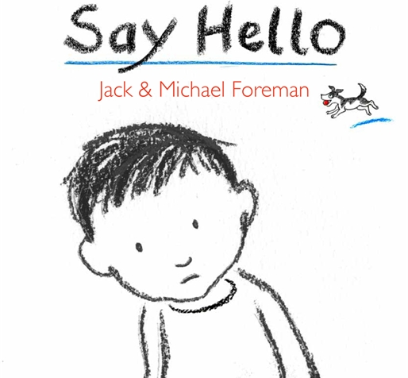
Lesson Journey | Step 1 Engagement (1 lesson)  Q: How could you show friendship to this character in the story to make them feel included?  Q: Do I need friends? Why?  Discuss things that a good friend does and does not do.  Children to sort statements/pictures under each heading -  Things a good friend does.  Things a good friend does not do.E.g. Laugh at you, play with you, call you names, listen to you, make you feel happy, help you, share things with you, hurt you etc. Is it always easy to show friendship? When might it be difficult/easy?  Plenary - https://www.youtube.com/watch?v=472AnCrHYVs Listen to hello song.
Activity | Bronze - identify what makes a good friend using role play as support.  Silver - Classify pictures into two groups - good friends and bad friends.  Gold - Compare a good and bad friend  Platinum - Use feeling words to justify how they would feel
Possible Misconceptions  (What are the children likely to find challenging?) | Children do not understand what the term special means.
Resources | Say hello video  Pictures  Hoola hoop to sort pictures  Hello song | Pillar Links | Heart - kindness and belonging
Working Wall  (What will go on the WW from this lesson?) | Display key vocabulary

RE MTP
Year 1, Spring 1 Week 2
Step 2: Investigation | Lesson 2
Focus Skill | Recall features of religious, spiritual and moral stories.  Recognise and name features of religious beliefs.
Learning Intention | To explain how Jesus showed friendship
SOLO SC: Uni- Structural Bronze | To identify how Jesus is a good friend
SOLO SC: Multi- Structural Silver | To describe what Jesus did to be a good friend
SOLO SC: Relational Gold | To explain how Jesus showed friendship
SOLO SC: Extended Abstract Platinum | To reflect on what Jesus did to show friendship and link it to your own experiences
Key Vocabulary for the lesson/unit | Lazarus, Mary, Martha, disciples, friendship, Jesus, Bible Help, Care
Starter | Recap the key characteristics of a good friend. Tch to scribe ideas in a outline of a person  
Lesson Journey | 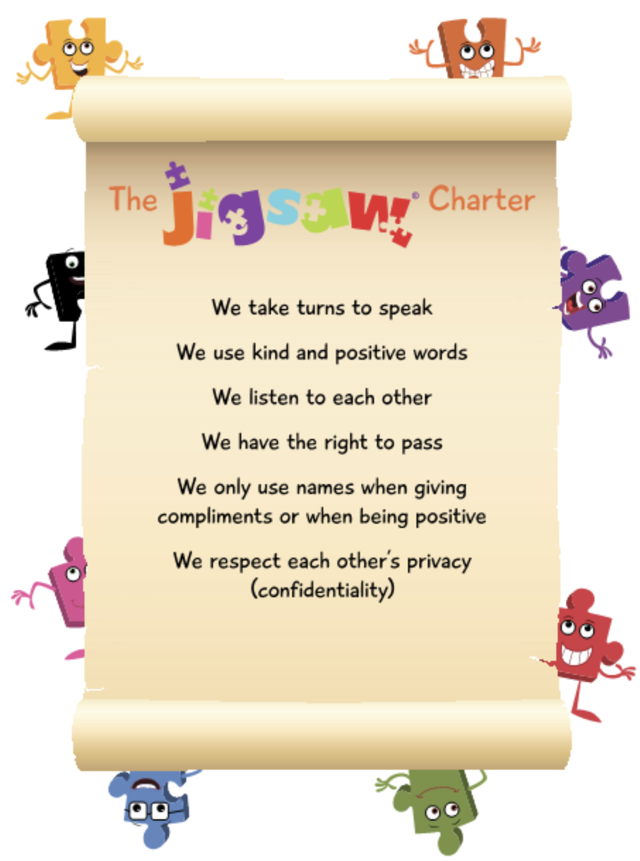  Step 2 Investigation (2 lessons)  In our class we all try to show friendship. Refer to the Jigsaw Charter  Explain that there are many stories in the bible which show Jesus being a good friend to others.  Explain to chn that today and in our next RE lesson we will be looking at 3 different bible stories which show how Jesus is a good friend to others.  Bible stories showing Jesus as a friend - use Children’s Bible or animated versions  - Story of Zacchaeus (Luke 19:1-9): Jesus showing friendship to someone who was isolated and unpopular.  - Stilling the Storm (Luke 8: 22-25) Jesus taking care of His friends during a dangerous time.  - Mary, Martha and Lazarus (Luke 10: 38-41) Jesus spending time with His friends at their home.  In today’s lesson share the bible story of Lazarus Jesus raises Lazarus from the dead  From the story extract the theme of friendship and ask the key qu: Was it always easy for Jesus to show friendship?  Why/why not?  Christians believe Jesus taught them they must always try to show friendship even when it is difficult, as that is what  God wants them to do. Christians believe that Jesus is a good friend to them, but how did Jesus show this friendship and was it always easy?  Q: When might Christians today find it difficult to show friendship and how would they ask God to help them?
Activity | Bronze: identify if Jesus is a good friend and draw picture to show this.  Silver: Describe what Jesus did to be a good friend?  Gold: Jesus was a good friend because....  Platinum: Reflect on what Jesus did and link it to own experience.
Possible Misconceptions  (What are the children likely to find challenging?) | Children might not understand how Jesus showed friendship to everyone whether they were good and bad.
Resources | Jigsaw charter  Bible story  worksheets | Pillar Links | Heart - Kindness  Hands - Risk-taking
Working Wall  (What will go on the WW from this lesson?) | Cut out - characteristics of a good friend

RE MTP
Year 1, Spring 1 Week 3
Step 2: Investigation | Lesson 3
Focus Skill | Recall features of religious, spiritual and moral stories.  Recognise and name features of religious beliefs.
Learning Intention | To compare what Jesus did to be a good friend in both stories.
SOLO SC: Uni- Structural Bronze | To identify and draw what Jesus did to be a good friend
SOLO SC: Multi- Structural Silver | To describe what Jesus did to be a good friend in both stories
SOLO SC: Relational Gold | To compare what Jesus did to be a good friend in both stories.
SOLO SC: Extended Abstract Platinum | To reflect on the type of people Jesus showed friendship too? Were they always good people? Justify why?
Key Vocabulary for the lesson/unit | Zacchaeus, tax collector, sinner, disciples, friendship, Jesus, bible help, care
Starter | Recap the story of Lazarus and ask chn to recall how Jesus showed friendship to Lazarus.
Lesson Journey | Step 2 Investigation - continued...  Recap the story of Lazarus - Jesus spending time with His friends at their home.  Q: What was the key message in the story of Lazarus?  Q: How did Jesus show Lazarus friendship?  Explain that today we will continue to look at two more bible stories showing Jesus as a friend - use Children’s Bible or animated versions  - Story of Zacchaeus (Luke 19:1-9): Jesus showing friendship to someone who was isolated and unpopular.  - Stilling the Storm (Luke 8: 22-25) Jesus taking care of His friends during a dangerous time.  Share the bible story of Zacchaeus Zacchaeus  Share the bible story of Jesus calming the storm Storm  From each story, extract the theme of friendship and ask the key question:  Q: Was it always easy for Jesus to show friendship? Why/why not?  Christians believe Jesus taught them they must always try to show friendship even when it is difficult, as that is what  God wants them to do. Christians believe that Jesus is a good friend to them, but how did Jesus show this friendship and was it always easy?  Q: When might Christians today find it difficult to show friendship and how would they ask God to help them?  Christians believe that Jesus is a good friend to them, but how did Jesus show this friendship and was it always easy?  Did everyone Jesus show friendship to treat him with kindness in return?  Did Jesus only show friendship to nice people?  Teacher Notes: Subject Knowledge  Zacchaeus  Jesus was passing through Jericho. There was a chief tax collector there named Zacchaeus, who was rich. Zacchaeus was a little man, and wanted to see Jesus, so he climbed a sycamore tree. Jesus looked up and said, “Hurry down, Zacchaeus, because I must stay in your house today.” The people started grumbling because Jesus was going to the home of a sinner. However, Zacchaeus promised to give half his belongings to the poor and pay back four times as much to anyone he had cheated.  By inviting himself to Zacchaeus’ house, Jesus showed his acceptance of someone who was regarded as a sinner and treated as an outcast. The crowd did not approve of Jesus’ controversial action.
Activity | Bronze: identify what Jesus did to be a good friend and draw picture.  Silver: Describe what Jesus did to be a good friend in both stories.  Gold: Compare what Jesus did to be a good friend in both stories.  Platinum: Reflect on the sort of people Jesus shows friendsHowhip to. Are they always good people?
Possible Misconceptions  (What are the children likely to find challenging?) | Children may not understand that Jesus is no longer on Earth.
Resources | Bible stories  Worksheets (Activity Sheet 1 & 2) | Pillar Links | Heart - Kindness  Hands - Risk-taking
Working Wall  (What will go on the WW from this lesson?) | Pictures from three stories  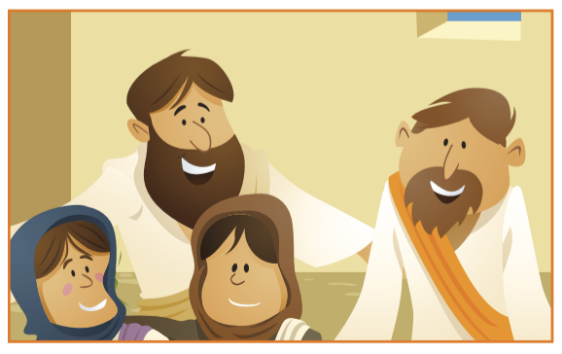  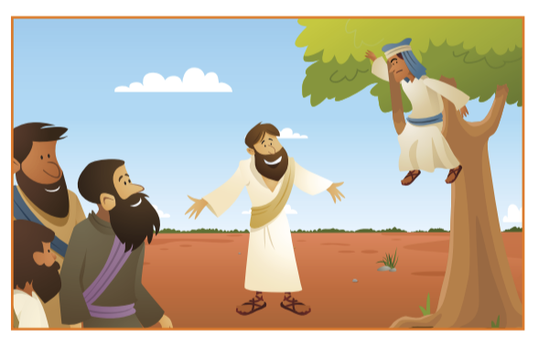  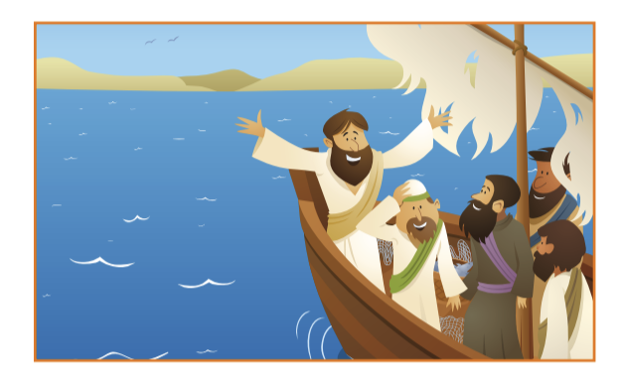
RE MTP
Year 1, Spring 1 Week 4
Step 3: Evaluation | Lesson 4
Focus Skill | Recall features of religious, spiritual and moral stories.
Learning Intention | To explain why it was easy or difficult for Jesus to show friendship in each bible story.
SOLO SC: Uni- Structural Bronze | To select pictures which show it is easy or difficult for Jesus to show friendship
SOLO SC: Multi- Structural Silver | To sequence pictures from bible stories according to when Jesus may found it easy or difficult to show friendship
SOLO SC: Relational Gold | To explain why it was easy or difficult for Jesus to show friendship in each bible story.
SOLO SC: Extended Abstract Platinum | To reflect on how Christians show friendship and how God helps them.
Key Vocabulary for the lesson/unit | Freeze frame, Christians overcome , friendship, easy, hard, difficult, difference,
Starter | Mini Quiz recap of 3 previously heard bible stories
Lesson Journey | Step 3 Evaluation (1 lesson)  Recap the three Bible stories about Jesus showing friendship. In groups, children to freeze-frame a scene from each story.  Discuss the feelings of the people in the story and discuss how easy it was for Jesus to show friendship to each of these people.  In groups, children freeze-frame a scene from each story.  Discuss the feelings of the people in the story and discuss how easy it was for Jesus to show friendship to each of these people. (Could use the structure of:  Q: What do you see?  Q: What do you think?  Q: What do you feel?  Q: What do you wonder? - applying to the children themselves and/or to the characters depicted in the freeze-frames.  When was it easiest for Jesus to show friendship and why?  When was it hardest for Jesus to show friendship and why?  Did God help Jesus show friendship even when it was difficult?  Jesus was human so would have found things difficult sometimes but Christians believe He was God’s son so would have been able to overcome these difficulties.
Activity | Support: Give pictures which show it is easy or difficult for Jesus to show friendship support chn with freeze framing, ask children how do you feel?  Challenge: Which story do you think Jesus showed friendship more easily? Which story was the most difficult to show friendship for Jesus?  Children have a picture from each story and order them according to when Jesus may have found it easy or difficult to show friendship and to explain why. Use Activity Sheet 1&2  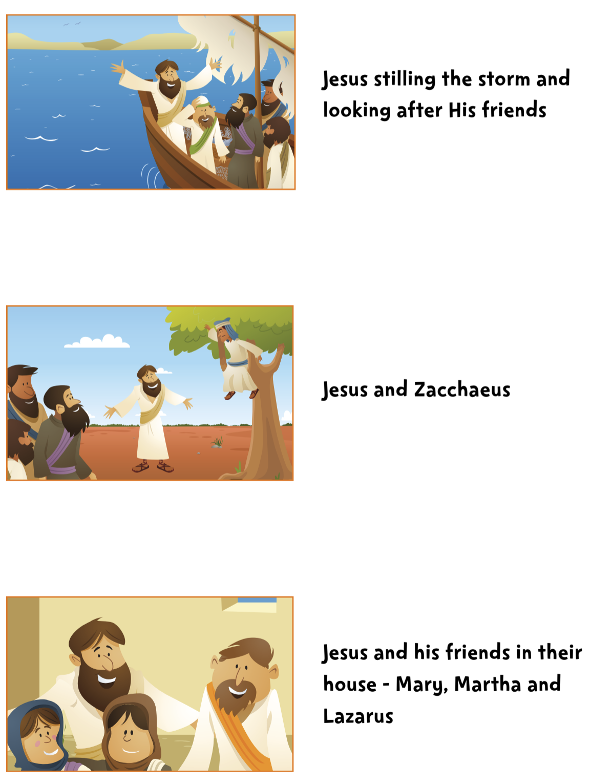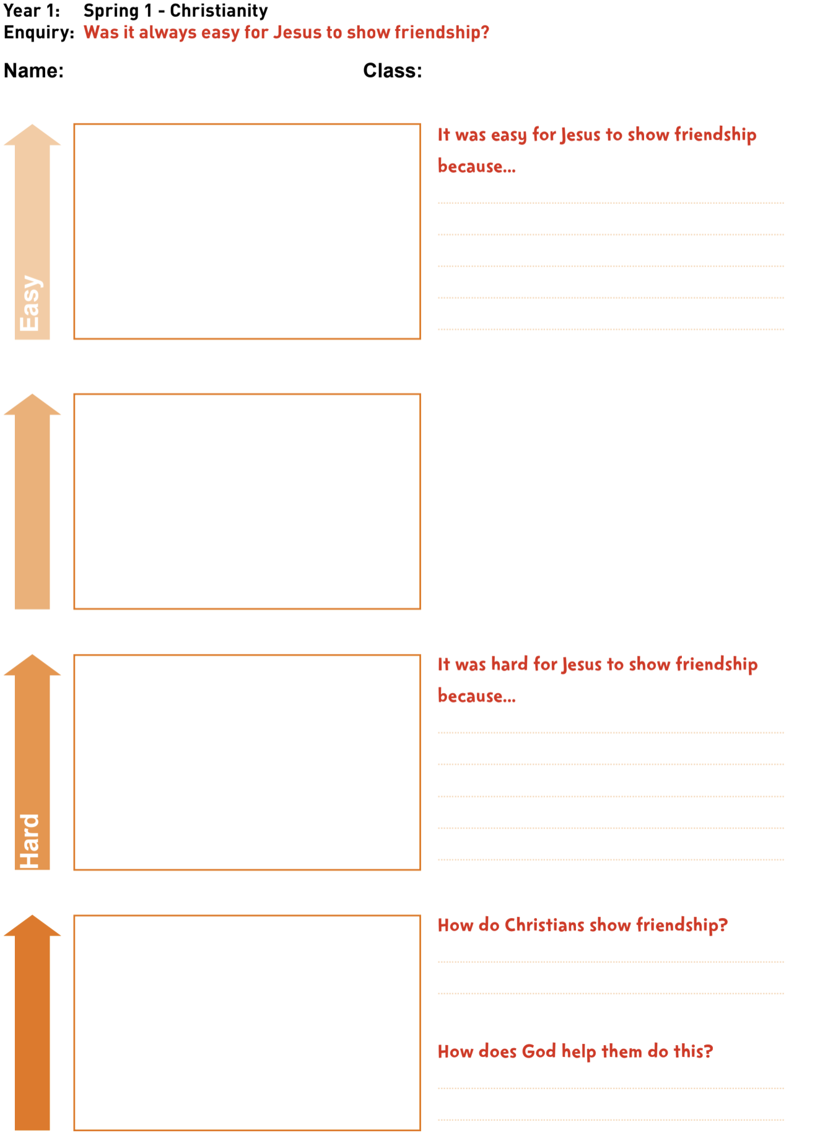
Possible Misconceptions  (What are the children likely to find challenging?) | Children do not understand that Jesus is no longer alive and lived a long time ago.
Resources | Flipchart  Pictures of 3 stories - Lazarus, Storm, Zaccheaus | Pillar Links | Heart - Tolerance  Head - Resilience
Working Wall  (What will go on the WW from this less | Children’s questions on the working wall.

RE MTP
Year 1, Spring 2 Week 5 & 6
Step 3: Evaluation | Lesson 5 & 6
Focus Skill | identify aspects of own experiences and feelings.
Learning Intention | To describe the key traits of a good friend and give an example of each
SOLO SC: Uni- Structural Bronze | To define what a good friend is
SOLO SC: Multi- Structural Silver | To list what makes a good friend
SOLO SC: Relational Gold | To describe the key traits of a good friend and give an example of each
SOLO SC: Extended Abstract Platinum | To reflect on how compliments make friends feel
Key Vocabulary for the lesson/unit | friend, bracelet, friendship web, chain, link, trait, compliment
Starter | Mini Quiz recap how Jesus shows friendship to others. Q: What makes a good friend?
Lesson Journey | 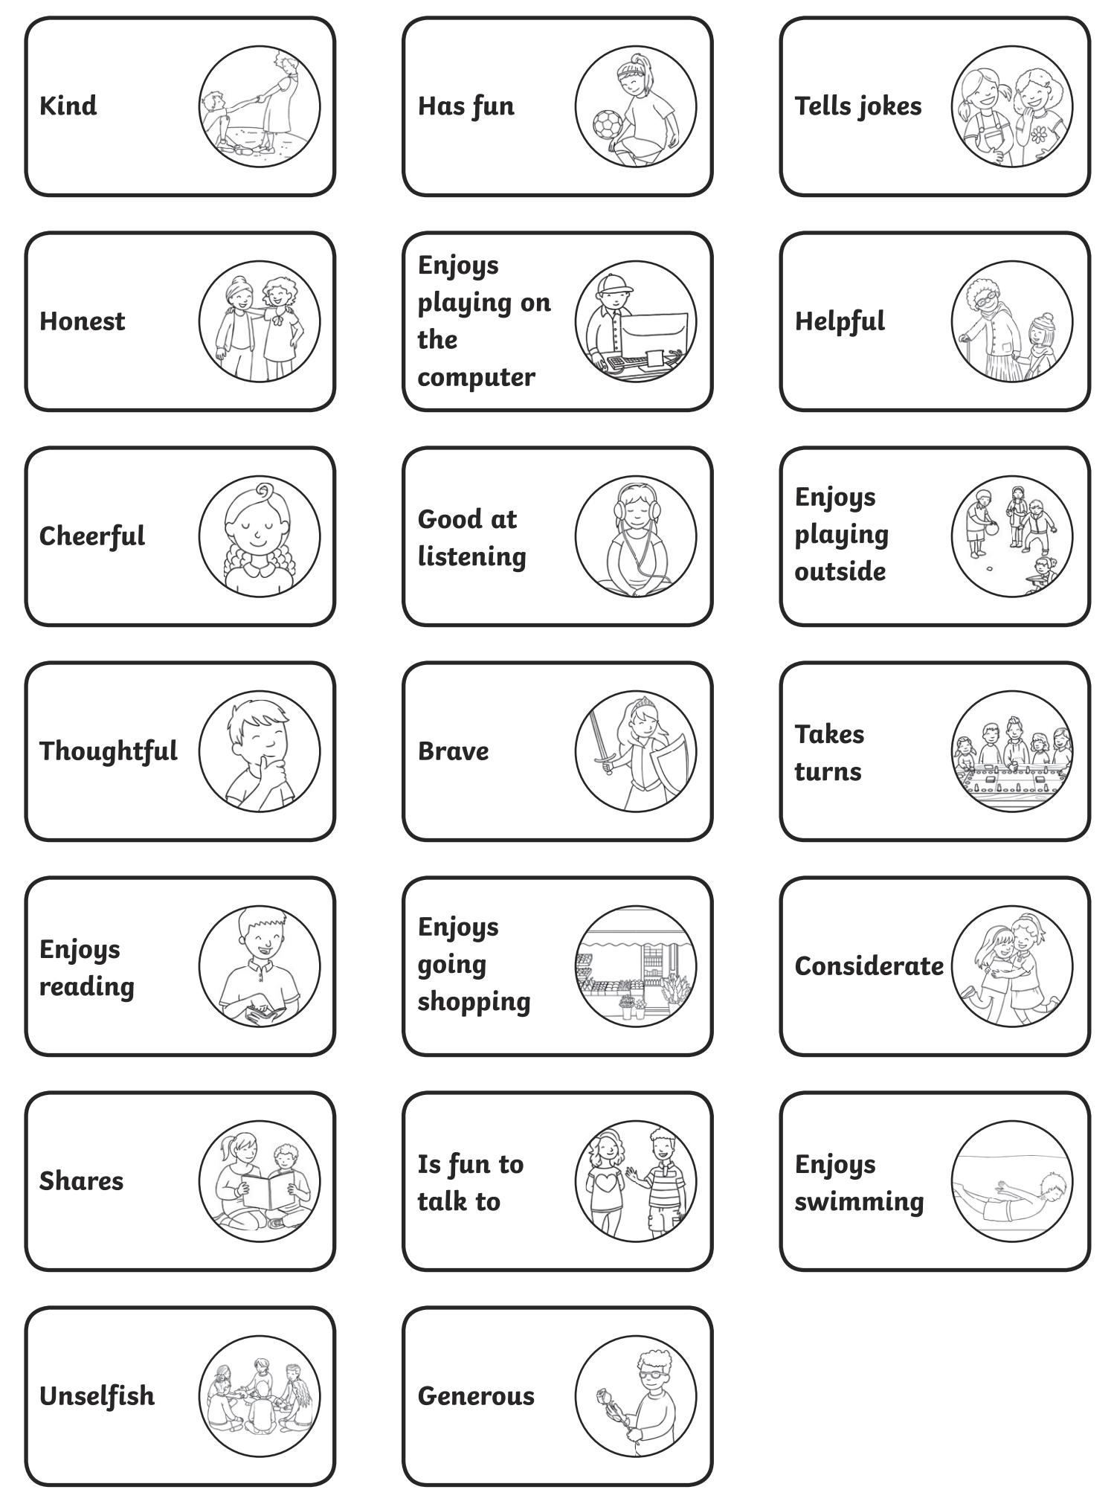  Step 4 Expression (2 lesson)  Lesson 5  What do I value about my friends?  Q: Who is your friend?  Q: What do you like about them?  Q: When have your been a good friend?  Tch to scribe chn’s ideas on f/c  Whole class activity  Create a web of friendship, a ball of wool is passed around the circle, with each child holding their part, saying ‘I find it easy to be friends with you because...’. At the end of the circle time, a visual web is created.  Remind children there are times when we may find it easy or difficult to show friendship, like Jesus did in the stories, but we can try to remember our web of friendship and show friendship to each other.  Remind chn how God helps Christians to show friendship to others even when it is difficult  Lesson 6  Children make friendship bracelets for their friends/paper chain/people paper chain.
Activity | Children can either make a paper people chain, paper chain link or a friendship paper bracelet  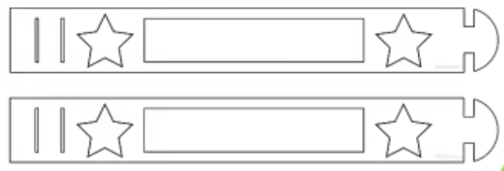  Support/Challenge  Support: sentence starter with visuals to help write sentences.  Challenge: write a compliment about their friend.  Paper People Chain Template  Friendship bracelet template 1
Possible Misconceptions
(What are the children likely to find challenging?)
Resources | Card/Paper for bracelets  People chain template  string/wool  Scissors  Items for decorating people chain template | Pillar Links | Hands - Creating  Heart - Kindness and belonging
Working Wall  (What will go on the WW from this lesson?) | Pictures of chn wearing their friendship bracelet

