
RE MTP Overview
Year 1 Spring 2
Jigsaw Unit Overview
Theme | Easter - Palm Sunday
Concept | Prayer & Worship
Religion | Christianity
Inquiry Question | Why was Jesus welcomed like a king or celebrity by the crowds on Palm Sunday?  The enquiry looks at the events of Palm Sunday and their significance to Christians today.
Learning Intention | To know that Jesus is special to Christians and how his welcome on Palm Sunday shows this.
Unit Resources | Video ‘Jesus of Nazareth’: show clips Crowds in modern Jerusalem (internet): show clips Pictures of palm leaves (internet): display - use real palm leaves if available Tell stories: Palm Sunday, Easter Day, Resurrection Candle
Assessment  Evidence in Discovery RE Journals: Palm leaves, the drawing and labelling of welcoming Jesus. | Engagement  WTS: I can tell you someone who is special to me.  EXS: I can talk about a person I admire.  GDS: I can discuss how I might treat a special person and say why. | Knowledge & Understanding  WTS: I can tell you something about Palm Sunday.  EXS: I can recall parts of the Easter story. I can recognise some symbols in the story.  GDS: I can recall what happened on Palm Sunday and can say what some of the symbols in the Easter story mean. |  | Evaluation/Critical Thinking  WTS: I can show some awareness that Jesus is special to Christians.  EXS: I can start to show understanding that Jesus is special to Christians and say why.  GDS: I can recognise that Jesus must be special to Christians to be welcomed in this way and start to explain their beliefs about Him.


RE MTP
Year 1, Spring 2 Week 1
Step 1: Engagement | Lesson 1
Focus Skill | Identify aspects of own experiences and feelings.
Learning Intention | To sequence special people and explain the reason for their order.
SOLO SC: Uni- Structural Bronze | To identify someone special.
SOLO SC: Multi- Structural Silver | To list special people who deserve a special welcome.
SOLO SC: Relational Gold | To sequence special people and explain the reason for their order.
SOLO SC: Extended Abstract Platinum | To justify why a special person deserves a special welcome.
Key Vocabulary for the lesson/unit | Salvation: the saving of mankind from permanent separation from God by the death and resurrection of Jesus  Palm Sunday: when Jesus rode into Jerusalem  Disciples: Jesus’ special friends.
Starter | What does special mean?
Lesson Journey | Step 1 Engagement (1 lesson)  What would you do if a member of the Royal Family came to visit? Discuss preparations and why. Role play a visit of a special person.  Watch clips of both formal and informal visits of e.g. the Queen and ask children what do they notice about how she is being welcomed.  Discuss  How might she feel? Why are people welcoming her this way? What do people feel about her?  Who is special to you? How do you welcome special people into your home? Are all special people welcomed the same way? What makes someone special? Who would you welcome in a special way if they came to school?
Activity | Make a list of people children think deserve a special welcome. Why these people?  Ask chn to choose 3 - 4 special people from the list and ask them to sequence from least special to most special. Explain reason for order e.g Queen, Prime Minister, Football player
Possible Misconceptions  (What are the children likely to find challenging?) | Children do not understand what the term special means.
Resources | Flipchart  Pictures of ‘special people’ i.e queen, royal family, prime minister, celebrities etc. | Pillar Links | Heart - Respect, Kindness
Working Wall  (What will go on the WW from this lesson?) | Star cut out - Class display  Key vocabulary

RE MTP
Year 1, Spring 2 Week 2
Step 2: Investigation | Lesson 2
Focus Skill | Recall features of religious, spiritual and moral stories.
Learning Intention | To compare how you would welcome Jesus if he came to school compared to a parent or a teacher.
SOLO SC: Uni- Structural Bronze | To identify how you would feel if Jesus came to school.
SOLO SC: Multi- Structural Silver | To describe how you would welcome Jesus if he came to school.
SOLO SC: Relational Gold | To compare how you would welcome Jesus if he came to school compared to a parent or a teacher..
SOLO SC: Extended Abstract Platinum | To imagine how you would welcome Jesus if he came to school.
Key Vocabulary for the lesson/unit | Salvation: the saving of mankind from permanent separation from God by the death and resurrection of Jesus  Palm Sunday: when Jesus rode into Jerusalem  Disciples: Jesus’ special friends.
Starter | Have 3 photos of different people on the screen.  Which of these people is special to you? Why?
Lesson Journey | Step 2 Investigation  Explain to the children that when special people come to visit it draws in crowds and people behave in particular ways.  Tell children that we are going to learn about a visit of a special person.  Use a Children’s Bible to tell the Easter story up to Palm Sunday and ask How was Jesus welcomed, as a king, celebrity, poor man or just another person? How do you know? Why did He ride a donkey?  Explain that the people welcomed Jesus like this because they had heard about all the amazing things He did e.g. healing people, calming the storm etc. and they believed He would be the ‘Messiah’, the one who would save them from the Roman occupation.  Draw out similarities and differences to royal/celebrity visits.  Watch clips such as Jesus of Nazareth and modern day clips of crowds in Jerusalem, walking the same route, to show children that Jerusalem is a real place and Christians today still wave palm leaves and celebrate Jesus’ arrival (i.e. when they are on Easter Pilgrimage to Jerusalem).
Activity | Children to make palm leaves (Activity Sheet 1) and write words/sentences on them, reflecting how they would welcome Jesus if they were Christians and Jesus came to school.
Possible Misconceptions  (What are the children likely to find challenging?) | Children may not understand that Jesus is no longer alive.
Resources | Activity Sheet 1  Flipchart  Colouring pencils | Pillar Links | Creating  Respect
Working Wall  (What will go on the WW from this lesson?) | Palm leave - Modelled

RE MTP
Year 1, Spring 2 Week 3
Step 2: Investigation | Lesson 3
Focus Skill | Identify aspects of own experiences and feelings.
Learning Intention | To compare how Jesus would be welcomed into town today to how he was welcomed on Palm Sunday.
SOLO SC: Uni- Structural Bronze | To draw how Jesus would be welcomed into town today.
SOLO SC: Multi- Structural Silver | To describe how Jesus would be welcomed into town today.
SOLO SC: Relational Gold | To compare how Jesus would be welcomed into town today to how he was welcomed on Palm Sunday.
SOLO SC: Extended Abstract Platinum | To explain why Jesus would be welcomed into town in such a manner.
Key Vocabulary for the lesson/unit | Salvation: the saving of mankind from permanent separation from God by the death and resurrection of Jesus  Palm Sunday: when Jesus rode into Jerusalem  Disciples: Jesus’ special friends.
Starter | Match the person to how they would be welcomed.
Lesson Journey | 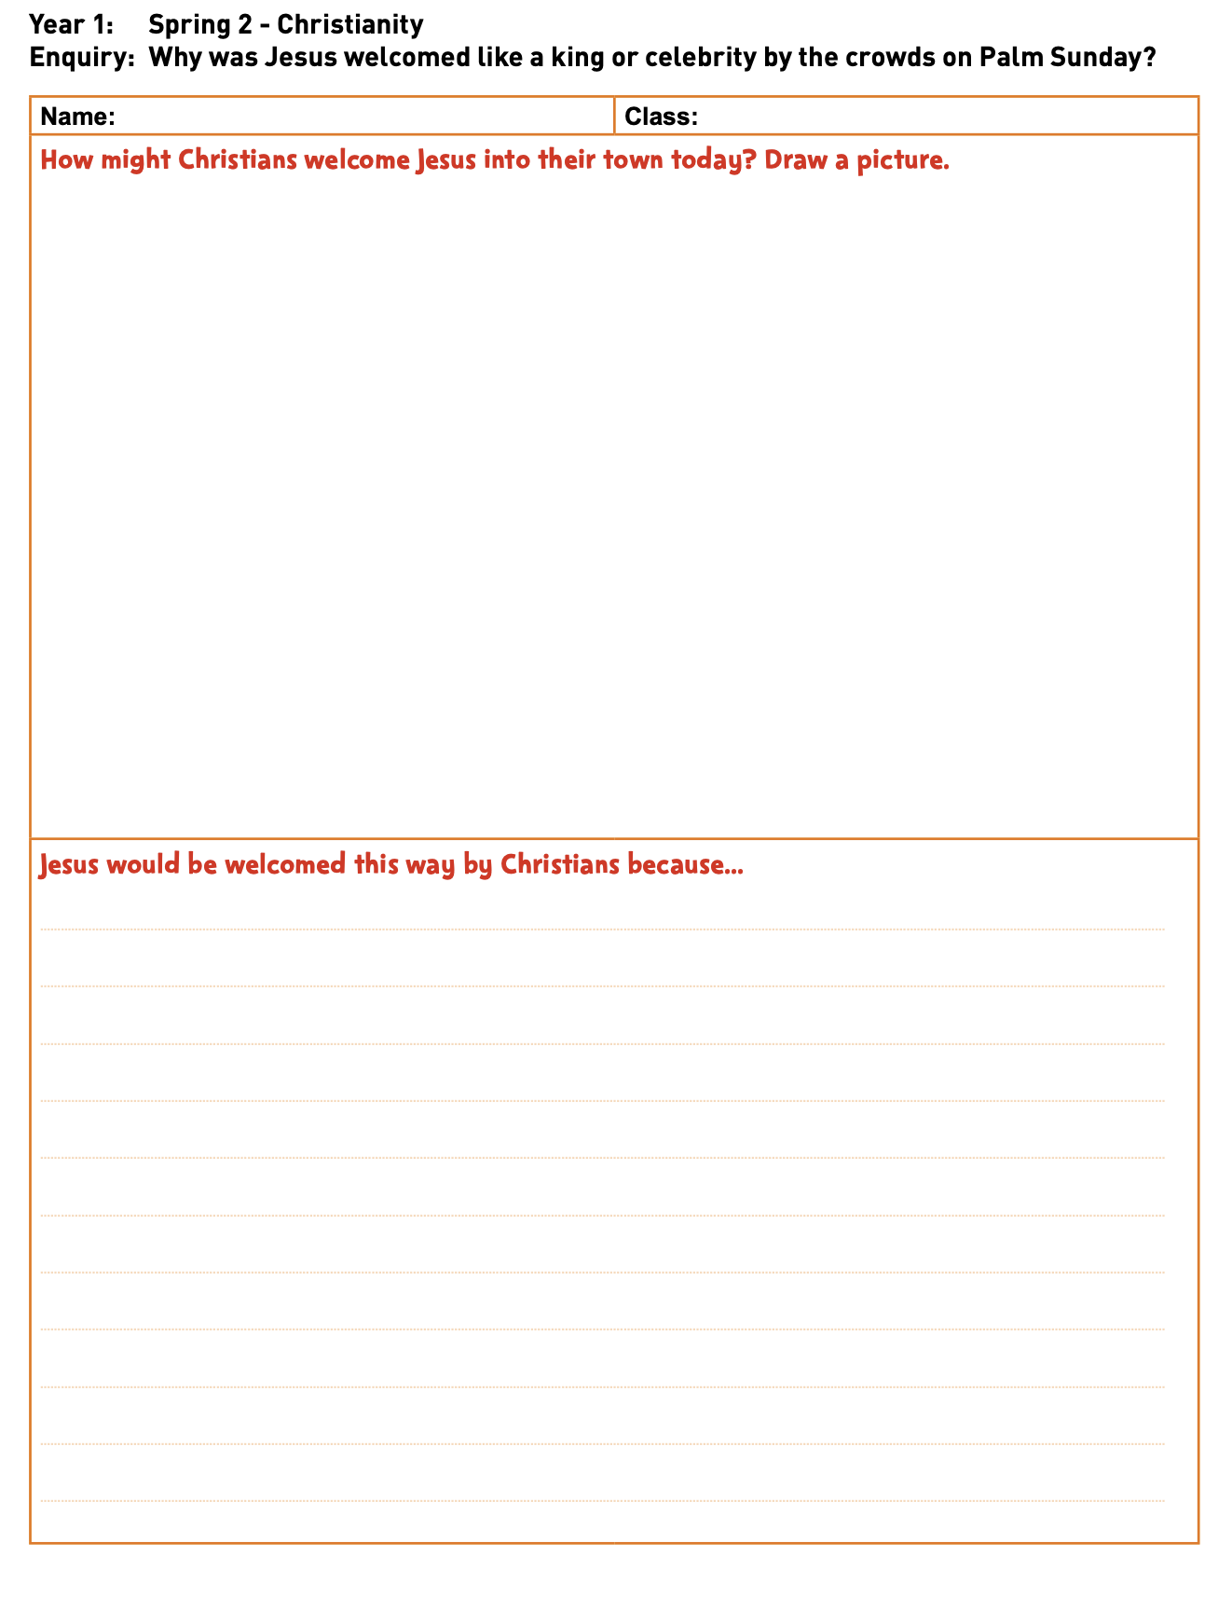  Step 2 Investigation - continued...  Children to re-enact Jesus’ arrival on Palm Sunday with their palm leaves. Activity Sheet 2: How would Christians welcome Jesus into their town today? Model drawing and labeling Jesus arriving and how Christians might welcome Him. Why would He be welcomed this way? Reinforce He is special to Christians because they believe He is the Son of God (Incarnation).
Activity | LA - Activity Sheet 2: How would Christians welcome Jesus into their town today? Children to draw Jesus arriving and how Christians might welcome Him.  MA - Activity Sheet 2: How would Christians welcome Jesus into their town today? Children to draw and label Jesus arriving and how Christians might welcome Him.  HA - LA - Activity Sheet 2: How would Christians welcome Jesus into their town today? Children to draw and label Jesus arriving and how Christians might welcome Him. Why would He be welcomed this way?
Possible Misconceptions  (What are the children likely to find challenging?) | Children may not understand that Jesus is no longer alive.
Resources | Activity sheet  Colouring pencils  Flipchart | Pillar Links | Creating  Belonging  Kindness
Working Wall  (What will go on the WW from this lesson?) | Images of Jesus and celebrities being welcomed

RE MTP
Year 1, Spring 2 Week 4
Step 3: Evaluation | Lesson 4
Focus Skill | Ask questions about what they find puzzling and interesting in life.  Recall features of religious, spiritual and moral stories.
Learning Intention | To sequence the Easter story.
SOLO SC: Uni- Structural Bronze | To match the pictures and sentences of Easter story.
SOLO SC: Multi- Structural Silver | To describe what happened in the Easter Story.
SOLO SC: Relational Gold | To sequence the Easter story.
SOLO SC: Extended Abstract Platinum | To create a story map of the main events of the Easter story.
Key Vocabulary for the lesson/unit | Salvation: the saving of mankind from permanent separation from God by the death and resurrection of Jesus  Palm Sunday: when Jesus rode into Jerusalem  Disciples: Jesus’ special friends.
Starter | Mini Quiz recap of the last three lessons.
Lesson Journey | Step 3 Evaluation (1 lesson)  Introduce key qu: Why was Jesus welcomed like a king or celebrity by the crowds on Palm Sunday?  Explain that people welcomed Him because He was special and they wanted to be near Him because they had heard of all the good things He had done; also, because they were hoping He would be able to help them be free as they were living under Roman rule (the Romans had taken over and were ruling their country).  Did He look/behave like a king?  Did Jesus want to be welcomed in this way? Do you think Jesus would have preferred a quieter entry into Jerusalem?  Read the Easter story. https://www.youtube.com/watch?v=zQeU6gZzHT4 (possible video)  Focus on Palm Sunday and recap key question. Continue reading the Easter story including the death and resurrection of Jesus. Talk about his resurrection. Does this show He was special?  Christians believe Jesus is the son of God. Jesus arrived as a king, but did He leave as one?
Activity | Read the Easter story and order main events using sequencing cards.  Challenge: create story map of main events of the Easter story.
Possible Misconceptions  (What are the children likely to find challenging?) | Children do not understand that Jesus is no longer alive and lived a long time ago.
Working Wall  (What will go on the WW from this lesson?) | Children’s questions on the working wall.  Sequenced pictures of the Easter Story (Twinkl)

RE MTP
Year 1, Spring 2 Week 5
Step 3: Evaluation | Lesson 5
Focus Skill | Recognise religious symbols.
Learning Intention | To explain why you would admire or respect someone.
SOLO SC: Uni- Structural Bronze | To identify someone you admire or respect.
SOLO SC: Multi- Structural Silver | To list the qualities of the person you admire or respect.
SOLO SC: Relational  Gold | To explain why you admire or respect the person.
SOLO SC: Extended Abstract Platinum | To evaluate what qualities are important to be respected and admired by others.
Key Vocabulary for the lesson/unit | Salvation: the saving of mankind from permanent separation from God by the death and resurrection of Jesus  Palm Sunday: when Jesus rode into Jerusalem  Disciples: Jesus’ special friends.
Starter | Mini Quiz recap of the last four lessons.
Lesson Journey | Step 4 Expression (1 lesson)  Read/ watch the Easter Story again.  Discuss why is the cross special to Christians?  Recap why was Jesus welcomed like a king or celebrity by the crowds on Palm Sunday?
Activity | Use a photo frame template chn to decorate the frame and draw a picture of someone they really admire/respect i.e. someone you would welcome in a big way if they visited. Why is this person worthy of such a welcome?  Support: List some of the qualities of the person they admire/respect  Challenge: Ask chn to write a sentence about the person they admire/respect
Possible Misconceptions  (What are the children likely to find challenging?) | Chn may need help giving reasons why they may admire or respect someone. What qualities help us admire others?
Resources | Photo frame template  Colouring pencils  flipchart | Pillar Links | Hands - Creating
Working Wall  (What will go on the WW from this lesson?) | Some photo frames of the person children drew

