Context
Unit |  | Gestural Drawing with Charcoal
Assessment
Concepts - How does this unit fit in? |  | Significant Artists  Edgar Degas (Expressionist painter/artist)  Laura Kendry |  | Colour  Exploration of light and dark and the application and/or removal of media to create a sense of light and dark. |  | Communication  To illustrate a sense of form through the use of light and shadow to create the illusion of depth.
Kapow Lesson |  | Learning Intention | Art Skills  Skills Progression | Knowledge Concepts | Diversity | Local Art | Curriculum Links
1 | Introduction to artists work | I can experiment with charcoal and link the techniques to artists work | D8, 9, 10, 11, 12 |  | Egdar Degas - French impressionist |  | CT to add
2 | Explore charcoal | To create my own gestural drawing using charcoal | DS10, 11, 12
3 | Drawing like a cave person | To create my own caveman drawing | DS10, 11, 12
4 | Charcoal project | To create my own gestural drawing using charcoal | DS9, 10, 11, 12
5 | Critique and reflect

Lesson 1
Access Art Lesson | Introduction to artists work
Learning Intention | I can experiment with charcoal and link the techniques to artists work  I can explore different artists who work with charcoal
SOLO SC: Uni- Structural  Bronze | I can define what gestural means  I know that charcoal can be used to make different kinds of marks.
SOLO SC: Multi- Structural  Silver | I can compare the work of the two artists  I can name two artists who work with charcoal.
SOLO SC: Relational  Gold | I can experiment with charcoal and link the techniques to artists work  I can explain how artists use charcoal in different ways.
SOLO SC: Extended Abstract  Platinum | I can create my own mark making using charcoal  I can form an opinion on a piece of art.
Activity  (What will the children do to demonstrate their understanding of the LI?) | This unit aims to introduce children to the idea of making gestural drawing, exploring charcoal as a medium and how we can use our bodies to inform how we make marks. Introduce the work of Laura McKendry who uses charcoal to make large gestural drawings of dogs. Explore the term gestural.  Have a discussion with the children:  Why do you think Laura likes to work in large scale when she uses charcoal?  Which words would you use to describe Laura’s charcoal dogs?  What kinds of lines does she use?  Where does she move from when she draws? Her wrist? Her elbow? Her shoulder? Her whole body?  Now explore the work of Edgar Degas, and discuss questions:  Can you describe one of the artworks above? What kinds of words would you use to describe the drawing to a person who couldn’t see it?  Degas often used coloured paper for his drawings. Why do you think he did this? What does it add to the drawings?  Degas often used two materials such as charcoal and chalk, or charcoal and graphite. Why do you think he did this? What does adding two or more drawing materials add to the drawing?  In some of Degas’ drawings you can see a faint grid. Why do you think Degas used a grid?  Look at “Two Dancers” and this time look at the areas of the page where there is “no” drawing. How are these areas of the drawing as important as the areas with marks on?  Chn can now create a page in their sketchbooks experimenting with charcoal. Explain to the chn that charcoal is very soft and can snap easily, it doesn’t require much pressure to create marks.  Show picture below and ask chn how these marks were created.  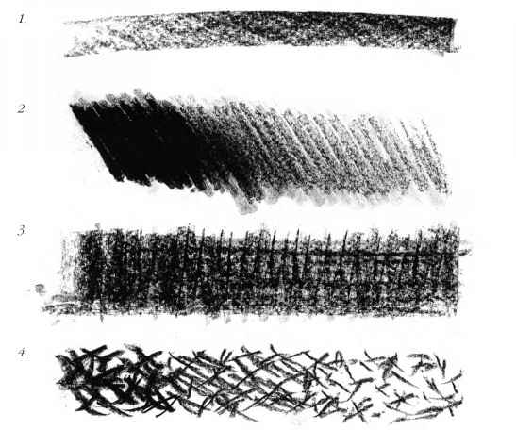  Watch video (watch from 2:40) with chn of artist modelling different ways of mark making using charcoal. Chn can then copy this in sketchbooks and even have a go at creating their own marks.
Key Vocabulary for the lesson | Charcoal, Laura Mckendry, Edgar Degas, gestural, mark making
Curriculum Links
Resources | Charcoal

Lesson 2
Access Art Lesson | Explore charcoal
Learning Intention | To create my own gestural drawing using charcoal  To explore different techniques using charcoal.
SOLO SC: Uni- Structural  Bronze | I can follow simple actions to create my own marks.  I can make different types of marks using charcoal.
SOLO SC: Multi- Structural  Silver | I can use charcoal in a variety of ways.  I can hold my charcoal in different ways to create different marks.
SOLO SC: Relational  Gold | I can create my own gestural drawing using charcoal  I can explain the different techniques I have used.
SOLO SC: Extended Abstract  Platinum | I can reflect on how my drawing shows I have thought about chiaroscuro  I can express which technique I prefer.
Activity  (What will the children do to demonstrate their understanding of the LI?) | In this lesson, chn will have the opportunity to explore and experiment with charcoal on a larger scale like Laura McKendry. As a warm up exercise, provide chn with sugar paper, explain that your voice is going to guide the marks they make so they need to listen carefully.  Action 1  Rub the charcoal on its side across the paper, and then move the dust around with your hand, to create a grey background.  Action 2  Hold the charcoal like a pencil and using the end, work back into the sheet, this time creating darker lines. How dark/fine can you get the marks?  Action 3  Use the compressed charcoal pencil to create even blacker lines.  Action 4  Use the dry brush to move the charcoal around, rather than your hand.  Action 5  Using the edge of the charcoal again, experiment with making dots, dashes, solid lines, broken lines. Let the lines and marks travel about your page.  Action 6  Use the white chalk to create white whites within your drawing. What kind of marks will you make?  Action 7  Use the eraser, brush or hand to smudge back.  Chn should have individual unique pieces creates which can then be stuck into sketchbooks (remember to hairspray to avoid transfer)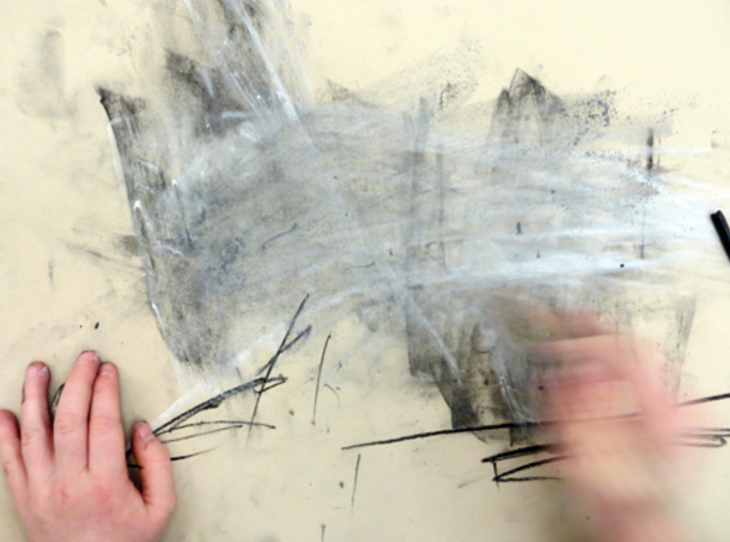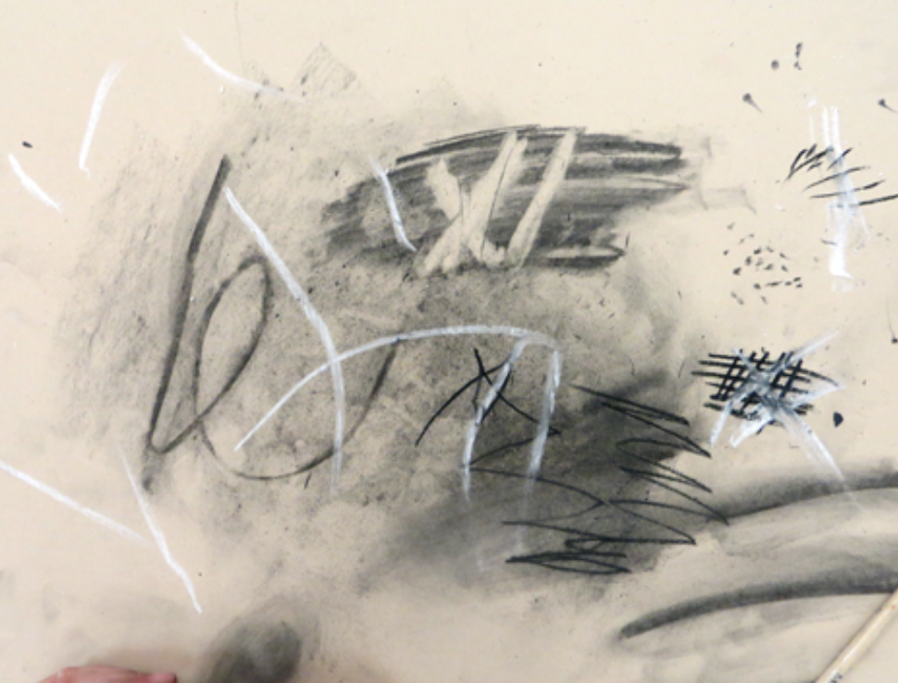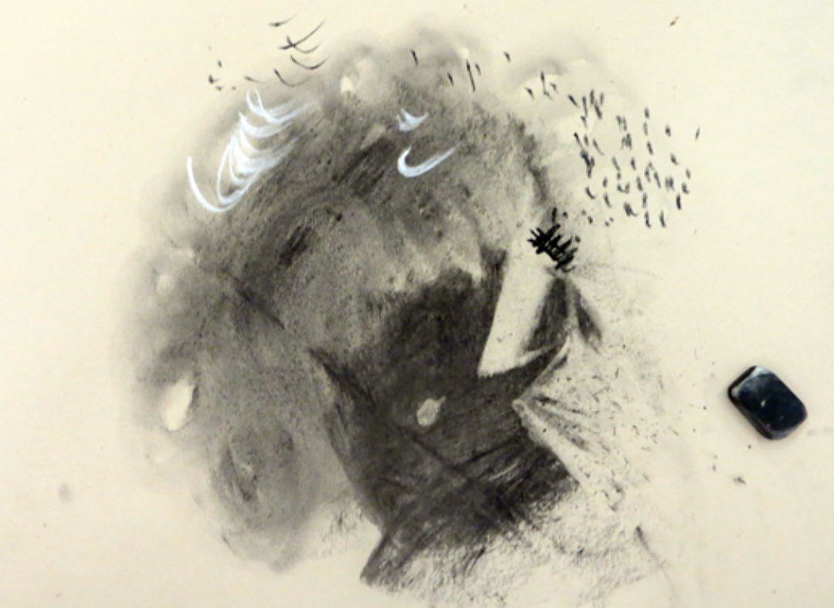  Explain to chn that when using charcoal as the main medium to create art, artists use the term chiaroscuro. This essentially means light to dark. It helps them create atmosphere and mood. Share images of artists work and discuss with the chn is it easy to identify the light source in the pictures?  Finally, chn will now create their own gestural drawings. This is when chn are able to use their whole body to work on large surfaces to create loose sketch like marks to create a drawing. Have a picture of a simple shape on the IWB for everyone to see such as a fossil or shell and chn can then create their own drawings on A3/A2 sugar paper using charcoal and chalk.  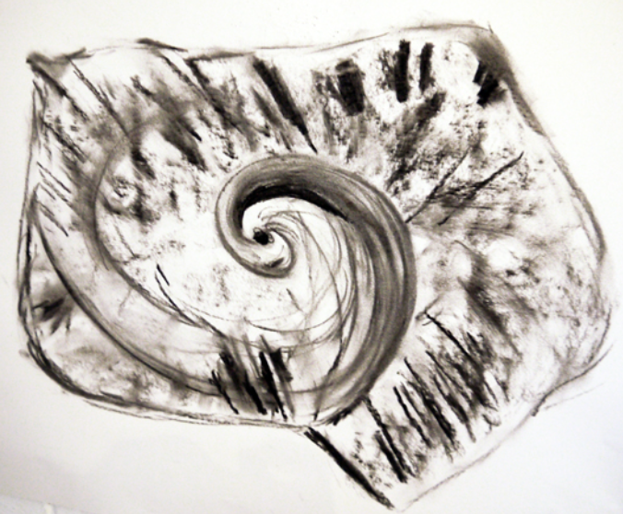
Key Vocabulary for the lesson | Charcoal, gestural, chiaroscuro, mark making, light, dark
Curriculum Links
Resources | Charcoal, white chalk, brushes, hairspray

Lesson 3
Access Art Lesson | Drawing like a cave person
Learning Intention | To create my own caveman drawing
SOLO SC: Uni- Structural  Bronze | I can define what a gestural drawing is.  I can discuss different gestural drawing techniques.
SOLO SC: Multi- Structural  Silver | I can describe what cave drawings look like
SOLO SC: Relational  Gold | I can create my own caveman drawing
SOLO SC: Extended Abstract  Platinum | I can use different body parts to create marks.
Activity  (What will the children do to demonstrate their understanding of the LI?) | Chn will continue with gestural drawings this week and look at cave drawings. Explore cave art with the chn by looking at the photos and videos of cave art found in France. Explain to the chn that these are some of the most significant prehistoric art sites and contain some of the best preserved figurative cave paintings in the world.  Discuss:  Describe what you can see in the cave paintings?  Which drawings are your favourites?  What material do you think they might have used to create these paintings?  How do you think it would feel to discover prehistoric cave paintings?  Why is it important that these paintings are preserved?  Invite chn to sit in a circle on the carpet and pretend there is a campfire in the middle to set the scene of the stone age. Tell the chn they will be creating their own cave art like they did in the stone age. Ask the chn what do you think cavemen drew with? Did they have brushes? Pencils? Wood? What will they use to make their marks?  After having this discussion, send chn back to places and challenge them to create their own cave drawings using paper, charcoal and their hands. Ask chn to draw around one hand to begin with and then use the techniques learnt in lesson 1 and 2 to see what other marks they could make in and around their hand. Encourage chn to use the other hand and even arm to smudge the charcoal.  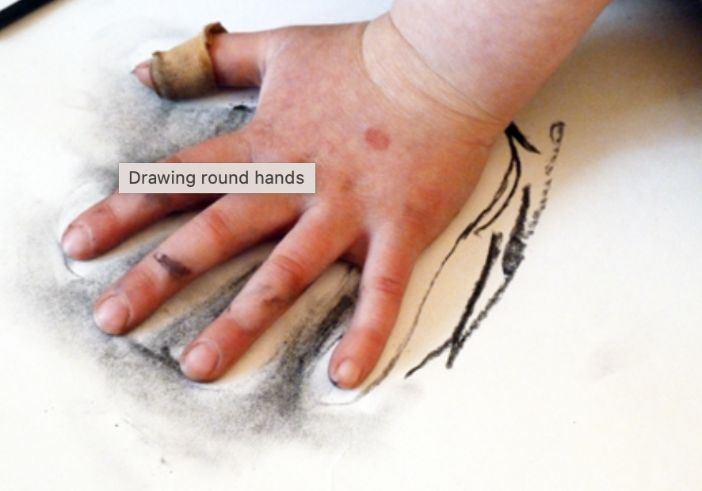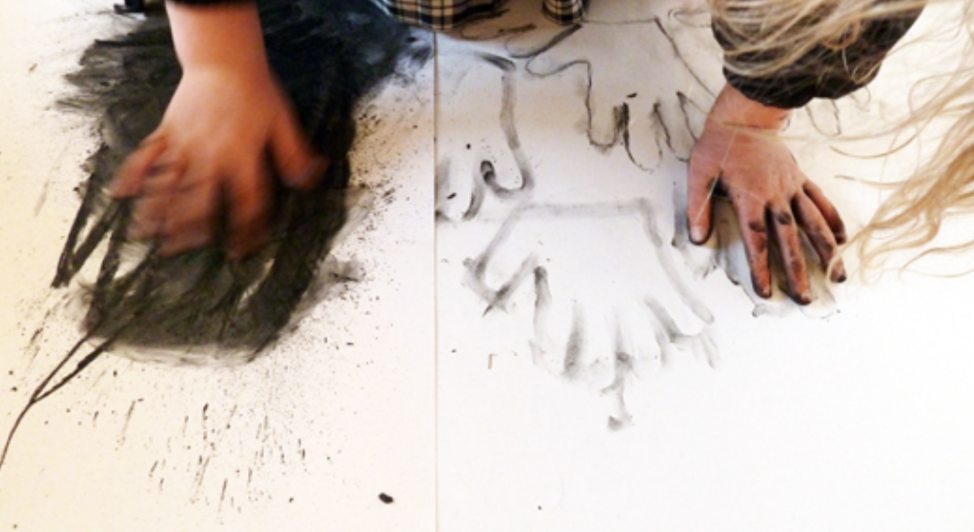  ASK CHN TO BRING IN SMALL TOYS/FIGURES OF THEIR CHOICE FROM HOME AS PART OF HOMEWORK
Key Vocabulary for the lesson | Charcoal, cave drawings, cavemen, stone age
Curriculum Links
Resources | Charcoal, sugar paper, hairspray

Lesson 4
Access Art Lesson | Charcoal project
Learning Intention | To create my own gestural drawing using charcoal
SOLO SC: Uni- Structural  Bronze | I can follow simple actions to create my own marks.
SOLO SC: Multi- Structural  Silver | I can use charcoal in a variety of ways.
SOLO SC: Relational  Gold | I can create my own gestural drawing using charcoal
SOLO SC: Extended Abstract  Platinum | I can reflect on how my drawing shows I have thought about chiaroscuro
Activity  (What will the children do to demonstrate their understanding of the LI?) | In this lesson chn will explore the idea of chiaroscuro further. They will be drawing by torchlight. Tell the chn that today they will be drawing in the dark. Chn can work on the carpet if this is more comfortable for them. Have chn take out the toys/figures they bought in from home and ask them to create a composition they are happy with on A2 sugar paper.  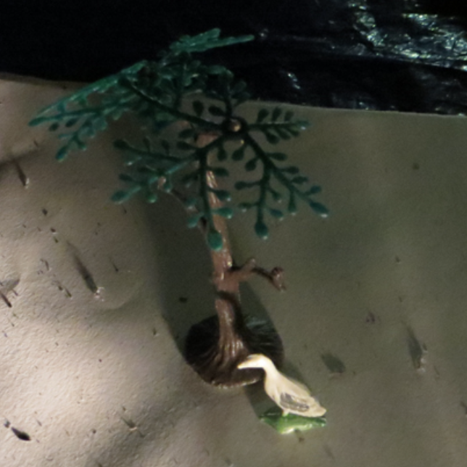  Now give each child a torch and ask them to shine it from different angles to see the shadow of the toy.  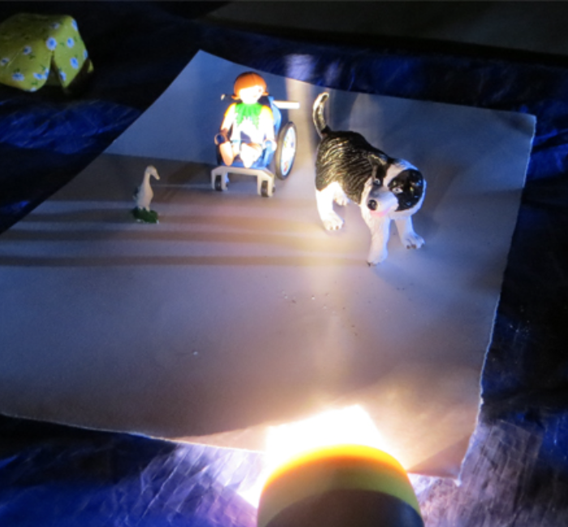  Chn can now use their charcoal to draw around the shadow roughly and once they can see the shape they can then begin to add detail using mark making. They can also use white chalk to create lines to show where the light source was coming from.  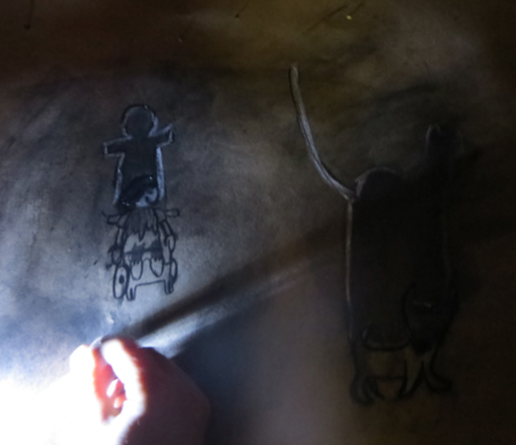  Once the lights are turned on, all the art work will be revealed and can be shared with their peers. Chn may naturally want to add further details onto their drawing which they can do.  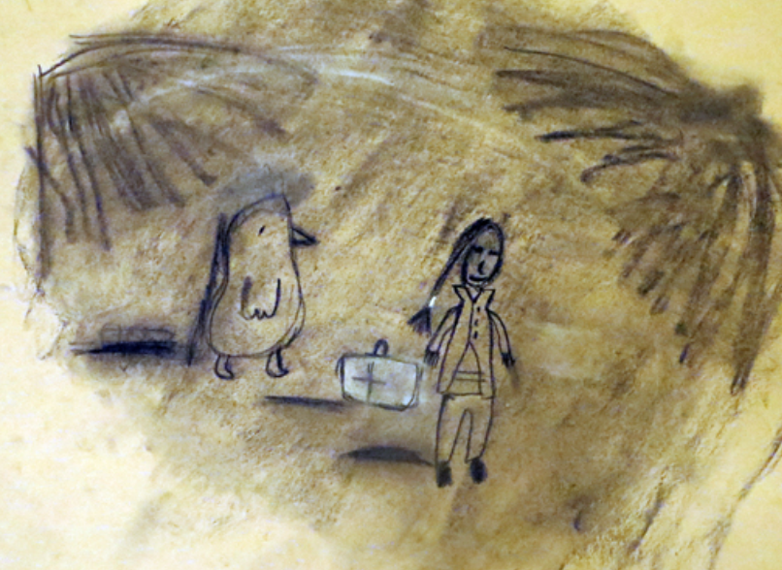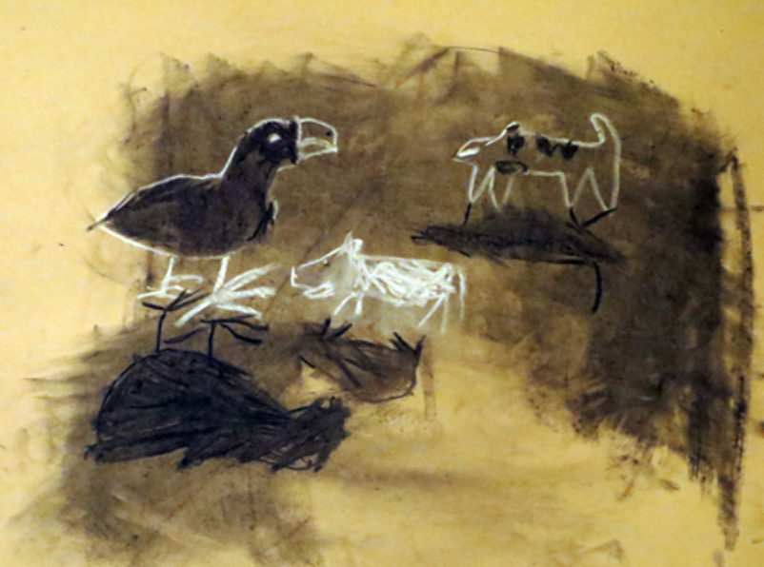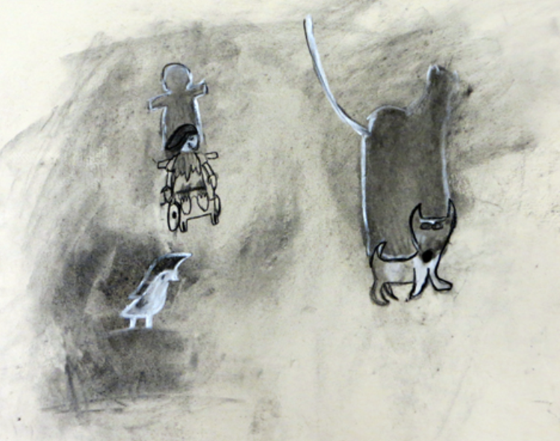  Create a mini gallery showing in the classroom if time in the same lesson use Crits in the Classroom resource to allow chn to self/peer reflect on their work.
Key Vocabulary for the lesson | Charcoal, chiaroscuro, gestural
Curriculum Links
Resources | Toys/objects, A2 sugar paper, charcoal, white chalk, brushes, erases, torches, hairspray

