Context
Unit |  | Access Art: Typography & Maps
Assessment |  | Final map created using paper and sketching techniques, demonstrating a knowledge of: typography, composition and overall aesthetic realisation.
Concepts - How does this unit fit in? |  | Significant Artists  (Historic) Neville Brody (typographer and graphic designer who is still alive) |  | Colour  Demonstrate a secure knowledge of how colour can be layered and can represent a mood / emotion. |  | Communication  Typography used as a creative communicative tool, to convey an emotion or message.
Access Art Lesson |  | Learning Intention | Art Skills  Skills Progression | Knowledge Concepts | Diversity | Local Art | Curriculum Links
1 | Cut Out Typography | To create my own typeface using cutting and collage. | D 8, 14, 16  DS 22, 24 | Significant Artist, Colour & Communication |  |  | Geography: maps
2 | Create your own typography | To use observational drawing to independently create my own typeface, recording texture and light. | D 8, 14, 15 | Colour & Communication |  |  | Geography: maps
3 | Block printing: letters | To print onto my collage, to build up layers, colour and texture. | D 11  TC 25, 29, 31  Pr 13, 14, 15, 17, 18 | Colour & Communication |  |  | Geography: maps
4 | n/a - Designing a road sign | To design and make my own typeface inspired by existing typography, to communicate emotion through a word. | D 8, 10, 14, 15  DS 22, 23, 24  Pr 13, 14, 15, 16, 17, 18  TC 25, 26, 29, 31 | Significant Artist, Colour & Communication |  |  | Geography: maps  Computing
5 | Reflect & Discuss: Crits in the classroom | I can present and share my artwork, explaining how my sketchbook work helped build my knowledge and skills towards my final piece. | D 10, 11, 14 | Significant Artist, Colour & Communication

Lesson 1
Access Art Lesson | Cut Out Typography
Learning Intention | To create my own typeface using cutting and collage.  To create my own typeface.
SOLO SC: Uni- Structural  Bronze | I can explore the typography designed by Neville Brody.
SOLO SC: Multi- Structural  Silver | I can identify and label the anatomy of typography.  I can represent letters using paper.
SOLO SC: Relational  Gold | I can create my own typeface using cutting and collage.  I can combine cutting and collage.
SOLO SC: Extended Abstract  Platinum | I can explore the translucent nature of media, to extend my artwork.  I can explore the translucent nature of tissue paper.
Activity  (What will the children do to demonstrate their understanding of the LI?) | In this lesson, chn will be introduced to the significant designer and typographer, Neville Body.  (Do not use the suggested artist on Access Art - typography examples do not match the outcome intentions of this unit.)  Chn should be taught the difference between ‘typography’ and ‘font’ and ‘typeface’ (see link for information) and how lettering in its own right, can be used to communicate a message / meaning/ feeling / mood. Chn must be given a selection of typography from which they can record first hand observation and explore ideas of design by Nevill Brody and make notes and annotations, referring to keywords and technical vocabulary. Know that as well as being legible, typefaces can be seen as works of art, to send a graphic message. Chn should select their favourite typefaces by Neville Brody, collect in sketchbooks and make annotations questioning and making thoughtful observations about the source material and select ideas and process to use in their work.  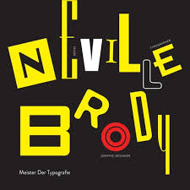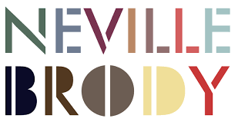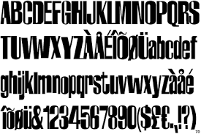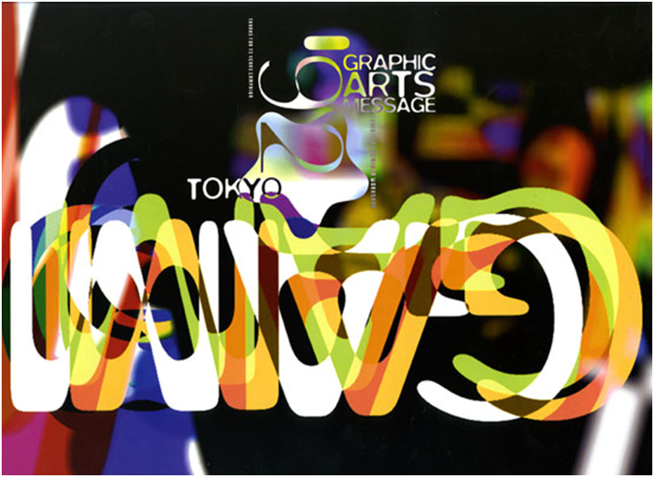  Notice that his typefaces are mainly sans serif and graphically bold. He layers colours to add texture to the image. Chn to discuss mood / emotion that different typefaces exude - bold, strong, fun, exciting, etc.  Chn to be introduced to the ‘Anatomy of Type’ and be given the opportunity in their sketchbooks, to annotate and label typefaces with technical vocabulary - watch the short ‘rubbermilk’ video.  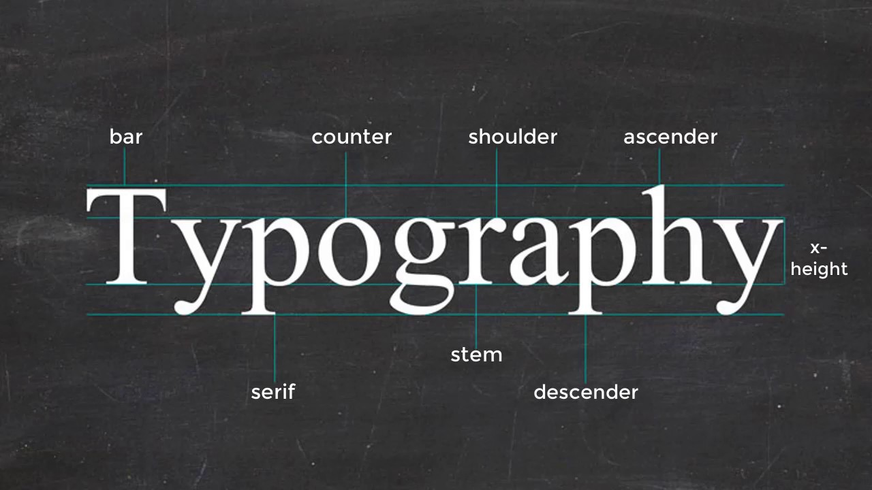  Chn will be invited to create their own Cut Out Typography. Chn will use paper, to cut out and create their own typography using a range of media (black sugar paper and tissue paper) to create a collage. Chn will layer cut out shapes of tissue papers over the black sugar paper, exploring the translucent nature of a range of media, to mimic the layering style of Neville Brody. Practise / experiment with layering first in sketchbooks before creating a larger typeface on separate paper. Choose overlayer tissue colour to reflect the mood/emotion of the typeface they are trying to create.  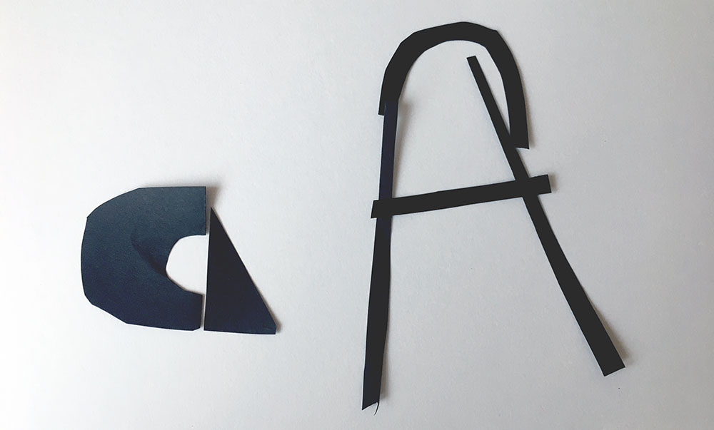 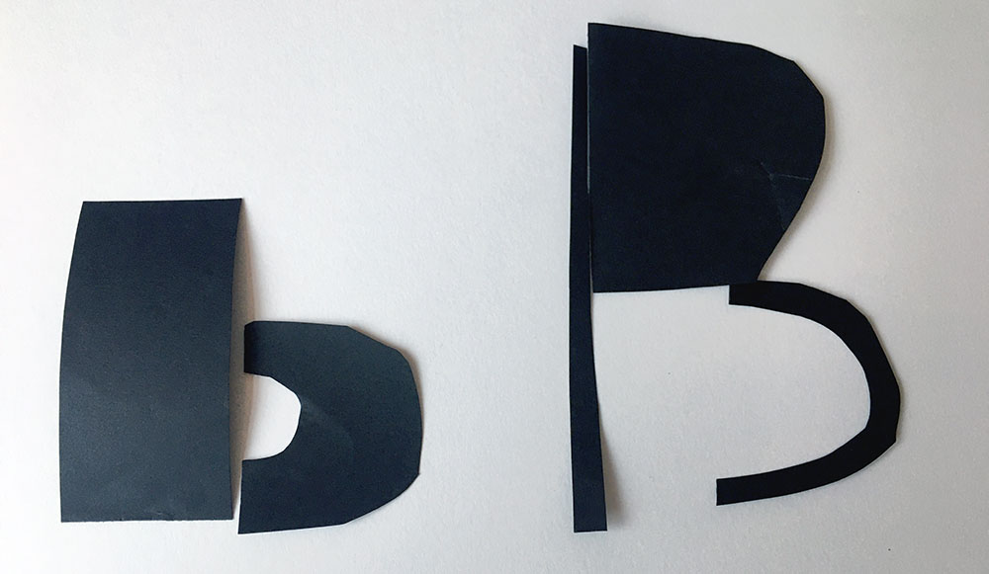 Chn should be made aware, that they will be adding and amending this typography over the following weeks. Experimental letters and tissue paper should be stuck into sketchbooks, to show experimentation with the paper media and translucent nature of some media. The main work should be on separate paper, stored carefully for the next session.
Key Vocabulary for the lesson | Typography, typeface, font, graphic design, serif, sans serif, bar, counter, shoulder, stem, ascender, descender, x-height
Curriculum Links | Geography: maps
Resources | Neville Brody typefaces, black sugar paper, coloured tissue paper, PVA glue, glue sticks, scissors, glue sticks, sketchbooks.

Lesson 2
Access Art Lesson | Create your own typography
Learning Intention | To use observational drawing to independently create my own typeface, recording texture and light.  To practise observational drawing.
SOLO SC: Uni- Structural  Bronze | I can select appropriate tools to create my sketch.  I can use everyday objects to create a specific effect.
SOLO SC: Multi- Structural  Silver | I can sketch an object using continuous contour line drawing.  I can sketch an object.
SOLO SC: Relational  Gold | I can use observational drawing to independently create my own typeface, recording texture and light.  I can show texture, light and shadow in a sketch.
SOLO SC: Extended Abstract  Platinum | I can adjust my sketch to explore the concept of perspective.
Activity  (What will the children do to demonstrate their understanding of the LI?) | Chn will record from first hand observation, experience and imagination, and explore ideas for different purposes by sketching found objects, and using their sketchbook to develop ideas. Chn will work in a sustained and independent way from observation, experience and imagination and will explore the potential properties of the visual elements, line, tone, pattern, texture, colour and shape. Chn will record the effect of light on objects from different directions, interpreting the texture of a surface and explore the concept of perspective.  Provide children with a range of found objects / take children on an object-finding walk. These objects will be used to create typefaces.  Get the children ready for observational sketching by using Continuous Line Drawing Exercise, in sketchbooks. Use sketching pens / black ink biros or handwriting pens - chn should be allowed to choose the ink pen tool of their choice. No pencils.  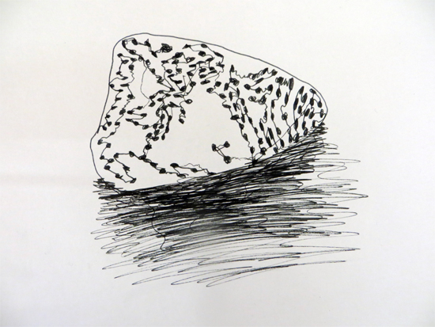  Once warmed up, chn to move onto the main activity - Create your own typography  To promote observational sketching further and to negate sketches turning ‘cartoon-like’, use the See 3 Shapes activities.  Chn to identify outlines, light, shadow and texture, once they have arranged their found objects into a letter form. Chn should record their sketches in their sketchbook.  Chn to explore ‘crosshatching pen shading technique - see YouTube video) and to practise by shading a 2D cube, to create the illusion of light and shadow.  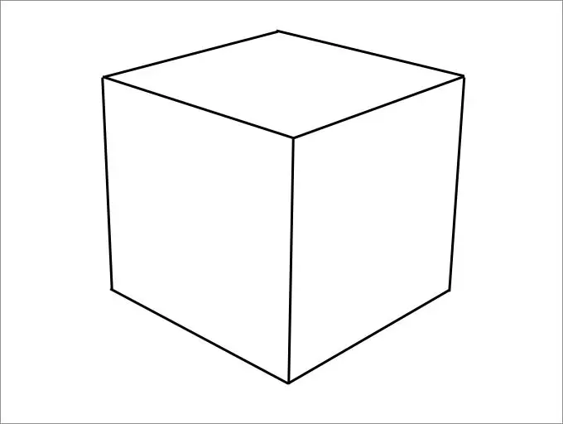  Chn should aim to create similar images:  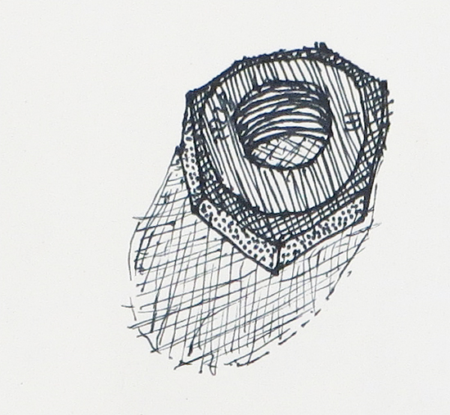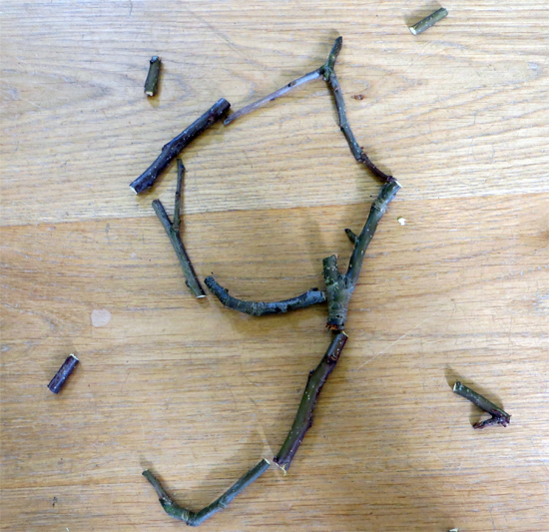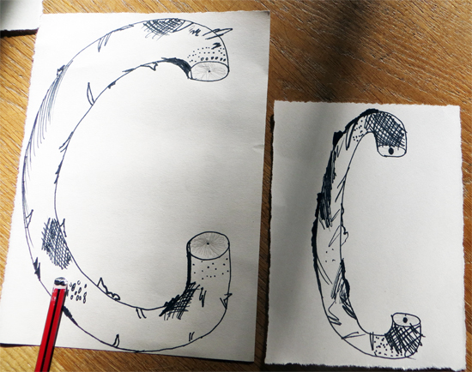
Key Vocabulary for the lesson | Typography, continuous contour line drawing, observation, light, dark, perspective,
Curriculum Links | Geography: maps
Resources | Various found objects, ink pens (handwriting pens, biros, etc), sketchbooks.

Lesson 3
Access Art Lesson | Block printing: letters
Learning Intention | To print onto my collage, to build up layers, colour and texture.  To create prints for my collage.
SOLO SC: Uni- Structural  Bronze | I can experiment with printmaking, in my sketchbook.
SOLO SC: Multi- Structural  Silver | I can recognise letters must be reversed, so that they print legibly.
SOLO SC: Relational  Gold | I can print onto my collage, to build up layers, colour and texture.  I can create prints for my collage.
SOLO SC: Extended Abstract  Platinum | I can combine prints to extend my work.
Activity  (What will the children do to demonstrate their understanding of the LI?) | 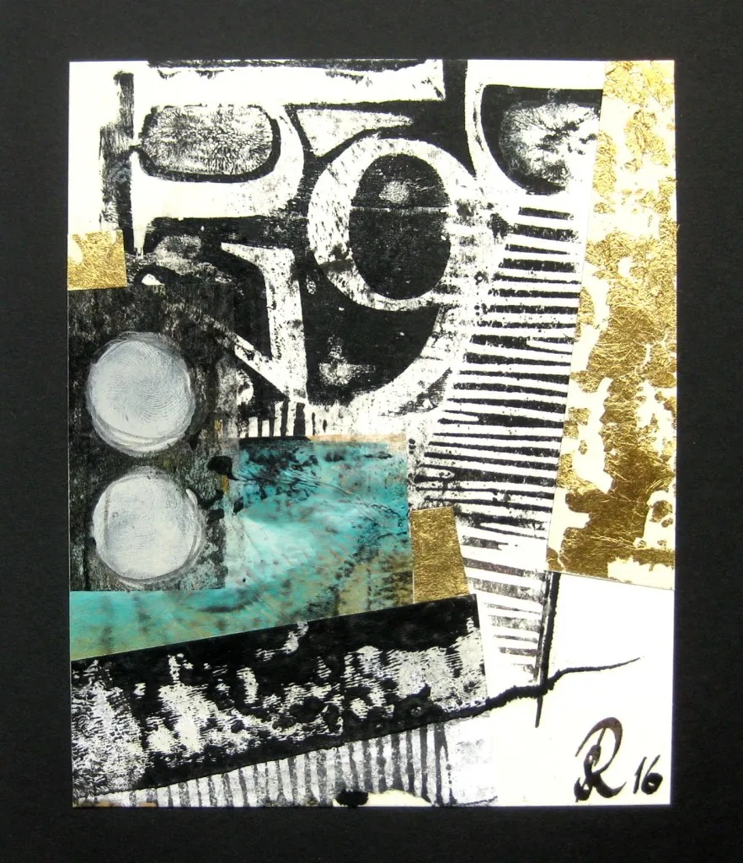  Chn will continue to explore creating their own typography using a range of media, using block printing to create their own printing typography. Chn will explore building up layers and colour, choosing inks and overlay styles. Chn will design and combine prints and will extend their previously made collage work using specific printing techniques and combine collage with other 2D techniques.  Children will use typography ideas produced last lesson, using found objects.  Chn should discuss the mood of their collage. What letters will add to that overall feeling.  Experiment by drawing letter forms onto foam and experiment in sketchbooks.  What letters will work on their collage? Upper / lowercase? Thick or thin? Use Block printing: letters and watch YouTube video Foam Block Prints.  Chn to select hand drawn typefaces that will complement the mood of the main collage and apply the typeface print to the collage.  Allow time for chn to experiment with layering media, by doing text prints in their sketchbook, over the cut paper experiments from the first lesson. Once confident, chn to apply print to their larger piece. Encourage chn to play with composition and to replicate / duplicate and experiment with position of text - does not need to be in a straight line - refer back to typography by Neville Brody and magazine covers, etc.  Chn may wish to use handdrwan type from sketchbook.  Demonstrate how to trace the sketch with tracing paper, and then place this on the foam block. Chn to see that the next step is to drawn onto the tracing paper, following the lines which will create the desired indents on the foam sheet, ready for printing.
Key Vocabulary for the lesson | Typography, continuous contour line drawing, block printing, composition, roller, plate, positive space, negative space, repetition, pattern
Curriculum Links | Geography: maps
Resources | Sketchbooks, printing ink, rollers, foam sheets, tracing paper, printing ink.

Lesson 4
Access Art Lesson | n/a - Designing a roadsign
Learning Intention | To design my own typeface inspired by existing typography, to communicate emotion through a word.  To design my own typeface.
SOLO SC: Uni- Structural  Bronze | I can select typography examples that suit my design.
SOLO SC: Multi- Structural  Silver | I can explain my choice of typography, justifying why it communicates a message about my location.  I can select colours to reflect my chosen word.
SOLO SC: Relational  Gold | I can design my own typeface inspired by existing typography, to communicate emotion through a word.  I can use colours and techniques to convey emotions about my word.
SOLO SC: Extended Abstract  Platinum | I can extend by design by layering colour and print.
Activity  (What will the children do to demonstrate their understanding of the LI?) | Chn should recall facts about the significant designer, Neville Brody and recall what the purpose of typography is - to communicate a message, through the composition of letters. Chn will draw upon ideas, methods and approaches in their own and others’ work and say what they think and feel about them. Chn will adapt their work according to their views and will use a sketchbook to develop their ideas. Chn will use a variety of source material of various street, road and rail signs. Discuss the purpose of typography in these instances - to be clear so as to inform and give directions.  Task: Chn will design their own roadsign for their favourite place - somewhere they have travelled to, a setting in a story book, etc.  - Chn will choose a word, no longer than 5-6 letters, that sum up the emotion they feel when they recall this place, e.g: Charlie and the Chocolate Factory = TASTY, or Disneyland = HAPPY, or London Underground = NOISY.  Allow chn time to collect visual information from a variety of sources by researching digital typefaces (DaFont, 1001 fonts) to inspire ideas.  Clip/crop and paste, no more than 3 favourite typefaces onto GoogleSlides into Google Classroom, so that chn can refer to these images while they design. (See Digital Lead if unsure how to set this up)  .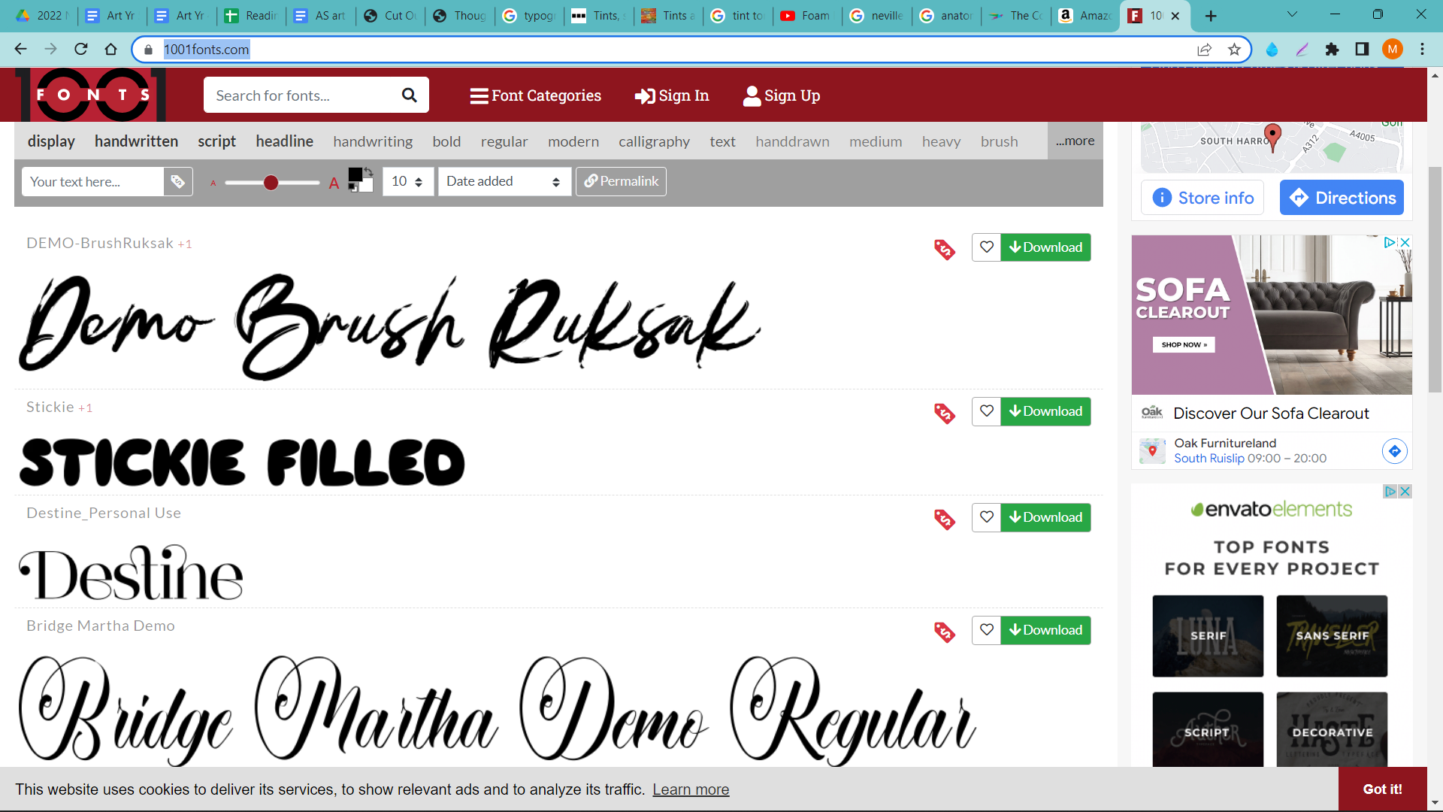  Chn will choose the printing method appropriate to the task by building up layers and colours/textures, choose inks and overlay styles and will create their own mixed media collage extending their work with specific techniques.  Chn will cut out and create their own typeface, layering with colour through ink printing or paper overlay. Chn will extend their artwork by designing a hand drawn typeface, which compliments their paper cut typeface, which will be layered onto the collage.  Encourage chn to create an interesting background, using various coloured and printed paper - or whatever suits their composition and mood/emotion they are creating.
Key Vocabulary for the lesson | Typography, typeface, font, composition, graphic design, serif, sans serif, bar, counter, shoulder, stem, ascender, descender, x-height, translucent, mixed media, layering.
Curriculum Links | Geography: maps
Resources | Sketchbooks, black sugar paper, coloured tissue paper, PVA glue, glue sticks, scissors, glue sticks, printing ink, rollers, foam sheets, tracing paper, printing ink,

Lesson 5
Access Art Lesson | Reflect & Discuss: Crits in the classroom
Learning Intention | To present and share my artwork, explaining how my sketchbook work helped build my knowledge and skills towards my final piece.
SOLO SC: Uni- Structural  Bronze | I can name art techniques I used to make my collage.
SOLO SC: Multi- Structural  Silver | I can describe the processes I used to create my artwork.
SOLO SC: Relational  Gold | I can present and share my artwork, explaining how my sketchbook work helped build my knowledge and skills towards my final piece.
SOLO SC: Extended Abstract  Platinum | Can reflect on my artwork and justify my decisions using art vocabulary.
Activity  (What will the children do to demonstrate their understanding of the LI?) | Once chn have been given time to finalise their artwork, chn will use this session to evaluate their own, and one another’s artwork, whether completed or not. A time to compare ideas, methods and approaches in their own and others’ work and say what they think and feel about them; to reflect and focus thoughts, and to listen to feedback from others. Chn will learn how to talk about others’ and their own art which is all part of making art. This process is called a Crit (Critique). Chn should be encouraged to discuss how they will/might adapt their work according to their views and describe how they might develop it further.  Use a large area to congregate and to display work and allow time for children to observe everyone’s work.  Children’s sketchbooks should be open and accessible, so that they can refer back to their initial sketch ideas so they can speak freely about their process of creating their final artwork.  Use ideas on ‘Crits in the Classroom’ page, as a guide to holding a successful crit.  Chn should be encouraged to use art vocabulary encountered during this unit as well as referring back to and comparing their work with the significant artist: composition, use of colour, effect of light on objects, use of print pattern and mixed media.  Show children a recognisable movie poster e.g. ‘Frozen’ or ‘Lightyear’ -  Think! Question - ‘Why was this typeface chosen to represent the name of this film?’  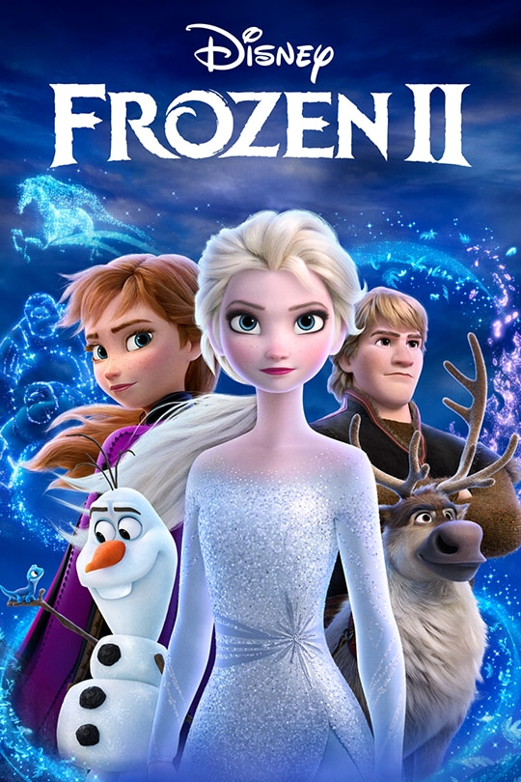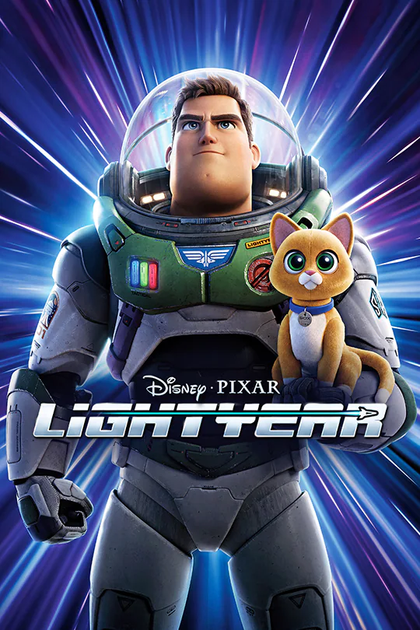  Artwork must be displayed and celebrated on a corridor board, with child’s name clearly printed. Art can be sent home once art is removed from board.
Key Vocabulary for the lesson | Crit / Critique,
Curriculum Links | Geography: maps
Resources | Materials needed to complete artwork, space to display work / congregate, children’s artwork

Assessment Think! Question | ‘What colour and print techniques would you choose, if you were to create a collage of another still life?’
Tasks | Show children recognisable movie posters and chn to analyse the typography to answer the Think! questions.  Chn to consider Think! Question and to respond appropriately verbally / in sketchbooks.
Key Vocabulary for the lesson | Choose from key vocabulary used this term used during this unit.
Curriculum Links | Geography: maps
Resources | Think! Question.

