Context
Unit |  | Access Art: Exploring Still Life (option1 Cut Paper Collage & Batik)
Assessment |  | Final cut paper collage created using mixed media, demonstrating a knowledge of: colour theory, print, texture, pattern and the effect of light.
Concepts - How does this unit fit in? |  | Significant Artists  Y3:  Y4: Paul Cezanne - Still Life  Hilary Pecis |  | Colour  Experiment with colour mixing and matching e.g. tint, tone and shade. Make and match colours with increasing accuracy |  | Communication  Painting, collage, sketching and Batik, to express observation of objects, surroundings and emotion. Bringing meaning to the objects around us and using composition to help give meaning to work.
Access Art Lesson |  | Learning Intention | Art Skills  Skills Progression | Knowledge Concepts | Diversity | Local Art | Curriculum Links
1 | Introduce artists: Paul Cezanne and Hilary Pecis | To demonstrate my observational drawing skills of an object by sketching the effect of light, scale and proportion. | D 8, 9, 10, 13 | Significant Artist, Colour & Communication |  |  | CT to add
2 | Cut Paper Collage Still Life | To choose and select from a variety of materials to create visually interesting print patterns. | P 15, 16, 17, 19, 21  Pr 10, | Colour and Communication |  |  | CT to add
3 | Cut Paper Collage Still Life | To demonstrate my understanding of tone and shade by altering my collage with paint. | DS 18, 19  P15, 18, 19, 20, 21  Pr 10, 11, 12  TC 17, 19, 20, 22, 24 | Colour and Communication |  |  | CT to add
4 | Making Batik textiles in the classroom | To extend work that I have already achieved by using Batik resist printing to further explore line and pattern. | DS 16, 17, 18, 19  Pr 10, 11, 12  TC 18, 19, 20, 22, | Colour and Communication | Cultural use of Batik / links to chn’s own experiences |  | CT to add
5 | Reflect & Discuss: Crits in the classroom | To present and share my artwork, explaining how my sketchbook work helped build my knowledge and skills towards my final piece. | D 10, 11 | Significant Artist, Colour & Communication |  |  | CT to add

Lesson 1
Access Art Lesson | Exploring Still Life
Learning Intention | To demonstrate my observational drawing skills of an object by sketching the effect of light, scale and proportion.
SOLO SC: Uni- Structural  Bronze | I can explore the still life work of Paul Cezanne and Hilary Pecis.
SOLO SC: Multi- Structural  Silver | I can examine art and express my thoughts about other artists’ work.
SOLO SC: Relational  Gold | I can demonstrate my observational drawing skills of an object by sketching the effect of light, scale and proportion.
SOLO SC: Extended Abstract  Platinum | I can independently explore relationships between line and tone, pattern and shape, line and texture.
Activity  (What will the children do to demonstrate their understanding of the LI?) | In this lesson, the chn will be introduced to various Still Life artists and how they communicate a thought / feeling through observation of objects around them, using colour, pattern line and texture. Know and discuss work by significant artist Paul Cezanne and contemporary artists Hilary Pecis - how do these artists use colour and composition in their work? Collect images of artists’ work in a sketchbook. Record notes and annotate feelings and ideas about the artists’ work in sketchbook.  Chn will develop their observational drawing skills and deepen their understanding of form by recording from first hand observation in their sketchbooks and making informed choices using various sketching media. Chn will sketch the effect of light, proportion and placement and explore relationships between line and tone, pattern and shape, line and texture using the See 3 Shapes activities.  Objects used for the still life should be chosen with bold, replicable patterns and texture.  The still life set up used during this session will directly correspond to the final outcome. Each class may choose different objects relating to their linked curriculum unit.  Share with children the outcome that they will be producing: show collage ‘still life jugs’ and Batik fabric fish print and that their still life images will be of the objects that have been provided.  Chn to know objects that the sketches they produce from this session, will inform what shapes they will be cutting out, so as to create their collage.  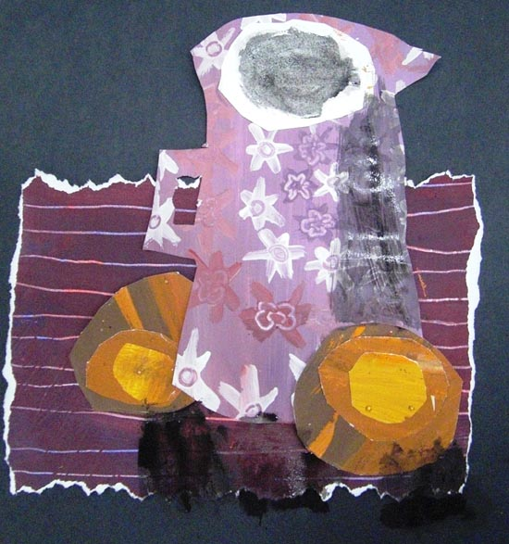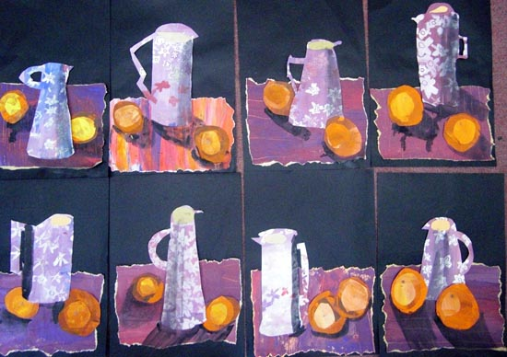  Objects chosen for still life 3 shapes activity, and during this unit, should correlate with a unit being taught in the Yr4 Curriculum.  - Curriculum unit to link with art: CT to add  - Objects to source for still life: CT to add
Key Vocabulary for the lesson | Gestural drawing, fluid marks, outline, form, highlight, shadow, texture, line, composition, still life.
Curriculum Links | CT to add
Resources | Poster paint, various objects CT to add, water pots and brushes

Lesson 2
Access Art Lesson | Cut Paper Collage Still Life
Learning Intention | To choose and select from a variety of materials to create visually interesting print patterns.
SOLO SC: Uni- Structural  Bronze | I can use careful observation to distinguish between different textures.
SOLO SC: Multi- Structural  Silver | I can select paint colours which match observed objects, with increasing accuracy.
SOLO SC: Relational  Gold | I can choose and select from a variety of materials to create visually interesting print patterns.
SOLO SC: Extended Abstract  Platinum | I can explore colour to reflect mood.
Activity  (What will the children do to demonstrate their understanding of the LI?) | Chn should recall knowledge of their significant and contemporary focus artists - discuss colour and composition. Chn will be creating the patterned / textured paper that will be cut out to create their still life composition.  Through observation of the still life objects, the chn will make and match colours with increasing accuracy, planning and creating different effects and textures with paint according to what they need for the task. They will choose paints and implements appropriately and should be encouraged to explore colour to reflect mood (an idea which will have been discussed when exploring the significant and contemporary artists). During this session, chn should begin to think about how they will create texture and pattern. A selection of creative tools should be provided (eg: sponges, bubble wrap, small brushes, etc.) to aid creative thought so that they can select broadly the kinds of material to print with in order to get the effect they want.  Children should select tools and materials to layer paint and create pattern and texture.  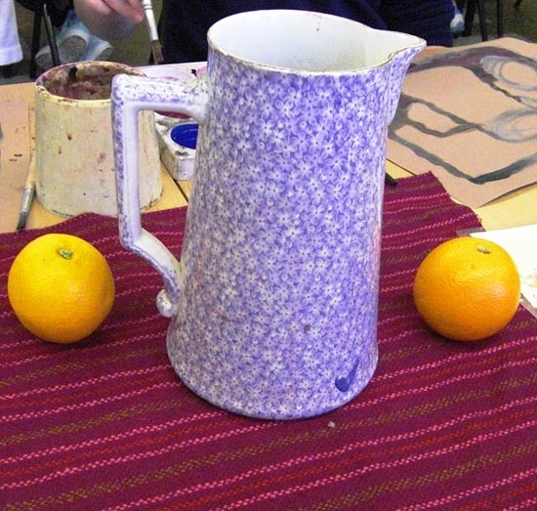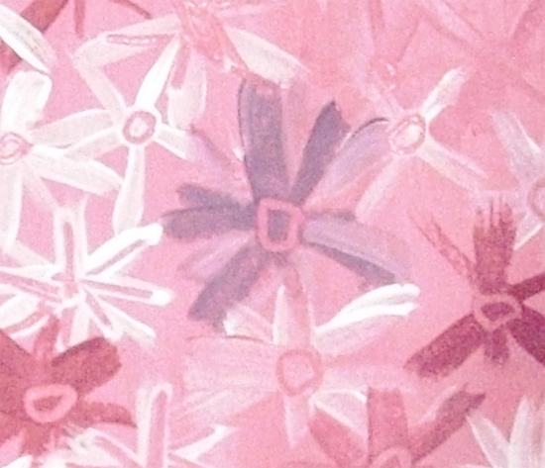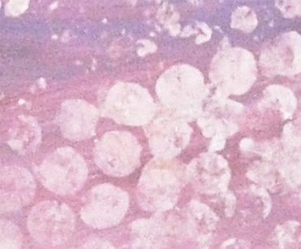
Key Vocabulary for the lesson | Texture, line, composition, still life, pattern, material, colour, mood / emotion
Curriculum Links | CT to add
Resources | Sugar paper, poster paint, brushes, palettes, water pots, sponges, bubble wrap (and other items CT to add  that can create interesting print patterns).

Lesson 3
Access Art Lesson | Cut Paper Collage Still Life
Learning Intention | To demonstrate my understanding of tone and shade by altering my collage with paint.
SOLO SC: Uni- Structural  Bronze | I can choose appropriate painting tools.
SOLO SC: Multi- Structural  Silver | I can use specific colour vocabulary and mix paint, accurately.
SOLO SC: Relational  Gold | I can demonstrate my understanding of tone and shade by altering my collage with paint.
SOLO SC: Extended Abstract  Platinum | I can alter my collage using tonal values of paint.
Activity  (What will the children do to demonstrate their understanding of the LI?) | Chn should recall knowledge of their significant and contemporary focus artists - discuss colour and composition. Understand tint, tone, hue and shade and experiment with colour mixing to produce variations of colour, with confidence. Chn will cut out object shapes from their painted pattern paper, to create their still life composition. Apply knowledge of light and shadow and colour mixing, to the composition.  Revisiting work in sketchbooks, chn should discuss tonal value of colour, by discussing the effect of light on an object. Chn must experiment with colour mixing and matching e.g. tint, tone and shade - painting must be recorded in sketchbooks. ( Info on Tint, Tone and Shade - Tint and Shade activity on YouTube.Chn should annotate sketchbooks, showing understanding of mixing white and black using more specific colour language eg. Tint, tone, shade and hue. This can be done straight into sketchbooks or, to allow to dry separately, can be done on a separate piece of paper which can be stuck into books later.  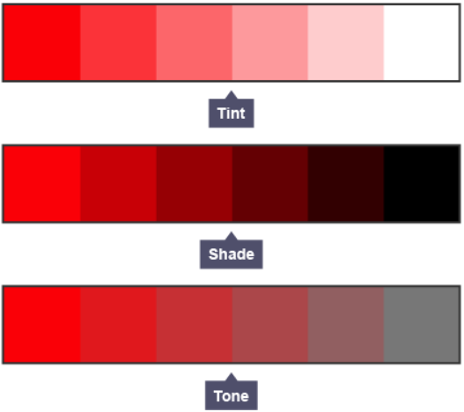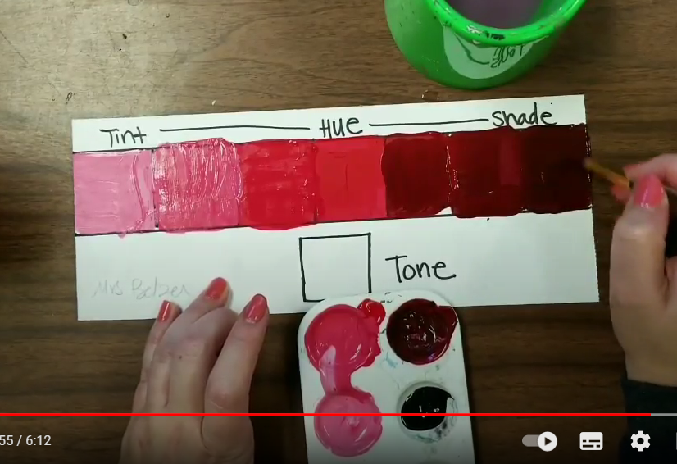  Chn will then work from a plan (from their sketchbooks) to create a collage, exploring positive and negative shapes and patterns with interlocking shapes, as they cut out and build their collage composition.  Once the composition is in place, encourage children to refine their print using a variety of techniques, including applying their knowledge of the effect of light and hue, tint, tone and shade and to refine and alter their ideas - apply black and white paint to create shadow and highlights on areas of the print collage.  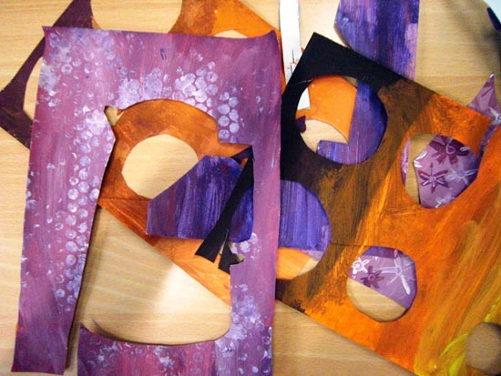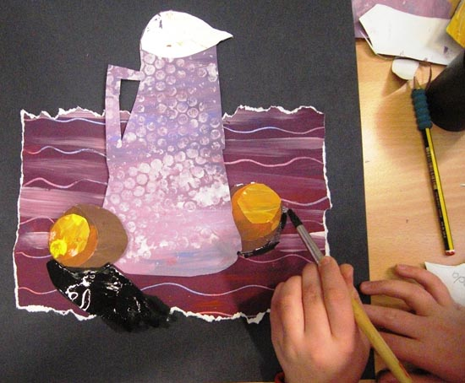
Key Vocabulary for the lesson | Texture, composition, still life, pattern, hue, tint, tone, shade, collage, mixed media, shadow
Curriculum Links | CT to add
Resources | ‘Tint, Tone and Shade activity sheet’, Sugar paper, poster paint, brushes, palettes, water pots, sponges, bubble wrap (and other items CT to add  that can create interesting print patterns).

Lesson 4
Access Art Lesson | Making Batik textiles in the classroom
Learning Intention | To extend work that I have already achieved by using Batik resist printing to further explore line and pattern.
SOLO SC: Uni- Structural  Bronze | I can use a variety of tools to create a print.
SOLO SC: Multi- Structural  Silver | I can discuss how I can alter my composition, using art vocabulary.
SOLO SC: Relational  Gold | I can extend work that I have already achieved by using Batik resist printing to further explore line and pattern.
SOLO SC: Extended Abstract  Platinum | I can further explore colour and mood using fabric dyes.
Activity  (What will the children do to demonstrate their understanding of the LI?) | Chn should recall knowledge of their significant and contemporary focus artists - discuss colour and composition. Children will be challenged to refine and alter their ideas; to reimage the composition of their collage by adding textiles as a means of extending work already achieved.  Introduce Batik and the idea of ‘resist printing’. Chn to know where Batik is used commonly in the world / culturally and the aesthetic look that is created using this style of printing.  Chn to choose a small element of their design which they will recreate using the resist printing technique of Batik. Chn will explore positive and negative shapes and patterns and match tools to the materials. Chn will be introduced to specific resist printing tools and vocabulary and will understand the safety elements of using these tools.  Chn will recall/revist still life sketching in sketchbooks and reflect on work already achieved, which will inform the textile sketch print they create. Chn to consider the size and composition of their print-paper collage and to choose a suitable size piece of fabric. Chn may wish to recreate a pattern, texture or object that features on their collage.  Chn to follow step of how to create a Batik print - Making Batik textiles in the classroom  SAFETY - Hot iron will be used to transfer wax sketches from paper to cotton fabric. Iron must be operated by an adult. Iron must be left to cool, away from children’s reach.  SAFETY - Hot electric paraffin wax melting pot. Hot melted paraffin wax. Tjanting metal tip will heat up and will drip hot paraffin wax. Chn must work around paraffin wax melting pot, in small groups under supervision of an adult. If hot wax drips on skin, run the burnt area under cold water and send the casualty to Medical.  (To manage the task safely, while majority of the chn are working on the previous step of their collage, have small breakaway groups to create Batik)  Video - How to use a Tjanting Tool  Tips - stretch fabric over a piece of cardboard, secured with masking tape, so that a flat surface is created upon which to draw with wax.  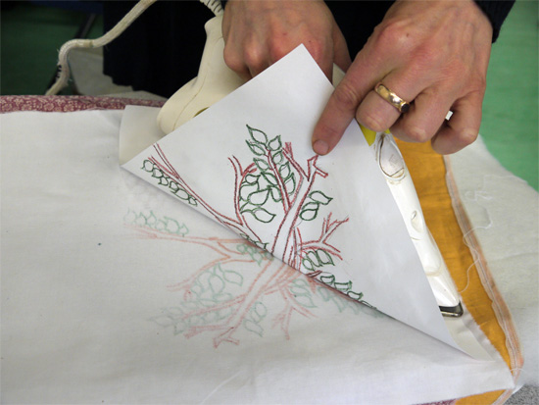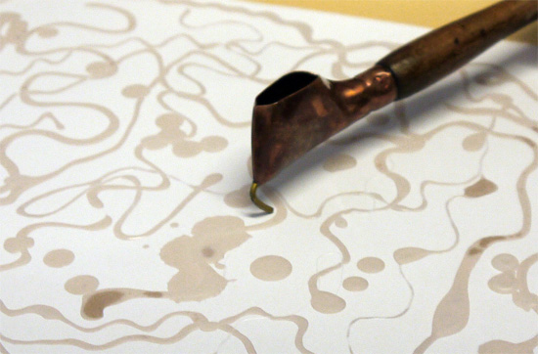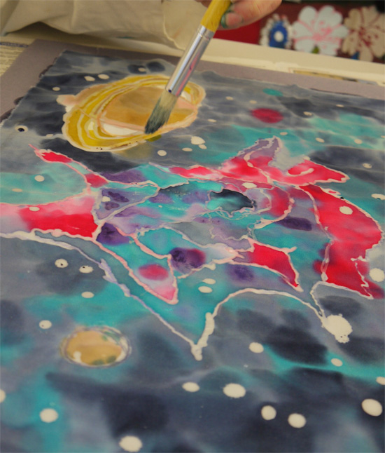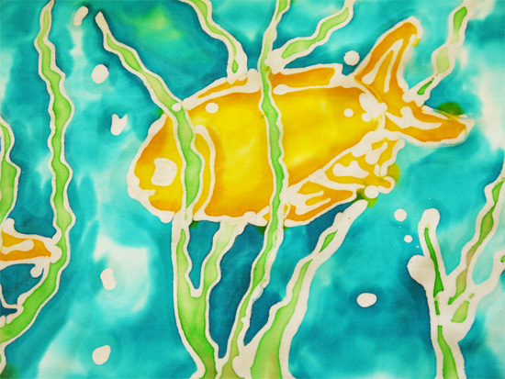  Chn should be encouraged to draw upon their Colour Theory and knowledge of colour and emotion, to add fabric inks to their resist Batik print.  Printed fabric should be ironed onto absorbent paper, to remove wax.  Children can choose whether they wish to add finished Batik print to their collage.  If not, stick Batik swatches into sketchbook. Chn to annotate Batik sample, explaining how they created the resist print, and to include technical vocabulary.  TOOLS / EQUIPMENT must be cleaned of wax after use and stored in Year 4 classroom cupboards, when cool. This equipment cannot be replaced. This is the responsibility of the adult.  Leftover wax should be poured onto a receptacle, for reuse.  Tjantings require heating and wiping to remove excess wax and when cool, using a paperclip, the pour spout should be driven through to ensure no clogged wax remains.
Key Vocabulary for the lesson | Texture, line, composition, Batik, tjanting, paraffin wax, iron, transfer
Curriculum Links | CT to add
Resources | Cardboard, masking tape, tjantings, paraffin wax, paraffin wax melts, iron, wax crayons, pre-cut pieces of cotton fabric

Lesson 5
Access Art Lesson | Reflect & Discuss: Crits in the classroom
Learning Intention | To present and share my artwork, explaining how my sketchbook work helped build my knowledge and skills towards my final piece.
SOLO SC: Uni- Structural  Bronze | I can name art techniques I used to make my collage.
SOLO SC: Multi- Structural  Silver | I can describe the processes I used to create my artwork.
SOLO SC: Relational  Gold | I can present and share my artwork, explaining how my sketchbook work helped build my knowledge and skills towards my final piece.
SOLO SC: Extended Abstract  Platinum | Can reflect on my artwork and justify my decisions using art vocabulary.
Activity  (What will the children do to demonstrate their understanding of the LI?) | Once chn have been given time to finalise their artwork, chn will use this session to evaluate their own, and one another’s artwork, whether completed or not. A time to compare ideas, methods and approaches in their own and others’ work and say what they think and feel about them; to reflect and focus thoughts, and to listen to feedback from others. Chn will learn how to talk about others’ and their own art which is all part of making art. This process is called a Crit (Critique). Chn should be encouraged to discuss how they will/might adapt their work according to their views and describe how they might develop it further.  Use a large area to congregate and to display work and allow time for children to observe everyone’s work.  Children’s sketchbooks should be open and accessible, so that they can refer back to their initial sketch ideas so they can speak freely about their process of creating their final artwork.  Use ideas on ‘Crits in the Classroom’ page, as a guide to holding a successful crit.  Chn should be encouraged to use art vocabulary encountered during this unit as well as referring back to and comparing their work with the significant artist: composition, use of colour, effect of light on objects, use of print pattern and mixed media.  Show children a different still life images -  Think! Question - ‘What colour and print techniques would you choose, if you were to create a collage of this still life?’  Artwork must be displayed and celebrated on a corridor board, with child’s name clearly printed. Art can be sent home once art is removed from board.
Key Vocabulary for the lesson | Crit / Critique, still life, Paul Cezanne, mixed media, tint, tone, shade, pattern, texture, negative and positive space, composition, Batik, resist printing.
Curriculum Links | CT to add
Resources | Materials needed to complete artwork, space to display work / congregate, children’s artwork

Lesson 6
Assessment Think! Question | ‘What colour and print techniques would you choose, if you were to create a collage of another still life?’
Tasks | Show children the image of a different still life (found on the internet - which may link to the same curriculum link or another unit/book being studied by the year group).  Chn to consider Think! Question and to respond appropriately verbally / in sketchbooks.
Key Vocabulary for the lesson | Choose from key vocabulary term used during this unit.
Curriculum Links | CT to add
Resources | Still life image, Think! Question.

