Context
Unit |  | Spirals (linked to
Assessment
Concepts - How does this unit fit in? |  | Significant Artists  Molly Haslund: Outdoor Circles  Tracy McGuinness Kelly: drawing snails |  | Colour  Children will be experimenting with different mediums (chalk, soft pencils, graphite sticks and pastels) to create different tones and have the choice of what colours they like to use. They will experiment with water and observe what it does when added to paint. |  | Communication  This unit will explore the idea of creating different patterns through whole body movement, explore mark-making and explore spirals which will lead to conversations about growth, movement and structure.
Kapow Lesson |  | Learning Intention | Art Skills  Skills Progression | Knowledge Concepts | Diversity | Local Art | Curriculum Links
1 | L1: Make drawings using your body | To relate my spiral drawing to parts of my body and create a spiral drawing. | DE1, DS1, DS2, | Significant artist, pattern, physical movement |  |  | CT to add
2 | L2: Develop your drawings | To apply my sketching skills to develop my spiral drawing. | DE3, DE4, DS1, DS2 | Significant artist, Pattern, physical movement, colour |  |  | CT to add
3 | L3: Observational Drawing: Continuous Line | To apply my drawing skills to make an observational drawing. | DE1,DE2,DS2 | Pattern, physical movement, colour, observation |  |  | CT to add
4 | L4: Experimental Mark-Making with Water Soluble Pens | To observe how my drawing changes when water is added. | DS2 | Pattern, physical movement, colour, observation |  |  | CT to add
5 | L5: Celebrate children's work | To explain the skills I have learnt this term and present my work to the class. | DE2, DE3, DE4 | Pattern, physical movement, colour, observation |  |  | CT to add

Lesson 1
Access Art Lesson | L1: Make drawings using your body
Learning Intention | To relate my spiral drawing to parts of my body - head, hand and heart.
SOLO SC: Uni- Structural  Bronze | To identify what body parts I will use to create my drawing.
SOLO SC: Multi- Structural  Silver | I can describe what movements I will need to make with my body to create a spiral.
SOLO SC: Relational  Gold | I can relate my spiral drawing to parts of my body and create a spiral drawing.
SOLO SC: Extended Abstract  Platinum | I can create several spirals using different mediums
Activity  (What will the children do to demonstrate their understanding of the LI?) | This lesson will introduce children to the idea that making a drawing is a physical activity which uses the whole body and connects head, hand and heart.  Children will explore using their whole body to create a large scale spiral using charcoal or graphite pencils. Whilst creating the spirals, play some music to encourage children to draw by letting the tune guide how big or small the spiral should be - Spiral Drawings (watch video with children).  Look at artist Molly Haslund, watch video of children creating circles using life size compasses. The focus of Molly Haslund’s work is on the physical action, on the movement of the circles, and the patterns emerging and disappearing again. Have a discussion about her work using the question prompts:  How would you feel if you came across these circles in your street or playground, without knowing who had made them or why? What would you do? Would they change the way you move?  How do you think Molly, the artist, chooses where to make her circles?  How could you make similar circles in your playground, using chalk tied to sticks?  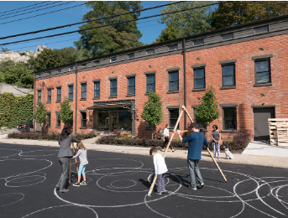  Respond to Molly Haslund’s work by asking children to make a tool that creates a circle when it has a drawing material attached. Use sticks from outside and chalk to make this tool. Children can practice making circles using their tool in the playground. Take photos of children's work.  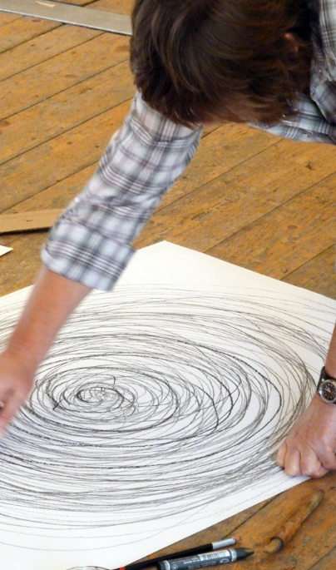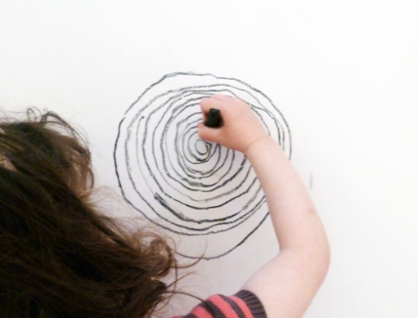
Key Vocabulary for the lesson | Molly Haslund, Spiral, body, movement
Curriculum Links | CT to add
Resources | A2 paper, graphite pencils, charcoal, sticks, chalk

Lesson 2
Access Art Lesson | L2: Develop your drawings
Learning Intention | To apply my sketching skills to develop my spiral drawing.
SOLO SC: Uni- Structural  Bronze | I can find one thing I want change about my drawing.
SOLO SC: Multi- Structural  Silver | I can select what medium I will use to change my drawing.
SOLO SC: Relational  Gold | I can apply my sketching skills to develop my spiral drawing.
SOLO SC: Extended Abstract  Platinum | I can create a spiral drawing by experimenting with different lines.
Activity  (What will the children do to demonstrate their understanding of the LI?) | In this lesson they will explore different qualities of line, colour blending, mark making. They will be building upon their skills from the previous lesson by creating more spirals and using the same movement to create a snail drawing.  Explore artist Tracy McGuinness Kelly (see her work below). Tracey works with the children collaboratively to create a beautiful, colourful mural which each child has had a chance to be part of. Her aim is for children to experiment and be imaginative with colour and shape to create their own unique pieces of art work.  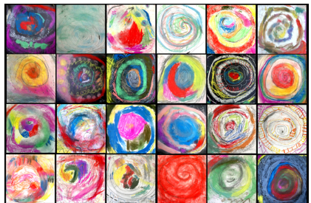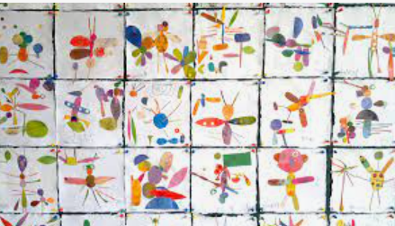  The chn will create a Snail Drawing on a large square of white cartridge paper or black sugar paper, using chalk and oil pastels. Introduce the idea of creating tone by showing the different shades of colours we can use. They may choose to go light to dark or vice versa.  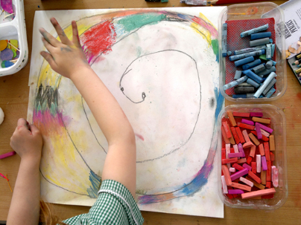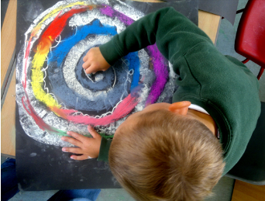
Key Vocabulary for the lesson | Spiral, movement, colour, line
Curriculum Links | CT to add
Resources | Square paper, chalk, oil pastels

Lesson 3
Access Art Lesson | L3: Observational Drawing: Continuous Line
Learning Intention | To apply my drawing skills to make an observational drawing.
SOLO SC: Uni- Structural  Bronze | I can identify what shapes I can see when looking at a shell.
SOLO SC: Multi- Structural  Silver | I can describe what sort of lines I need in my drawing.
SOLO SC: Relational  Gold | I can apply my drawing skills to make an observational drawing.
SOLO SC: Extended Abstract  Platinum | I can reflect on my drawing and see how it can be improved.
Activity  (What will the children do to demonstrate their understanding of the LI?) | Continue with the spiral exploration by applying drawing skills to making observational drawings of shells. Try to collect real shells and have these ready for the lesson so children are able to see what they are drawing. If you do not have shells, use Drawing Source Materials: Shells to access different sources which include shell photos and videos.  Ensure you do the exercises alongside the children (to model your own open exploration), or before the lesson so that you understand how it feels.  Start the session by creating a calm meditative environment. Use this exercise to create Observational Drawings using Continuous Line. Encourage careful observation and intentional mark making. Children will be doing a continuous line drawing of the shell in sketchbooks. They provide an excellent way to help children develop hand eye coordination. Continuous line drawings are made by keeping the pen or pencil in contact with the paper for the duration of the exercise, and by matching speed of looking with speed of drawing. (look at the example of a continuous line drawing below).  You may want to ask children to experiment with scale, different materials, dominant and non-dominant hand. By the end of this session children will have completed a number of line drawings in their sketchbooks.  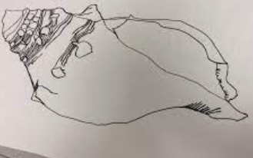
Key Vocabulary for the lesson | Spiral, shell, observational, line
Curriculum Links | CT to add
Resources | Shells, Pencils

Lesson 4
Kapow Lesson | L4: Experimental Mark-Making with Water Soluble Pens
Learning Intention | To observe how my drawing changes when water is added.
SOLO SC: Uni- Structural  Bronze | I can identify what colour I want to add to my drawing.
SOLO SC: Multi- Structural  Silver | I can combine the skills of mark making to add colour to my drawing.
SOLO SC: Relational  Gold | I can observe how my drawing changes when water is added.
SOLO SC: Extended Abstract  Platinum | I can reflect on my drawing and explain the experimental process.
Activity  (What will the children do to demonstrate their understanding of the LI?) | Start the session by creating a calm meditative environment again. Have the shells (or photographs) ready again for the lesson. They will be drawing the shell again, ensuring they use the majority of the space in sketch books. As they draw, encourage students to look closely at the texture and form of the object and to take their time. Do this activity with the children.  They will now go over this painting with a black water soluble felt tip pen. They will now focus on adding colour to their work. Ask these questions to get them thinking about colour:  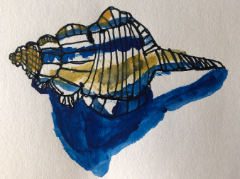  How can we create a lighter tint? (add more water)  How to make a colour more intense? (add more paint)  How to make a duller version of a colour? (add the complementary colour)  How to paint white using watercolour? (leave the paper blank!)  Which colours come forward (warm colours) and which recede (cool colours)  Model adding colour using the coloured felt tip pens and adding water using a paint brush TOL what you are doing to create texture, brightness, boldness, warm tones, cool tones etc.
Key Vocabulary for the lesson | Spiral, mark making, colour, line
Curriculum Links | CT to add
Resources | Shells, pencil, black felt tip pens, coloured felt tip pens, water, brushes

Lesson 5
Kapow Lesson | L5: Celebrate children's work
Learning Intention | To explain the skills I have learnt this term and present my work to the class.
SOLO SC: Uni- Structural  Bronze | I can find one thing that I like about my work.
SOLO SC: Multi- Structural  Silver | I can describe the process of exploring, creating and developing to my peers.
SOLO SC: Relational  Gold | I can explain the skills I have learnt this term and present my work to the class.
SOLO SC: Extended Abstract  Platinum | I can evaluate my peers work in an appropriate manner.
Activity  (What will the children do to demonstrate their understanding of the LI?) | Time to see the work which has been made, talk about intention and outcome. Link it back to Molly Haslund, and say how we viewed her work at the very beginning of the unit and now it's our time to be the artists and have others view our work.  Invite children to display the work in a clear space, and walk around the work as if they are in a gallery. Give the work the respect it deserves. Try to make time to appreciate what has been made, to reflect and focus your thoughts, and to listen to feedback from others. Learning how to talk about art, especially art you have made yourself, is all part of making art. This process can take place even if the work is unfinished. Remind the children of their hard work.  Demonstrate and nurture a sense of valuing the work. Clear the space. Presenting their work in a clear space is really important: it helps people see what is there. This might be as simple as cleaning table tops, and maybe even laying down a sheet of paper to present the object. As pupils get older and more experienced, thinking about how they present their work (i.e. on a plinth, on a cloth, on the floor etc) can be developed further.  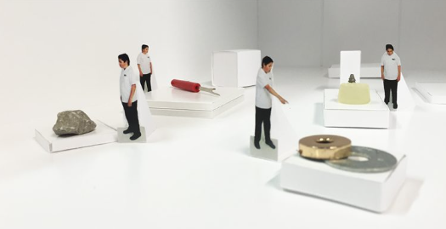  Give children time to walk around the gallery and view others' work. Bring the children back together and ask questions:  How do I feel about what I have made? How does it relate to the starting point?  How far did I come away from the initial starting point?  What do I like about it? Which parts of the process did I enjoy?  Where did I feel lost? What did I discover?  What did I enjoy?  What do other people think about what I have made?
Key Vocabulary for the lesson | Spiral, colour, shape, texture
Curriculum Links | CT to add
Resources | Sketchbooks with work

