Context
Unit | Set Design
Assessment | To explore the work of set designers and create my own set.
Key Knowledge  How does this unit fit in?  What Big Ideas are explored? | In this unit pupils explore the work of set designers – in the first instance a set designer that works in theatre, and in the second instance a maker that creates sets for animation. Pupils go on to explore how they can create their own model set, inspired by a creative stimulus (Floodland - reading text) Sketchbooks are used throughout to brainstorm, record, test and reflect. Key knowledge that will be covered includes learning that designers and makers design “sets” which form the backdrop/props to give context to drama (theatre, film or animation). We can use many disciplines including painting, making, drawing to create sets, as well as thinking about lighting, scale, perspective, composition, and sound. We can take our inspiration from the sources of literature or music to inform our creative response and to capture the essence of the drama.
Skills  What skills are taught in this unit? | D8 Select and record from first hand observation, experience and imagination, and explore ideas for different purposes  D14 Question and make thoughtful observations about starting points and select ideas and process to use in their work.  D10 Compare ideas, methods and approaches in their own and others’ work and say what they think and feel about them.  D11 Adapt their work according to their views and describe how they might develop it further.  D15 Use a sketchbook to develop ideas.  DS23 Work in a sustained and independent way from observation, experience and imagination.  DS24 Explore the potential properties of the visual elements, line, tone, pattern, texture, colour and shape.  DS25 Record the effect of light on objects and people from different directions.  DS26 Interpret the texture of a surface.  TC25 Use a range of media to create a collage.  TC31 Combine collage with other 2D techniques.  M19 Use a variety of materials.  M27 Use recycled, natural and man-made materials to create sculpture.
Vocabulary  To be displayed on the working wall | Set design, designers, makers, set, theatre, Rae Smith, Melotti, dramatic drawings, structure, light, collage, sustainable materials

Unit Overview
Kapow / Access Art Lesson |  |  | Learning Intention | Focus Skill | Diversity | Local Art | Curriculum Links
1 | Introduce set designs |  | To explain how set designs are created in theatre | D8,D14,D10,D11,D15 | Fausto Melotti - Italian sculptor
2 | Plan |  | To create a dramatic drawing | D15,DS23,DS24,DS25 |  |  | Reading text - Floodland
3 | Create a set design |  | To create my own set design | DS26,TC25,TC31,M19,M27 |  |  | Reading text - Floodland
4 | Create a set design |  | To create my own set design | DS26,TC25,TC31,M19,M27 |  |  | Reading text - Floodland

Lesson 1
Access Art Lesson | Introduce set designs
Learning Intention | To explain how set designs are created in theatre
SOLO SC: Uni- Structural  Bronze | I can draw my initial thoughts.
SOLO SC: Multi- Structural  Silver | I can describe what I like about the set designs that are created.
SOLO SC: Relational  Gold | I can explain how set designs are created in theatre
SOLO SC: Extended Abstract  Platinum | I can begin to develop my own ideas for my own set.
The lesson  (How will children meet the LI?) | - Introduce the new unit - ask chn if they have ever been to a theatre before. Discuss: What do you see? Do you know what a set is? How do they make the sets, props and costumes? Explain to the chn that they will explore set designs and designers and at the end of the unit they will be making their own.  - Introduce set designer Rae Smith to the chn. Explain that she is a British Designer who has created many sets, one project she did included creating sets for Michael Morporgo’s adaptation of Warhorse. Share first video of the set. Chn to describe what they saw and materials used.  - Tell the chn that before sets are made, detailed drawings are created to plan what will be made. Watch clips of it and ask chn if they can describe what is happening? How similar are the drawings to the set? Why did they use Charcoal?  - Finally watch the last video of Rae speaking about how she starts every new project. Have a discussion about this.  - Now look at the work of Fausto Melotti, an Italian sculptor who made pieces for sets.  - Have a discussion: How does his work make you feel? Describe the atmosphere of the set? How is it different from the work of Rae Smith?  - Chn to create a visual notes page in sketchbooks to show the different set designs they saw of both artists and to annotate their views, materials used, how it makes them feel etc. Have pictures of the sets printed out for chn to use.  - 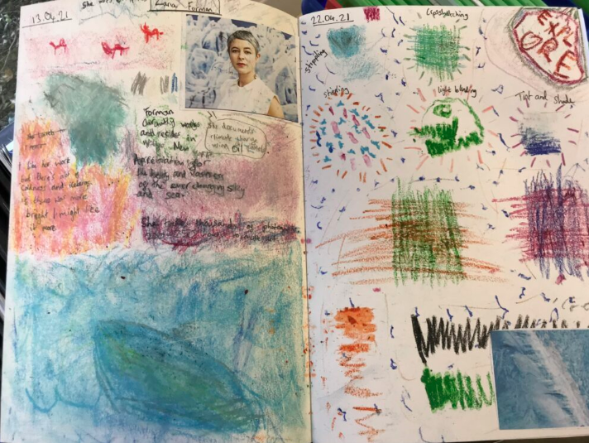
Key Vocabulary for the lesson | Set design, designers, makers, set, theatre, Rae Smith, Melotti
Resources | Sketchbooks, pencils

Lesson 2
Access Art Lesson | Plan
Learning Intention | To create a dramatic drawing
SOLO SC: Uni- Structural  Bronze | I can identify how parts of the story make me feel
SOLO SC: Multi- Structural  Silver | I can describe how I will create my drawing
SOLO SC: Relational  Gold | I can create a dramatic drawing
SOLO SC: Extended Abstract  Platinum | I can annotate my drawing with dramatic phrases.
The lesson  (How will children meet the LI?) | - Retrieval quiz - what was the name of the set designers we looked at last week?  - Ask chn, before making sets, designers have to plan what the sets will look like. What medium did they use to sketch?  - Charcoal - we are going to use charcoal to make dramatic drawings. Why do you think Charcoal creates a dramatic atmosphere?  - Share video of different techniques of how charcoal can be used (watch video from 4:00)  - Now tell chn that next week they will begin making a set for your reading text - Floodland.  - Read sections from the story which have a dramatic scene paired with dramatic music in the background. Ask chn to close their eyes while listening to you reading this section.  - Brainstorm ideas of what the chn were visualising.  - Either in sketchbooks or on large sugar paper to give chn more space, chn can now draw what they were visualising using the charcoal. They could even split the page into sections if they want to draw more than one scene.  - When using the charcoal, ask chn to look at the areas that needed to be darker to add more drama and which areas need to be lighter and use the appropriate technique to get the right effect.  - For homework - ask chn to bring in cardboard boxes and old toys they dont mind using in their set designs.  - 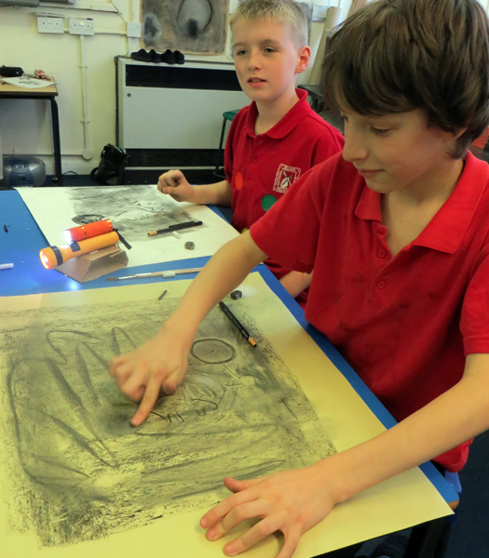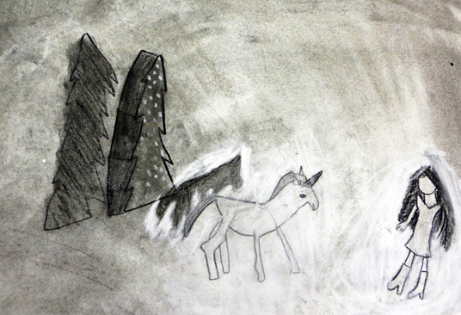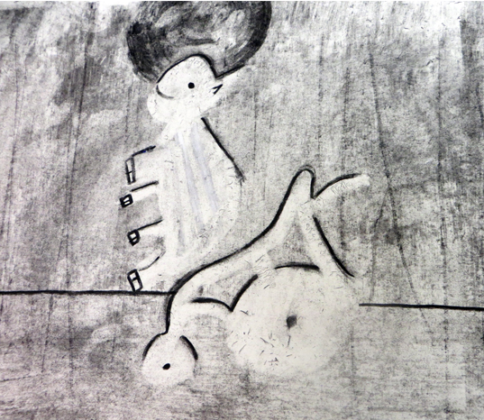
Key Vocabulary for the lesson | Set, designer, charcoal, dramatic drawing, light
Resources | Charcoal, sketchbooks

Lesson 3
Access Art Lesson | Create a set design
Learning Intention | To create my own set design
SOLO SC: Uni- Structural  Bronze | I can choose materials to make my set design
SOLO SC: Multi- Structural  Silver | I can describe how I will use sustainable materials to make my set design.
SOLO SC: Relational  Gold | I can create my own set design
SOLO SC: Extended Abstract  Platinum | I can make my set design more dramatic by adding extra features
The lesson  (How will children meet the LI?) | - Retrieval quiz - how can we create more drama when using charcoal? What charcoal techniques can you remember?  - Today chn will begin to make their set structure. Depending on how many boxes chn bring, you may have to work in pairs or groups.  - Chn need to keep the boxes horizontal with the open end facing them. This will act as the main structure of the set.  - Chn need to choose a scene from Floodland they want to create as a set design and then think about the background.  - If theres lots of water, they may want to use lots of shades of blue and green in different materials.  - Ask chn how can they make more sustainable choices? (using scrap materials, using the back of written paper)  - Chn can now start collaging and layering materials to build the background.  - 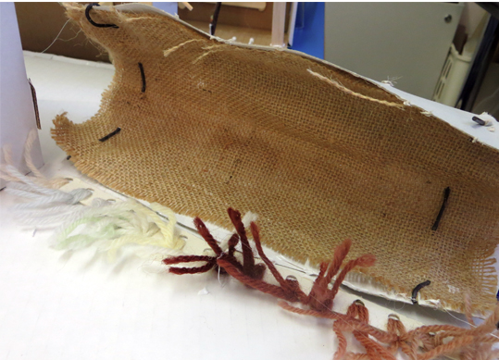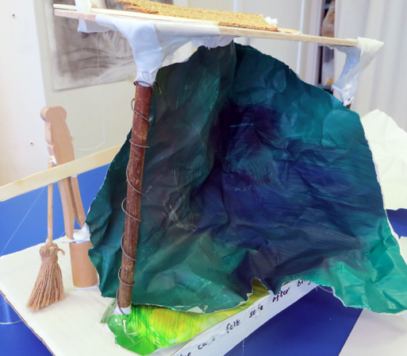  - Chn can now think about other things their set includes - maybe a boat or characters.  - They can use any materials available to create these models and start placing these inside the structure.  - 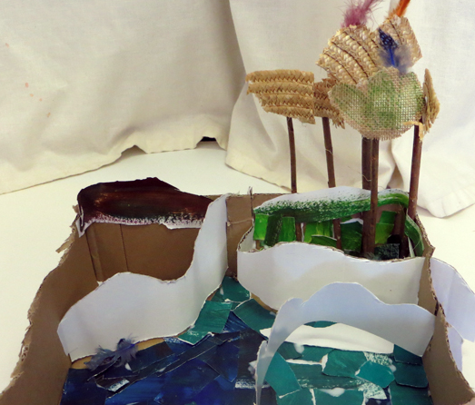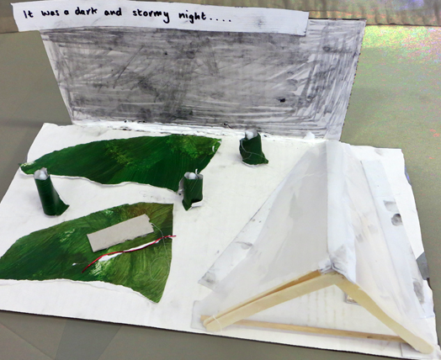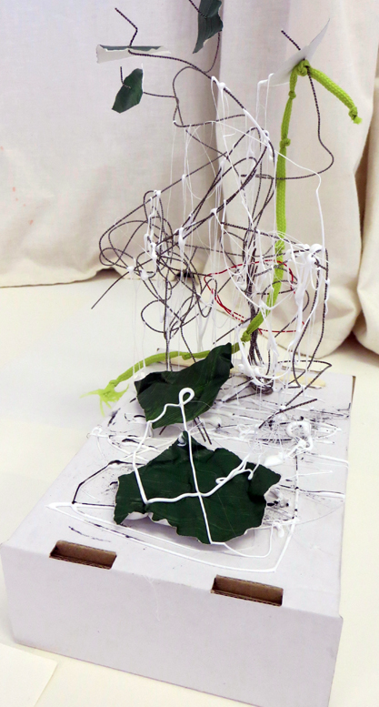
Key Vocabulary for the lesson | Set design, designer, collage, model, structure, light, sustainable materials
Resources | Cardboard box, tissue paper, coloured card, toys and any other collage materials

Lesson 4
Access Art Lesson | Create a set design
Learning Intention | To create my own set design
SOLO SC: Uni- Structural  Bronze | I can choose materials to make my set design
SOLO SC: Multi- Structural  Silver | I can describe how I will use sustainable materials to make my set design.
SOLO SC: Relational  Gold | I can create my own set design
SOLO SC: Extended Abstract  Platinum | I can make my set design more dramatic by adding extra features
The lesson  (How will children meet the LI?) | - Chn will continue to make their structures in this lesson and finish them off.  - If they have finished, ask chn how they can make this more dramatic. They could cut parts of their charcoal drawings and add this to their set designs. They could also write dramatic phrases to describe the scene and add these to the structure.  - 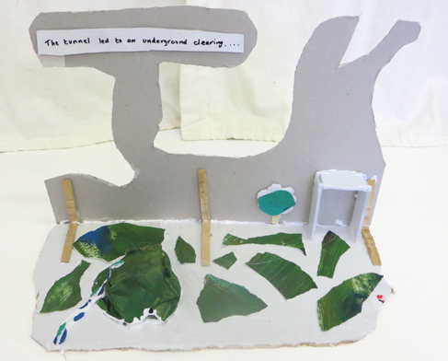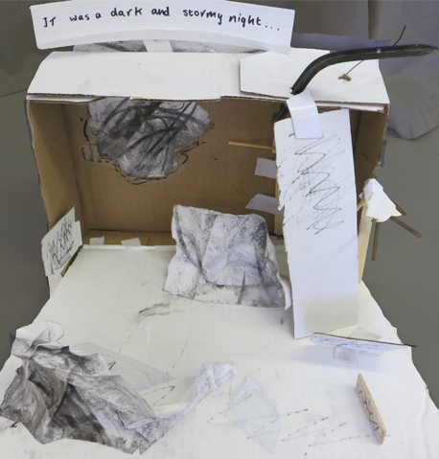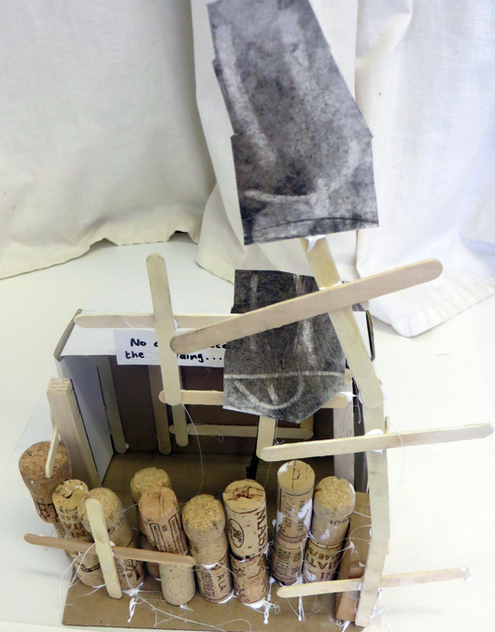  - Once structures are complete, create a visual gallery and give chn space to walk around and view each others creations.  - How do I feel about what I have made? How does it relate to the starting point?  - How far did I come away from the initial starting point?  - What do I like about it? Which parts of the process did I enjoy? Where did I feel lost? What did I discover? What did I enjoy? Are there clues for what’s next?  - What do other people think about what I have made?  - Chn can then answer these questions about their peers work and share feedback.
Key Vocabulary for the lesson | Set design, designer, collage, model, structure, light, sustainable materials
Resources | Cardboard box, tissue paper, coloured card, toys and any other collage materials

