Context
Unit | Festival Feasts
Assessment | To make mini chocolate sculptures to share at a picnic feast.
Key Knowledge  How does this unit fit in?  What Big Ideas are explored? | In this unit children are enabled to begin to recognise that their individual creative response will be different to that of their peers, but that it is valued and can contribute to a larger shared artwork. The unit begins with an exploration of artists who make sculptures of food, working at unexpected scales, working in a sketchbook to make visual notes to consolidate their experience. Children then further develop drawing skills by drawing from still imagery and from life, and using modroc and other modelling and construction materials they will make a shared sculptural feast. Key knowledge covered in this unit includes how we can respond to a creative stimulus through lots of different media (paper, pen, paint, modelling materials and fabric) to work towards drawing, painting, collage, and sculpture. We can use our knowledge and curiosity of line, shape, colour and form to make playful and inventive art. We can make an individual artwork which contributes to a larger shared piece, or we can work on a shared artwork. Finally, that making art can be fun and joyful, and that we can find subject matter which inspires us all and brings us together.
Skills  What skills are taught in this unit? | D8 Select and record from first hand observation, experience and imagination, and explore ideas for different purposes  D9 Question and make thoughtful observations about starting points and select ideas to use in their work.  D10 Compare ideas, methods and approaches in their own and others’ work and say what they think and feel about them.  D11 Adapt their work according to their views and describe how they might develop it further.  DS16 Make informed choices in drawing, incl. paper and media.  DS17 Use research to inspire drawings from memory and imagination.  DS18 Explore relationships between line and tone, pattern and shape, line and texture.  P16 Plan and create different effects and textures with paint according to what they need for the task.  P20 Experiment with colour mixing and matching e.g. tint, tone and shade.  P21 Show increasing independence and creativity with the painting process.  M19 Use a variety of materials.  M20 Talk about their work understanding that it has been sculpted, modelled or constructed.  M21 Make informed choices about the 3D technique chosen.  M22 Plan, design, make and adapt models.  M23 Show understanding of shape, space and form.  M24 Shape, form, model and construct from observation or imagination.
Vocabulary  To be displayed on the working wall | Sculptures, food, festival, feasts, Claes Oldenberg, Lucia Hierro, Rowan Briggs Smith,  Shape, texture, composition, 3D, Nicole Dyer, modroc, modelling, form

Unit Overview
Kapow / Access Art Lesson |  |  | Learning Intention | Focus Skill | Diversity | Local Art | Curriculum Links
1 | Introduce artists/explore and draw |  | To create sketches inspired by artists | D8,D9,D10,D11,DS16,DS17,DS18 | Claes Oldenberg - Swedish artist  Lucia Hierro - American artist | British artist - Rowan Briggs Smith | English text - The Great Chocoplot
2 | Drawing food we like |  | To explore and draw food using the visual elements. | D8,D9,D10,D11,DS16,DS17,DS18
3 | Making a sculptural feast |  | To create a sculptural feast | M19,M20,M21,M22,M23,M24 | Nicole Dyer - Dutch sculpturist
4 | Making a sculptural feast |  | To apply paint to finish my sculpture. | P16,P20,P21

Lesson 1
Access Art Lesson | Introduce artists/explore and draw
Learning Intention | To create sketches inspired by artists
SOLO SC: Uni- Structural  Bronze | I can name materials the artists used.
SOLO SC: Multi- Structural  Silver | I can describe how sculptures make me feel.
SOLO SC: Relational  Gold | I can create sketches inspired by artists
SOLO SC: Extended Abstract  Platinum | I can develop my sketches further by using colour.
The lesson  (How will children meet the LI?) | - Starter: What is your favourite food? What shape is it? What colour is it?  - Explain to the chn that in this new unit they will be consolidating on their drawing skills by sketching food and towards the end of the unit they will be making their own 3D sculpture linked to your english text ‘The great Chocoplot’.  - Explore the work of artist Claes Oldenberg. Watch the video and have a discussion:  How do his sculptures make you feel?  Which food sculpture is your favourite? Why?  How do you think the sculptures feel?  If you created your own sculpture store, what would be in it?  - Give chn some time now to sketch and make visual notes of what they saw in books. You could play the video again and pause at certain points to give chn time to sketch. They can then annotate drawings with how the sculptures made them feel.  - Now Explore the work of artist Lucia Hierro.Watch the video and have a discussion:  Describe what you can see.  How do the colours in the installations make you feel?  How does her work make you feel?  - What are the similarities and differences between Oldenbergs and Hierro work?  - Again give chn some time to sketch and make visual notes of what they saw in books. You could play the video again and pause at certain points to give chn time to sketch. They can then annotate drawings with how the sculptures made them feel.By the end of the lesson, chn should have a 2 page spread of sketches inspired by the two artists.  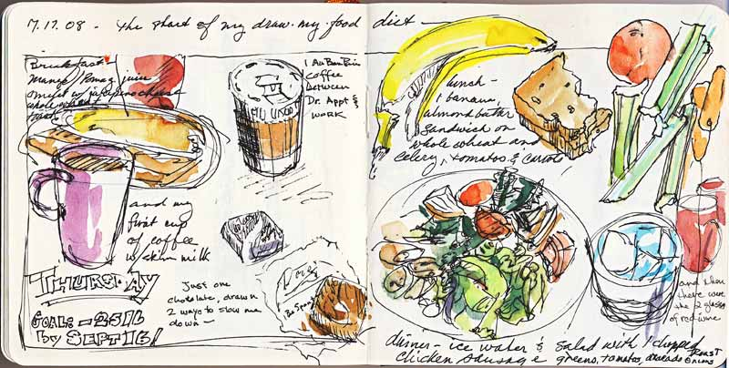  - Finally, share the work of artist Rowan Briggs Smith. Share images of the process of how she creates her mini sculptures. Have a discussion:  - What materials does she use?  - How does she create the shine on her sculptures?  - What tools does she use?  - What difficulties do you think she might have when making her mini sculptures?  - FOR HOMEWORK - ASK CHN TO BRING IN PACKAGING OF A FOOD WHICH CONTAINS CHOCOLATE.
Key Vocabulary for the lesson | Sculptures, food, Claes Oldenberg, Lucia Hierro, Rowan Briggs Smith,
Resources | Sketch pencils, colour pencils

Lesson 2
Access Art Lesson | Drawing food we like
Learning Intention | To explore and draw food using the visual elements
SOLO SC: Uni- Structural  Bronze | I can name the visual elements using the visual elements.
SOLO SC: Multi- Structural  Silver | I can describe the visual elements of a picture.
SOLO SC: Relational  Gold | I can explore and draw food using the visual elements.
SOLO SC: Extended Abstract  Platinum | I can evaluate my sketches with my peers.
The lesson  (How will children meet the LI?) | - Starter: Share images of artist work and name the artists who created the sculptures.  - Chn should have brought in food packaging from home (if they haven’t please have images printed out of food with chocolate (cupcakes, biscuits, chocolate bars)  - Share image of the chocolate cupcake with chn:  -   - Ask chn to describe the visual elements: shape, colour, texture and composition.  - Now using the food packaging they have bought in or the pictures, chn need to create sketches in books of the item.  - They should focus on different parts of the packaging , for example if its a chocolate bar, chn can draw just the logo first. Then they might draw the background packaging and practice using different shades and tones of colour to find the right match.  - By the end of the lesson chn should have a series of sketches of their chosen item. Chn can annotate pictures to describe the visual elements they see using key vocabulary.  - 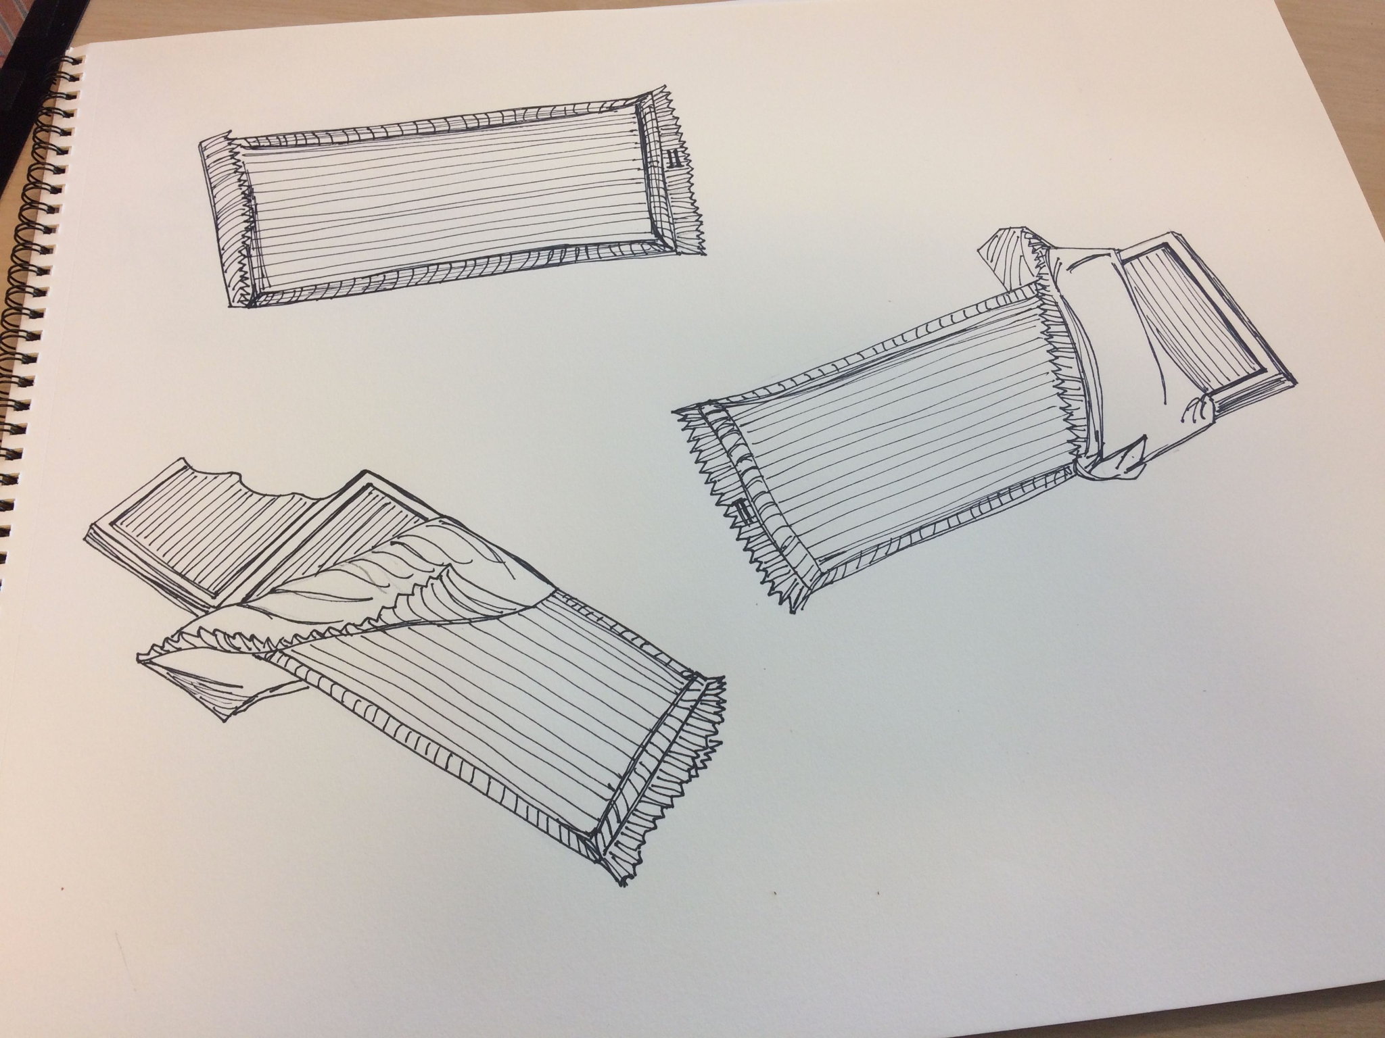
Key Vocabulary for the lesson | Sculptures, food, Shape, texture, composition,
Resources | Pencils, colour pencils, food/food packagaing, images of food packaging

Lesson 3
Access Art Lesson | Making a sculptural feast
Learning Intention | To create a sculptural feast
SOLO SC: Uni- Structural  Bronze | I can name the materials I need to build my sculpture.
SOLO SC: Multi- Structural  Silver | I can describe what I will need to do to make my sculpture.
SOLO SC: Relational  Gold | I can create a sculptural feast
SOLO SC: Extended Abstract  Platinum | I can evaluate the process of building my sculpture.
The lesson  (How will children meet the LI?) | - Starter: describe the visual elements of an image of food.  - Explain to the chn that they are going to use a material called modroc to create their own 3D sculptures of chocolate from the Great Chocoplot which will then be shared in a class picnic.  - Explore sculptures created by dutch artist Nicole Dyer.  - 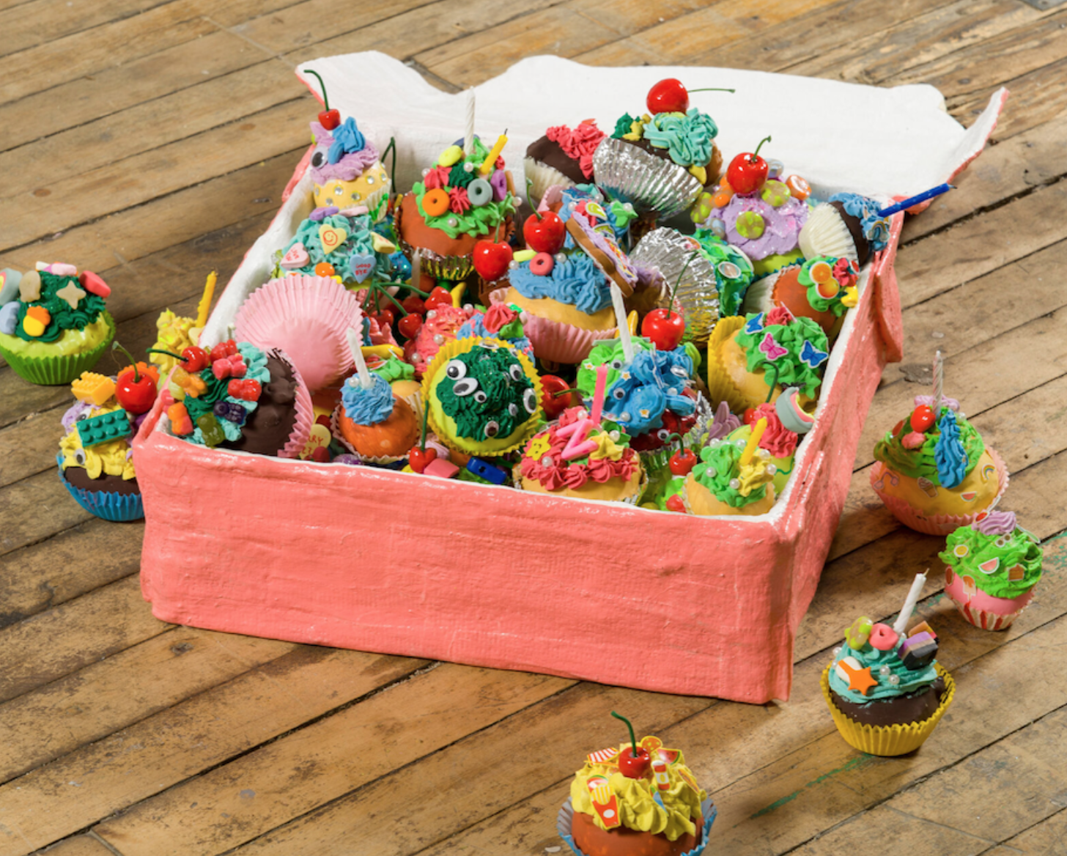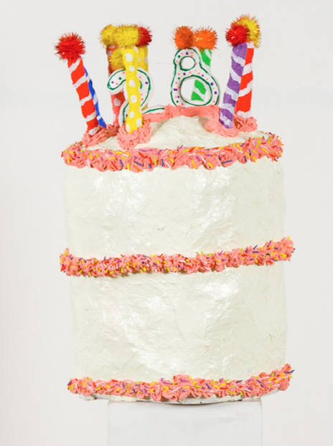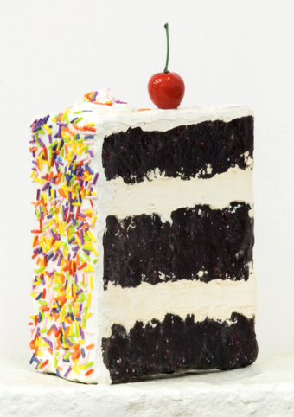  - Discuss:  Describe what you see.  How does it make you feel?  What materials do you think were used to make these food sculptures?  Which sculpture is your favourite? Why?  - When using modroc, ensure tables are covered so it is as less messy as possible. Cut the modroc into small pieces for the chn to use. Have water containers ready for the modroc to be dipped in. Watch this video which will guide you how to use modroc.  - Chn will begin making the basic shape of their sculpture using newspaper and tape to hold it together. Have pictures or sketchbooks open for chn to refer back to their chocolate sketch.  - Then chn will take pieces of modroc, dip it into water and cover the newspaper. Small sculptures only require 1 or 2 layers of modroc.  - Ensure chn put enough water in order to mould and build the modroc into your desired shape. Chn will have to ensure they are apply enough pressure to mould the modroc allowed it to make your sculpture stronger.  - Leave the modroc to dry until the next lesson. It will feel dry, powdery and chalky once it is dry. They should look like this.  - 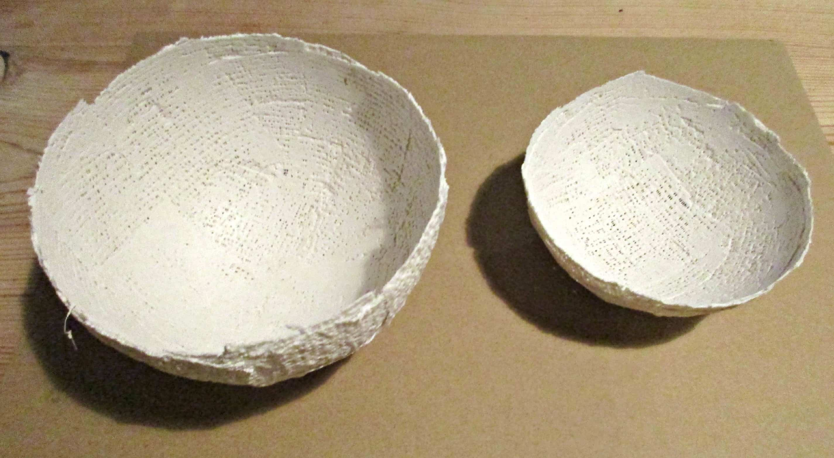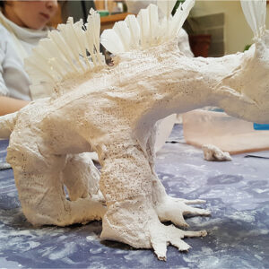  - Once you have cleaned up, you can speak to the chn about how they found using modroc. Was it hard? What did you enjoy?
Key Vocabulary for the lesson | Sculptures, food, festival, feasts, Shape, texture, composition, 3D, Nicole Dyer, modroc, modelling, form
Resources | Newspaper, masking tape, Modroc,water, paint, pictures of food

Lesson 4
Access Art Lesson | Making a sculptural feast
Learning Intention | To apply paint to finish my sculpture.
SOLO SC: Uni- Structural  Bronze | I can name the colours I will paint my sculpture.
SOLO SC: Multi- Structural  Silver | I can discuss how I will use my paintbrush to create texture.
SOLO SC: Relational  Gold | I can apply paint to finish my sculpture.
SOLO SC: Extended Abstract  Platinum | I can evaluate my work and my peers sculpture.
The lesson  (How will children meet the LI?) | - Starter: Explain how we use modroc.  - Today the chn will finish their sculptures by adding colour and texture.  - Have picture/sketchbooks ready for the children to look at the item they chose.  - Chn will paint the details onto their modroc sculptures. Ensure chn are looking at the details, shades and tones they need to use. They may want to add white in areas to create a shine effect or darker tones for a shadow.  - Ask chn to think about what sort of brushstrokes they can make to create texture.  - Chn can also use other collage materials like pom poms, or tissue paper for any extra detail they want to add.  - Leave sculptures to dry and if time in the same lesson create a picnic atmosphere for sculptures to be shared. Think about how this will be displayed. You might like to use a picnic blanket on the floor or table to display work.  - 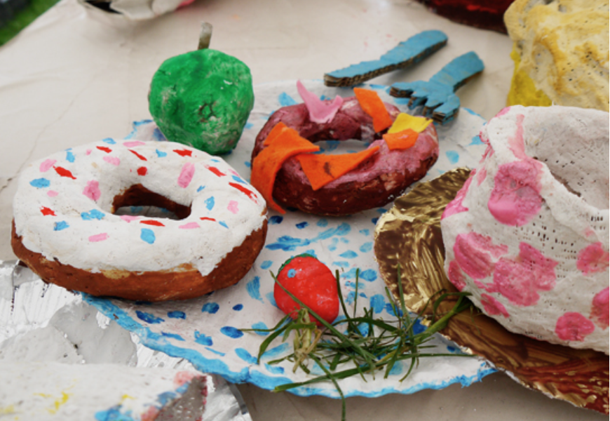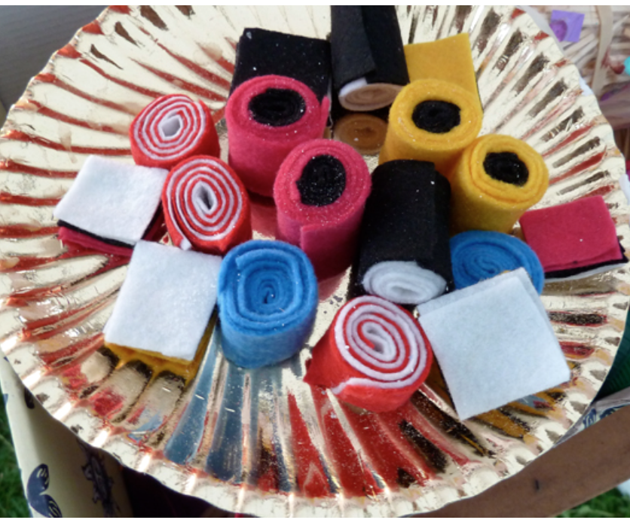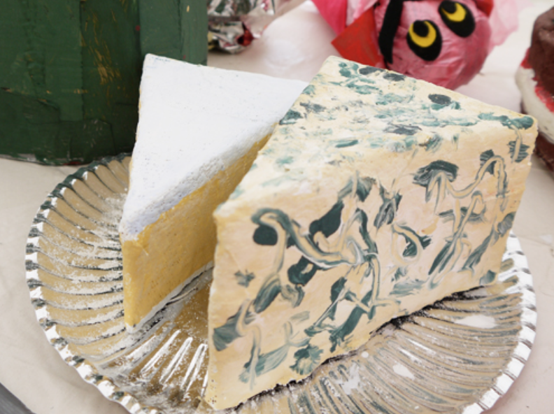  Have the chn walk around and enjoy their work. Ask chn to think about what they like about their peers' work? Was there anything they found difficult? What artists inspired their work? Do you think your sculpture looks realistic? Tell me about the process of making it.  - Chn can then complete a self and peer assessment in sketchbooks.
Key Vocabulary for the lesson | Sculptures, food, festival, feasts, Shape, texture, composition, 3D, Nicole Dyer, modroc, modelling, form
Resources | Paint, brushes, water, pictures of chocolate, any other collage materials (tissue paper)

