Context
Unit | Working with shape and colour
Assessment | Being able to create a collage focusing on the key elements of shape, line, colour and composition.
Key Knowledge  How does this unit fit in?  What Big Ideas are explored? | This unit aims to enable pupils to respond to a painting from another culture or era and use visual literacy skills to come to their own understanding of the artwork. Children then go on to make their own creative response to the original painting, using layering of shape, colour and line using collaging, printmaking and drawing. Collaging will develop the concept of ‘painting with scissors’. It will allow children to be free with their ideas of shape and line and not be afraid of being too neat or precise in ensuring it is the same as the artists explored. There will be a big focus on composition, which again will allow the children to understand that art is a process and cannot be rushed. They have the freedom to change their mind and play around with different positions. In year 2, children were introduced to mono printing which was a technique to create an additional layer to their art work. In this unit, children will be introduced to another technique of printing, which includes creating their own stencils and using their knowledge of colour to add different tones and shades of a primary colours to add extra detail to their collage.
Skills  What skills are taught in this unit? | D8 Select and record from first hand observation, experience and imagination, and explore ideas for different purposes  D9 Question and make thoughtful observations about starting points and select ideas to use in their work.  D10 Compare ideas, methods and approaches in their own and others’ work and say what they think and feel about them.  D12 Use sketchbook to collect and record visual information from different sources.  DS11 Use different media to achieve variation in line, texture, tone, colour, shape and pattern.  DS13 Draw both the positive and negative shapes.  PR8 Explore pattern and shape, creating designs for printing.  TC14 Experiment with a range of media, e.g: overlapping, layering, etc
Vocabulary  To be displayed on the working wall | hape, colour, collage, explore, cutting, Gustav Klimt, Henri Matisse, lines,, composition, stencils, printing  S

Unit Overview
Kapow / Access Art Lesson |  |  | Learning Intention | Focus Skill | Diversity | Local Art | Curriculum Links
1 | Explore artwork |  | To explain the visual elements of an artwork using key vocabulary. | D8, D9, D10, D12 | Exploring work from Henri Matisse - French artist  Exploring work from Gustav Klimt - Austrian artist |  | Linking to science topic - How do we grow a garden? Exploring artists who paint nature (paints, flowers)
2 | Painting with scissors |  | To create a collage using a variety of shapes, colour and lines. | D12, DS11, DS13 | Exploring work from Henri Matisse - French artist |  | Linking to science topic - How do we grow a garden? Looking at the shapes they see in plants and flowers
3 | Creating your collage |  | To create a collage using a variety of shapes, colour and lines. | DS11,DS13,TC14 |  |  | Linking to science topic - How do we grow a garden? Creating a collage which makes a garden
4 | Finalising your collage by adding detail |  | To apply detail to my work by using a printing technique. | PR8,TC14,D10 |  |  | Linking to science topic - How do we grow a garden? Creating a collage which makes a garden

Lesson 1
Access Art Lesson | Explore artwork
Learning Intention | To explain the visual elements of an artwork using key vocabulary.  To explore the work of Henri Matisse.
SOLO SC: Uni- Structural  Bronze | I can identify some of the shapes the artist used in their work.  I can use scissors accurately.
SOLO SC: Multi- Structural  Silver | I can describe some of the colours and shapes used in the art work.  I can explore how to cut a continuous shape.
SOLO SC: Relational  Gold | I can explain the visual elements of an artwork using key vocabulary.  I can create a continuous shape in the style of Henri Matisse.
SOLO SC: Extended Abstract  Platinum | I can compose ideas for my composition.  I can create a shape with more difficult curved lines.
The lesson  (How will children meet the LI?) | - Starter: what is a composition? Discuss this term and explain to the chn that all artists think about the shapes, lines, and colours they want to use and then decide where things will go. It is ok to change your mind. Tell the chn they will be creating their own composition over the new few weeks using a technique called collaging.  - Linking to your science topic of ‘How to grow a garden’, chn will begin by exploring the work of two artists who focus on painting plants and flowers.  - The first artist is Gustav Klimt. Discuss questions below:  - What medium has he used to create this work?  - What colours can you see?  - What shapes can you see?  - 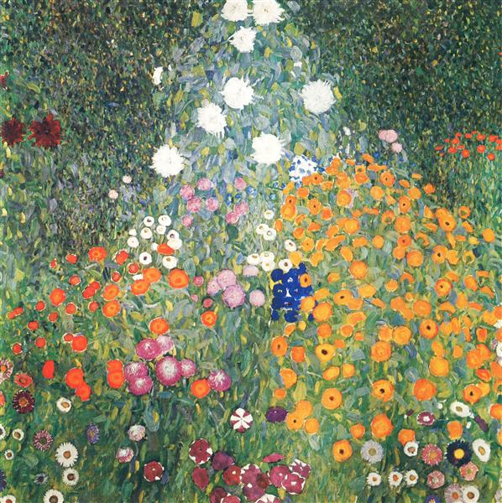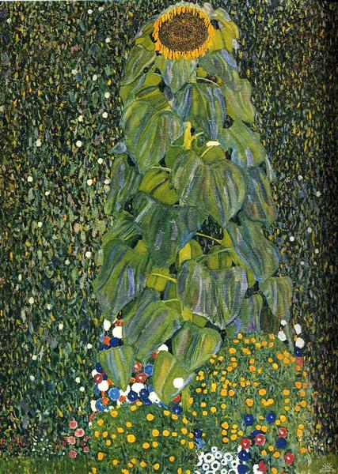  - Then look at the work of Henri Matisse and discuss the same questions.  - 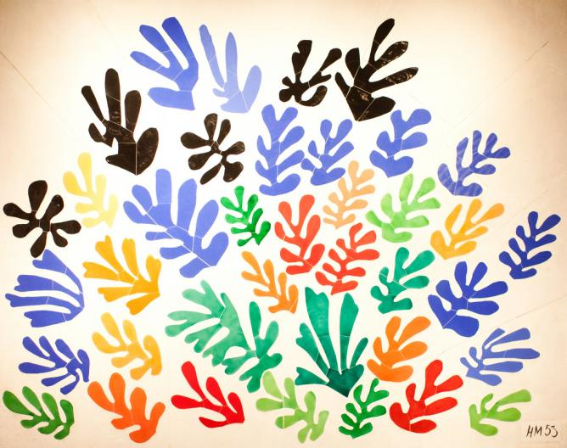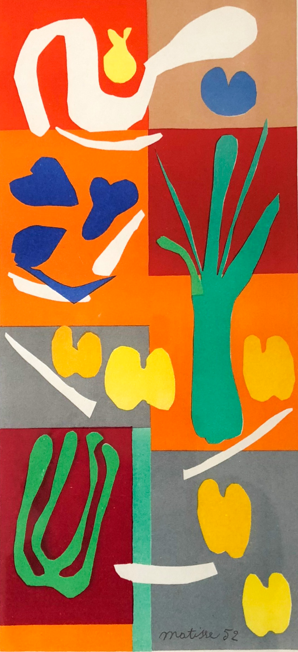  - Ask the chn: how is the work from both artists different?  - Have a deep discussion about the different visual elements that each artist has used. Klimt has used thin, fine lines, his primary colour is green and has added hints of brightness by focusing attention onto the bright flowers. However, Mattise has used big bold colours, using simple shapes to create the outline of plants. He has used thick and thin lines.  - In the chn’s sketchbooks, they will use a double spread to ‘draw what they see’ and practice techniques of both artists. Chn will use one page for Klimt and one page for Mattise. They will explore and experiment with the lines, colours and shapes they could see. They can label and annotate their ideas. Have a look at the example below of what sketchbooks should look like:  - 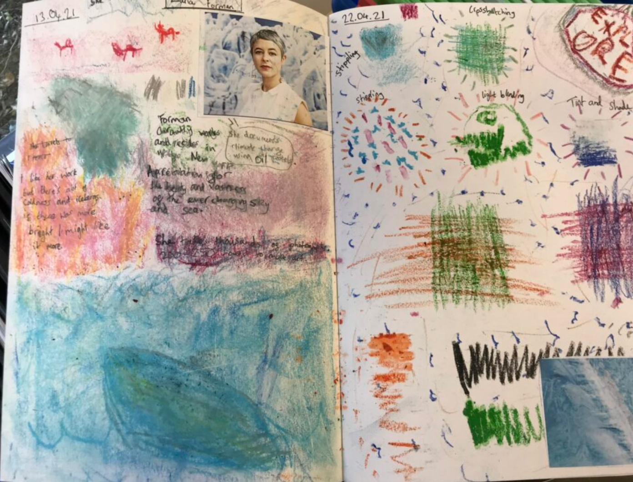
Key Vocabulary for the lesson | Shape, colour, explore, cutting, Gustav Klimt, Henri Matisse, lines
Resources | Sketch pencils, colour pencils, photos of artists work

Lesson 1A
Access Art Lesson | Explore artwork
Learning Intention | To explain the visual elements of an artwork using key vocabulary.  To explore the work of Gustav Klimt.
SOLO SC: Uni- Structural  Bronze | I can identify some of the shapes the artist used in their work.  I can create a pattern.
SOLO SC: Multi- Structural  Silver | I can describe some of the colours and shapes used in the art work.  I can identify some of Klimt’s styles in his work.
SOLO SC: Relational  Gold | I can explain the visual elements of an artwork using key vocabulary.  I can explore some of the painting styles used by Gustav Klimt.
SOLO SC: Extended Abstract  Platinum | I can compose ideas for my composition.  I can combine Klimt’s styles in my work.
The lesson  (How will children meet the LI?) | - See slides
Key Vocabulary for the lesson | Shape, colour, explore, cutting, Gustav Klimt, Henri Matisse, lines
Resources | Sketch pencils, colour pencils, photos of artists work

Lesson 2
Access Art Lesson | Painting with scissors
Learning Intention | To create a collage using a variety of shapes, colour and lines.
SOLO SC: Uni- Structural  Bronze | I can find one material to use to cut some simple shapes.  I can cut out a variety of shapes
SOLO SC: Multi- Structural  Silver | I can select a variety of shapes to cut out.  I can use a variety of shapes and materials in my collage
SOLO SC: Relational  Gold | I can create a collage using a variety of shapes, colour and lines.  I can create a collage thinking about composition.
SOLO SC: Extended Abstract  Platinum | I can evaluate my collage independently and with my peers.  I can compare my work to the work of Matisse and Klimt
The lesson  (How will children meet the LI?) | - Starter: Share work from artists looked at in previous lesson, can the chn remember the names of the artist?  - Introduce the idea of ‘painting with scissors’ to the chn - they will be experiment with this technique today.  - Share video of Matisse’s work and discuss questions below:  How do you think the size of the scissors matisse used affected the artwork he created?  Do you think Matisse drew on the paper first before he cut the shapes out?  Do you think Matisse had a “plan” in his head when he picked up coloured paper and scissors?  - Chn will then choose materials to start cutting shapes. Remind chn of safety rules when using scissors.  - Share pictures of plants on each table for chn to look at when cutting shapes to help with inspiration.  - Chn will be creating their collages of A3 paper next lesson so ensure any shapes that are cut out are big enough to fill the page.  - 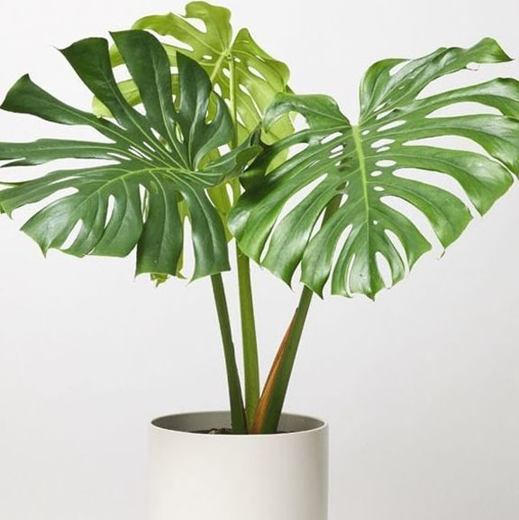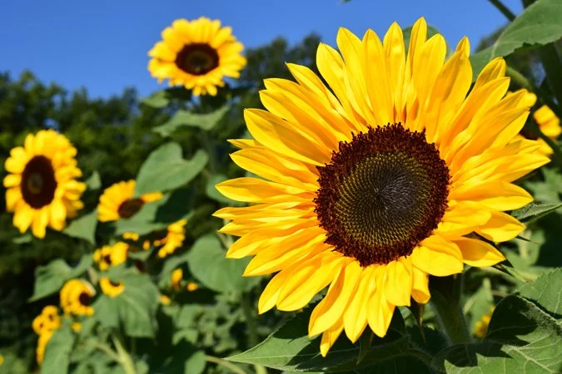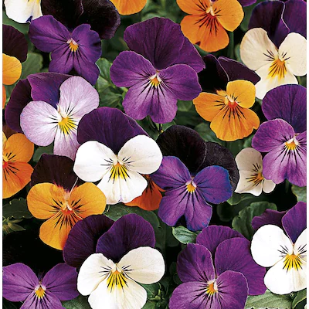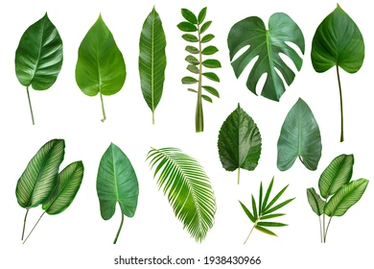  - If chn are happy with the shapes they have cut out, ask them to start planning their composition. Play around with where you want to position the shapes. Experiment with layering - particularly with tissue paper (can you see new colours when tissue paper is layered?)  - Ask chn to cut thin lines and thick lines and experiment with using these in their collage.
Key Vocabulary for the lesson | Shape, colour, collage, cutting, lines, Matisse, composition
Resources | Pictures of plants, Collage materials (coloured paper/card, fabric, foam, tissue paper), scissors

Lesson 3
Access Art Lesson | Creating your collage
Learning Intention | To create a collage using a variety of shapes, colour and lines.
SOLO SC: Uni- Structural  Bronze | I can find one material to use to cut some simple shapes.
SOLO SC: Multi- Structural  Silver | I can select a variety of shapes to cut out.
SOLO SC: Relational  Gold | I can create a collage using a variety of shapes, colour and lines.
SOLO SC: Extended Abstract  Platinum | I can evaluate my collage independently and with my peers.
The lesson  (How will children meet the LI?) | - Starter: show a colour wheel with primary and secondary colours. How can you make different tones? (adding white to making lighter shades, adding brown to make darker shades).  - Chn will continue ‘painting with scissors’ this week. If they have not finished cutting all their pieces they can continue doing this. Encourage chn to use different shades of green. In a garden we have leaves which are different shades of green.  - Talk about ‘composition’, explain that artists take their time when deciding where things will be positioned. Share work from Matisse again and describe the composition of his collages.  - For example, he made leaf shapes and placed them carefully on the page to create a big leaf.  - Once chn are happy with their composition, they will stick their shapes onto A3 paper.  - If time, ask chn to discuss what they like about their composition and then peer assess each others work.
Key Vocabulary for the lesson | Shape, colour, collage, cutting, lines, Matisse, composition
Resources | Pictures of plants, Collage materials (coloured paper/card, fabric, foam, tissue paper), scissors, A3 paper, composition

Lesson 4
Access Art Lesson | Finalising your collage by adding detail
Learning Intention | To apply detail to my work by using a printing technique.
SOLO SC: Uni- Structural  Bronze | I can draw pictures to add some detail.
SOLO SC: Multi- Structural  Silver | I can discuss how I will add detail to my collage.
SOLO SC: Relational  Gold | I can apply detail to my work by using a printing technique.
SOLO SC: Extended Abstract  Platinum | I can evaluate my collage independently and with my peers.
The lesson  (How will children meet the LI?) | - Starter: define composition  - If chn have not yet finished their collage, give them some time to do this.  - Explain to the chn they will be adding more detail to their collage using the method of printing.  - The chn will make their own stencils - they need to draw simple shapes onto some paper.  - 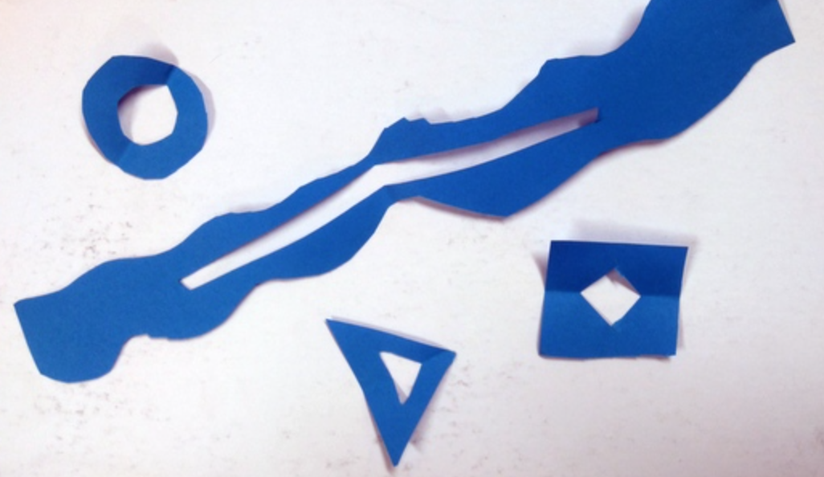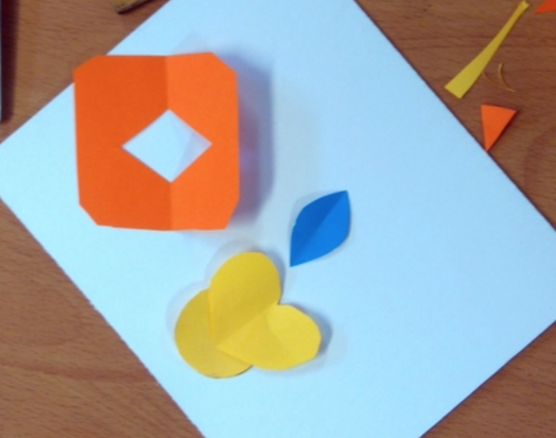  - Again ask the chn to play around with the composition of where they want the stencils to go. Encourage chn to layer stencils too.  - Once they are happy with where the stencils go, they can stick the stencils onto their paper with masking tape.  - 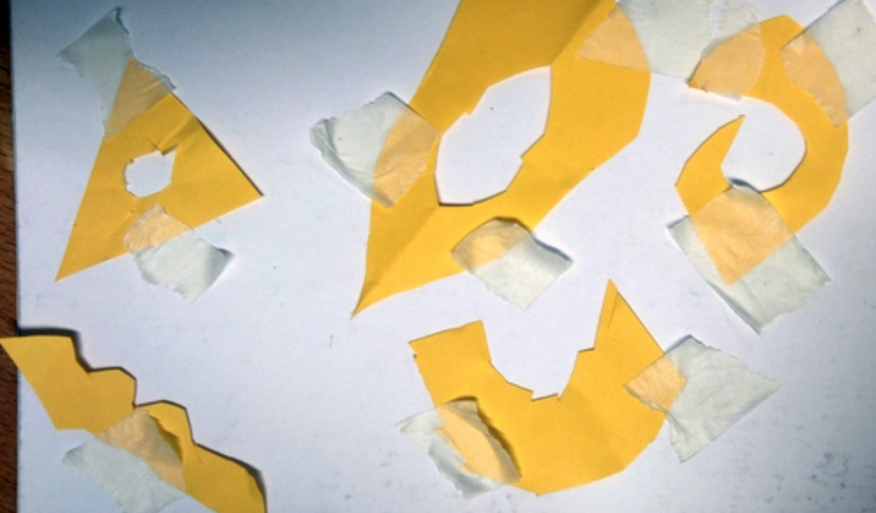  - Chn can now paint the shapes inside the stencils. They will have to let this dry overnight and then peel the stencils next lesson.  - Spend the next lesson encouraging chn to self-assess and peer assess their collages. Encourage chn to use key vocabulary when discussing their art work. Questions to use:  - What did you like about your collage?  - Who was this work inspired by?  - What sort of colours did you use?  - Is there anything you found challenging?
Key Vocabulary for the lesson | Shape, colour, collage, cutting, lines, Matisse, composition, stencil, printing,
Resources | Paper, scissors, masking tape, paint, brushes

