Context
Unit | Flora and Fauna & Printmaking
Assessment | Explore the materials around them to understand how we can use repetition, pattern, colour, line, shape, and texture to make images.
Key Knowledge  How does this unit fit in?  What Big Ideas are explored? | In the Autumn term, children looked at drawing shapes using whole body movements and began to see how we can use different lines to show movement and colour to show feeling. This term the children will be building upon these skills by using nature (flora and fauna) to create their own collage. The lessons will focus on creating shapes using a variety of mediums (tissue paper, coloured card, magazine photos, ink and crayons). They will have the opportunity to have a look at artists' work that has been inspired by flora and fauna such as Henri Rousseu and even a local artist based in Hillingdon - Lisa Enright. This will allow the children to develop their ideas and see how artists have used different colours, tones and shades to create life within their work. It will also give children the opportunity to understand that art is a work in progress, we work in steps to create layers that will build our final outcome. Throughout the unit, children will get to experiment with a wide range of techniques to help build their final outcome, this includes collage, making rubbings and foam printing. This will help children understand how we can create patterns and texture within our work using different mediums. Children will also understand the idea of composition, this will give them the freedom to be independent when creating their work but also understand it is fine to change things during the making process. By the end of the unit, children will be able to host their own gallery to present and share their work and provide feedback and even make links between their own work and artists that were looked at.
Skills  What skills are taught in this unit? | DE1 Record and explore ideas from first hand observation, experience and imagination.  DE3 Review what they and others have done and say what they think and feel about it (eg.: annotate in sketchbook)  DE4 Identify what they might change in their current work or develop in future work.  DE5 Use a sketchbook to gather and collect artwork.  PR1 Make marks in print with a variety of objects, including natural and made objects.  PR3 Make rubbings.  PR4 Build a repeated pattern and recognise patterns in the environment.  TC3 Use a wide variety of media, inc. photocopied material, fabric, plastic, tissue, magazines, crepe paper, etc.  TC6 Explore how textiles create things.
Vocabulary  To be displayed on the working wall | Flora and Fauna, collage, artists, Henri Rousseu, Erin Anfinson, Hannah Borger, Jan van Kessel, Eric Carle, texture, colour, nature, composition, printing, rubbings, repeated pattern,

Unit Overview
Kapow / Access Art Lesson |  |  | Learning Intention | Focus Skill | Diversity | Local Art | Curriculum Links
1 | Introduce Flora and Fauna |  | I can combine my own ideas and artists' work to create a sketch. | DE1, DE3, DE5 | Henri Rousseu - french painter  Jan van Kessel - Flemish painter | Lisa Enright - Artist in Hillingdon who focuses her paintings around nature. 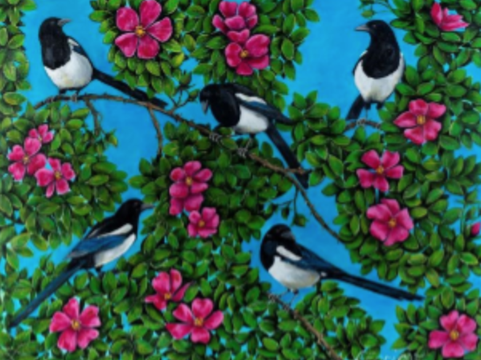 | Power of reading text (The snail and the whale)
2 | Create Eric Carle inspired collage |  | I can explain how my collage can be linked to Eric Carle’s work. | TC3, TC6 |  |  | Power of reading text (The snail and the whale)
3 | Introduce printing by making rubbings |  | I can apply my knowledge of flora and fauna to find natural objects that can create rubbings. | PR1, PR3 |  |  | Power of reading text (The snail and the whale)
4 | Foam printing to make repeated patterns |  | I can design and make my own foam print to create a repeated pattern. | PR1, PR4 |  |  | Power of reading text (The snail and the whale)
5 | Creating my own composition |  | I can compose my own version of what flora and fauna means to me. | PR1, PR3, PR4, TC3, TC4 |  |  | Power of reading text (The snail and the whale)
6 | Assessment - Present, reflect and discuss |  |  | DE3, DE4 |  |  | Power of reading text (The snail and the whale)

Lesson 1
Access Art Lesson | Introduce Flora and Fauna
Learning Intention | To explore flora and fauna
SOLO SC: Uni- Structural  Bronze | I can recognise elements of flora and fauna in art work.
SOLO SC: Multi- Structural  Silver | I can describe what I like about the artist's work.
SOLO SC: Relational  Gold | I can combine my own ideas and artists' work to create a sketch which incorporates flora and fauna.
SOLO SC: Extended Abstract  Platinum | I can interpret an artist's work in my own way and describe it.
The lesson  (How will children meet the LI?) | - Introduce what ‘Flora and Fauna’ means to the children.  - Share work from international and local artists and describe how they have incorporated nature (flora and fauna) into their work. International artists - Henri Rousseau, Erin Anfinson, Hannah Borner. Local artist based in Hillingdon- Laura Enright  - Ask children these questions when looking at the work:  - Describe what you see.  Look at the artwork as a whole – which words would you use to describe the whole piece?  Tell me about the details you like.  How does it make you feel?  - Share pictures from reading text ‘The snail and the whale’ - ask chn what elements of flora and fauna they can see. Ask the red questions again.  - 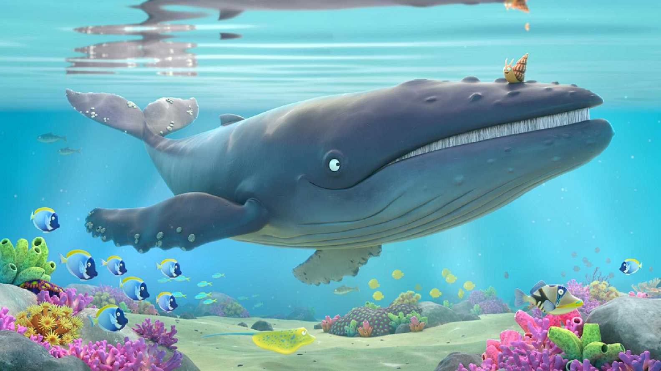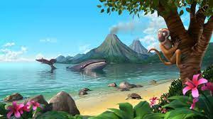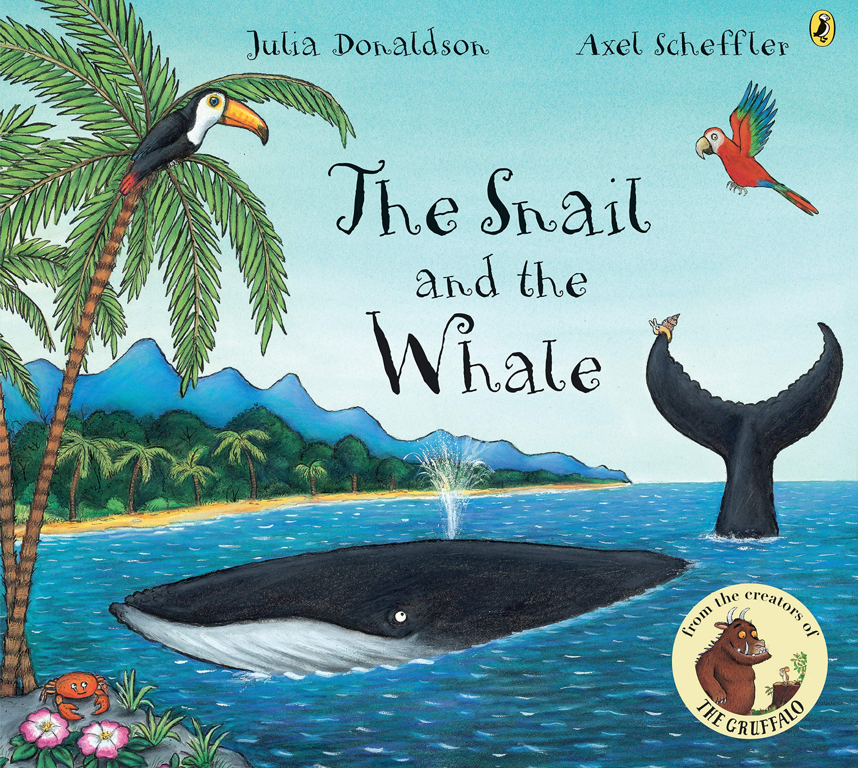  - Linking this back to the artists which were shared at the beginning of the lesson - have images of their work printed out ready for the children to stick into their sketchbooks, creating a collage of their work. Chn to choose their favourite picture and write what they like about it.  - Share flora and fauna videos and stop the video at a chosen frame. Chn will create sketches of what they see and hear, use your voice to direct their drawing. Choose words which relate to the imagery, for example you might decide to focus their attention on vertical lines, so you might choose words like: line, growth, upward, downward, fall or you might choose to attract their attention to the energy of a wave or the curve of an animal's back. These sketches should be quick - 2-3 minutes.  - Chn to add colour using colouring pencils, ask chn to focus on what type of colours the artists used - bright, bold colours.
Key Vocabulary for the lesson | Flora and Fauna, artists, Henri Rousseu, Erin Anfinson, Hannah Borger, Jan van Kessel, texture, colour,
Resources | Artists work, collection of artist work printed, sketch pencils, colouring pencils

Lesson 2
Access Art Lesson | Create Eric Carle inspired collage
Learning Intention | To explain how my collage can be linked to Eric Carle’s work.
SOLO SC: Uni- Structural  Bronze | I can identify a material that can be used when creating a collage.
SOLO SC: Multi- Structural  Silver | I can describe how i will create my collage.
SOLO SC: Relational  Gold | I can explain how my collage can be linked to Eric Carle’s work.
SOLO SC: Extended Abstract  Platinum | I can present my composition and explain the process.
The lesson  (How will children meet the LI?) | - Starter - share work of artists that were looked at last week and ask chn to discuss which one was their favourite and why.  - Explore the work of artist Eric Carle. Ask the following questions:  Have you read The Very Hungry Caterpillar? (If you have the book in school it may be a nice idea to pass it round the class.)  What do you like about Eric Carle’s work?  How does the caterpillar in Eric Carle’s work make you feel?  What’s your favourite insect? Why?  - Tell the chn they will be making their own collage using different materials (tissue paper, coloured paper, foil, printed pictures etc). Their collage will be linked to the snail and the whale.  - Share pictures from the book, ask chn to think about what materials could be used for the water, the trees, the underwater animals. What shapes can they see? How can we create texture? Discuss what composition means - how will they decide where things need to go?  - Model creating a collage using the materials, keep referring back to the picture and discuss the process - the colours you are using, how you are creating texture, the shapes you can see. Show explicitly how you won’t stick it all down and play around making your perfect composition until you are happy with it. Chn will then have a go at creating their own collage.  - Chn to swap work with table partner and share 2 things they like about their partners work - share with the class.  - 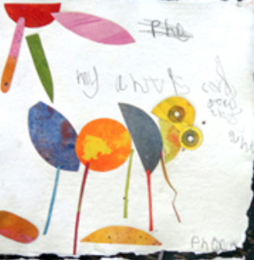
Key Vocabulary for the lesson | Eric Carle, collage, composition, texture, colour
Resources | Tissue paper, photos of artists work, magazines, coloured card/paper

Lesson 3
Access Art Lesson | Introduce printing by making rubbings
Learning Intention | To apply my knowledge of flora and fauna to find natural objects that can create rubbings.
SOLO SC: Uni- Structural  Bronze | I can identify one way printing can be done.
SOLO SC: Multi- Structural  Silver | I can discuss how prints can be created in a variety of ways.
SOLO SC: Relational  Gold | I can apply my knowledge of flora and fauna to find natural objects that can create rubbings.
SOLO SC: Extended Abstract  Platinum | I can present my composition and explain the process.
The lesson  (How will children meet the LI?) | - Starter - show pictures of collages and ask chn to discuss what materials, techniques and mediums have been used to create them.  - Introduce the idea of printing. The chn will be building upon their collage by learning a new technique. Share pictures and ask chn what tools were used to create these prints?  - 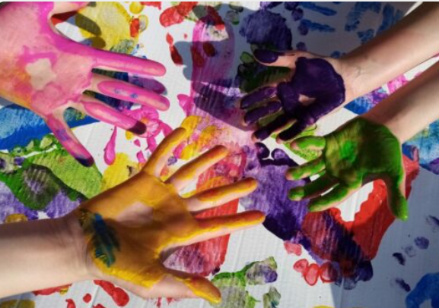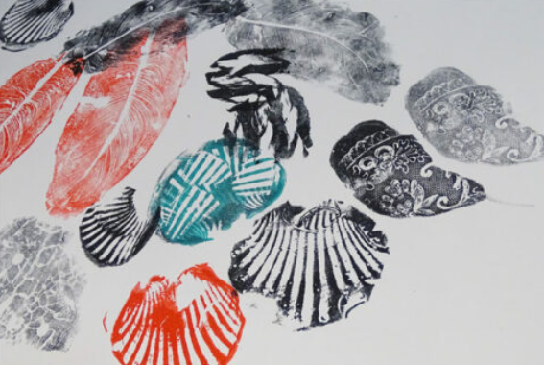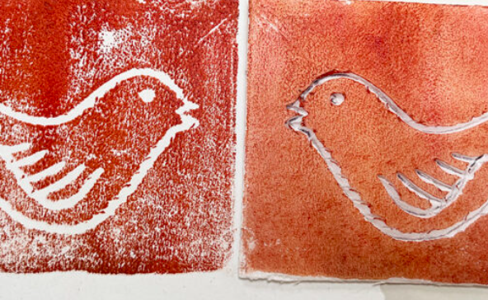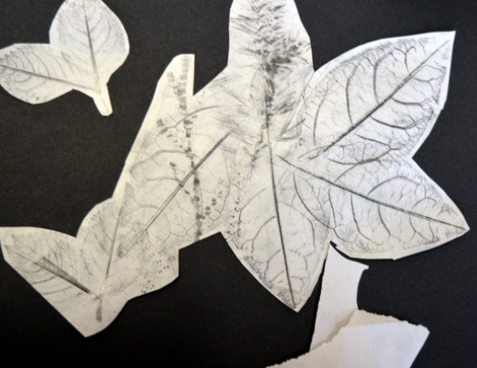  - Explain to the chn that printing is also part of collaging. In this lesson they will be focusing on rubbings. Show examples of this.  - Share picture of the snail and the whale - tell the chn they will be focusing on the palm tree in the picture.  - Take the children outside to collect leaves (different shapes and sizes) and make rubbings of the tree bark on sugar paper using brown crayons. Model this first.  - Bring the leaves into the classroom and ask chn to make rubbings of them using different shades of green.  - Model making a composition - cutting the bark rubbings to create the trunk, placing the leaf rubbings to make a tree and play around with this until your happy. Chn to do the same to create their own collage.  - (KEEP THE LEAVES AS CHN WILL NEED THEM IN LESSON 5)
Key Vocabulary for the lesson | Collage, printing, rubbings, nature
Resources | Natural objects (leaves, twigs, sticks, flowers) paper, crayons

Lesson 4
Access Art Lesson | Foam printing to make repeated patterns
Learning Intention | To design and make my own foam print to create a repeated pattern.
SOLO SC: Uni- Structural  Bronze | I can recognise shapes in repeated patterns.
SOLO SC: Multi- Structural  Silver | I can discuss what shapes and colours I will use to make my repeated pattern.
SOLO SC: Relational  Gold | I can design and make my own foam print to create a repeated pattern.
SOLO SC: Extended Abstract  Platinum | I can compare and evaulate both printing techniques.
The lesson  (How will children meet the LI?) | - Starter - show examples of repeated patterns and ask chn what shapes they can see.  - 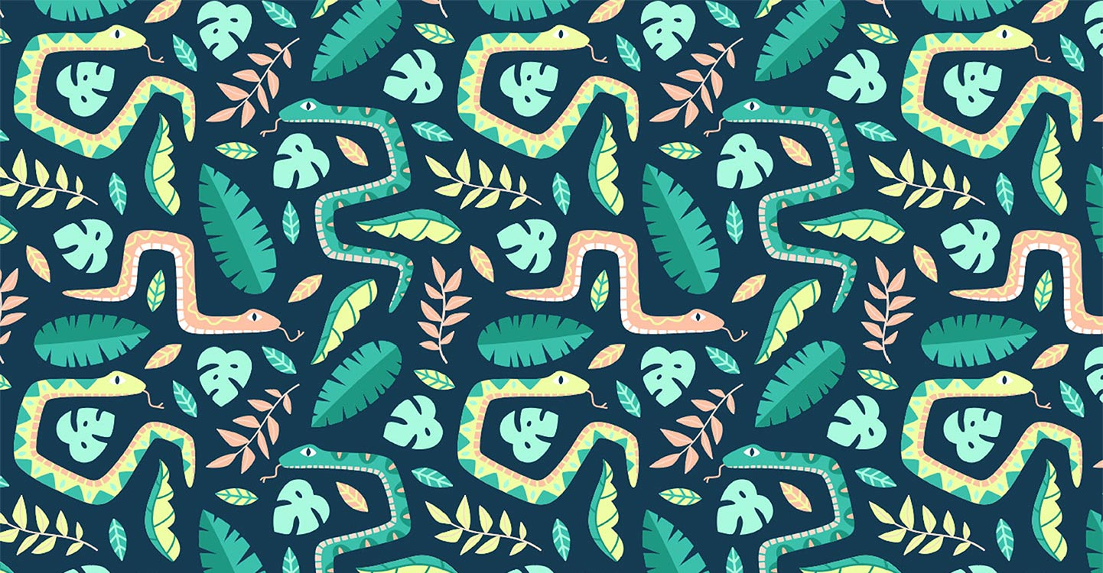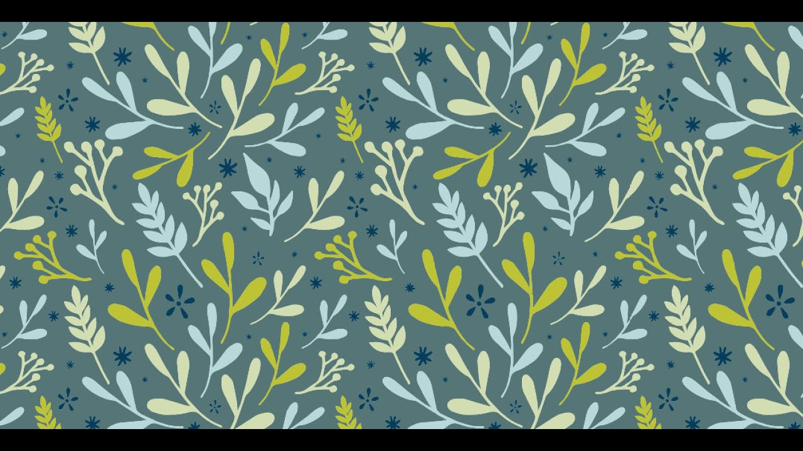  - Chn will continue working on prints today but will explore a different type of printing - foam printing.  - Share the picture of the snail and whale again and tell the chn they will be printing fish in the water using foam boards.  - Model carving a simple fish onto a foam board and using ink, print this onto some blue sugar paper.  - 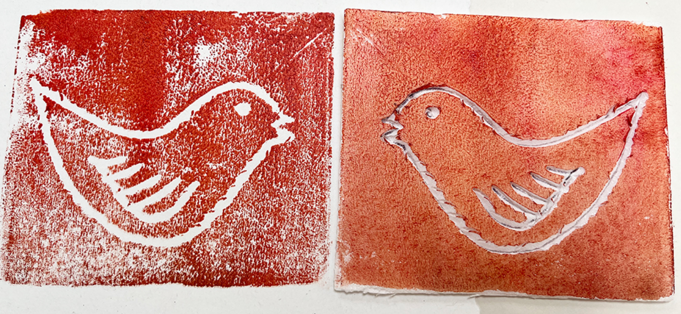  - Chn can make two sea animal prints on the foam boards (KEEP THE FOAM BOARDS FOR LESSON 5) - using different coloured inks, can chn experiment creating a repeated pattern. E.g one blue fish followed by a yellow fish etc.  - Plenary - ask chn which type of printing they prefer - rubbing or foam printing. Which one did they find more difficult and why? What would they do differently next time?
Key Vocabulary for the lesson | Collage, printing, repeated pattern, composition
Resources | Foam polystyrene boards, carving tools, printing ink

Lesson 5
Access Art Lesson | Creating my own composition
Learning Intention | To compose my own version of what flora and fauna means to me.
SOLO SC: Uni- Structural  Bronze | I can recall all the techniques I have learnt.
SOLO SC: Multi- Structural  Silver | I can apply the techniques learnt to create
SOLO SC: Relational  Gold | I can compose my own version of what flora and fauna means to me.
SOLO SC: Extended Abstract  Platinum | I can imagine being an artist and evaluating someone else’s work.
The lesson  (How will children meet the LI?) | - In this lesson, chn will be bringing together all the skills and techniques they have learnt to create one big masterpiece linked to the snail and the whale on A3 paper.  - Take the chn through the lesson as if you are retelling the story. First begin with creating the water - this will be done using tissue paper and other scrap blue material linking this to the work of Eric Carle.  - Then layering on top, make the snail and the whale, again cutting and ripping shapes out of tissue paper. Remind chn to think about their composition again.  - Now the chn will create the trees using rubbings and again layer this on top - use the leaves saved from lesson 3.  - Finally the chn will now create the final layer of their collage by using their foam prints to print fish and other under water animals or plants.  - If time, give children time to walk around the classroom as if its a gallery and reflect on their own and others work. Ask the children: How have you incorporated flora and fauna into your art work? What was your favourite part? What did you find difficult? What would you change next time?
Key Vocabulary for the lesson | Composition, Flora and Fauna, collage, rubbings, printing
Resources | A3 white card, collage, foam printer, printing ink, collage materials

