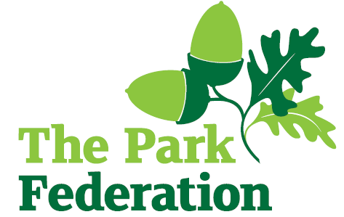
Deputy Principal
Salary: £75,433 - £82,816
Grade: L14 - L18
Hours: Full time
Contract: Permanent
Start Date: September 2026

West Drayton Academy would like to appoint a committed and enthusiastic Deputy Principal with skills in four key areas; Strategic vision and leadership, teaching & learning excellence, operational and people management, resilience and presence. We are looking for someone who remembers exactly why they chose this profession and cannot wait to inspire the next generation. This is an exciting opportunity for someone to make a positive impact in raising standards and promoting the quality of the curriculum. Your standards will be high.

You will be responsible for the operational implementation of strategies and processes across the school. A sharp knowledge of English, inclusion and assessment would be advantageous. The successful candidate will raise expectations and aspirations, promote the academy’s pedagogy for highly effective learning and help achieve positive outcomes for children. We offer you a great opportunity to develop your career in a well-respected, Multi Academy Trust working with a forward thinking, vibrant and supportive team.
For the right candidates, we will offer
- Extensive support and CPD;
- The opportunity to work with other professional colleagues across the Multi-Academy Trust;
- A welcoming school, with friendly, enthusiastic and supportive staff team;
- An ambitious and dynamic Senior leadership Team;
- A dedicated Governing Body;
- Supportive parents and children who are keen to learn;
- an employee assistance programme (EAP)
West Drayton Academy is a popular and oversubscribed school. Visits to the Academy are warmly welcomed. For further information, please contact the school on 01895 - 442904 or email wdaoffice@theparkfederation.org. Please visit the school website for an application pack, we do not accept CV’s.
CLOSING DATE: Monday 2nd March – 12pm
“The School is committed to safeguarding and promoting the welfare of children and young people and expect all staff and volunteers to share in this commitment. The successful applicant will be required to undertake an Enhanced DBS Check with a check of the DBS Barred List”

